ONLINE SUPPLEMENT

Additional analyses for the following manuscript:

Monitored anesthesia care by sedation-trained providers in acute stroke thrombectomy.

Supplementary Table I. Medications administered during mechanical thrombectomy with sedation-trained providers or anesthesia providers.
Supplementary Table II. Medications administered to patients who underwent mechanical thrombectomy by conscious sedation or general anesthesia, regardless of provider type.
Supplementary Table III. Blood pressure data for patients undergoing mechanical thrombectomy with sedation-trained providers or anesthesia teams.
Supplementary Figure I. Mean diastolic blood pressures during mechanical thrombectomy.

 | Sedation-trained provider, no conversions  N=59 | Anesthesia team, including conversions  N=45 | p-value
No sedation | 15 (25.4%) | 12 (26.7%) | 1.0
Fentanyl | 44 (74.6%) | 30 (66.7%) | 0.392
Midazolam | 5 (8.5%) | 11 (24.4%) | 0.0308
Dexmedetomidine | 0 (0%) | 2 (4.4%) | 0.185
Propofol | 0 (0%) | 14 (31.1%) | < 0.0001
Multiple drugs | 5 (8.5%) | 18 (40%) | 0.0002

Supplementary Table I. Medications administered during mechanical thrombectomy with sedation-trained providers or anesthesia providers. Patients who began the procedure under interventionist sedation but required conversion to general anesthesia are included in the anesthesia team group in this table. Overall p-value < 0.0001.

 | Total | Conscious (or no) sedation  N=96 | General anesthesia  N=8 | p-value
No sedation | 27 | 27 (28.1%) | 0 (0%) | 0.108
Fentanyl | 76 | 69 (71.9%) | 7 (87.5%) | 0.679
Midazolam | 17 | 11 (11.5%) | 6 (75%) | 0.0002
Dexmedetomidine | 2 | 1 (1.0%) | 1 (12.5%) | 0.149
Etomidate | 1 | 0 (0%) | 1 (12.5%) | 0.077
Propofol | 15 | 9 (9.4%) | 6 (75%) | < 0.0001
Multiple drugs | 24 | 16 (16.7%) | 8 (100%) | < 0.0001

Supplementary Table II. Medications administered to patients who underwent mechanical thrombectomy by conscious sedation or general anesthesia, regardless of provider type. Dexmedetomidine and propofol for conscious sedation were always administered by an anesthesia professional. Overall p-value (excluding multiple drugs) is < 0.0001.

 | Sedation provider | Anesthesia provider | p-value
BP ranges
Highest SBP | 167.9 ± 23.0 | 161.9 ± 23.6 | 0.247
 | 165 (154 – 180) | 160 (148.5 – 175.5)
Lowest SBP | 117.5 ± 21.1 | 121.6 ± 18.6 | 0.328
 | 117.5 (101.25 – 130.5) | 120 (105 – 130)
Highest DBP | 89.4 ± 18.1 | 88.1 ± 22.7 | 0.719
 | 86 (78 – 100) | 82 (78.75 – 100)
Lowest DBP | 68.8 ± 18.5 | 71.2 ± 16.1 | 0.414
 | 66 (60-78) | 70 (59.5 – 80.75)
Repeated Measures ANOVA
(Graph of means)
SBP |  |  | 0.618
DBP |  |  | 0.427
BP metrics
MAP Fall more than 40% | 7/63 (11.1) | 3/38 (7.3) | 0.736
Time to SBP < 140  (minutes) | 6.8 (0-14.3) | 4 (0-24) | 0.556
Target BP within 10 minutes | 36 / 63 (57.1) | 25 / 41 (60.9) | 1.0
Any SBP reading < 140 mm Hg prior to recanalization | 27 / 63 (42.9) | 16 / 41 (39.0) | 0.839
Systolic BP
Standard Deviation
Pre Recanalization | 14.1 ± 9.5 | 11.4 ± 8.1 | 0.203
Post Recanalization | 9.9 ± 7.0 | 7.7 ± 7.7 | 0.087
Coefficient of Variation
Pre Recanalization | 10.0 ± 7.0 | 7.8 ± 5.6 | 0.202
Post Recanalization | 7.4 ± 5.8 | 5.6 ± 5.1 | 0.142
Successive Variation
Pre Recanalization | 15.1 ± 17.5 | 13.2 ± 19.4 | 0.133
Post Recanalization | 15.3 ± 22.7 | 7.0 ± 8.1 | 0.001
Diastolic BP
Standard Deviation
Pre Recanalization | 8.8 ± 6.6 | 11.9 ± 9.8 | 0.137
Post Recanalization | 9.0 ± 10.3 | 6.0 ± 6.3 | 0.136
Coefficient of Variation
Pre Recanalization | 11.0 ± 8.5 | 14.4 ± 10.2 | 0.092
Post Recanalization | 11.4 ± 12.0 | 8.1 ± 7.0 | 0.207
Successive Variation
Pre Recanalization | 11.9 ± 11.0 | 12.4 ± 13.6 | 0.813
Post Recanalization | 13.3 ± 20.4 | 5.2 ± 6.3 | 0.003

Supplementary Table III. Blood pressure data for patients undergoing mechanical thrombectomy with sedation-trained providers or anesthesia teams. SBP= systolic blood pressure; DBP = diastolic blood pressure. Successive variation of blood pressure measurements post-recanalization was significantly greater in the sedation provider group. Otherwise, there were no significant differences between groups.

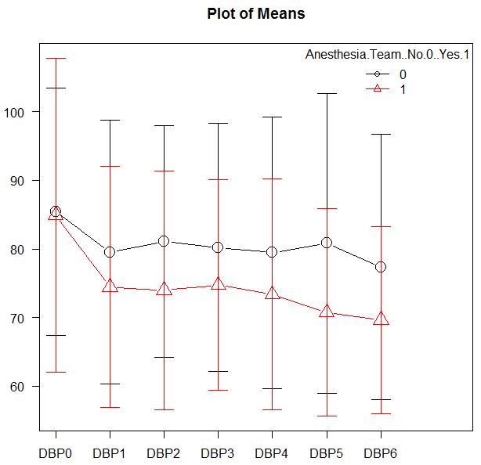

Supplementary Figure I. Mean diastolic blood pressures during mechanical thrombectomy.
Patients in the sedation-trained provider group are represented in black, and patients in the anesthesia team group are represented in red. DBP0 represents diastolic blood pressure on arrival to the interventional lab. DBP1-3 are measurements taken prior to recanalization, while DBP4-6 are measurements taken after recanalization.

