Panel strains in each phenotypes | ST | PIP | PIP-TZ | CAZ | FEP | IPM | MEM | CAZ-CLV | SAM
ESBL |  | R | I/R | R | R | S | S
A. baumanniiYMC2003/5/C86 | 423 | 256,R | 128,R | 64,R | 64,R | 32,R | 32,R | 8,S | 32,R
A. nosocomialis YMC2003/1/R306 | 948 | 256,R | 32,I | 64,R | 64,R | 2,S | 4,S | 4,S | 32,R
Over-expressed AmpC β-lactamase |  | I/R | I/R | R | I/R | S | S
A. baumanniiYMC2009/2/B6756 | 191 | 256,R | 256,R | 256,R | 32,R | 2,S | 4,S | 64,R | 32,R
A. baumanniiYMC2012/7/R3167 | 208 | 256,R | 8,S | 64,R | 32,R | 1,S | 4,S | 64,R | 32,R
A. baumanniiYMC2009/3/B7798 |  | 256,R | 1,S | 256,R | 128,R | 2,S | 2,S | 64,R | 32,R
A.BaumanniiYMC2009/6/P319 |  | 256,R | 1,S6 | 256,R | 128,R | 4,S | 64,R | 64,R | 128,R
A.BaumanniiYMC2009/3/R1487 |  | 32,I | 256,R | 128,R | 64,R | 32,R | 32,R | 128,R | 128,R
A.BaumanniiYMC2009/7/B8464 |  | 256,R | 1,S | 256,R | 32,R | 2,S | 2,S | 64,R | 32,R
Oxa-carbapenemase |  | R | R | S | S | I/R | I/R
A.BaumanniiYMC2011/2/C582 | 208 | 256,R | 256,R | 256,R | 128,R | 256,R | 128,R | 64,R | 128,R
A.BaumanniiYMC2011/7/R812 | 1386 | 256,R | 256,R | 4,S | 16,I | 16,R | 32,R | 4,S | 32,R
A.BaumanniiYMC2012/1/R79 | 191 | 256,R | 256,R | 256,R | 128,R | 32,R | 64,R | 64,R | 32,R
A.BaumanniiYMC2012/9/R2209 | 229 | 256,R | 256,R | 256,R | 64,R | 8,I | 32,R | 64,R | 32,R
A.BaumanniiYMC2011/7/U2158 |  | 256,R | 256,R | 4,S | 16,I | 16,R | 32,R | 4,S | 32,R
A.BaumanniiYMC2011/7/P479 |  | 256,R | 256,R | 16,I | 8,S | 8,I | 64,R | 8,S | 8,S
A.BaumanniiYMC2010/9/R966 |  | 256,R | 256,R | 16,I | 16,I | 32,R | 32,R | 4,S | 8,S
A.pittiiYMC2012/1/U133 |  | 256,R | 256,R | 64,R | 128,R | 32,R | 32,R | 64,R | 128,R
A.BaumanniiYMC2010/10/R659 |  | 256,R | 256,R | 16,I | 16,I | 32,R | 64,R | 16,I | 16,R
A.BaumanniiYMC2012/1/U17 |  | 256,R | 0.5,S | 256,R | 128,R | 64,R | 64,R | 64,R | 64,R
Metallo-β-lactamase |  | R | R | R | R | R | R
A.pittiiYMC2013/3/R2081 | 1030 | 256,R | 4,S | 256,R | 64,R | 4,S | 64,R | 32,R | 16,R
A.BaumanniiYMC2013/2/U2800 |  | 256,R | 64,I | 32,R | 32,R | 32,R | 64,R | 32,R | 16,R
A.BaumanniiYMC2012/3/U2025 |  | 128,R | 64,I | 32,R | 8,S | 32,R | 128,R | 32,R | 128,R
A.BaumanniiYMC2011/6/U1483 |  | 256,R | 0.5,S | 8,S | 128,R | 32,R | 64,R | 32,R | 64,R
A.BaumanniiYMC2012/9/U3624 |  | 256,R | 0.5,S | 8,S | 128,R | 128,R | 256,R | 32,R | 128,R
Narrow-spectrum β-lactamase |  | I/R | I/R | S | S | S | S
A.pittii YMC2010/8/T346 | 1385 | 32,I | 0.5,S | 4,S | 4,S | 2,S | 16,R | 4,S | 4,S
A.BaumanniiYMC2011/6/R1565 |  | 32,I | 0.5,S | 256,R | 4,S | 0.25,S | 2,S | 4,S | 4,S
Narrow-spectrum β-lactamase |  | R | R | S | S | S | S
A.pittiiYMC2009/2/B2968 | 1638 | 32,I | 0.5,S | 4,S | 4,S | 0.25,S | 0.5,S | 4,S | 2,S
Wild type |  | S | S | S | S | S | S
YMC2013/1/R3000 |  | 256,R | 0.5,S | 8,S | 16,I | 0.25,S | 1,S | 4,S | 4,S
Table S1: Complete list of Acinetobacter spp. and its MIC ((μg/mL, interpretation).

Note: MLST, Multilocus sequence typing; R, Resistant; I, Intermediate; S, susceptible; PIP, piperacillin; PIP/TZ, piperacillin-tazobactam; CAZ, ceftazidime; FEP, cefepime; IPM, imipenem; MER, meropenem; CIP, ciprofloxacin, CAZ/CLV, ceftazidime-clavulanate; SAM, Ampicillin/Sulbactam.

Table S2: Profile of AdeABC efflux pump along with its transcriptional regulators AdeRS in Acinetobacter isolates.
Panel strains in each phenotypes | adeR | adeS | adeA | adeB | adeC
ESBL
YMC2003/5/C86 | + | + | + | + | +
YMC2003/1/R306 | + | + | + | + | +
Over-expressed AmpC β-lactamase
YMC2009/2/B6756 | + | + | + | + | +
YMC2012/7/R3167 | + | + | + | + | +
OXA-type carbapenemase
YMC2011/7/R812 | - | - | - | + | -
YMC2012/1/R79 | + | + | + | + | +
YMC2011/2/C582 | + | + | + | + | +
YMC2012/9/R2209 | + | + | + | + | -
Metallo-β-lactamase
YMC2013/3/R2081 | + | + | + | + | -
Narrow-spectrum β-lactamase
YMC2010/8/T346 | + | + | + | + | -
Narrow-spectrum oxacillinase
YMC2009/2/B2968 | + | + | + | + | -

Panel strains | TM |  |  | S |  | HAMP |  |  |  | Dhp |  |  |  |  |  |  |  |  |  |  | CA
 | 27V | 32V |  | 48F |  | 94A | 125N | 139N |  | 143W | 144N | 149H | 152R | 163Q | 186G | 189H | 214F | 227D | 235V |  | 252I | N | 268N | 280S | 281Q | G1 | 299Q | F | G2 | 331I | 336G | 337T | 348V | 352K | 354S
C86 | V | V |  | F |  | A | N | N |  | W | N | H | R | Q | V | H | F | D | V |  | I |  | H | S | Q |  | Q |  |  | I | G | T | I | K | S
R306 | L | L |  | I |  | A | N | N |  | W | N | H | R | Q | G | H | F | D | V |  | I |  | N | S | Q |  | R |  |  | I | G | T | I | K | S
B6756 | V | V |  | F |  | A | N | N |  | W | N | H | R | Q | V | H | F | D | V |  | I |  | H | S | Q |  | Q |  |  | I | G | T | I | K | S
R3167 | V | V |  | F |  | A | N | N |  | W | N | H | R | Q | V | H | F | D | V |  | I |  | H | S | Q |  | Q |  |  | I | G | T | I | K | S
R812 | - | - |  | - |  | - | - | - |  | - | - | - | - | - | - | - | - | - | - |  | - | - | - | - | - | - | - | - | - | - | - | - | - | - | -
R79 | V | V |  | F |  | R | N | N |  | W | N | H | R | Q | V | H | F | D | V |  | I |  | H | S | Q |  | Q |  |  | I | G | T | I | K | S
C582 | V | V |  | F |  | A | N | N |  | W | N | H | R | Q | V | H | F | D | V |  | I |  | H | S | Q |  | Q |  |  | I | G | T | I | K | S
R2209 | V | V |  | F |  | A | N | N |  | W | N | H | R | Q | G | Y | F | D | I |  | I |  | N | S | Q |  | Q |  |  | I | G | T | V | K | P
R2081 | L | G |  | L |  | A | N | N |  | W | N | H | R | Q | G | N | F | E | K |  | I |  | N | Q | T |  | R |  |  | V | G | Q | I | S | P
T346 | L | G |  | L |  | A | N | N |  | W | N | H | R | Q | G | N | F | E | K |  | I |  | N | Q | T |  | R |  |  | V | G | Q | I | S | P
B2968 | L | G |  | L |  | A | N | N |  | W | N | H | R | Q | G | N | F | E | K |  | I |  | N | Q | T |  | R |  |  | V | G | Q | I | S | P
Table S3: Amino acid substitutions in AdeS.

Table S4: Amino acid substitutions in AdeR.
Panel strains | REC |  |  |  |  |  |  |  |  |  | Output
 | 14V | D | 56P | 63D | D | K | 120V | 134N | 136A | 137T | 142L | 158H | 175I | 192L | 195H | 219E | 228I | 243V
C86 | V |  | P | D |  |  | I | N | V | T | L | H | I | L | H | S | I | V
R306 | V |  | P | D |  |  | V | N | A | S | I | H | I | L | H | S | I | V
B6756 | V |  | P | D |  |  | I | N | V | T | L | H | I | L | H | S | I | V
R3167 | V |  | P | D |  |  | I | N | V | T | L | H | I | L | H | S | I | V
R812 | - | - | - | - | - | - | - | - | - | - | - | - | - | - | - | - | - | -
R79 | V |  | P | D |  |  | I | N | V | T | L | H | I | L | H | S | I | V
C582 | V |  | P | D |  |  | I | N | V | T | L | H | I | L | H | S | I | V
R2209 | V |  | P | D |  |  | V | N | A | T | L | H | I | L | H | S | I | V
R2081 | L |  | P | D |  |  | V | Q | T | P | I | H | I | L | Q | S | I | K
T346 | L |  | P | D |  |  | V | Q | T | P | I | H | I | L | Q | S | I | K
B2968 | L |  | P | D |  |  | V | Q | T | P | I | H | I | L | Q | S | I | K

Table S5: Profile of adeN-adeIJK, adeL-adeFGH and BaeSR in Acinetobacter isolates.
 | adeN | adeIJK | adeL | adeFGH | baeSR
ESBL
YMC2003/5/C86 | + | + | + | + | +
YMC2003/1/R306 | + | + | + | + | +
Over-expressed AmpC β-lactamase
YMC2009/2/B6756 | + | + | + | + | +
YMC2012/7/R3167 | ISAba1 | + | + | + | +
Oxa-type carbapenemase
YMC2011/7/R812 | + | + | + | + | +
YMC2012/1/R79 | + | + | + | + | +
YMC2011/2/C582 | ISAba1 | + | + | + | +
YMC2012/9/R2209 | ISAba1 | + | + | + | +
Metallo-β-lactamase
YMC2013/3/R2081 | + | + | + | + | +
Narrow-spectrum β-lactamase
YMC2010/8/T346 | + | + | + | + | +
Narrow-spectrum oxacillinase
YMC2009/2/B2968 | + | + | + | + | +

Table S6: Non-RND efflux-pump systems in Acinetobacter spp.
 | CrA | AmvA | AbeM | AbeS | AdeXYZ | AdeDE | CmlA | FLoR
ESBL
YMC2003/5/C86 | + | + | + | + | + | - | - | -
YMC2003/1/R306 | + | + | + | + | + | + | - | -
Over-expressed AmpC β-lactamase
YMC2009/2/B6756 | + | + | + | + | + | - | - | -
YMC2012/7/R3167 | + | + | + | + | + | - | - | -
OXA-type carbapenemase
YMC2011/7/R812 | + | + | + | + | + | - | - | -
YMC2012/1/R79 | + | + | + | + | + | - | - | -
YMC2011/2/C582 | + | + | + | + | + | - | - | -
YMC2012/9/R2209 | + | + | + | + | + | - | - | -
Metallo-β-lactamase
YMC2013/3/R2081 | + | + | + | + | + | + | + | -
Narrow-spectrum β-lactamase
YMC2010/8/T346 | + | + | + | + | + | - | - | -
Narrow-spectrum oxacillinase
YMC2009/2/B2968 | + | + | + | + | + | - | - | -

Table S7: Outer membrane proteins.
 | CarO | 33-36Kda | OprD
ESBL
YMC2003/5/C86 | + | + | +
YMC2003/1/R306 | + | + | +
Over-expressed AmpC β-lactamase
YMC2009/2/B6756 | + | + | +
YMC2012/7/R3167 | + | + | +
Oxa-type carbapenemase
YMC2011/7/R812 | + | + | +
YMC2012/1/R79 | + | + | +
YMC2011/2/C582 | + | + | +
YMC2012/9/R2209 | + | + | +
Metallo-β-lactamase
YMC2013/3/R2081 | + | + | +
Narrow spectrum β-lactamase
YMC2010/8/T346 | + | + | +
Narrow-spectrum oxacillinase
YMC2009/2/B2968 | + | + | +

Table S8: Virulence and pathogenesis factors in Acinetobacter strains.

Virulence factor | Biofilm  formation |  |  | Capsular polysaccharide |  | Phospholipase D | Penicillin-binding protein 7/8 | Outer membrane vesicles |  |  |  |  |  |  |  |  |  |  | Acinetobactin-mediated iron acquisition system
Gene | ompA | Bfmr-bfms | bap | ptk | epsA | Phospholipase D | pbpG | Csu  A/B | CsuC | CsuD | Putative hemolysin | Putative serine protease | Cu/Zn superoxide dismutase | Fimbrial protein | Bacterioferritin | RND superfamily-like exporter | Putative RND type efflux pump | Putative protease | bauD | bauC | bauE | bauB | bauA | basC | basD
C86 | + | + | + | + | + | + | + | + | + | + | + | + | + | + | + | + | + | + | + | + | + | + | + | + | +
R306 | + | + | + | + | + | + | + | + | + | + | + | + | + | + | + | - | + | + | - | - | - | - | - | - | -
B6756 | + | + | + | + | + | + | + | + | + | + | + | + | + | + | + | + | + | + | + | + | + | + | + | + | +
R3167 | + | + | + | + | + | + | + | + | + | + | + | + | + | + | + | + | + | + | + | + | + | + | + | + | +
R812 | + | + | - | + | + | + | + | + | + | + | + | + | + | + | + | -(inser) | + | + | + | + | + | + | + | + | +
R79 | + | + | + | + | + | + | + | + | + | + | + | + | + | + | + | + | + | + | + | + | + | + | + | + | +
C582 | + | + | + | + | + | + | + | - | - | - | + | + | + | + | + | + | + | + | + | + | + | + | + | + | +
R2209 | + | + | - | + | + | + | + | + | + | + | + | + | + | + | + | + | + | + | + | + | + | + | + | + | +
R2081 | + | + | - | + | + | + | + | + | + | + | + | + | + | + | + | + | + | + | + | + | + | + | + | + | +
T346 | + | + | + | + | + | + | + | - | - | - | + | + | + | + | + | + | + | + | + | + | + | + | + | + | +
B2968 | + | + | - | + | + | + | + | + | + | + | - | + | + | + | + | -(inser) | + | + | + | + | + | + | + | + | +

Figure S1: A. baumannii YMC2003/5/C86 expressing bla_{PER-1}, bla_{ADC-31} bla_{OXA-82}, and bla_{TEM-1D}.

Figure S2: A. nosocomialis YMC2003/1/R306 expressing bla_{PER-1} and bla_{ADC-25.}

Figure S3: A. baumannii YMC2009/2/B6756 expressing bla_{TEM-1D}, bla_{ADC-30} and bla_{OXA-66} (a bla_{OXA-51-like} gene₎
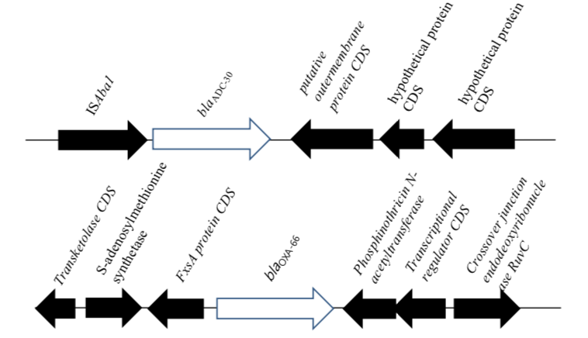

Figure S4: A. baumannii YMC2012/7/R3167 expressing bla_{OXA-66} and bla_{ADC-30.}

Figure S5-A: A. baumannii YMC2011/7/R812 expressing bla_{OXA-120}, bla_{OXA-23}and bla_{ADC-77}.
Figure S5-B: Genomic comparison of YMC2011/7/R812 with YMC2009/2/B2968 indicating the deletion of adeRS, two-component system regulating AdeABC expression system.

Figure S6: A. baumannii YMC2012/1/R79 expressing bla_{TEM-1D}, bla_{ADC-30,} bla_{OXA-23} and bla_{OXA-66.}

Figure S7: A. Baumannii YMC2011/2/C582 expressing bla_{PER-1}, bla_{OXA-66}, bla_{OXA-23} and bla_{ADC-30.}

Figure S8: A. Baumannii YMC2012/9/R2209 expressing ISAba1-bla_{OXA-82} and ISAba1-bla_{ADC-30.}
Figure S9: A. pittii YMC2013/3/R2081 expressing bla_{PER-1}, bla_{SIM-1}, bla_{ADC-18}, bla_{CARB-8} and bla_{OXA-500.}

Figure S10: A. pitti YMC2010/8/T346 expressing bla_{OXA-213-like}, bla_{ADC-41} and bla_{OXA-499.}

Figure S11: A. pittii YMC2009/2/B2968 expressing bla_{OXA-213} family and bla_{ADC-22.}

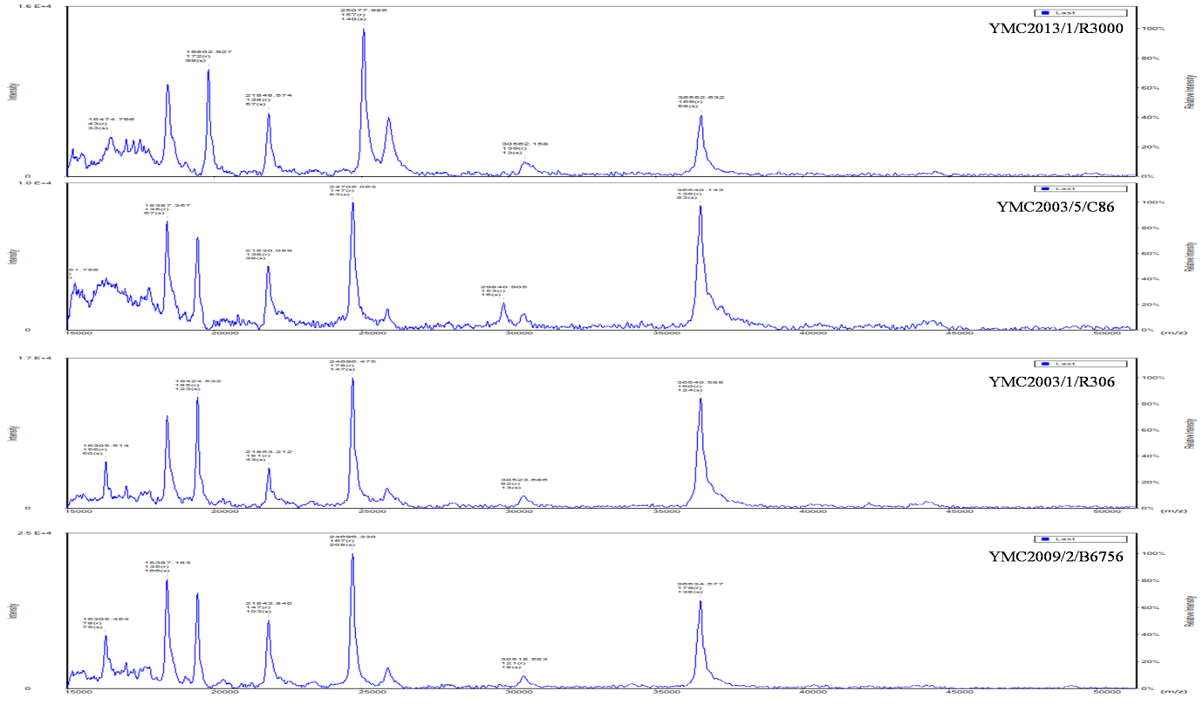
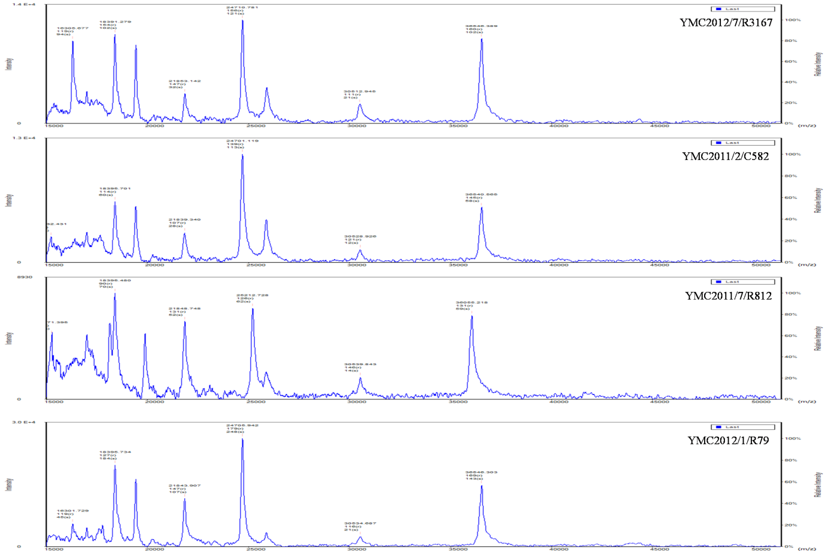
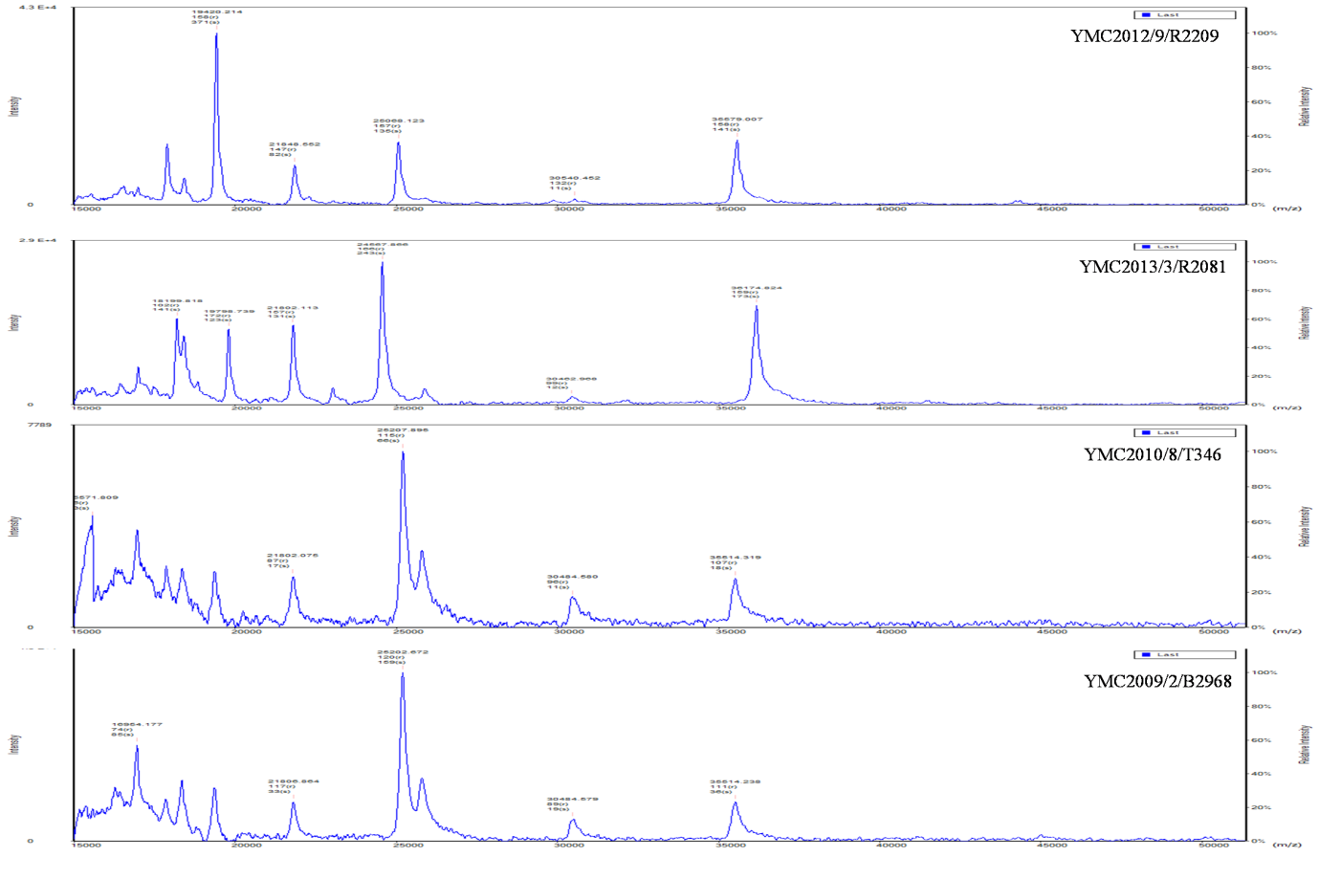
Figure S12: MALDI-TOF MS analysis of Acinetobacter isolates. x axis, mass per charge in Daltons (m/z, Da); y axis, absolute intensity of signal.

Figure S13: Expression of outer membrane proteins, CarO, OprD and 33-36 Kda omp.

Table S9: Primer sequences used for qRT-PCR of adeB, adeJ, adeG, BaeSR, CarO, OprD and 33-36 Kda genes.
 |  | B6756 | R79 | R3167 | C582 | C86 | R812 | R2209 | R306 | R2081 | B2968 | T346
adeB For | CTTGCATTTACGTGTGGTGT | + | + | + | + | +
adeB Rev | GCTTTTCTACTGCACCCAAA | + | + | + | + | +
adeB For_2 | CTTGCATTTACCTGTGGTGT |  |  |  |  |  | + | +
adeB Rev_2 | GCTTTTCTACTGCACCCAGA |  |  |  |  |  | + | + | +
adeB For_3 | CTTGCGTTTACCTGTGGTGT |  |  |  |  |  |  |  | +
adeB Rev_3 | GTTTCTCTGCAGCTCCCAAC |  |  |  |  |  |  |  |  |  | +
adeB For_4 | TTAGCATTTACATGCGGAGT |  |  |  |  |  |  |  |  | +
adeB Rev_4 | ATTTATCAACAGTTCCCATA |  |  |  |  |  |  |  |  | +
adeB For_5 | CTTGCCTTTACCTGTGGTGT |  |  |  |  |  |  |  |  |  | + | +
adeB Rev_5 | GTTTCTCTGCGGCTCCCAAC |  |  |  |  |  |  |  |  |  |  | +
adeB Rev_6 | GCTTTTCTACTGCCCCCAGA
adeJ For | GGTCATTAATATCTTTGGC | + | + | + | + | + | + | +
adeJ Rev | GGTACGAATACCGCTGTCA | + | + | + | + | + | + | + | +
adeJ Rev_2 | GGTACGAATACCGCTGTTA |  |  |  |  |  |  |  |  | + | +
adeJ Rev_3 | GGTACGAATACGGCTGTTA |  |  |  |  |  |  |  |  |  |  | +
adeJ For_2 | TGTTATTAATATTTTTGGC |  |  |  |  |  |  |  | +
adeJ For_3 | TGTTATTAATATCTTTGGC |  |  |  |  |  |  |  |  | + | + | +
adeG For | TTCATCTAGCCAAGCAGAAG | + | + | + | + | + | + | +
adeG Rev | CCTGCTAATGGTAGGGTTAAG
adeG Rev_2 | CTGCTAATGGTAGGGTTAAG | + | + | + | + | + | + | + | +
adeG Rev_3 | CAGCTAAAGGCAAAGTCAGA |  |  |  |  |  |  |  |  | +
adeG Rev_4 | CTGCAAAAGGCATTGACCAA |  |  |  |  |  |  |  |  |  | +
adeG Rev_5 | CAGCTAAAGGCAAAGTTAGA |  |  |  |  |  |  |  |  |  |  | +
adeG For_2 | TTCATCTAGCCAAGCTGAGG |  |  |  |  |  |  |  | +
adeG For_3 | TTCATCTAGCCAAGCTGAAG |  |  |  |  |  |  |  |  | +
adeG For_4 | TTCATCTGGTCAGGCAACTG |  |  |  |  |  |  |  |  |  | +
baeSR_F | CGCGTAGTACAGGTGGAACA | + | + | + | + | + | + | + | + | + | + | +
baeSR_R2 | CGACTTCATCCTCAACCAACA | + | + | + | + | + | + | +
baeSR_R3 | CGACTTCATCTTCAACCAACA |  |  |  |  |  |  |  | + | + | + | +
carO_rt_F | TGCCGATGGTGTCAAAATTA
carO_rt_R | CGAATACGCCCCAGTTTTTA
carO_rt_R_2 | TACATATGGGTTGGCTTGCC |  |  |  |  |  | + |  |  |  | + | +
carO_rt_R_3 | TACATATGGGTTTGCTTGCC | + | + | + | + | + |  | + | + | +
carO_rt_F_2 | ACAGCTTTACTTGCTGCTGG | + | + | + | + | + | + | + | +
carO_rt_F_3 | ACAGCTTTATTCGCTGCTGG |  |  |  |  |  |  |  |  | + | + | +
oprD_rt_F | GTTTCGGTGTAGGCGTTGTT | + | + | + | + | + |  | + | +
oprD_rt_R | GGTCGTAAGCTGAACCATCG | + | + | + | + | + |  | +
oprD_rt_F_2 | GTTTCGGTGTGGGCATTGTT |  |  |  |  |  | +
oprD_rt_F_3 | GTTTCGGTGTTGGCGCTGTG |  |  |  |  |  |  |  |  | + | + | +
oprD_rt_R_2 | GATCGTAAGAATCACCGCAC |  |  |  |  |  | +
oprD_rt_R_3 | GATCGTAAGCTGAACCATCA |  |  |  |  |  |  |  | +
oprD_rt_R_4 | GATCATAAGCGGAGCCATCA |  |  |  |  |  |  |  |  | + | + | +
33–36 kDa_rt_F | AATCGGTTTTGAAGCTGCTG | + | + | + | + | + | + | + | +
33–36 kDa_rt_R | CCTACGAAAGTAGCGCCAAC
33–36 kDa_rt_F_2 | AATTGGTTTTGAAGCTGCTG |  |  |  |  |  |  |  |  | + | + | +
33–36 kDa_rt_R_2 | GTTTACGTTACCACCCCAAGCT | + | + | + | + | + | + | + | + | + | + | +

Note: ' + ' indicates the specific primers used for PCR. Owing to the polymorphisms in the efflux pumps and porin genes, numerous primer sequences had to be designed.

Table S10: Experimental conditions used in RT-qPCR based on MIQE requirements.
Experimental design
Number of samples | 12
Place of experiment performed | Department of Laboratory Medicine and Research Institute of Bacterial Resistance, Yonsei University College of Medicine
Sample and Nucleic acid extraction
Type of sample | Acinetobacter spp.
Volume | 2 ml in LB broth with OD₆₀₀ 0.7-0.8
RNA extraction kit | RNeasy Mini Kit with RNAprotect Bacteria Reagent (Qiagen, Hilden, Germany)
Storage | Samples processed immediately
DNase treatment | On-column DNase I digestion for 15 min at RT (as described in the RNeasy Mini Kit)
Nucleic acid quantification | NanoDrop spectrophotometer (ND- 2000 Thermo scientific, USA)
Yield | 400-500 ng/ul
Purity | 260/280 ratio from 1.9 to 2.1, 260/230 ratio from 2.0 to 2.5
RNA integrity | Analyzed by agarose gel electrophoresis
Reverse Transcription
Complete reaction condition | Reaction performed as described by the M-MLV cDNA Synthesis Kit (Enzynomics, Korea)
Amount of RNA and reaction volume | 1 ug of RNA in 20ul of reaction volume.
Priming oligonucleotide | 50 μM random hexamers
Reverse transcriptase and concentration | M-MLV Reverse Transcriptase, 200U/ reaction
Temperature and time | 25°C for 10 min and then 42°C for 60 min, Inactivation at 95°C for 5 min
cDNA storage | -20°C and -80°C (for longer use)
qPCR target information
Genes | adeB, adeG, adeJ, baeSR, carO, 33-36kDa omp and oprD genes
Amplicon length | 70-130bp
qPCR oligonucleotides
Primer sequences | Please refer Table S9
Manufacturer of oligonucleotides | Macrogen Inc, Korea
Purification method | MOPC
qPCR protocol
complete reaction conditions | 95˚C for 3 min (1X) followed by 95˚C for 10 sec (40X) and 56˚C for 1 min(1X)
Reaction volume and amount of cDNA | 20-μl reaction volume containing 2 μl (100ng) of cDNA
qPCR kit | iQ SYBR Green Supermix (Bio-Rad, CA, USA) containing antibody-mediated hot-start iTaq DNA polymerase, dNTPs, MgCl2, SYBR® Green I dye, enhancers, stabilizers, and fluorescein
Manufacturer of tubes | MicroAmp Fast 8-Tube Strip, 0.1 mL (Cat: 4358293, Applied Biosystems)
Manufacturer of qPCR instrument | StepOne Real-Time PCR System (Life technologies, CA, USA)
qPCR validation
Specificity | Dissociation curve was generated for each run
Data Analysis
qPCR analysis program | StepOnePlus Software v2.2 (Life technologies, CA, USA)
Method of C_{q} determination and outlier identification | Calculated on Microsoft Excel using the method described by Livak and Schmittgen, 2001. (https://www.ncbi.nlm.nih.gov/pubmed/11846609)

