Supplementary material to Draxler et al:
“t-PA suppresses the immune response and aggravates neurological deficit in a murine model of ischemic stroke”
”

Supplementary table 1. Antibody panels used for flow cytometry

antibody cocktail | fluorochrome-labelled antibody | supplier
 | CD11c V450, MHC class II APCeFluor780, B220 AF700 | BD Biosciences, USA
myeloid subsets | CD103 AF647, F4/80 PerCPCy5.5, CD8 BV650 and CD80 biotin | BioLegend, USA
 | CD11b PECy7, Gr1 FITC, CD86 PE | eBiosciences, USA
 | LIVE/DEAD™ Fixable Aqua Dead Cell Stain Kit | Life Technologies, USA
 | CD4 BV605, B220 AF700 | BD Biosciences, USA
 | CD8 BV650 | BioLegend, USA
lymphoid subsets | CD3 APCeFluor780, CD69 V450, NK1.1 PE, CD19 FITC | eBiosciences, USA
 | LIVE/DEAD™ Fixable Aqua Dead Cell Stain Kit | Life Technologies, USA

Supplementary Figure 1. Gating strategy used to identify leukocyte phenotypes and functional markers
A summary table of leukocyte markers used for gating (A) and representative flow cytometer panels exemplifying the gating strategy for identification of myeloid cell subsets (B) and lymphoid cell subsets (C). The panels shown in (B) and (C) are from a cervical lymph nodes (cLN) sample of a sham mouse. Spleen samples were gated equivalently.

(A) A summary table of leukocyte markers used for gating

Myeloid cell phenotypes
cDC | SSC low | B220- | F4/80- | MHCII+ | CD11c+ |  | CD11b-
monocytes | SSC med |  | F4/80+ | MHCII- | CD11c- |  | CD11b+ |  | Gr-1-
macrophages | SSC med |  | F4/80+ | MHCII+ |  |  | CD11b+ |  | Gr-1-
Myeloid cells – functional markers
activation/maturation | CD80 |  | CD86 |  |  |  | MHCII
viability | Live/Dead stain
Lymphoid cell phenotypes
CD4+ T cells | SSC low | B220- | CD3+ | CD4+ | CD8-
CD8+ T cells | SSC low | B220- | CD3+ | CD4- | CD8+
B cells | SSC low | B220+ | CD3- | CD19+
NK cells | SSC low | B220- | CD3+ | NK1.1+
Lymphoid cells – functional markers
activation | CD69
viability | Live/Dead stain

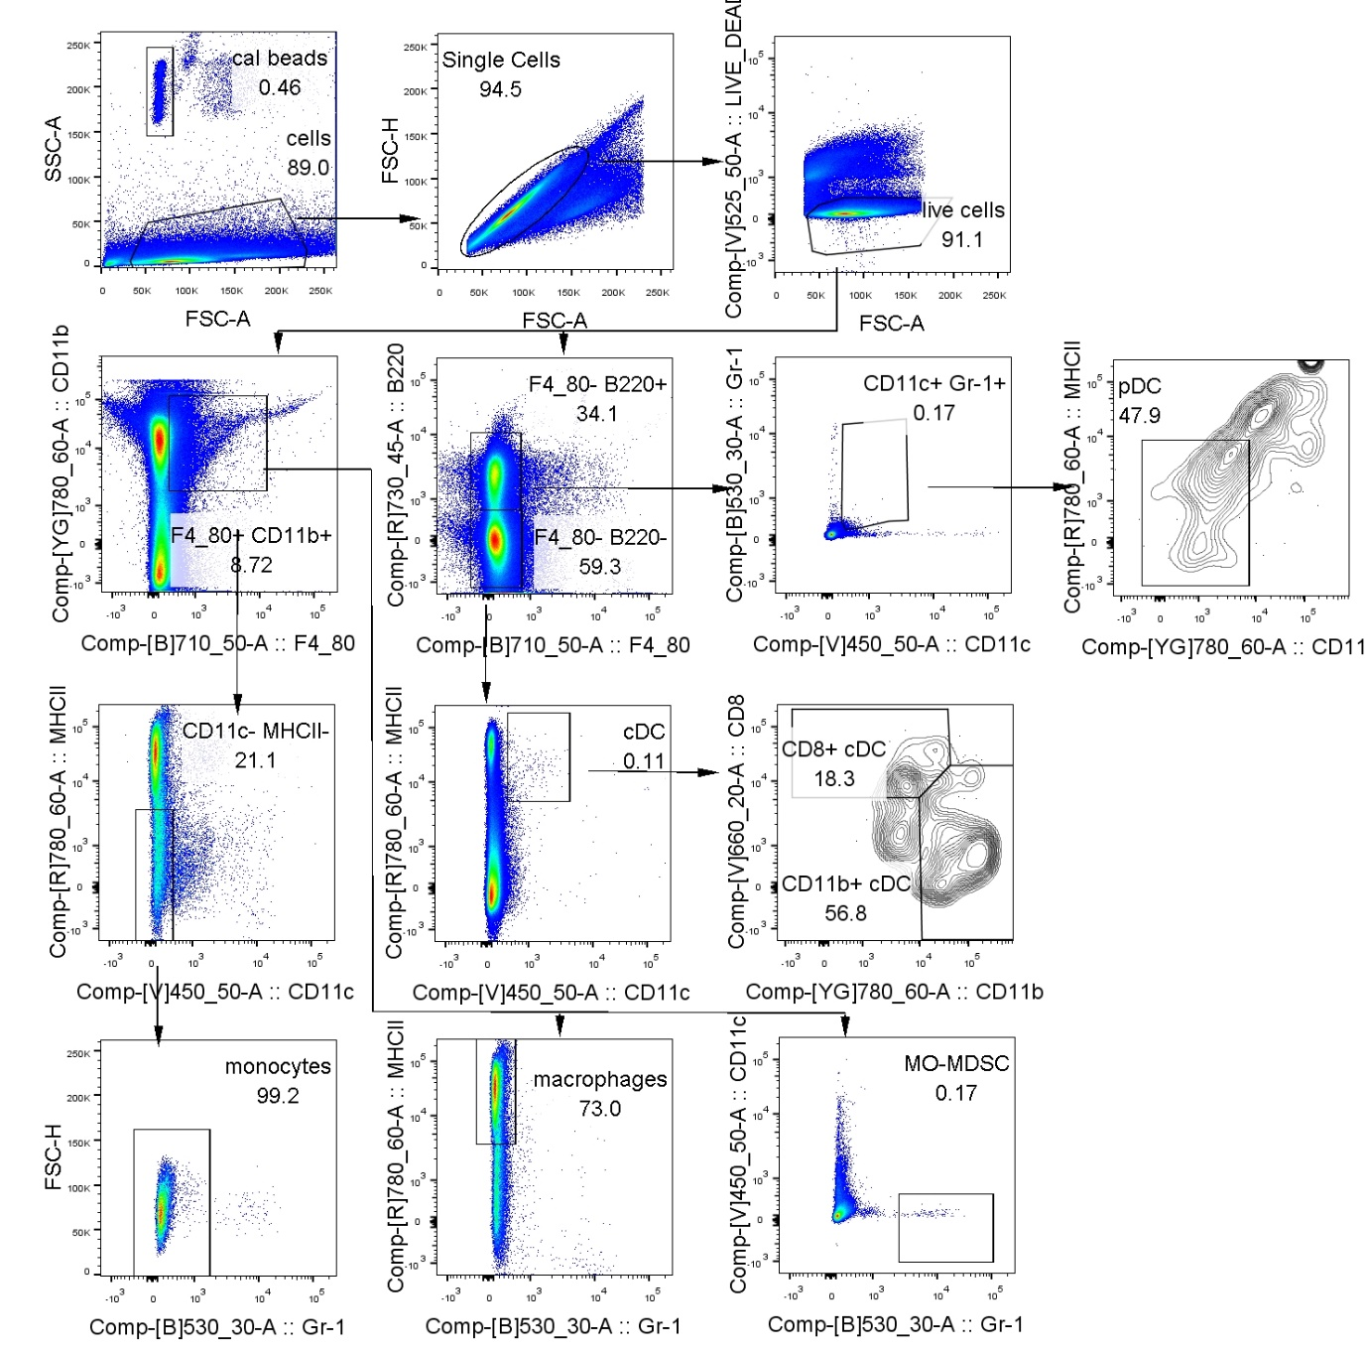
(B) Gating strategy used for flowcytometric characterization of myeloid cell subsets in cLN and spleen samples.

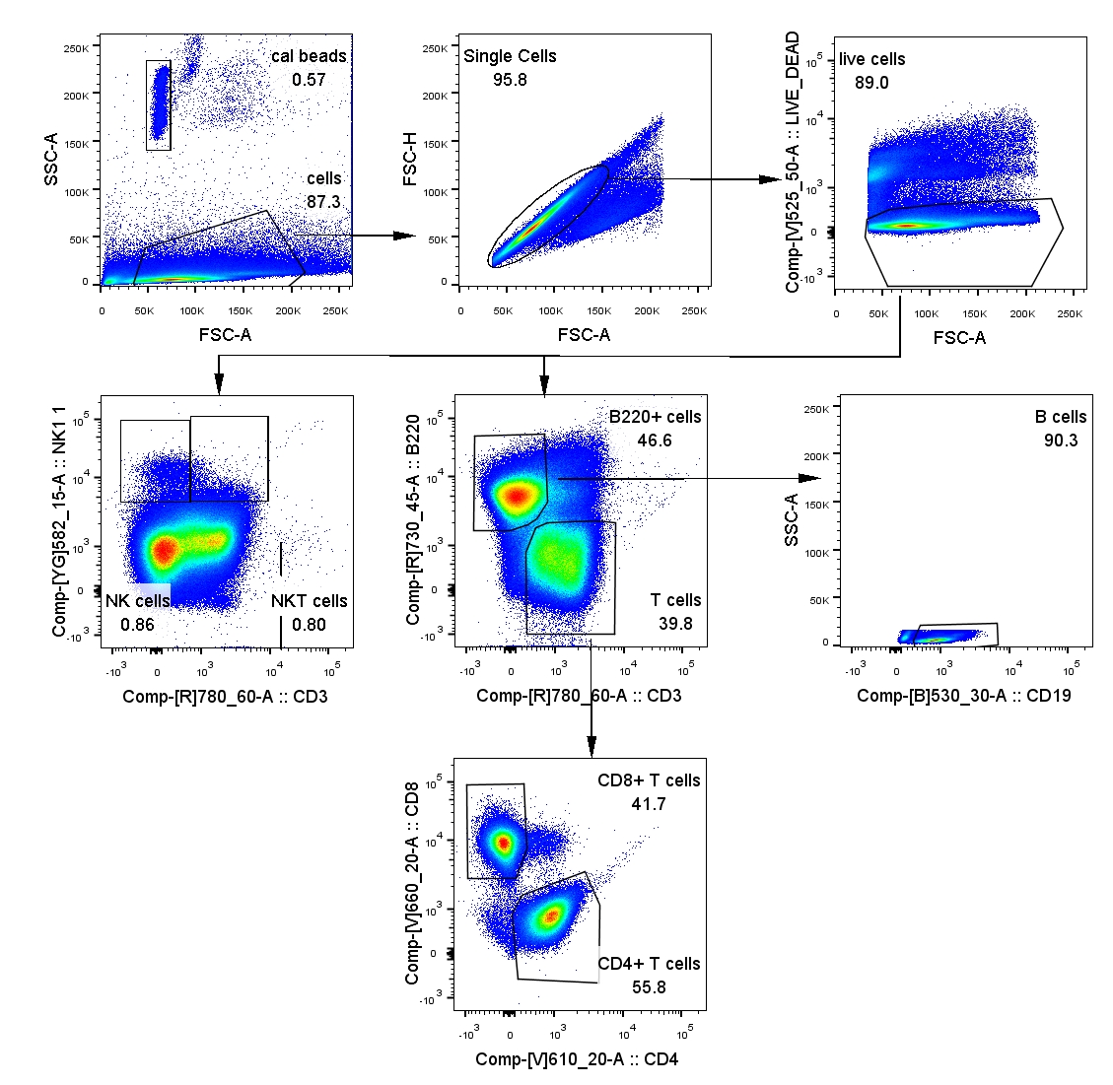
(C) Gating strategy used for flowcytometric characterization of lymphoid cell subsets in cLN and spleen samples.

