Supplementary material.

Figures.
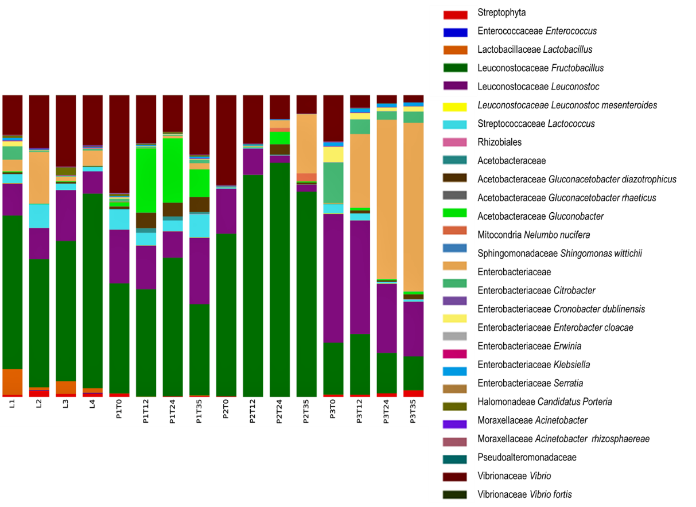

Figure 1S. Taxonomic identification. Most abundant OTU’s using the 0.01% abundance filter OTUs table.

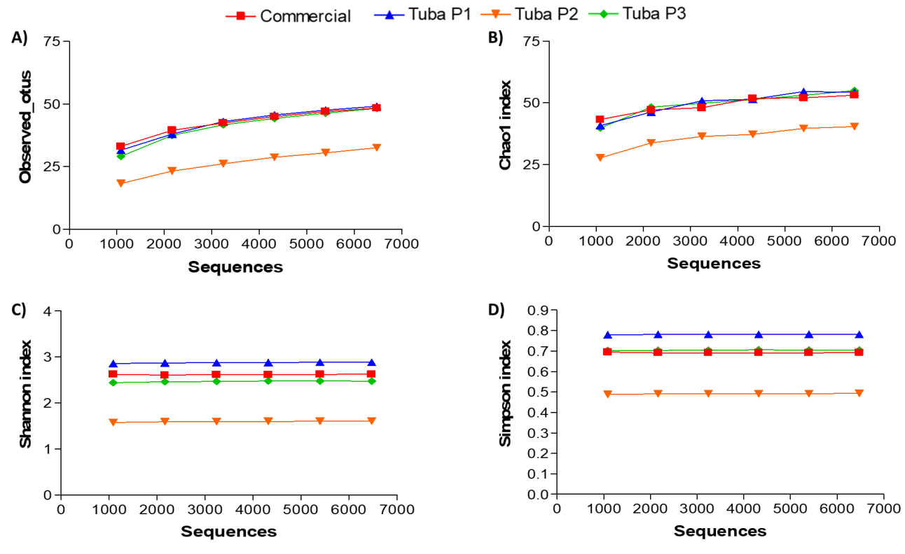
Figure 2S. Alpha diversity rarefaction plots with 0.01%. A) Observed_otus, B) Chao1, C) Shannon and D) Simpson. Each population is represented for a specific color in all the graphics.

Figure 3S. Abundance of invertase gene (K01193). Analysis performed with the function “metagenome_contributions.py” obtained by PICRUSt analysis and plotted with R studio.
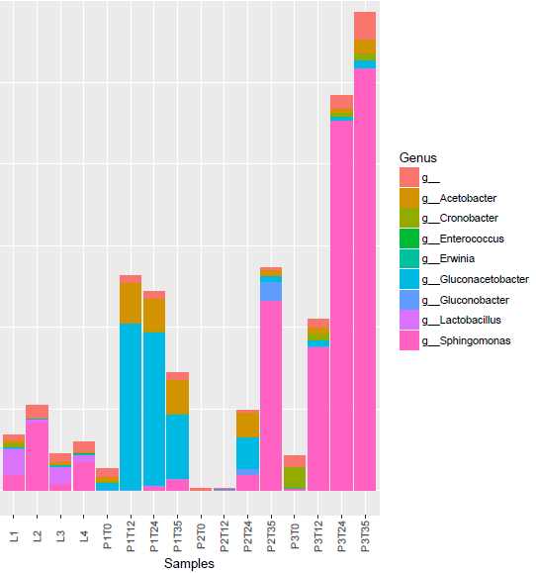
Figure 4S. Main bacteria with 15-cis-phytoene synthase gene (K02291 KEGG code). Analysis performed with the function “metagenome_contributions.py” obtained by PICRUSt analysis and plotted with R studio.

Tables.

Table 1S. Chemical composition of the Tuba.
 | Tuba P1 | Tuba P2 | Tuba P3 | Commercial L1 | Commercial L2 | Commercial L3 | Commercial L4
Time (h) | Proteins (g/L)
0 | 0.068 | 0.115 | 0.097 | 0.087 | 0.173 | 0.166 | 0.054
12 | 0.094 | 0.038 | 0.109
24 | 0.057 | 0.084 | 0.046
35 | 0.082 | 0.147 | 0.042
Time (h) | Sucrose (g/L)
0 | 85.147 | 121.760 | 95.203 | 45.310 | 13.455 | 99.291 | 4.316
12 | 0.393 | 113.293 | 19.837
24 | 0.374 | 102.178 | 0.883
35 | 0.262 | 4.206 | 0.747
Time (h) | Glucose (g/L)
0 | 21.146 | 13.179 | 14.665 | 59.240 | 39.814 | 35.078 | 51.846
12 | 61.414 | 3.452 | 39.814
24 | 60.144 | 21.649 | 7.264
35 | 21.036 | 59.050 | 0.887
Time (h) | Fructose (g/L)
0 | 16.016 | 11.078 | 11.922 | 50.874 | 45.528 | 32.765 | 40.953
12 | 47.358 | 1.918 | 29.177
24 | 48.562 | 13.028 | 39.734
35 | 44.836 | 45.633 | 28.122
Time (h) | Total sugars (g/L)
0 | 122.311 | 146.018 | 121.791 | 155.425 | 98.798 | 167.135 | 97.116
12 | 109.166 | 118.665 | 88.829
24 | 109.081 | 136.856 | 47.882
35 | 66.135 | 108.890 | 29.757
Time (h) | Acetate (g/L)
0 | 0.686 | 0.893 | 0.645 | 1.520 | 1.644 | 1.527 | 1.984
12 | 3.067 | 1.406 | 1.104
24 | 6.914 | 2.764 | 2.835
35 | 6.074 | 3.559 | 3.957
Time (h) | Ethanol (g/L)
0 | 0.411 | 0.166 | 0.252 | 1.517 | 1.419 | 0.701 | 4.420
12 | 2.239 | 0.000 | 1.175
24 | 4.427 | 0.000 | 41.365
35 | 47.114 | 6.806 | 50.692
Time (h) | pH
0 | 3.73 | 3.65 | 3.64 | 4.0 | 4.0 | 4.0 | 4.0
4 | 3.34 | 3.38 | 3.3
10 | 3.15 | 3.21 | 3.12
12 | 3.1 | 3.19 | 3.11
24 | 2.93 | 3.12 | 2.98
35 | 2.94 | 2.81 | 2.94

