Supplementary Material

**Decadal-scale acidification trends in adjacent North Carolina estuaries: competing role of anthropogenic CO2 and riverine alkalinity loads**

Bryce R. Van Dam, Hongjie Wang

**\* Correspondence:** Corresponding Author: Bryce R. Van Dam, bvandam@fiu.edu

**Table S1.** The model compositions for six different GAMM models

|  |  |  |  |  |  |  |
| --- | --- | --- | --- | --- | --- | --- |
|  | Long-term  Change | Seasonal  Cycle | Daily  cycle | YSI Salinity | YSI DOsat | Heteroscedasticity  along salinity |
| model 0 | + | + | + | + | + | + |
| model 1 | + | + | + | + | + |  |
| Model 2 | + | + |  | + | + | + |
| Model 3 | + | + | + |  |  |  |
| Model 4 | + | + | + | + |  |  |
| Model 5 | + | + | + |  | + |  |

**Table S2.** Endmember values and estuarine constants

|  |  |  |  |  |  |
| --- | --- | --- | --- | --- | --- |
|  | Parameter | Type | NewRE | NeuseRE | |
| Ocean Endmember | DICO (µM) | Calculated | *f*(*p*CO2, TA) | | |
| TAO (µM) | Constant | 2500 | | |
| SalO | Constant | 35 | | |
| *p*CO2 (µatm) | Input Variable | 350 to 800  In equilibrium with atmosphere | | |
| River  Endmember | QR (m3 s-1) | Input Variable | 1.3 to 8.9 | | 82 to 221 |
| DICR (µM) | Set by empirical relationship (Van Dam et al., 2018b) | = 2048 - 535.2 x log(Q) | | = 1126 - 145.9 x log(Q) |
| TAR (µM) | Set by empirical relationship | = - 30.8 + DICR x 1.1 | | = -81.1 + DICR x 0.94 |
| SalR | Constant | 0 | | |
| Estuary | (mol C m-2 yr-1) | Constant  (Herrmann et al. 2015) | 6.7 | | 7.3 |
| τFW (years) | Segment-specific value (Van Dam et al., 2018) | | | |
| Zave (m) | Constant | 1.8 | | 2.7 |
| R (mol C m-2 yr-1) | Constant | 2.68 | | 2.92 |

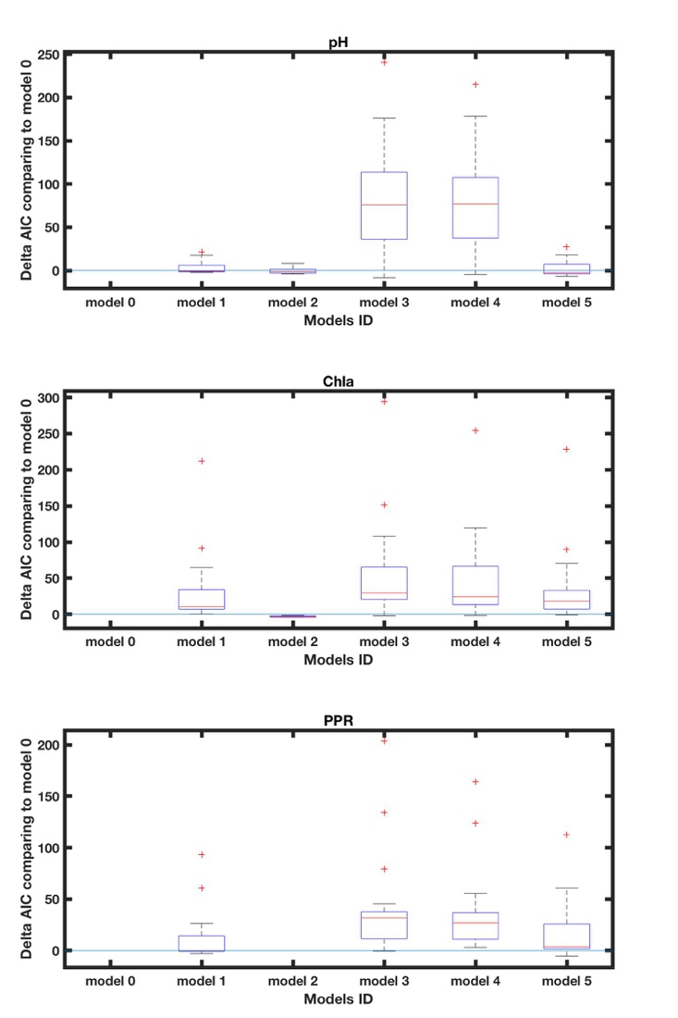

**Fig. S1.** The AIC value comparing to the complete model for pH, Chl a and PPR in Neuse Estuary. Note, the smaller AIC value represent a better model.



*

*

*

*

**Figure S2.** Scatter plot of ENSO index and monthly-averaged river discharge (m3 s-1), broken down by season. Linear regressions were significantly different from 0 for Spring and Winter seasons only (F-test, p-value < 0.01).

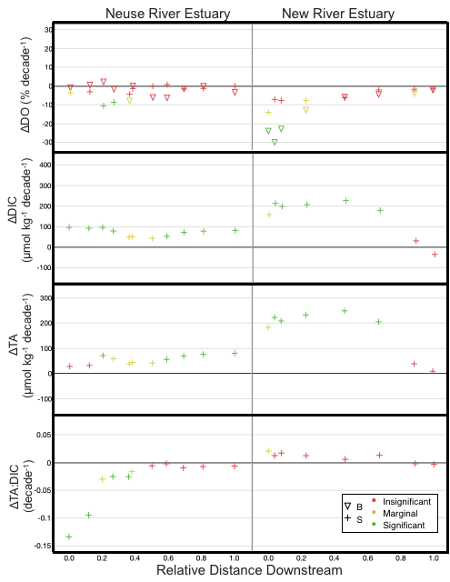

**Fig. S3.** Post-2005 trends for DO % saturation, DIC, TA, and TA:DIC ratio for surface (+) and bottom water (▽). Colors indicate the p-value for a t-test on the slope of the trend line (green: p < 0.01; yellow: 0.01 < p < 0.1; red: p > 0.1). Bottom water trends are not shown for TA, DIC, and TA:DIC because bottom water samples were only analyzed for these parameters during the last two years of the period of record.

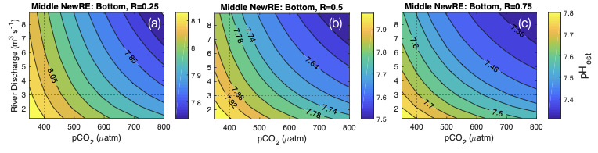

**Fig. S4.** Modeled bottom water pHest in the middle NewRE as a function of atmospheric pCO2 (µatm) and river discharge (m3 s-1), where pHest values are shown by the colored contours. Model results are shown for R values of 0.25 (a), 0.5 (b), and 0.75 (c).