Supplementary Material
Connecting a Trophic Model and Local Ecological Knowledge to Improve Fisheries Management: The Case of Gulf of Nicoya, Costa Rica
Astrid Sánchez-Jiménez*, Marie Fujitani, Douglas MacMillan, Achim Schlüter & Matthias Wolff*

* Correspondence:
Astrid Sánchez Jiménez
Matthias Wolff
astrid.sanchez@leibniz-zmt.de
matthias.wolff@leibniz-zmt.de

Recruitment questionnaire contents
Questionnaire S1 | English version of the recruitment interview applied to fishers in Gulf of Nicoya
Centro de Investigación en Ciencias del Mar y Limnología  Universidad de Costa Rica  San Pedro, Costa Rica  + (506) 2511-2200 | Leibniz Centre for Tropical Marine Research (ZMT)  Fahrenheitstr. 6  28359 Bremen, Germany  +49 (421) 23800-70
Number of the survey | Place | Date and time

Code Site: Isla Chira 99 ( ) Costa de Pájaros 98 ( ) Paquera 96 ( )

Good morning!
This interview is part of a doctoral study about adaptation of small scale fishers to more sustainable fishing regimes in Gulf of Nicoya. The interview is confidential and volunteer, all the information gathered will be used for the purpose of academic research and you can drop the interview at any given moment. Are you interested in being part of it?

General Respondent Information

Do you live here?
Yes No

For how long have you been living in the community?
1-5 years 5-10 years More than 10 years

Are you currently a fisher?
Yes No

Which option represent you better? I´ve been a fisherman for…
Less than 5 years between 5-10 years between 10-20 years
More than 20 years

Which are the three most important species do you fish?
Croakers Shrimps Snappers
Sardines Others__________________

Which fishing gears do you use for fishing each species?
Hand line __________________ Gillnet __________________ Longline __________________
Taiwanese line __________________ Other__________________

In a typical day of a good fishing season, for how long do you go out and fish with your main fishing gear? Hours per day
Less than 6 hours 6-9 hours 9-12 hours
12-15 hours More than 15 hours

In a typical day of a good fishing season, for how many days in a week do you go out and fish?
Less than 2 days 2-6 days Everyday

Do you have a fishing license of INCOPESCA up to date?
Yes No (go and ask about demographic and household information, and end of the survey)

Demographic information of the respondent

Genera
Male Female Other

How old are you?
8-25 years old 26-32 years old 33-39 years old
40-46 years old 47-53 years old 54-60 years old
Senior citizen

Which is your highest level of formal education approved?
None Incomplete primary school Complete primary
Incomplete high school Complete high school incomplete university
Complete University Technician Other_____________

Household and socio economic information of the respondent

Which statement represent you better about your household?
I´m the owner of my house my house is rented I live with relatives
Other

Which economic activities do you practice?
Fishing Tourism services (hotel, restaurant) Tour operator
Housework Student Office services

What is the main source (job or activity) of income in your household?
Fishing | Tourism | Agriculture | Other

From every 100,000 colones of income in your household, approximately how much do you get from the main source of work?
Colones

How many people depend of your income?
Number of dependents

Which option represent you better? For fishing I use…
A simple boat Panga con motor fuera de borda Lancha con motor infra borda
I don’t use boat

If you use a boat, are you the captain of the boat?
Yes No

Are you the owner of the boat?
Yes No

How do you acquire the boat?
Own savings Bank loan Informal loan
Inherited Borrowed Other

Additional Feedback

Do you have something additional to comment?

Thank you very much for taking the time to answer this survey. All the information contained here is really appreciated and will be used for the purpose of this research only. To finish I just have a last question for you:

Would you like to provide us some personal information like your name and a telephone number where I can to contact you for invite you to a workshop?
Yes | No

Personal Information
First Name | Last Name | Gender | Age
Address | City | Email | Phone

Supplementary Figures and Tables

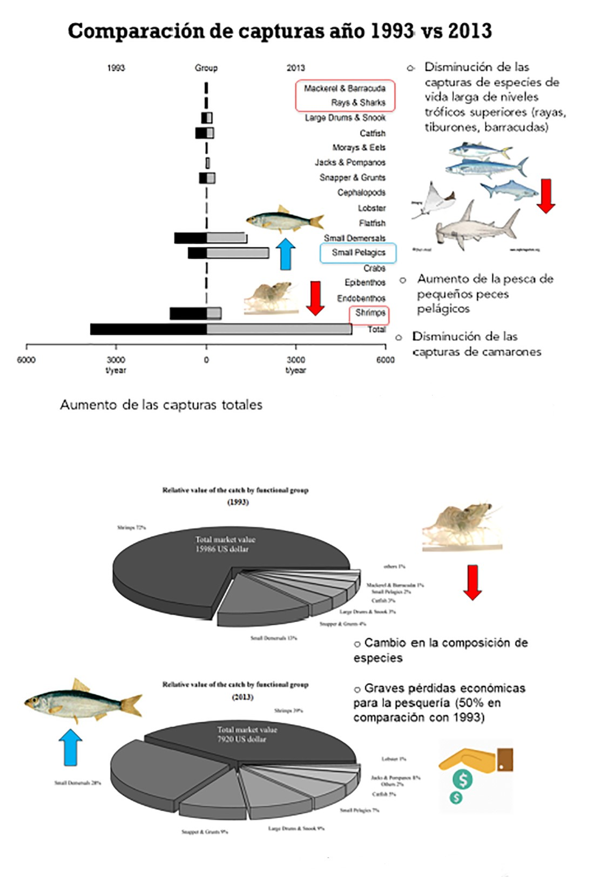
Figure S1 | Lecture slides (in the original language Spanish). Changes in the catch and the relative value of the catch by functional groups 1993 vs 2013. Adapted from Alms and Wolff, (2019).

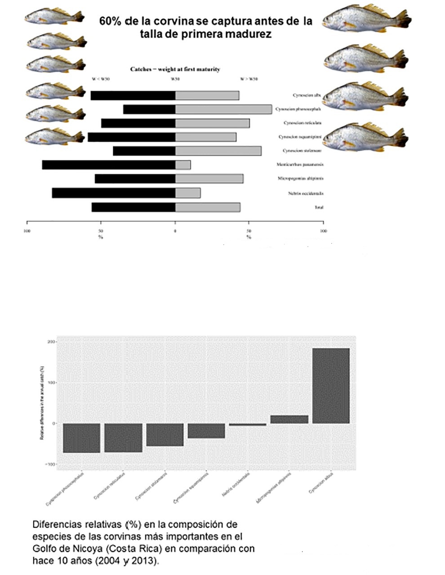
Figure S2 | Lecture slides (in the original language Spanish). Changes in the catch of corvinas 1993 vs 2013. Adapted from Alms and Wolff, (2019).

Figure S3 | Lecture slides (in the original language Spanish). The impact of the fishing fleets on the functional groups in the ecosystem in 1995 and 2013. The circles indicate the proportional impact (white=positive, black=negative impact). Most severe changes are indicated by the red squares.. Adapted from Alms and Wolff, (2019).

Table S1 | Interactions between different attributes to evaluate the state of shrimps, extracted from two systems of knowledge (LEK and EwE).

Descriptor | Attributes | Past (1990s-early 2000s) |  | Interaction | Present (early 2000s- 2010s) |  | Interaction
 |  | EwE | LEK | EwE+LEK | EwE | LEK | EwE+LEK
Abundance | Abundance |  | High | Complementarity= high abundance |  | Low | Complementarity= low abundance
 | Biomass | High |  |  | (-) biomass reductions (trophic levels II, III)
 | CPUE |  | 600-1131 individuals/gillnet/day* |  | -50% reduction shrimp-CPUE | 200-441 individuals/gillnet/day*
 | Unit of individuals needed to catch a Kilogram |  | 20-29 ind/kg |  |  | 40-49 ind/kg
Profitability | Profits | Shrimps, 72% of the total value (artisanal and semi-industrial fleets) | High profits | Complementarity= high profitability | -Severe economic loses (semi-industrial/artisanal fleets)  -Shrimps strong value’s decline (39%) in the total catches  (-) inshore resources, affects artisanal fishers | Low profits | Complementarity=low profitability
 | Commercial importance |  | Low-medium (used as bait) Increases, end of the decade. |  |  | High
 | Prices (costarrican colones per Kilo) |  | <500 costarrican colones/kg |  |  | 1000-5000 costarrican colones/kg

Table S2 | Interactions between different attributes to evaluate the state of corvinas, extracted from two systems of knowledge (LEK and EwE).

Descriptor | Attributes | Past (1990s-early 2000s) |  | Interaction | Present (early 2000s- 2010s) |  | Interaction
 |  | EwE | LEK | EwE+LEK | EwE | LEK | EwE+LEK
Abundance | Abundance |  | High | Complementarity=high abundance | N/I | Low abundance of some species, recovery of some others | Complementarity=low abundance
 | Biomass | From 1990s to early 2000s, impacted biomass of large drums |  |  | From 2000s a growing impact on biomass of large drums
 | CPUE |  | 35-81 individuals/gillnet/day |  |  | 20-116 individuals/gillnet/day
 | Unit of individuals needed to catch a Kilogram |  | 0.5-0.9 ind/Kg |  |  | 1-4 ind/Kg
 | Sizes |  | Big individuals |  | 80% of corvinas caught below the weight of first maturity | Small individuals
Profitability | Profits |  | High profits | Information just provided by the LEK | -Small pelagic 7% of the value, still the largest contribution in the catches  -Only whitefin and the stolzmann weakfish, sold as first class product. Rest of species are smaller and low value classes  -Artisanal fleet can´t compete with the semi-industrial fishing fleet (in profit maximization, vessels and capacities to go fishing far) | Low profits | Complementarity= low profits
 | Commercial importance |  | Low-medium (used as bait) Increases, end of the decade. |  |  | High
 | Prices (costarrican colones per Kilo) |  | 500-1000 costarrican colones |  |  | 1000-4900 costarrican colones

Table S3 | Interactions between different attributes to evaluate the state of large-predators, extracted from two systems of knowledge (LEK and EwE)

Descriptor | Attributes | Past (1990s-early 2000s) |  | Interaction | Present (early 2000s- 2010s) |  | Interaction
 |  | EwE | LEK | EwE+LEK | EwE | LEK | EwE+LEK
Abundance | Abundance |  | -Presence  -High abundance | Information just provided by the LEK |  | Absence | Complementarity= significant reduction in biomass
 | Biomass |  |  |  | Biomass in high trophic levels (-) (mackerels, barracudas, shark and rays)
 | Catches |  |  |  | Catches of large predatory species (-) | Narrowly distributed
Profitability | Profits |  |  | No info available | High profits | Low profits | Contradiction= high profits (EwE) and low profits (LEK)

Table S4 | Categorical variables that characterize the interviews respondents.
Respondents‘ characteristics | Total response | % Response | Respondents‘ characteristics | Total response | % Response | Respondents‘ characteristics | Total response | % Response
Gender | N=58 |  | Education | N=58 |  | Time of residence | N=58
Male | 48 | 82.8 | None | 4 | 6.9 | 1-5 years | 1 | 1.7
Female | 10 | 17.2 | Primary (inc)* | 9 | 15.5 | 5-10 years | 1 | 1.7
N | 58 | 100.0 | Primary (co)* | 30 | 51.7 | >10 years | 56 | 96.6
 |  |  | H-school* (inc) | 8 | 13.8 | N | 58 | 100.0
 |  |  | H-school(co) | 7 | 12.1
Boat owner | N=58 |  | Basic Expenses ₡* | N=55 |  | Income from fishing ₡* | N=57
No | 18 | 31.0 | 80-110 ^{000*} | 13 | 23.6 | 100 ^{000*} | 11 | 19.3
Yes | 40 | 69.0 | 110-140 ⁰⁰⁰ | 11 | 20.0 | 200 ⁰⁰⁰ | 22 | 38.6
 |  |  | 140-170 ⁰⁰⁰ | 7 | 12.7 | 300 ⁰⁰⁰ | 22 | 38.6
 |  |  | 170-200 ⁰⁰⁰ | 10 | 18.2 | 500 ⁰⁰⁰ | 2 | 3.5
 |  |  | 200-230 ⁰⁰⁰ | 10 | 18.2
Fishing experience | N=57 |  | Fishing-effort (hours) | N=57 |  | Fishing effort (days) | N=58
<5 years | 4 | 7.0 | <6 hours | 11 | 19.3 | < 2 days | 2 | 3.4
5-10 years | 5 | 8.8 | 6-9 hours | 23 | 40.4 | 2-6 days | 23 | 39.7
10-20 years | 21 | 36.8 | 9-12 hours | 17 | 29.8 | every day | 33 | 56.9
>20 years | 27 | 47.4 | 12-15 | 6 | 10.5
Fishing gear | N=57 |  | Commercial species caught | N=58 |  | Fishing sites | N=58
Gillnet | 98 | 66.7 | Corvina & shrimps | 20 | 34.5 | Zone 201 (1) | 10 | 17.2
Gillnet & handline | 15 | 26.3 | Corvina & snappers | 15 | 25.9 | Zone 202 (2) | 5 | 8.6
Gillnet bottomline | 4 | 7.0 | Corvina | 13 | 22.4 | Zone 203 (3) | 13 | 22.4
 |  |  | Shrimps | 6 | 10.3 | Zones 1 & 2 | 19 | 32.8
 |  |  | All species | 4 | 6.9 | Zones 1 & 3 | 1 | 1.7
 |  |  |  |  |  | Zones 3 & 2 | 5 | 8.6
 |  |  |  |  |  | All sites | 5 | 8.6
*The basic expenses and the income from fishing are given in Costa Rican colones (₡), 1€: ₡611.00 (as of survey year/month). inc= incomplete and co= complete, h-school stands for high school. ⁰⁰⁰ = thousand

Table S5 | Continuous variables that characterize the interviews respondents.
Respondents‘ characteristics | Total response | Ave. | Min. | Max. | s.d
-Age | 58 | 41 | 18 | 70 | 12,52
-Number of dependents | 58 | 3,3 | 0 | 7 | 1,46

Table_v6 | Qualitative data from the workshops in Gulf of Nicoya, coded into individual themes according to the most frequent words used by respondents.
Table_v7 | Recruitment questionnaire applied to artisanal fishers in Gulf of Nicoya.

