SUPPLEMENTARY material

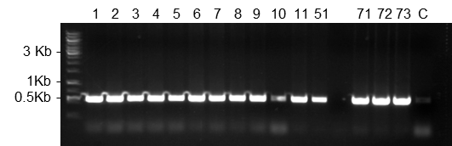
Supplementary Figure 1. PCR based screening for the presence of the transgene in the genome of moss transgenic lines surviving after selection. The expected size of the PCR product was 559 bp. C: parental plant Δxt/ft.

Supplementary Table 1. Screening of promising plants grown in liquid culture for productivity via ELISA
Lines | µg MFHR1/g FW
P1 | 14.0
P4 | <0.1
P5 | 12.5
P101 | 1.1
P102 | 0.1
P105 | 0.1
HRP 1 | 6.6
HRP 15 | 3.7
HRP 27 | 1.3

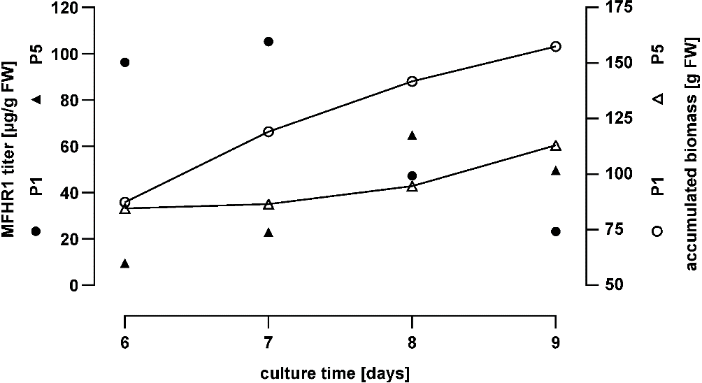
Supplementary Figure 2. Kinetics of biomass accumulation and MFHR1 concentration of lines P1 and P5 in batch cultures carried out in a 5 L photobioreactor.

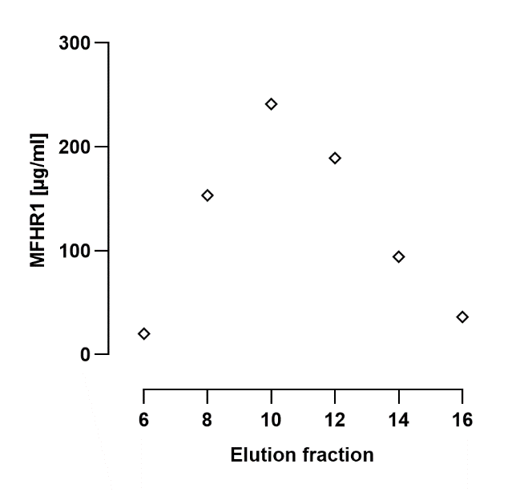
Supplementary Figure 3. MFHR1 concentration of every second elution fraction from the Ni-NTA affinity chromatography, from 6th to 16th.

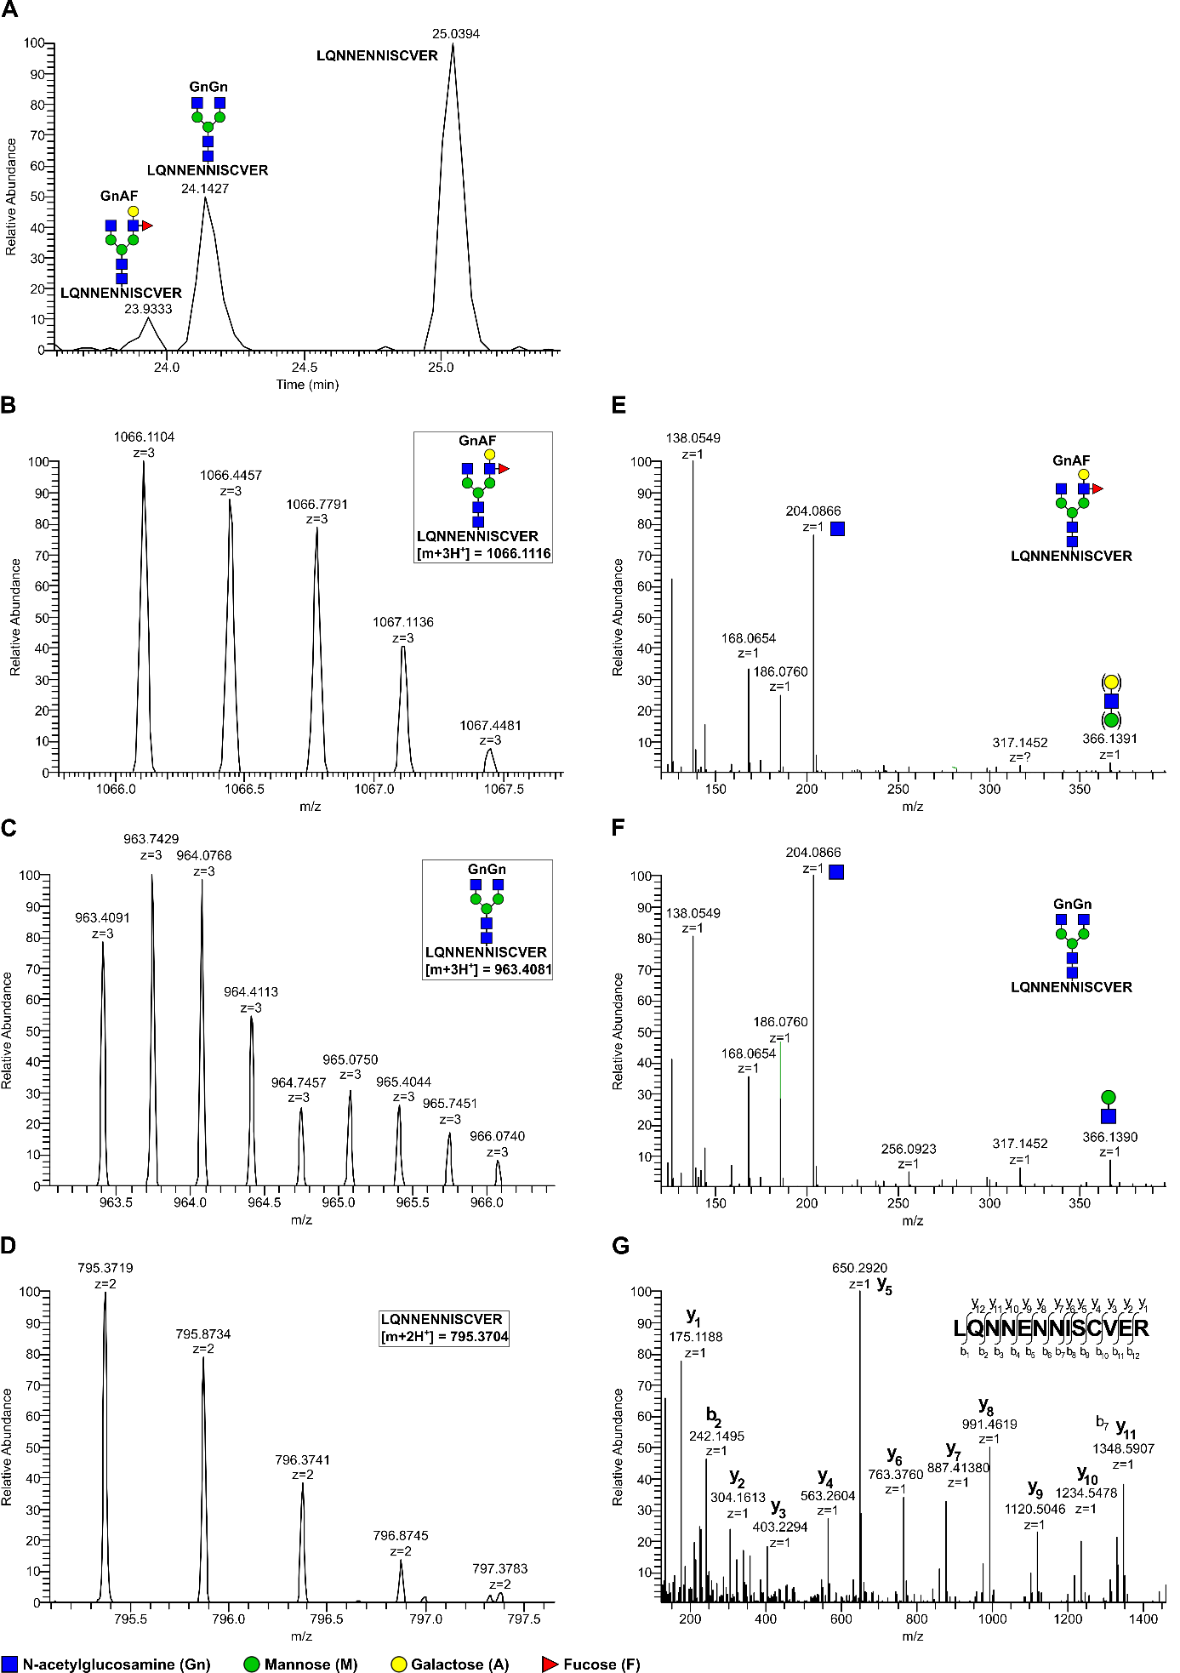

Supplementary Figure 4. Confirmation of peptide and glycopeptide identity flanking Asn108 on MS1-level and fragment ion spectra (MS2). (A) Repetition of Figure 4B for better clarity – showing the elution profiles (extracted ion chromatogram, EIC) of the tryptic peptide (₁₀₂LQNNENNISCVER₁₁₃) which flanks the glycosylation site NIS (Asn108) with and without N-glycosylation. (B,C,D) Isotope patterns of identified peptides and glycopeptides, resp., on MS1 level showing observed charge states and m/z ratios (MS1 tolerance: 5 ppm). (E,F,G) Fragment ion spectra (MS2) corresponding to the selected precursors (left panel (B,C,D). Confirmation of glycopeptide identity (E,F) was done by the presence of reporter ions from glycan structures such as N-acetylglucosamine (Gn, m+H⁺: 204.0872) and its typical oxonium ion series (Gn-H₂O, m+H⁺: 186.0766; Gn-2H₂O, m+H⁺: 168.0661; Gn-CH₆O_{3,} m+H⁺: 138.0555) as well as N-acetylglucosamin-Hexose (Gn-Hex, m+H⁺: 366.1395). (G) Fragment ion spectrum of the unglycosylated peptide flanking Asn108 with identified Y-ion series. M: Mannose Gn: N-acetylglucosamine, A: Galactose, F: Fucose.

