Supplemental Data

Supplement Table

Legend Supplement Table S1:

Supplement Table S1. Immunological phenotype in patients with NFKB2 mutations. Black/ arrow down=decreased, grey=no information provided, white nv=normal value, white/arrow up=increased. MZ=marginal zone *IgD+CD27- of CD19+, **IgD-CD27+, ***IgD+CD27+.

Supplemental Figure S1
Supplemental Figure S1. Vitiligo in Patient P2 (Fam689). The photograph demonstrates the pronounced vitiligo patient P21 is suffering from.

Supplemental Figure S2

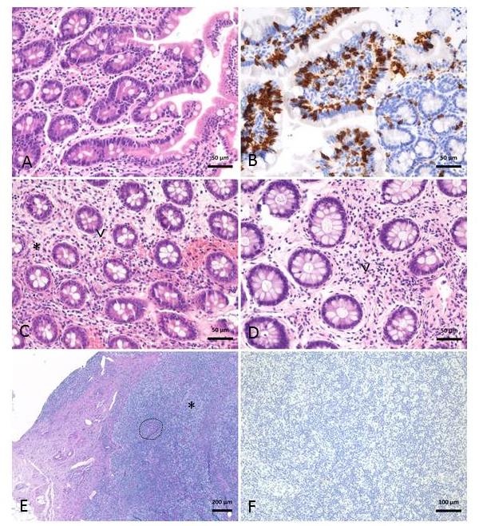
Supplemental Figure S2. Histology of NFKB2-mutated patients. (A-D) P49 (Fam846). (A) Duodenal biopsy with normal architecture and without inflammation but lacking stromal plasma cells. (B) CD8 staining (brown) shows villi with high numbers of intraepithelial lymphocytes. (C, D) Biopsies from the colon descendens (C) and rectum (D) display minor chronic damage with few apoptotic bodies in the stroma (C; asterisk, exemplary), patchy eosinophilic infiltrate (C, D; arrowhead) and reduced crypt diameters. (E, F) P41 (Fam246). (E) Lymph node with sparse, small germinal centers (dotted line, exemplary) and cortical macrophage infiltration (asterisk, exemplary) and lacking plasma cells in the CD138 staining (F) Original magnifications indicated by scale bars.

