Supplementary material
Supplementary Table 1. Extension of damage per region in the patient.
AAL Atlas labels (ID) | Affected regions | Lesion extension (%)
FAD (2002) | Precentral gyrus L | 1.62%
F2D (2202) | Middle Frontal gyrus R | 9.32%
F3OPD (2302) | Inferior frontal operculum R | 24.05%
F3TD (2312) | Inferior frontal gyrus, pars triangularis R | 10.23%
F3OD (2322) | Orbital part of the inferior frontal gyrus R | 14.91%
ORD (2332) | Rolandic operculum R | 28%
COBG (2501) | Olfactory cortex L | 10.61%
ING (3001) | Insular cortex L | 12.22%
IND (3002) | Insular cortex R | 73.12%
CIPD (4022) | Posterior cingulum cortex R | 7.54%
HIPPOG (4101) | Hippocampus L | 3.94%
HIPPOD (4102) | Hippocampus R | 2.84%
PARA_HIPPOG (4111) | Parahippocampal gyrus L | 1.50%
PARA_HIPPOD (4112) | Parahippocampal gyrus R | 14.03%
AMYGDG (4201) | Amygdala L | 69.13%
AMYGDD (4202) | Amygdala R | 35.62%
V1D (5002) | Calcarine cortex R | 11.17%
LINGD (5022) | Lingual gyrus R | 11.78%
O1D (5102) | Superior occipital cortex R | 4.58%
O2D (5202) | Middle occipital cortex R | 52.88%
FUSID (5402) | Fusiform gyrus R | 7.52%
PAD (6002) | Postcentral gyrus R | 1.75%
P1D (6102) | Superior parietal cortex R | 6.17%
P2D (6202) | Inferior parietal cortex R | 66.14%
GSMD (6212) | Supramarginal gyrus R | 33.65%
GAD (6222) | Angular gyrus R | 72.74%
PQD (6302) | Precuneus R | 1.23%
NLG (7011) | Putamen L | 39.94%
NLD (7012) | Putamen R | 27.11%
PALLG (7021) | Globus pallidus L | 5.38%
HESCHLG (8101) | Heschl’s gyrus L | 1.50%
HESCHLG (8102) | Heschl’s gyrus R | 91.43%
T1D (8112) | Superior temporal gyrus R | 80.32%
T1AG (8121) | Superior temporal pole L | 3.65%
T1AD (8122) | Superior temporal pole R | 34.09%
T2D (8202) | Middle temporal gyrus R | 71.82%
T2AD (8212) | Middle temporal pole R | 41.61%
T3D (8302) | Inferior temporal gyrus R | 32.25%
As in previous works of our group (García-Cordero et al., 2016), to estimate the extension of the lesion in each area in the MNI space, we used the Automated Anatomical Labeling (AAL) Atlas (Tzourio-Mazoyer et al., 2002) to parcel the normalized lesion-mask of the patient. Based on this parcellation, we calculated the percent of volume of each AAL region (116 in total) that was covered by the extent of the lesion-mask. We only included the regions that present at least > 1% of lesion according to this method.

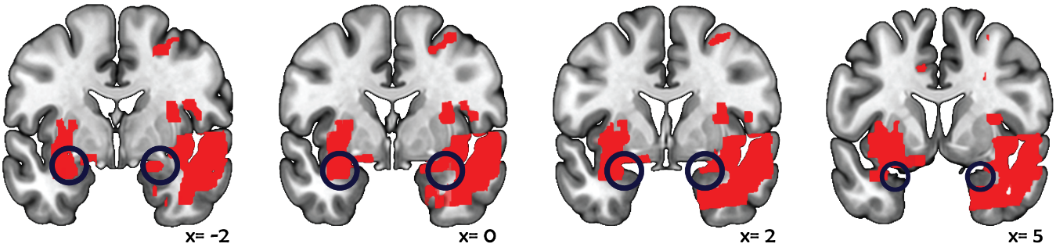
Supplementary Figure 1. Additional sections highlighting damage to the left and right amygdalae.

Supplementary references
García-Cordero, I; Sedeño, L; De la fuente, L; Slachevsky, A; Forno, G; Klein, F; Lillo, P; Ferrari, J; Rodriguez, C; Bustin, J; Torralva, T; Baez, S; Yoris, A; Estevez, S; Melloni, M; Salamone, P; Huepe, D; Manes, F, García, A; Ibáñez, A. (2016). Feeling, learning from and being aware of inner states: interoceptive dimensions in neurodegeneration and stroke. Philosophical Transactions of the Royal Society B: Biological Sciences. 371:1708. doi: 10.1098/rstb.2016.0006
Tzourio-Mazoyer, N., Landeau, B., Papathanassiou, D., Crivello, F., Etard, O., Delcroix, N., Mazoyer, B; Joliot, M. (2002). Automated anatomical labeling of activations in SPM using a macroscopic anatomical parcellation of the MNI MRI single-subject brain. Neuroimage.15:1. doi: :10.1006/nimg.2001.0978

