Supplementary material

Supplementary Figure 1. Confirmation of C3 signal in human B cells.

Western blot results analyzing endogenous C3 expression of human B cells. Lysates prepared from the human B cell line, Raji were fractionated into cytoplasmic and membrane fractions and analyzed by Western blot with the goat polyclonal anti-C3 antibody from Quidel. As positive control, lysates prepared from mock, or C3-pcDNA3 transfected HEK293 cells and A549 cells (which express endogenously C3) were used. As negative controls, mock transfected HEK293 cell lysates or Crispr/Cas9 edited, C3 KO A549 cells were involved. As loading controls, the cytoplasmic marker B-tubulin and the membrane marker, Na/K ATPase were used. Results shown are representative of two independent experiments.

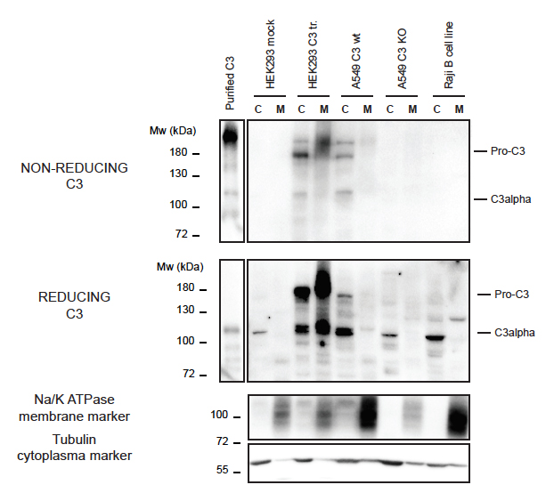

Supplementary Figure 2. C3 uptake is common among immune cells.

Western blot results analyzing C3 uptake by the human Jurkat T cell line (A) and human monocytoid THP-1 cells (B). Cells were treated with distinct sources of C3 (10 % NHS, 100 μg/ml C3, 100 μg/ml C3met) in DGVB++, Mg-EGTA or EDTA-GVB buffer for 1 h at 37 ºC. C3 uptake was investigated by Western blot using the goat polyclonal anti-C3 antibody from Quidel under non reducing conditions. Data shown are representative of two independent experiments.

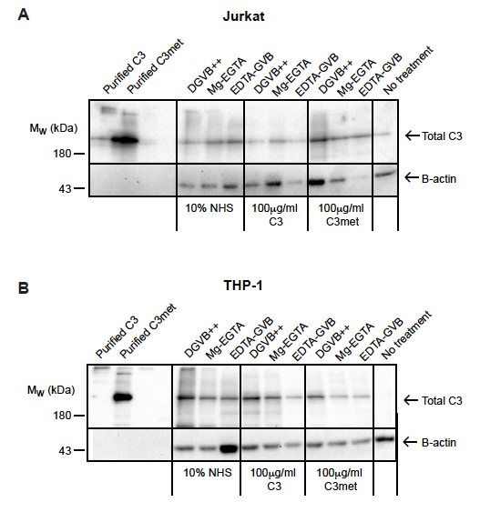

Supplementary Figure 3. C3 loading to the nucleus is not restricted to B cells.

Western blot results showing presence of C3 in nuclear compartments of Jurkat cells. Cells were incubated either with NHS, C3 or C3met in EDTA-GVB buffer for 1 h at 37 ºC. After lysis, cytoplasmic and soluble nuclear fractions were separated and analyzed by Western blot with the goat polyclonal anti-C3 antibody under non reducing conditions. The purity of distinct cellular fractions was verified using antibodies against B-actin (cytoplasmic marker) and lamin B1 (nuclear marker). Data shown are results of one representative experiment out of two independent analyzis.
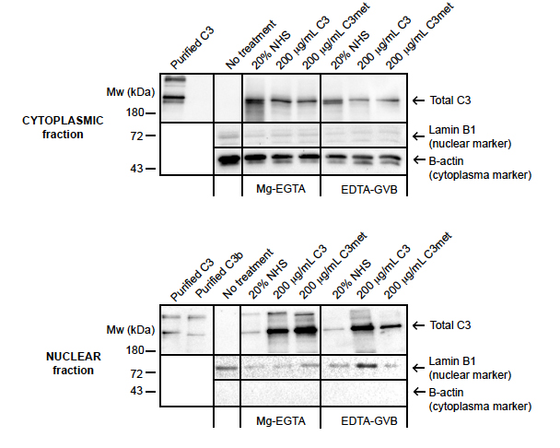
Original agarose gel electrophoresis and Western blot pictures

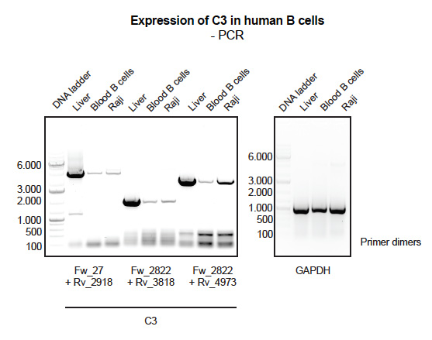
Figure 1B. Endogenous expression of C3 is very low in human B cells – PCR results.

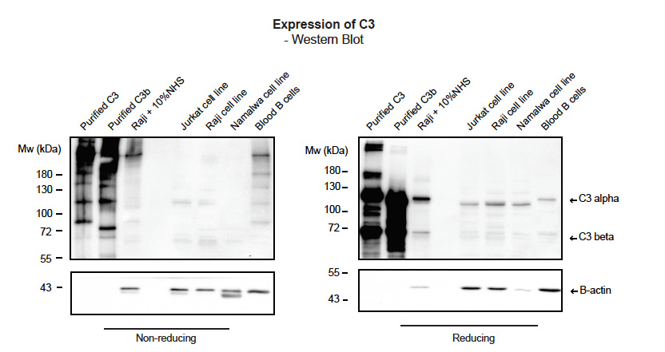
Figure 1C. Endogenous expression of C3 is very low in human B cells – Western blot results. Samples were run under non-reducing and reducing conditions. Membranes were cut around 50kDa – upper membrane developed with polyclonal goat anti-C3 antibody, lower developed with anti-B-actin antibody.

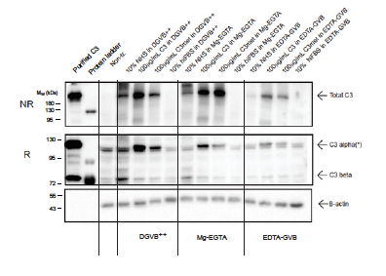
Figure 2A Internalization of C3 by human B cells. Samples were run under non-reducing (NR) and reducing ® conditions. Membranes, blotted after reducing SDS-PAGE, were cut around 60kDa – upper membrane developed with anti-C3 antibody, lower developed with anti-B-actin antibody.

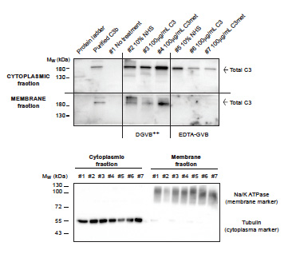
Figure 2B Internalization of C3 by human B cells – cytoplasmic/membrane fractionation of Raji cells. Samples were run under non-reducing condition (C3 Western blot) or under reducing condition to develop loading controls. C3 blots were cut around 100kDa, lower membrane – developed for loading controls – around 70kDa and developed either with anti-Na/K ATPase or anti-beta tubulin antibodies.

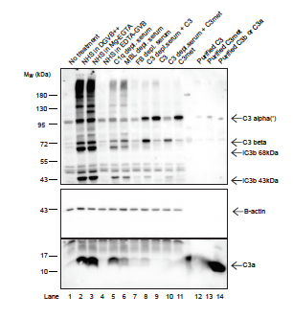
Figure 3. C3a in B cells is generated extracellularly by alternative pathway C3-convertases. Samples were run on reducing SDS-PAGE. In case of C3a detection, membranes were cut around 26kDa. Upper part developed with polyclonal rabbit anti-C3a, lower developed with anti-B-actin antibody.

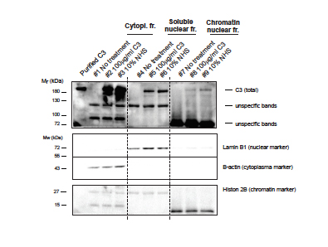
Figure 4A. Western blot results showing presence of C3 in nuclear compartments of Raji cells. Samples were run on non-reducing SDS-PAGE for C3 detection. To analyze the purity of cytoplasmic, membrane and chromatin-associated fractions, samples were run on reducing SDS-PAGE, membranes cut around 55kDa and 36kDa, and developed with anti-lamin B1 (upper), or anti-B-actin (middle) or histone 2B (lower) antibodies.
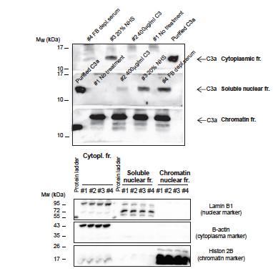
Figure 4B. Western blot results showing presence of C3a in nuclear compartments of Raji cells. Samples were run on reducing SDS-PAGE, each fraction separately, membranes cut around 36kDa and lower part of the membranes were developed with the rabbit polyclonal anti-C3a antibody. To analyze the purity of cytoplasmic, membrane and chromatin-associated fractions, samples were run on reducing SDS-PAGE, membranes cut around 55kDa and 26kDa, and developed with anti-lamin B1 (upper), or anti-B-actin (middle) or histone 2B (lower) antibodies.

