Supplementary Material
Assessing Snow Accumulation Patterns and Changes on the Patagonian Icefields
Claudio Bravo^{1*}, Deniz Bozkurt^{2,3}, Alvaro Gonzalez-Reyes⁴, Duncan J. Quincey¹, Andrew N. Ross⁵, David Farías-Barahona⁶ and Maisa Rojas^{2,3}
¹School of Geography, University of Leeds, Leeds, UK.
²Center for Climate and Resilience Research (CR2), Universidad de Chile, Santiago, Chile.
³ Departamento of Geofísica, Universidad de Chile, Santiago, Chile.
⁴Instituto de Ciencias de la Tierra, Facultad de Ciencias, Universidad Austral de Chile, Valdivia, Chile
⁵ School of Earth and Environment, University of Leeds, Leeds, UK.
⁶ Institut für Geographie, Friedrich-Alexander-Universität Erlangen-Nürnberg, Erlangen, Germany.
* Correspondence:
Corresponding Author
gycabl@leeds.ac.uk

Supplementary Figures and Tables

Supplementary Figures
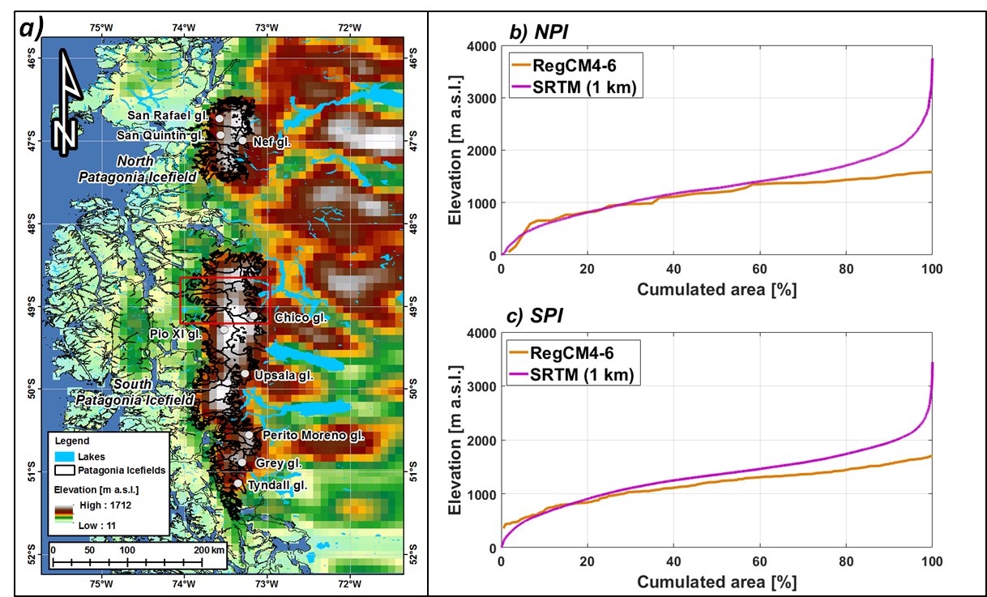
Figure S1. a) RegCM4.6 topography at 10 km resolution, b) and c) comparative hypsometric curves of the icefields using 1 km SRTM topographic data (Figure 1) and data from a).

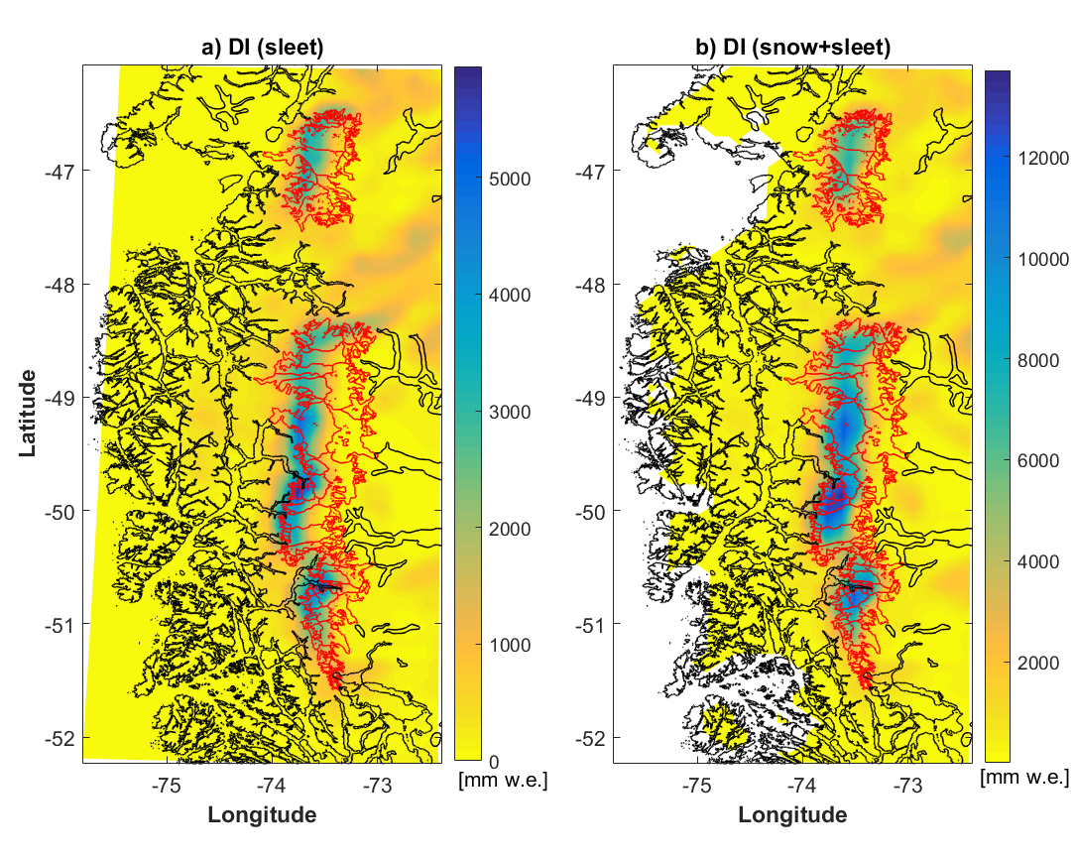
Figure S2. 1980-2015 annual mean value of accumulation type for DI PPM. a) sleet and b) snow plus sleet. Red line corresponds to the Icefields limits and glaciers.
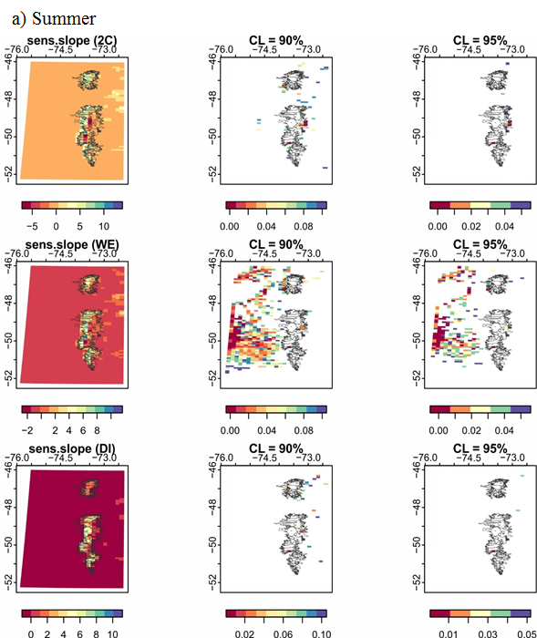
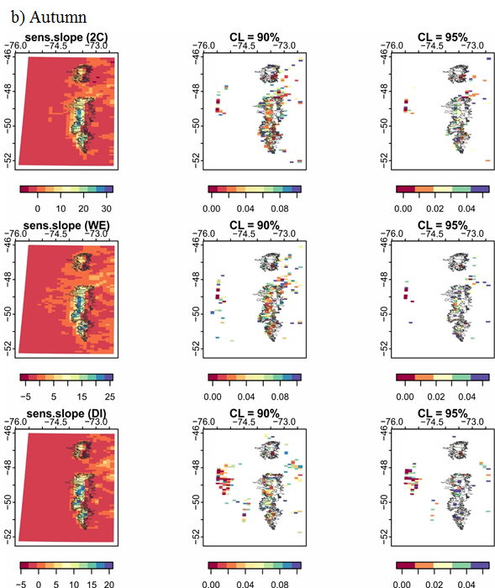
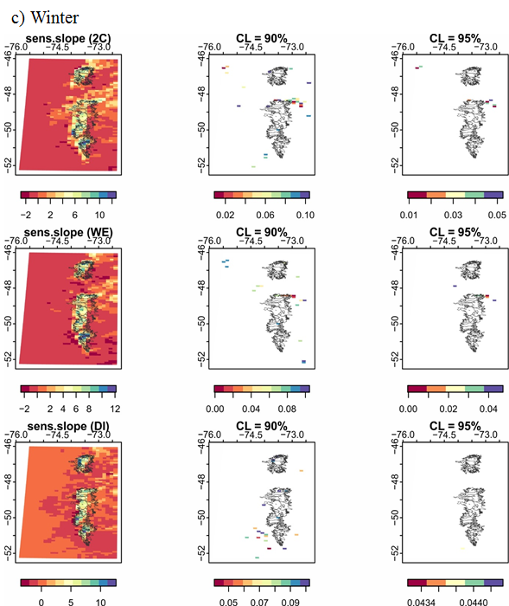
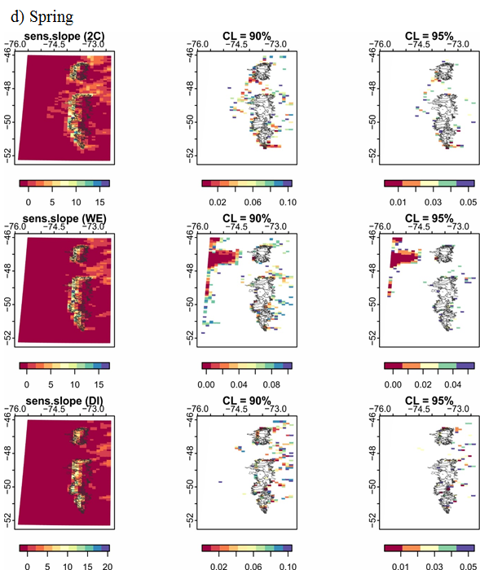
Figure S3. Seasonal trends 1980-2015 in mm w.e. yr⁻¹ for three PPMs using Sen’s slope method. (a) Summer, (b) Autumn, (c) Winter and (d) Spring. Statistically significant trend (p<0.1 and p<0.05) are also shown. Icefields contours in black.
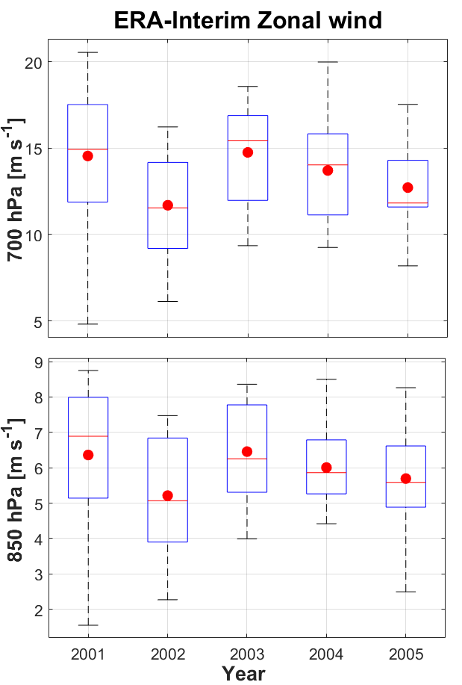
Figure S4. Boxplot of the ERA-Interim zonal wind for a region covering the Icefields for calendar years 2001 to 2005 at two pressure levels of 700 hPa and 850 hPa.

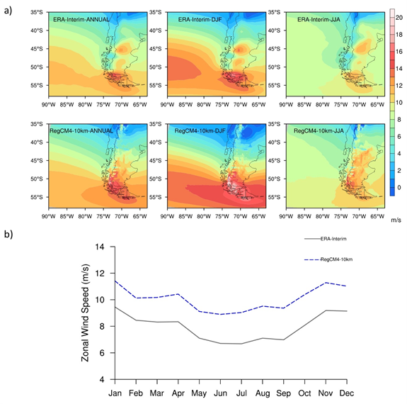
Figure S5. (a) Spatial distribution of 36-year (1980-2015) mean annual, DJF and JJA average of 850hPa zonal wind speed (m/s) from ERA-Interim and RegCM4. (b) 36-year (1980-2015) mean annual cycle of 850hPa zonal wind speed (m/s) from ERA-Interim and RegCM4 for a region covering the Icefields.

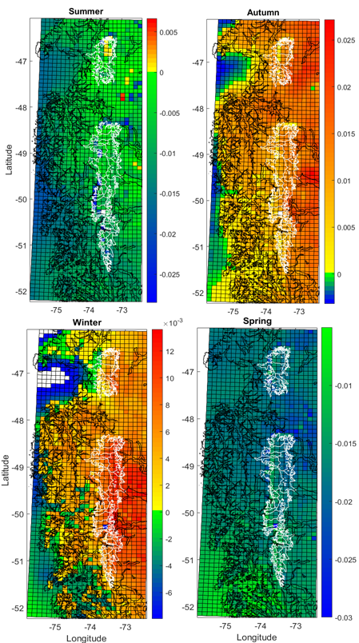
Figure S6. Seasonal trends 1980-2015 for the near surface air temperature obtained from RegCM4.6. Colorbar in in °C yr⁻¹. Note that each season show a different scale in the trends. Icefields limits in white and coastlines in black.

Supplementary Tables
Table S1. Mean and standard deviation (inter-annual variability) of the snow accumulation values by season, zone and PPM in the period 1980-2015.
Zone | Season | PPM / RegCM4.6 [mm w.e.]
 |  | 2C |  | WE |  | SC |  | DI |  | DI (snow+sleet)
 |  | Mean | Std Dev | Mean | Std Dev | Mean | Std Dev | Mean | Std Dev | Mean | Std Dev
NPI W | Summer | 711 | 235 | 492 | 203 | 491 | 203 | 250 | 144 | 694 | 234
 | Autumn | 1,396 | 245 | 1,198 | 227 | 1,199 | 227 | 896 | 206 | 1,378 | 244
 | Winter | 1,601 | 327 | 1,525 | 302 | 1,526 | 302 | 1,331 | 250 | 1,597 | 325
 | Spring | 1,232 | 256 | 1,098 | 248 | 1,099 | 248 | 838 | 225 | 1,223 | 254
 | Annual | 4,941 | 463 | 4,313 | 416 | 4,314 | 416 | 3,315 | 381 | 4,892 | 459
NPI E | Summer | 90 | 38 | 55 | 28 | 56 | 28 | 31 | 18 | 90 | 38
 | Autumn | 332 | 71 | 274 | 69 | 274 | 69 | 204 | 65 | 330 | 71
 | Winter | 429 | 53 | 396 | 50 | 396 | 50 | 337 | 50 | 429 | 53
 | Spring | 233 | 62 | 188 | 57 | 189 | 57 | 138 | 47 | 234 | 62
 | Annual | 1,084 | 107 | 913 | 98 | 914 | 99 | 710 | 92 | 1,084 | 107
SPI NW | Summer | 1,274 | 344 | 820 | 279 | 819 | 279 | 378 | 175 | 1,229 | 339
 | Autumn | 2,051 | 456 | 1,640 | 373 | 1,640 | 373 | 1,103 | 274 | 2,015 | 446
 | Winter | 2,452 | 612 | 2,227 | 548 | 2,227 | 548 | 1,782 | 443 | 2,440 | 606
 | Spring | 2,233 | 413 | 1,813 | 367 | 1,813 | 368 | 1,204 | 292 | 2,199 | 408
 | Annual | 8,010 | 908 | 6,500 | 796 | 6,500 | 796 | 4,467 | 641 | 7,883 | 891
SPI NE | Summer | 852 | 160 | 715 | 155 | 715 | 156 | 513 | 149 | 841 | 159
 | Autumn | 1,104 | 200 | 1,027 | 195 | 1,027 | 195 | 894 | 176 | 1,099 | 200
 | Winter | 1,172 | 264 | 1,133 | 255 | 1,133 | 255 | 1,066 | 239 | 1,170 | 263
 | Spring | 1,058 | 175 | 999 | 169 | 999 | 169 | 890 | 159 | 1,055 | 175
 | Annual | 4,186 | 381 | 3,873 | 358 | 3,874 | 358 | 3,363 | 326 | 4,166 | 380
SPI SW | Summer | 1,031 | 213 | 698 | 200 | 697 | 200 | 330 | 143 | 999 | 210
 | Autumn | 1,387 | 292 | 1,182 | 248 | 1,182 | 248 | 867 | 187 | 1,374 | 289
 | Winter | 1,532 | 345 | 1,469 | 320 | 1,470 | 321 | 1,291 | 281 | 1,529 | 343
 | Spring | 1,520 | 242 | 1,332 | 233 | 1,332 | 232 | 967 | 206 | 1,507 | 240
 | Annual | 5,471 | 532 | 4,680 | 492 | 4,680 | 491 | 3,455 | 436 | 5,408 | 527
SPI SE | Summer | 636 | 94 | 519 | 93 | 519 | 93 | 340 | 99 | 630 | 94
 | Autumn | 780 | 129 | 723 | 126 | 723 | 126 | 616 | 109 | 780 | 129
 | Winter | 833 | 149 | 815 | 146 | 815 | 146 | 775 | 136 | 833 | 148
 | Spring | 785 | 97 | 743 | 97 | 744 | 97 | 656 | 96 | 784 | 98
 | Annual | 3,033 | 226 | 2,801 | 215 | 2,801 | 216 | 2,388 | 201 | 3,027 | 224
Table S2. Maximum and minimum values of the mean snow accumulation values (1980-2015) by season, zone and PPMs.
Zone | Season | PPM / RegCM4.6 [mm w.e.]
 |  | 2C |  | WE |  | SC |  | DI |  | DI (snow+sleet)
 |  | Max | Min | Max | Min | Max | Min | Max | Min | Max | Min
NPI W | Summer | 1,187 | 93 | 876 | 65 | 875 | 65 | 506 | 15 | 1,156 | 94
 | Autumn | 2,132 | 229 | 1,755 | 209 | 1,756 | 209 | 1,449 | 175 | 2,104 | 229
 | Winter | 2,558 | 269 | 2,334 | 266 | 2,335 | 266 | 1,936 | 251 | 2,545 | 269
 | Spring | 1,921 | 175 | 1,685 | 160 | 1,684 | 160 | 1,369 | 130 | 1,906 | 175
 | Annual | 7,556 | 767 | 6,389 | 701 | 6,391 | 701 | 5,170 | 594 | 7,458 | 767
NPI E | Summer | 354 | 8 | 243 | 2 | 243 | 2 | 166 | 1 | 339 | 10
 | Autumn | 1,127 | 121 | 830 | 95 | 831 | 95 | 526 | 72 | 1,099 | 124
 | Winter | 1,472 | 167 | 1,343 | 150 | 1,343 | 150 | 1,012 | 139 | 1,469 | 170
 | Spring | 986 | 58 | 756 | 40 | 757 | 40 | 423 | 36 | 974 | 63
 | Annual | 3,942 | 358 | 3,094 | 290 | 3,096 | 290 | 1,959 | 257 | 3,884 | 368
SPI NW | Summer | 3,430 | 30 | 2,889 | 7 | 2,889 | 7 | 1,977 | 0 | 3,397 | 29
 | Autumn | 3,454 | 480 | 3,305 | 260 | 3,304 | 260 | 2,912 | 83 | 3,445 | 470
 | Winter | 3,552 | 1,149 | 3,391 | 752 | 3,391 | 751 | 3,252 | 314 | 3,547 | 1,122
 | Spring | 3,653 | 574 | 3,593 | 261 | 3,593 | 261 | 3,350 | 56 | 3,648 | 550
 | Annual | 13,821 | 2,235 | 13,069 | 1,281 | 13,069 | 1,278 | 11,503 | 454 | 13,774 | 2,171
SPI NE | Summer | 2,210 | 4 | 1,993 | 0 | 1,993 | 0 | 1,620 | 0 | 2,196 | 4
 | Autumn | 2,375 | 181 | 2,329 | 142 | 2,330 | 141 | 2,193 | 46 | 2,375 | 181
 | Winter | 2,262 | 214 | 2,262 | 210 | 2,262 | 210 | 2,261 | 163 | 2,262 | 214
 | Spring | 2,315 | 133 | 2,305 | 97 | 2,306 | 97 | 2,239 | 14 | 2,315 | 133
 | Annual | 9,170 | 620 | 8,898 | 559 | 8,899 | 558 | 8,321 | 222 | 9,156 | 626
SPI SW | Summer | 2,740 | 16 | 2,107 | 2 | 2,105 | 2 | 1,325 | 0 | 2,646 | 17
 | Autumn | 3,105 | 274 | 2,735 | 188 | 2,732 | 188 | 2,255 | 69 | 3,070 | 275
 | Winter | 3,020 | 313 | 2,999 | 312 | 3,000 | 312 | 2,873 | 225 | 3,020 | 313
 | Spring | 3,365 | 235 | 3,158 | 144 | 3,159 | 143 | 2,556 | 24 | 3,352 | 237
 | Annual | 12,240 | 988 | 10,814 | 870 | 10,812 | 870 | 8,839 | 319 | 12,099 | 993
SPI SE | Summer | 2,482 | 32 | 2,103 | 17 | 2,103 | 17 | 1,534 | 0 | 2,430 | 35
 | Autumn | 2,351 | 123 | 2,196 | 102 | 2,197 | 102 | 1,960 | 93 | 2,347 | 126
 | Winter | 2,239 | 154 | 2,235 | 147 | 2,235 | 147 | 2,185 | 144 | 2,239 | 155
 | Spring | 2,678 | 80 | 2,603 | 60 | 2,605 | 60 | 2,324 | 54 | 2,676 | 83
 | Annual | 9,751 | 388 | 9,010 | 326 | 9,013 | 326 | 7,934 | 305 | 9,693 | 399

