Succession of microbial communities and metabolic functions in cow manure and corn straw composting
Qingxin Mengª, Wei Yangª, Mengqi Menª, Ayodeji Belloª, Xiuhong Xu^{a*},Benshu Xuª, Liting Dengª, Xin Jiangª, Siyuan Shengª, Xiaotong Wuª, Yue Hanª, Haifeng Zhuª
ª College of Resources and Environment, Northeast Agricultural University, Harbin 150030, China.
*Correspondence:
Dr. Xiuhong Xu
E-mail: xuxiuhong@neau.edu.cn.

Supplementary Figure 1 Changes of physicochemical characteristics during the cow manure composting. (A) pH; (B) Temperature; (C) Moisture content (M).

Supplementary Figure 2 Changes of physicochemical characteristics during the cow manure composting. (A) NO₃⁻-N; (B) NH₄⁺-N; (C) total nitrogen (TN); (D) C/N.

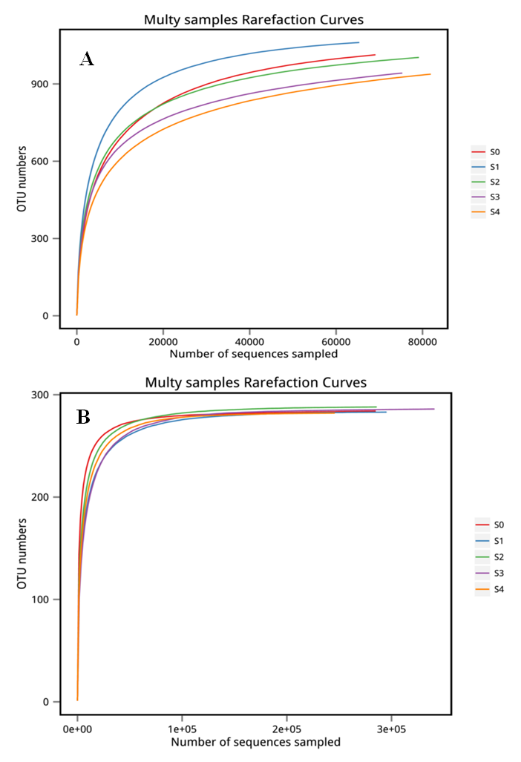
Supplementary Figure 3 Rarefaction curves for the observed OTUs of bacteria (A) and fungi (B) among different composting stages.

Supplementary Table 1 One-way ANOVA examining the effects of the cow manure compost phases on environmental variables, diversity indices and abundances of bacteria and fungi.
 | Phase
Variables | F | P
NO₃––N | 64.885 | <0.001
NH₄⁺–N | 8.309 | 0.003
TN | 20.428 | <0.001
C/N | 25.930 | <0.001
pH | 8.585 | 0.003
T | 383.416 | <0.001
M | 58.281 | <0.001
Bacterial Shannon index | 3.421 | 0.052
Fungal Shannon index | 5.130 | 0.016
16S gene abundance | 3.593 | 0.046
ITS gene abundance | 3.745 | 0.041
TN, total nitrogen; C/N, the ratio of TC to TN; T, temperature; M, Moisture content.

PCR amplification thermal cycling condition
The thermal cycling of MiSeq sequencing was as follows: (1) for bacteria, an initial denaturation at 94◦C for 4 min, 30 cycles of denaturation at 94°C for 40s, annealing at 56°C for 1 min, and extension at 72°C for 1 min, followed by a final extension at 72°C for 10 min; (2) for fungi, 94°C for 5 min, followed by 34 cycles of 94°C for 30 s, 54°C for 30 s and 68°C for 45 s, followed by a final elongation step at 72°C for 10 min. The quantification PCR cycling condition was 95°C for 5 min, followed by 40 cycles of 95°C for 5 s, 58°C for 30 s for 16S rRNA gene; 55°C for 30 s for ITS gene, and 72°C for 40 s.

