**Supplemental Figure 1**: Methods used for measuring egg length (**A**), egg area (**B**), hatched blastula length (**C**), hatched blastula area (**D**). 

**Supplemental Figure 2:** Oxygen and pH inside and outside of a kelp forest environment at MKO, 1m off the bottom, for Deployment 2 (March 10 ~ April 08, 2015). Within our detection limits, this relationship is conserved over this distance.

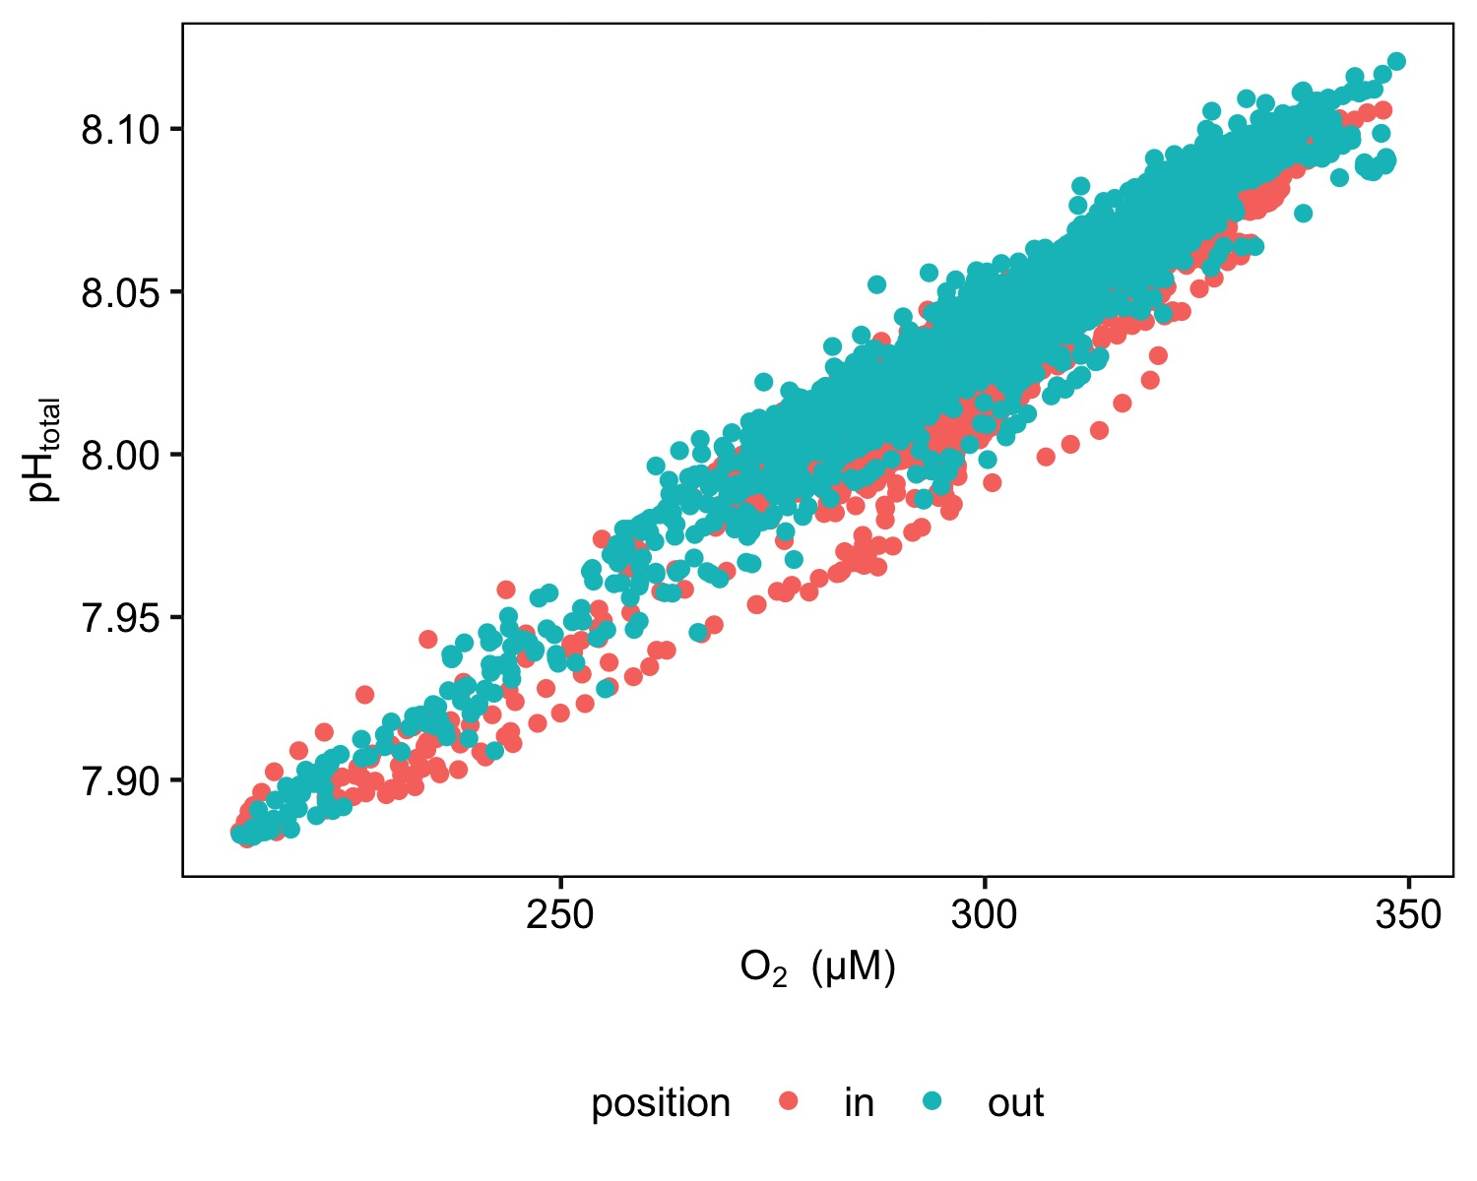

Supplemental Figure 3 Spectrograms for two contrasting months (March and July) in Deployment 3. Bars by y axis represent the 95% confidence intervals.

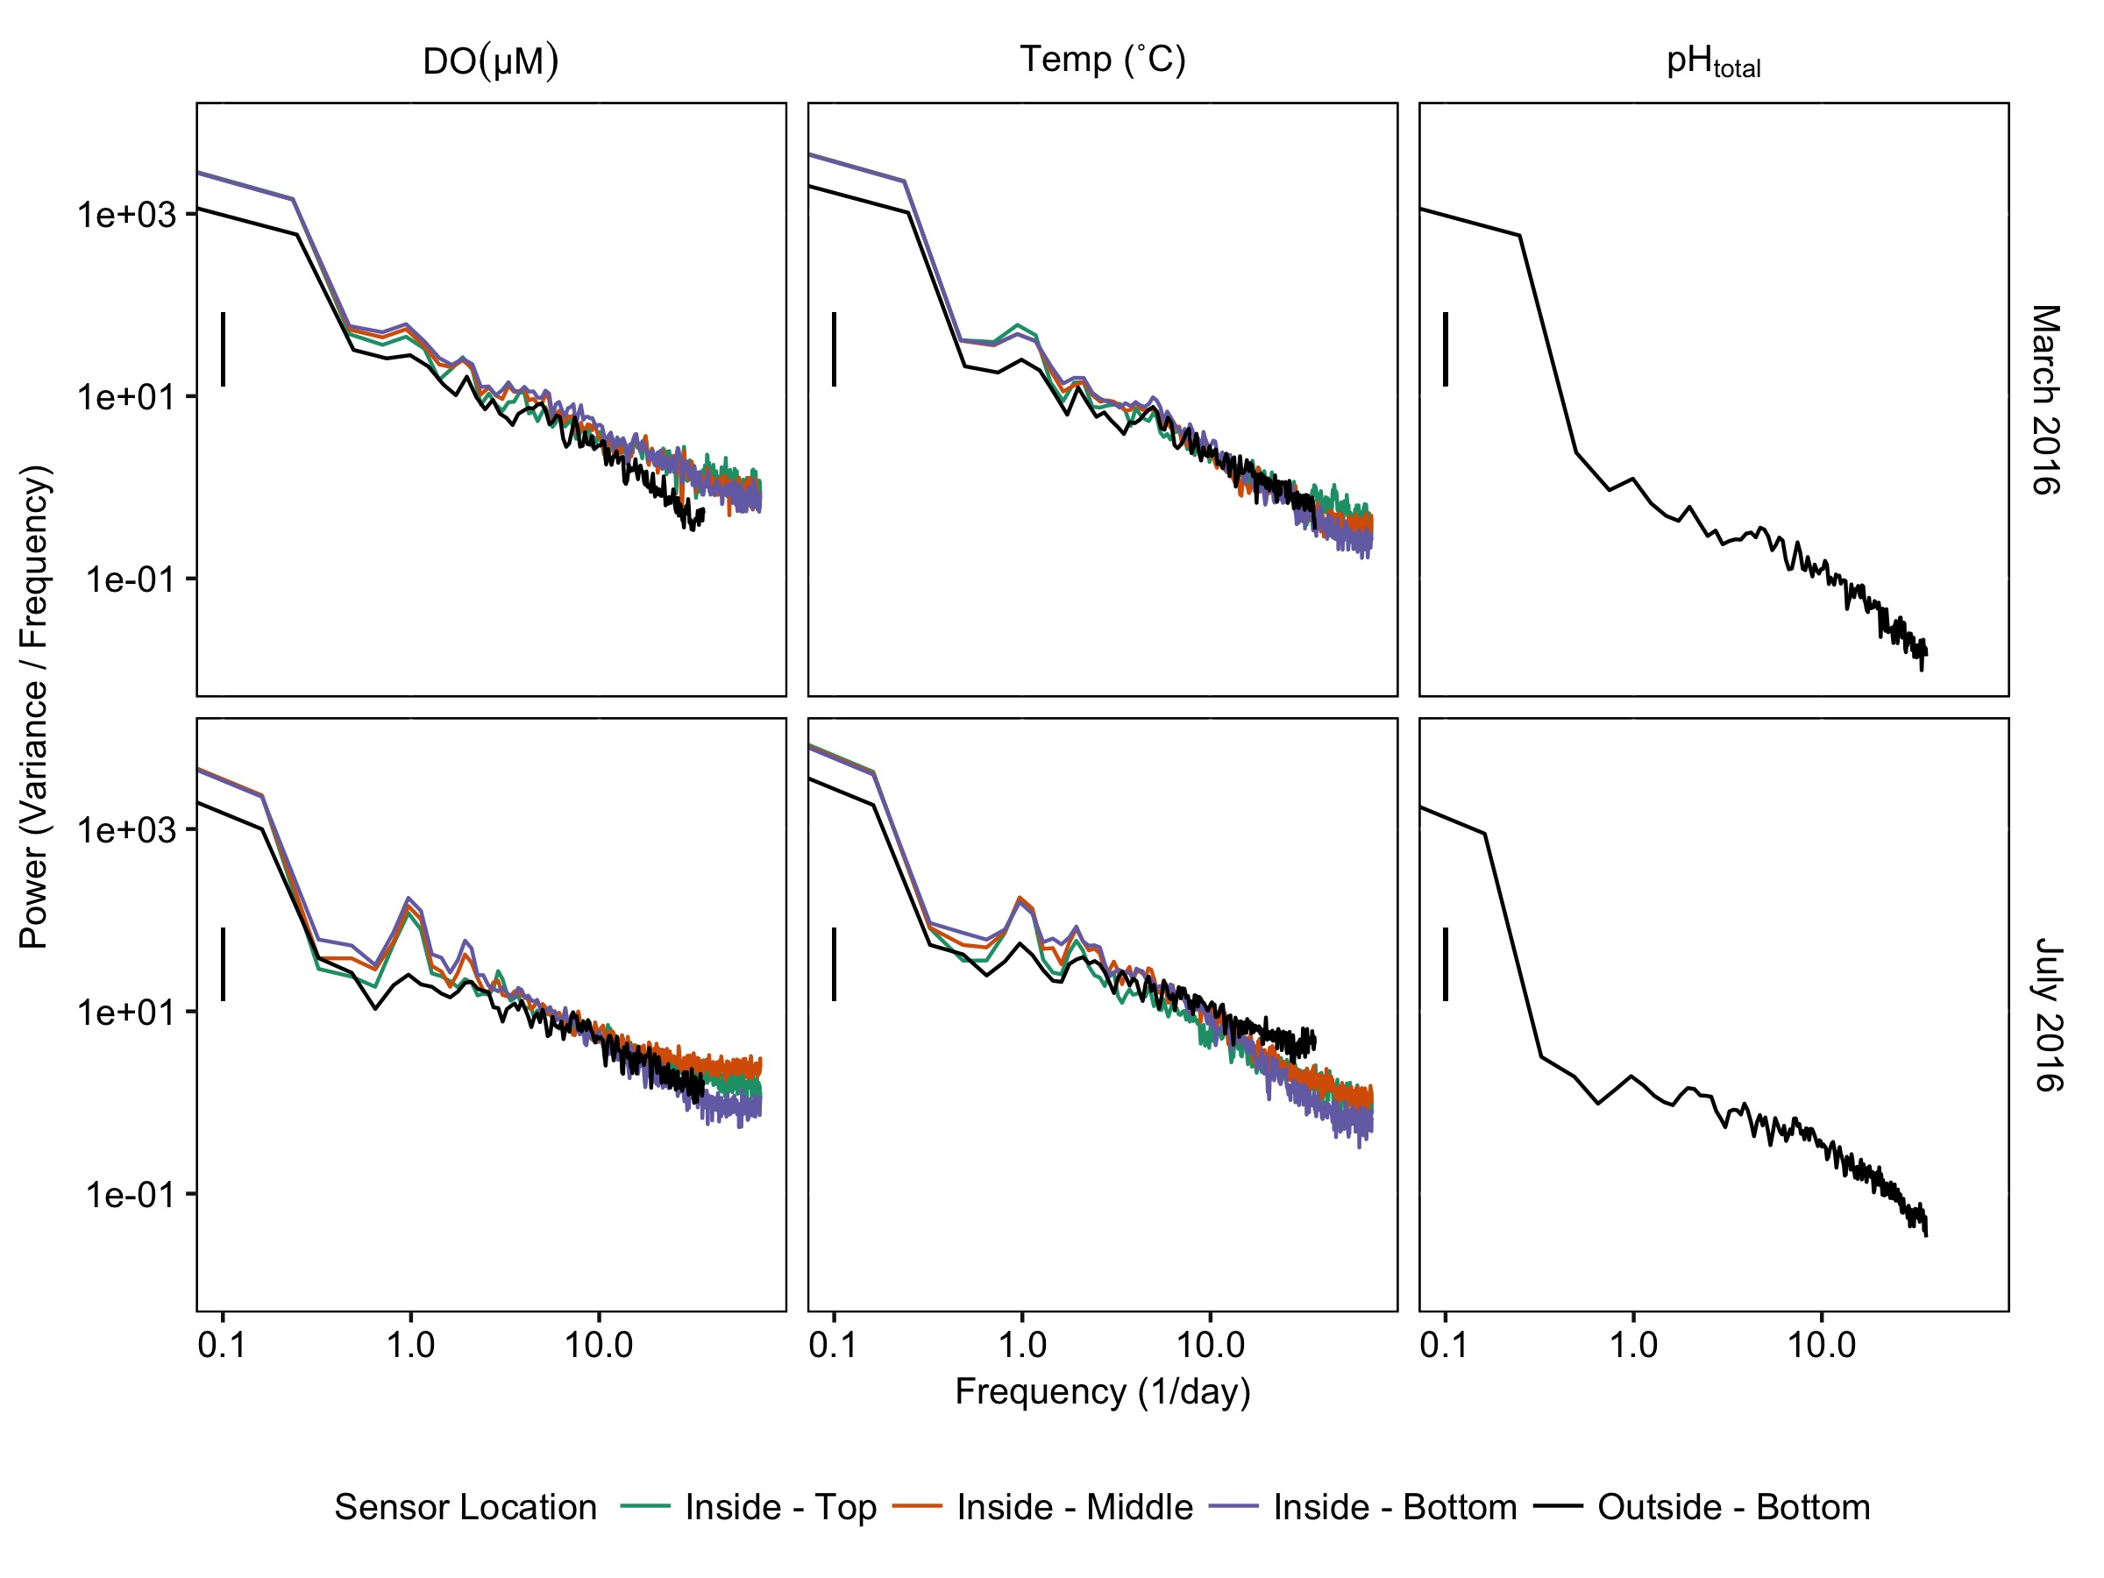

**Supplemental Figure 4:** Correlation of egg area and average diameter for eggs from mothers conditioned inside and outside of a kelp forest environment.

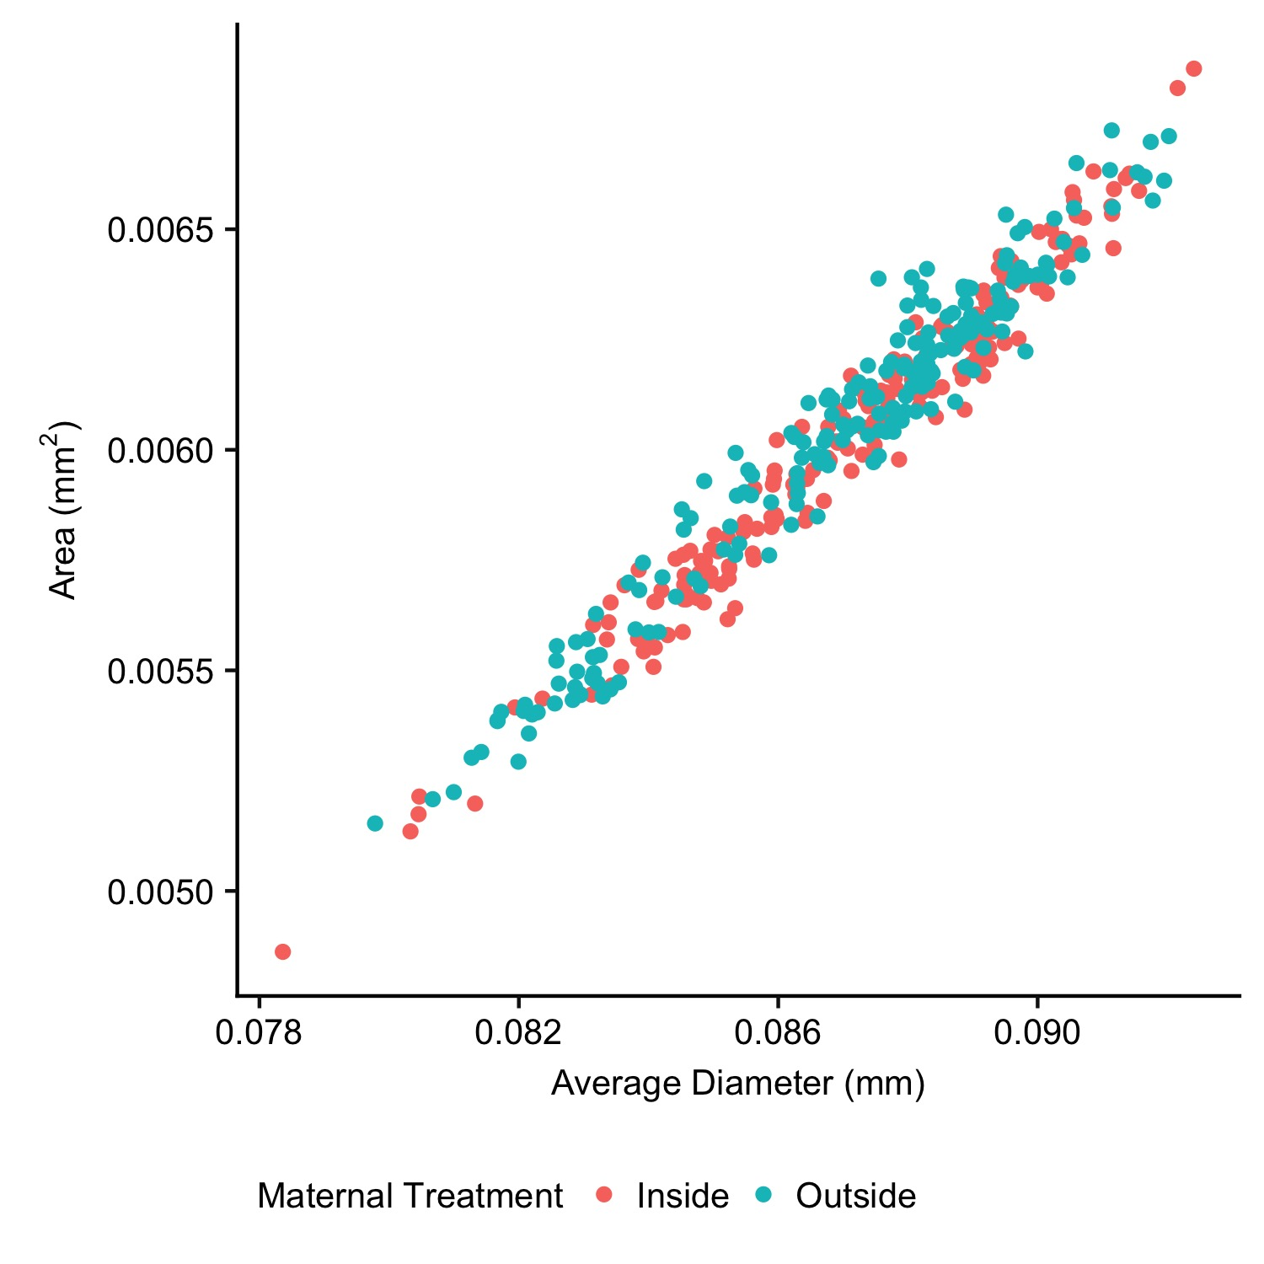

**Supplemental Table 1:** Average pH (**A**), Oxygen and Temperature (**B**) for Deployment 3, expressed as mean ± s.d. Colors correspond to those used in Figures 5 and 6.

**A.**

|  |  |
| --- | --- |
| Month | pH (total) |
| 3 | 7.92 ± 0.09 |
| 4 | 7.93 ± 0.1 |
| 5 | 7.89 ± 0.08 |
| 6 | 7.89 ± 0.09 |
| 7 | 7.96 ± 0.05 |
| 8 | 7.98 ± 0.06 |
| 9 | 7.99 ± 0.03 |
| 10 | 8.02 ± 0.01 |

**B.**

|  |  |  |  |  |
| --- | --- | --- | --- | --- |
| Month | Sensor Location |  | Oxygen (mg/L) | Temperature (˚C) |
| 3 | Inside - Top |  | 9.08 ± 1.28 | 14.7 ± 1.2 |
| Inside - Middle |  | 8.92 ± 1.34 | 14.5 ± 1.2 |
| Inside - Bottom |  | 8.89 ± 1.36 | 14.4 ± 1.2 |
| Outside - Bottom |  | 7.85 ± 1.46 | 13.9 ± 1.2 |
| 4 | Inside - Top |  | 10 ± 1.61 | 14.6 ± 1.3 |
| Inside - Middle |  | 9.82 ± 1.69 | 14.4 ± 1.2 |
| Inside - Bottom |  | 9.74 ± 1.73 | 14.2 ± 1.2 |
| Outside - Bottom |  | 8.58 ± 1.77 | 13.6 ± 1.1 |
| 5 | Inside - Top |  | 10.77 ± 1.19 | 15.5 ± 1.1 |
| Inside - Middle |  | 10.38 ± 1.25 | 15.1 ± 1.1 |
| Inside - Bottom |  | 10.05 ± 1.41 | 14.8 ± 1.1 |
| Outside - Bottom |  | 8.52 ± 1.37 | 14.0 ± 1.1 |
| 6 | Inside - Top |  | 11.02 ± 0.95 | 16.7 ± 1.4 |
| Inside - Middle |  | 10.53 ± 1.2 | 16.1 ± 1.5 |
| Inside - Bottom |  | 9.9 ± 1.38 | 15.5 ± 1.6 |
| Outside - Bottom |  | 8.38 ± 1.48 | 14.3 ± 1.6 |
| 7 | Inside - Top |  | 10.43 ± 0.7 | 19.1 ± 1.0 |
| Inside - Middle |  | 10.45 ± 0.74 | 18.3 ± 1.1 |
| Inside - Bottom |  | 10.12 ± 0.87 | 17.7 ± 1.2 |
| Outside - Bottom |  | 8.97 ± 0.82 | 16.3 ± 1.2 |
| 8 | Inside - Top |  | 9.95 ± 0.42 | 18.9 ± 0.9 |
| Inside - Middle |  | 8.29 ± 0.97 | 17.7 ± 1.3 |
| Inside - Bottom |  | 7.91 ± 1.02 | 17.1 ± 1.3 |
| Outside - Bottom |  | 8.49 ± 0.82 | 16.1 ± 1.4 |
| 9 | Inside - Middle |  | 7.67 ± 0.49 | 18.3 ± 1.1 |
| Inside - Bottom |  | 7.7 ± 0.59 | 17.8 ± 1.2 |
| Outside - Bottom |  | 8.57 ± 0.51 | 17.0 ± 1.4 |
| 10 | Inside - Middle |  | 7.88 ± 0.58 | 16.9 ± 0.9 |
| Inside - Bottom |  | 7.73 ± 0.61 | 16.7 ± 1.0 |
| Outside - Bottom |  | 8.93 ± 0.23 | 17.1 ± 0.8 |
| 11 | Inside - Middle |  | 7.71 ± 0.49 | 16.7 ± 0.8 |
| Inside - Bottom |  | 7.63 ± 0.5 | 16.6 ± 0.9 |
| 12 | Inside - Middle |  | 7.83 ± 0.47 | 15.1 ± 0.6 |
| Inside - Bottom |  | 7.74 ± 0.45 | 15.1 ± 0.6 |

**Supplemental Table 2:** Means and standard errors for the values added into the PCA analysis.

|  |  |  |  |  |  |  |  |  |  |  |  |
| --- | --- | --- | --- | --- | --- | --- | --- | --- | --- | --- | --- |
| 1. Egg stage | | |  | | |  | | |  | |  |
| Maternal conditioning | Egg Count | | | | Egg Protein (ng egg-1) | | Area  (µm2) | | Diameter (µm) | | Test Diameter (mm) |
| Inside Kelp | 11266 ± 4499.7 | | | | 47.72 ± 3.71 | | 6.04 ± 0.11 | | 87.19 ± 0.86 | | 60 ± 2.74 |
| Outside Kelp | 70733 ± 12218.9 | | | | 37.65 ± 2.22 | | 6.04 ± 0.15 | | 86.95 ± 1.13 | | 62 ± 2.37 |
| 1. Hatched Blastula stage | | | | | | | | | |  | |
| Treatment code | | Area (µm2) | | Diameter (µm) | | | | Protein (ng egg-1) | |  | |  |
| IB | | 8.21±0.02 | | 103.27±0.11 | | | | 27.95±2.16 | |  | |  |
| IR | | 8.38±0.09 | | 103.34±0.17 | | | | 30.88±1.25 | |  | |  |
| OB | | 8.09±0.07 | | 102.68±0.62 | | | | 35±2.15 | |  | |  |
| OR | | 8.79±0.11 | | 107.28±0.55 | | | | 32.91±1.34 | |  | |  |