Supplementary Material

Streptomyces tirandamycinicus sp. nov., a novel marine sponge-derived actinobacterium with antibacterial potential against Streptococcus agalactiae

Xiaolong Huang^{1,2}, Fandong Kong², Shuangqing Zhou¹, Dongyi Huang¹, Jiping Zheng¹ and Weiming Zhu^{2,3*}
¹ Hainan Key Laboratory for Sustainable Utilization of Tropical Bioresources, Hainan University, Haikou 570228, China
² Key Laboratory of Marine Drugs, Ministry of Education of China, School of Medicine and Pharmacy, Ocean University of China, Qingdao 266003, China
³ Open Studio for Druggability Research of Marine Natural Products, Pilot National Laboratory for Marine Science and Technology (Qingdao), Qingdao, 266237, China

* Correspondence: W. Zhu, E-mail: weimingzhu@ouc.edu.cn, Fax: +86-532-82031268; Tel: +86-532-82031268

Table S1. Allele sequence accession numbers of species of the genus Streptomyces used for the present study

Species | Strains | atpD | gyr B | rec A | rpo B | trp B
Streptomyces tirandamycinicus | HNM0039 ^{T} | CP029188 | CP029188 | CP029188 | CP029188 | CP029188
Streptomyces spongiicola | HNM0071^{T} | CP029254 | CP029254 | CP029254 | CP029254 | CP029254
Streptomyces wuyuanensis | CGMCC 4.7042 ^{T} | NZ_FNHI01000041 | NZ_FNHI01000010 | NZ_FNHI01000001 | NZ_FNHI01000004 | NZ_FNHI01000012
Streptomyces albaduncus | NRRL B-3605^{T} | KT384449 | KT384798 | KT385146 | KJ996741 | KT389118
Streptomyces althioticus | NRRL_B-3981^{T} | KT384460 | KT384809 | KT385157 | KT388779 | KT389129
Streptomyces_erythrogriseus | NRRL B-3808^{T} | KT384542 | KT384891 | KT385240 | KT388861 | KT389211
Streptomyces griseoflavus | NRRLB-5312^{T} | KT384578 | KT384927 | KT385276 | KT388897 | KT389247
Streptomyces griseoincarnatus | NRRL B-5313^{T} | KT384580 | KT384929 | KT385278 | KT388899 | KT389249
Streptomyces griseorubens | NRRL B-3982 ^{T} | KT384583 | KT384932 | KT385281 | KT388903 | KT389252
Streptomyces labedae | NRRL B-5616^{T} | KT384613 | KT384962 | KT385312 | KT388933 | KT389282
Streptomyces lusitanus | NRRL B-5637^{T} | KJ196366 | KJ196368 | KJ196370 | KJ196372 | KJ196374
Streptomyces luteosporeus | NRRL 2401^{T} | KT384633 | KT384982 | KT385333 | KT388953 | KT389302
Streptomyces malachitofuscus | NRRL B-12273^{T} | KT384634 | KT384983 | KT385334 | KT388954 | KT389303
Streptomyces matensis | NRRL B-2576 ^{T} | KT384637 | KT384986 | KT385337 | KT388957 | KT389306
Streptomyces paradoxus | NRRL B-3457 ^{T} | KT384674 | KT385024 | KT385375 | KT388994 | KT389343
Streptomyces variabilis | NRRL B-3984 ^{T} | KT384743 | KT385091 | KT385445 | KT389063 | KT389412
Streptomyces werraensis | NRRL B-5317 ^{T} | KT384762 | KT385110 | KT385464 | KT389082 | KT389431

Table S2. MLSA distance values for selected strains in this study.
Strains | MLSA distance (Kimura two-parameter)
 | 1 | 2 | 3 | 4 | 5 | 6 | 7 | 8 | 9 | 10 | 11 | 12 | 13 | 14 | 15 | 16 | 17
1
2 | 0.015
3 | 0.021 | 0.027
4 | 0.582 | 0.59 | 0.588
5 | 0.567 | 0.573 | 0.578 | 0.056
6 | 0.567 | 0.573 | 0.578 | 0.056 | 0.014
7 | 0.59 | 0.595 | 0.597 | 0.071 | 0.075 | 0.069
8 | 0.568 | 0.574 | 0.578 | 0.056 | 0.014 | 0.002 | 0.071
9 | 0.572 | 0.579 | 0.583 | 0.063 | 0.026 | 0.034 | 0.071 | 0.034
10 | 0.576 | 0.58 | 0.583 | 0.075 | 0.057 | 0.05 | 0.082 | 0.05 | 0.054
11 | 0.568 | 0.574 | 0.573 | 0.049 | 0.023 | 0.024 | 0.066 | 0.024 | 0.041 | 0.063
12 | 0.577 | 0.584 | 0.587 | 0.101 | 0.1 | 0.099 | 0.097 | 0.097 | 0.103 | 0.105 | 0.094
13 | 0.577 | 0.582 | 0.585 | 0.042 | 0.043 | 0.045 | 0.066 | 0.045 | 0.056 | 0.069 | 0.039 | 0.096
14 | 0.566 | 0.572 | 0.577 | 0.055 | 0.003 | 0.016 | 0.073 | 0.016 | 0.027 | 0.059 | 0.021 | 0.098 | 0.04
15 | 0.61 | 0.611 | 0.614 | 0.079 | 0.084 | 0.08 | 0.096 | 0.081 | 0.083 | 0.081 | 0.08 | 0.121 | 0.077 | 0.084
16 | 0.568 | 0.574 | 0.578 | 0.056 | 0.014 | 0.002 | 0.071 | 0 | 0.034 | 0.05 | 0.024 | 0.097 | 0.045 | 0.016 | 0.081
17 | 0.568 | 0.574 | 0.573 | 0.056 | 0.018 | 0.017 | 0.071 | 0.017 | 0.037 | 0.056 | 0.022 | 0.092 | 0.044 | 0.018 | 0.082 | 0.017
Strains: 1: Streptomyces tirandamycinicus HNM0039 ^{T}, 2: Streptomyces spongiicola HNM0071^{T},3:Streptomyces wuyuanensis CGMCC 4.7042 ^{T},4: Streptomyces albaduncus NRRL B-3605^{T}, 5: Streptomyces althioticus NRRL_B-3981^{T}, 6: Streptomyces_erythrogriseus NRRL B-3808^{T}, 7: Streptomyces griseoflavus NRRLB-5312^{T}, 8: Streptomyces griseoincarnatus NRRL B-5313^{T}, 9: Streptomyces griseorubens NRRL B-3982 ^{T}, 10: Streptomyces labedae NRRL B-5616^{T}, 11: Streptomyces lusitanus NRRL B-5637^{T}, 12: Streptomyces luteosporeus NRRL 2401^{T}, 13: Streptomyces malachitofuscus NRRL B-12273^{T}, 14: Streptomyces matensis NRRL B-2576 ^{T}, 15: Streptomyces paradoxus NRRL B-3457 ^{T},16: Streptomyces variabilis NRRL B-3984 ^{T}, 17: Streptomyces werraensis NRRL B-5317 ^{T}.

Table S3. Cultural characteristics of strain HNM0039^{T} on various media at 28°C after 2 weeks. +, positive; -, negative.

Agar medium | Aerial mycelium | Substrate mycelium | Diffusible pigment
ISP1 | Absent | Light yellow | -
ISP2 | Absent | Yellow | -
ISP3 | Absent | Grey pink | -
ISP4 | White-grey | Yellow | -
ISP5 | Absent | Yellow | -
ISP6 | Absent | Dark yellow | +
ISP7 | White-grey | Dark brown | +

Table S4. Functional cluster of orthologous genes (COG) classification of predicted genes in strain HNM0039^{T}.
COG functional categories | CDS | of CDS
Information storage and processing |  | 18.9%
[A] RNA processing and modification | 1
[B] Chromatin structure and dynamics | 1
[J] Translation, ribosomal structure and biogenesis | 167
[K] Transcription | 228
[L] Replication, recombination and repair | 185
Cellular processes and signaling |  | 17.7%
[D] Cell cycle control, cell division, chromosome partitioning | 25
[M] Cell wall/membrane/envelope biogenesis | 146
[N] Cell motility | 0
[O] Posttranslational modification, protein turnover, chaperones | 122
[T] Signal transduction mechanisms | 163
[U] Intracellular trafficking, secretion, and vesicular transport | 22
[V] Defense mechanisms | 66
[W] Extracellular structures | 0
[Y] Nuclear structure | 0
[Z] Cytoskeleton | 1
Metabolism |  | 47.9%
[C] Energy production and conversion | 259
[E] Amino acid transport and metabolism | 354
[F] Nucleotide transport and metabolism | 89
[G] Carbohydrate transport and metabolism | 214
[H] Coenzyme transport and metabolism | 128
[I] Lipid transport and metabolism | 140
[P] Inorganic ion transport and metabolism | 187
[Q] Secondary metabolites biosynthesis, transport and catabolism | 106
Poorly characterized |  | 15.5%
[R] General function prediction only | 251
[S] Function unknown | 228

Table S5. The NMR data of tirandamycin A (1) in DMSO-d₆ and tirandamycin B (2) in MeOH-d₄.
position | Tirandamycin A (1) |  |  |  | Tirandamycin B (2)
 | δ_{C} | δ_{H} (J in Hz) | COSY | HMBC | δ_{C} | δ_{H} (J in Hz) | COSY | HMBC
1 | 173.3, C |  |  |  | 176.0, C
2 | 116.3, C | 7.03, d (15.1) | H-3 | C-1, 4 | 117.5, CH | 7.19, d (15.0) | H-3 | C-1, 4
3 | 148.1, CH | 7.48, d (15.1) | H-2 | C-15, 3, 1 | 150.4, CH | 7.57, d (15.0) | H-2 | C-15, 3, 1
4 | 134.2, C |  |  |  | 136.2, C
5 | 143.9, CH | 6.19, br d (10.0) | H-6 | C-15, 16, 3, 7 | 145.1, CH | 6.22, br d (9.5) | H-6 | C-15, 16, 3, 7
6 | 34.0, CH | 2.89, m | H-5, 7, 16 | C-4, 16, 5 | 35.7, CH | 2.97, m | H-5, 7, 16 | C-4, 16, 5
7 | 75.9, CH | 3.76, overlap | H-6, 8 | C-8, 6, 17 | 78.2, CH | 3.76, br d (11.5) | H-6, 8 | C-8, 6, 17
8 | 34.0, CH | 1.81, m | H-7, 9, 17 | C-9, 17, 10 | 35.7, CH | 1.97, m | H-7, 9, 17 | C-9, 17, 10
9 | 77.9, CH | 4.04, br d (6.4) | H-8 | C-9, 13, 10 | 80.0, CH | 4.04, br d (6.1) | H-8 | C-9, 13, 10
10 | 202.9, C |  |  |  | 203.4, C
11 | 60.0, CH | 3.47, s |  | C-12, 10 | 57.9, CH | 3.62, s |  | C-12, 10
12 | 56.8, C |  |  |  | 61.0, C
13 | 96.2, C |  |  |  | 97.2, C
14 | 22.5, C | 1.45, s |  |  | 23.7, CH₃ | 1.54, s
15 | 12.1, CH₃ | 1.84, s |  |  | 12.4, CH₃ | 1.93, s
16 | 16.7, CH₃ | 1.07, d (6.9) | H-6 | C-5, 6, 7 | 17.3, CH₃ | 1.17, d (6.5) | H-6 | C-5, 6, 7
17 | 11.1, CH₃ | 0.63, d (6.9) | H-8 | C-7, 8, 9 | 11.7, CH₃ | 0.74, d (6.5) | H-8 | C-7, 8, 9
18 | 15.2, CH₃ | 1.40, s |  | C-12, 13 | 58.3, CH₂ | 3.92, d (13.4) |  | C-12, 13
 |  |  |  | C-12, 13 |  | 4.00, d (13.4) |  | C-12, 13
2' | 175.8, C |  |  |  | 176.0, C
3' | 100.5, C |  |  |  | 102.2, C
4' | 193.5, C |  |  |  | 196.3, C
5' | 51.5, CH₂ | 3.77, overlap |  | C-4' | 52.3, CH₂ | 3.83, s |  | C-4'

Fig. S1. Marine sponge SP-1, the source of Streptomyces tirandamycinicus sp. nov.

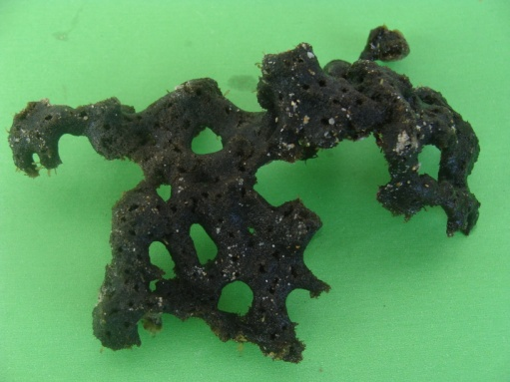

Fig. S2. The phospholipid profile of strain HNM0039^{T} detected with phosphomolybdic acid (a), molybdenum blue (b) and ninhydrin (c). Chloroform-methanol-water (65:25:4) was used in the first direction, followed by chloroform-acetic acid-methanol-water (80:15:12:4) in the second direction. Abbreviations: DPG, diphosphatidylglycerol; PE, phosphatidylethanolamine; PG, phosphatidylglycerol; PIM, phosphatidylinositolmannoside; PL1-2, unidentified phospholipids; L, unidentified lipid.
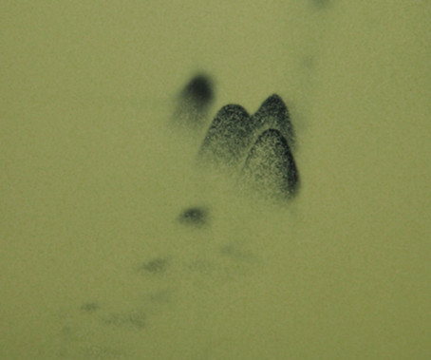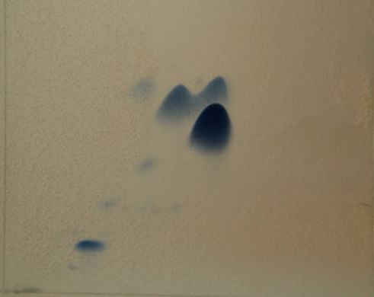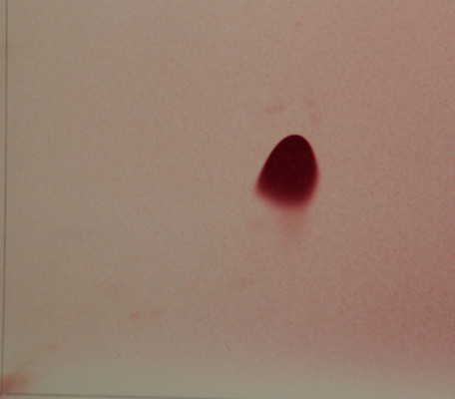
PE
DPG
DPG
PL1
c
b
a
2
2
2
1
1
1
PIM
PL2
PE
PIM
L
PG
PL2
PE
L
PG
PL1

Fig. S3. Secondary metabolite clusters are from strain HNM0039^{T} on the online antiSMASH v4.2.0

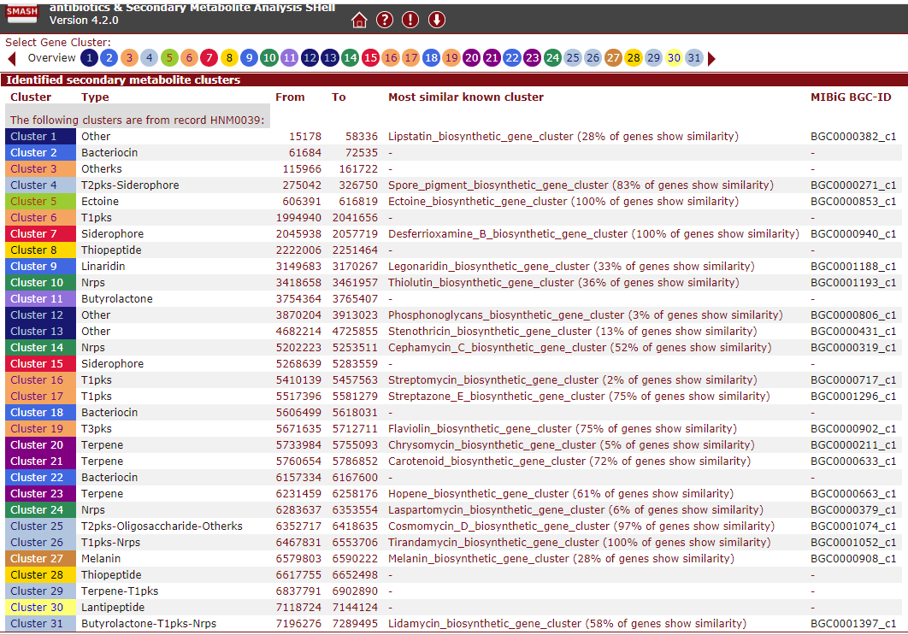

Fig. S4. The ¹H NMR spectrum of tirandamycin A (1) in DMSO-d₆

Fig. S5. The ¹³C NMR spectrum of tirandamycin A (1) in DMSO-d₆

Fig. S6. The HMBC spectrum of of tirandamycin A (1) in DMSO-d₆

Fig. S7. The HMQC spectrum of of tirandamycin A (1) in DMSO-d₆
Fig. S8. The ¹H-¹H COSY spectrum of of tirandamycin A (1) in DMSO-d₆

Fig. S9. The ¹H NMR spectrum of tirandamycin B (2) in CD₃OD

Fig. S10. The ¹³C NMR spectrum of tirandamycin B (2) in CD₃OD

Fig. S11. The HMBC spectrum of of tirandamycin B (2) in CD₃OD

Fig. S12. The HMQC spectrum of of tirandamycin B (2) in CD₃OD

Fig. S13. The ¹H-¹H COSY spectrum of of tirandamycin B (2) in CD₃OD

