Supplementary Figures

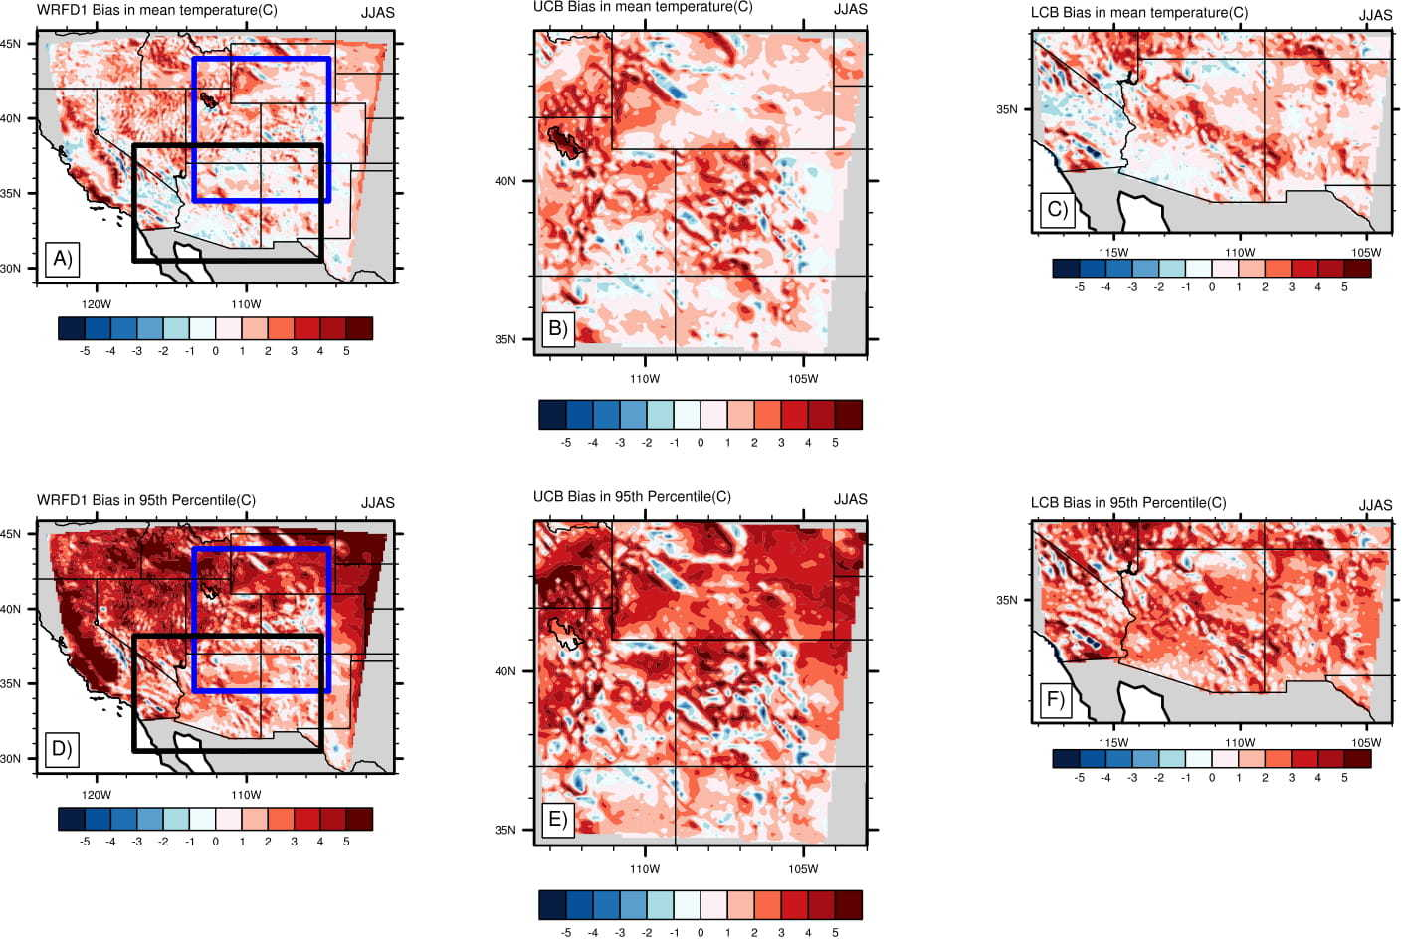

Supplementary Figure S1. Absolute bias (modeled-observed, degree C) in mean (A-C) and extreme (95th percentile, D-F) 2m-temperature simulated in the WRFD1 (A, D) and CPM runs (B, C, E, F) in warm season. The blue and the black boxes in WRFD1 plots represent the upper and lower Colorado basins (UCB and LCB) respectively where CPM simulations are performed.

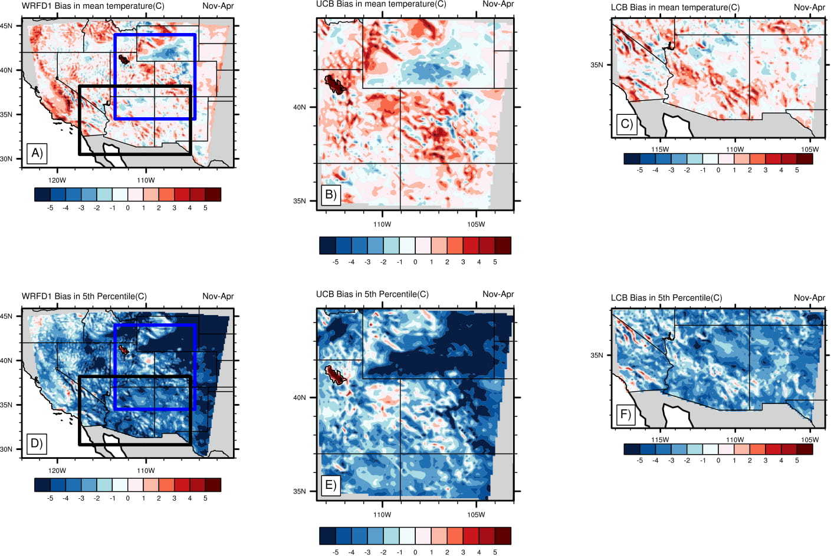

Supplementary Figure S2. Absolute bias (modeled-observed, degree C) in mean (A-C) and extreme (5th percentile, D-F) 2m-temperature simulated in the WRFD1 (A, D) and CPM runs (B, C, E, F) in cool season. The blue and the black boxes in WRFD1 plots represent the upper and lower Colorado basins (UCB and LCB) respectively where CPM simulations are performed.

