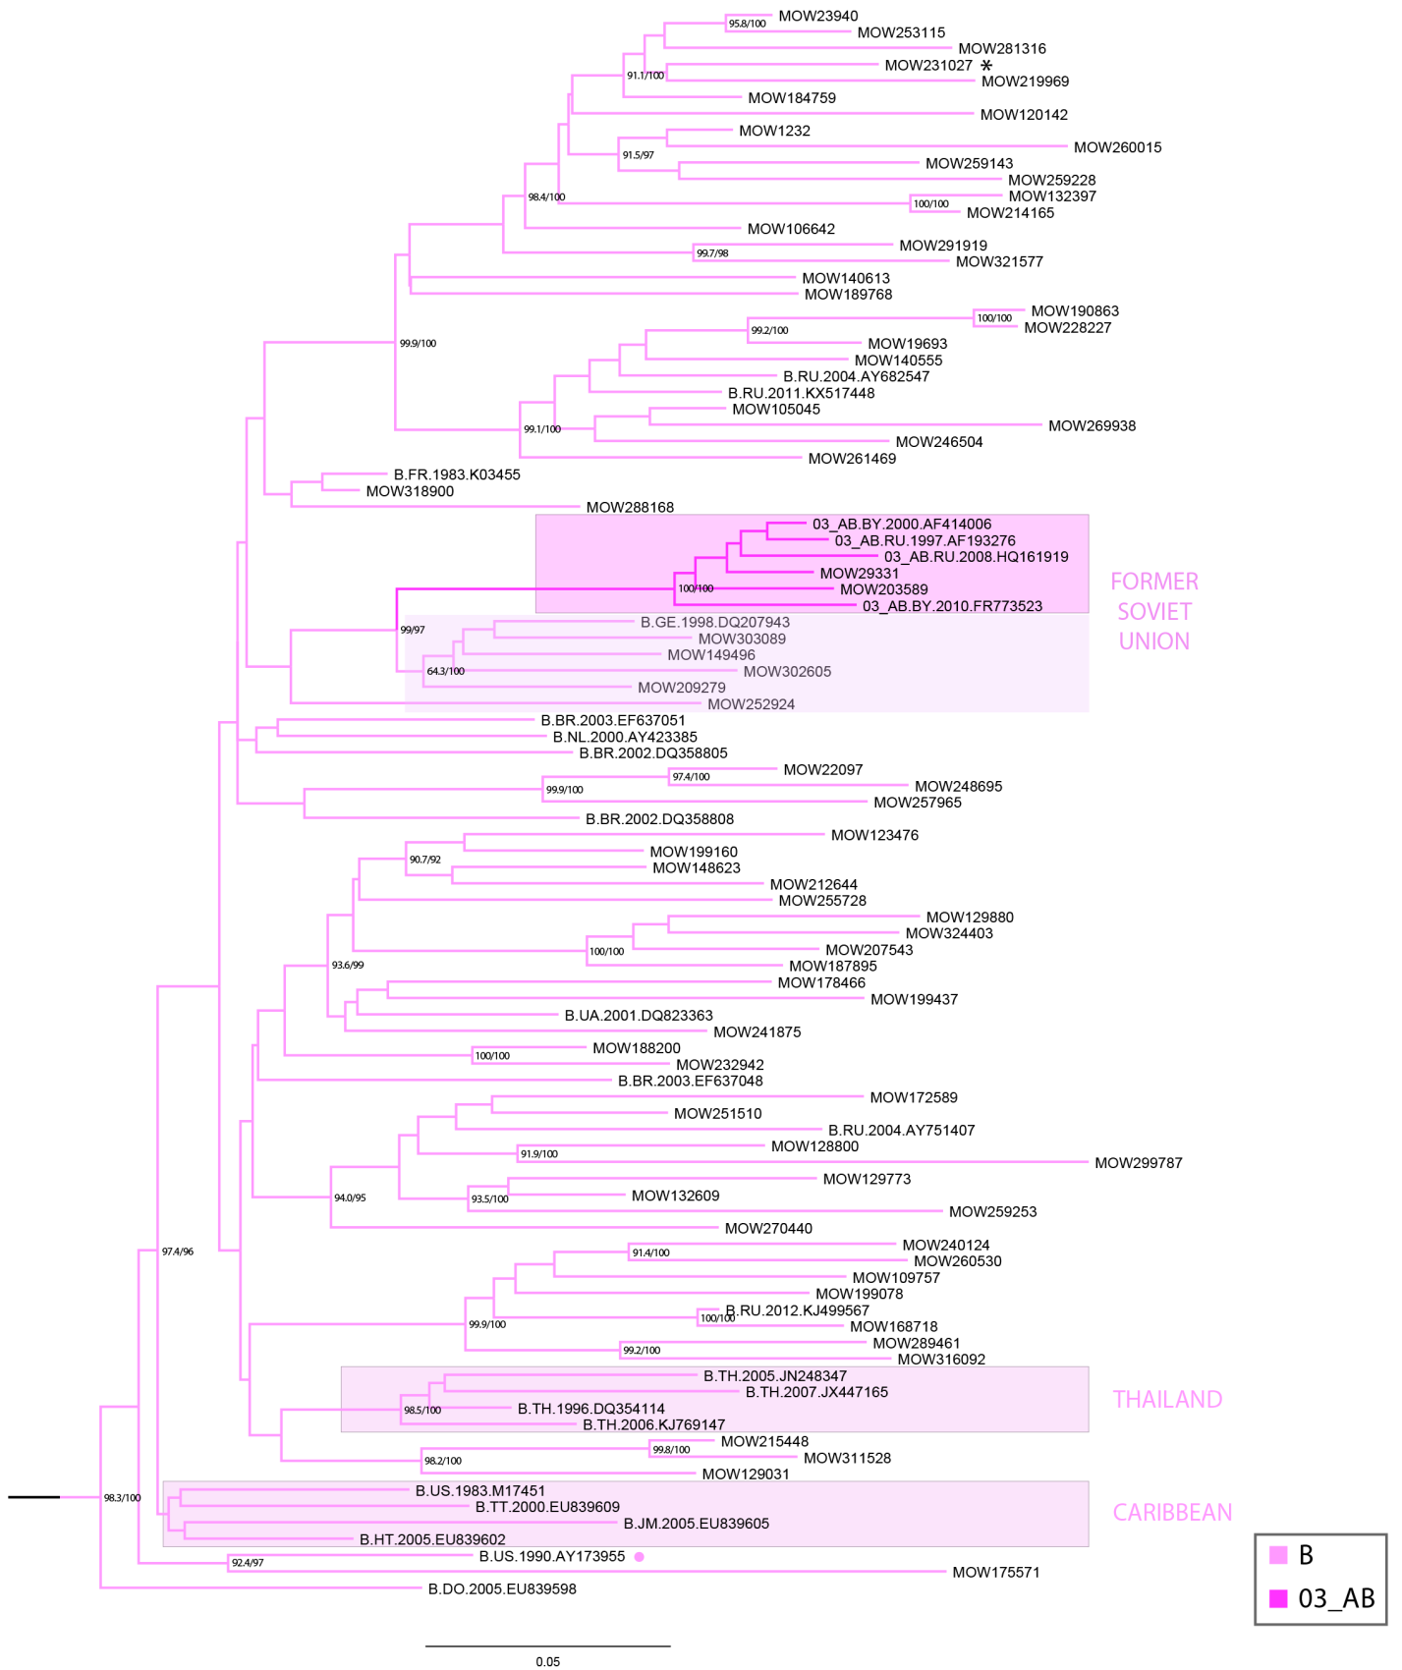

Supplemental Figure S1. The topology of the A6-clade and B/03_AB-clade for maximum-likelihood phylogenetic tree of 896 HIV-1 pol sequences from HIV-infected individuals in Moscow, from 2011-2016 (see main text). Branches are colored according to the HIV-1 subtypes as indicated in the legend. Support values (BS/SH-aLRT) are shown for the key nodes. Asterisks point to locations of unique recombination forms. The reference sequence for each subtype was selected using the Reference Alignment from Rega HIV-1 Subtyping Tool and marked by a circle.

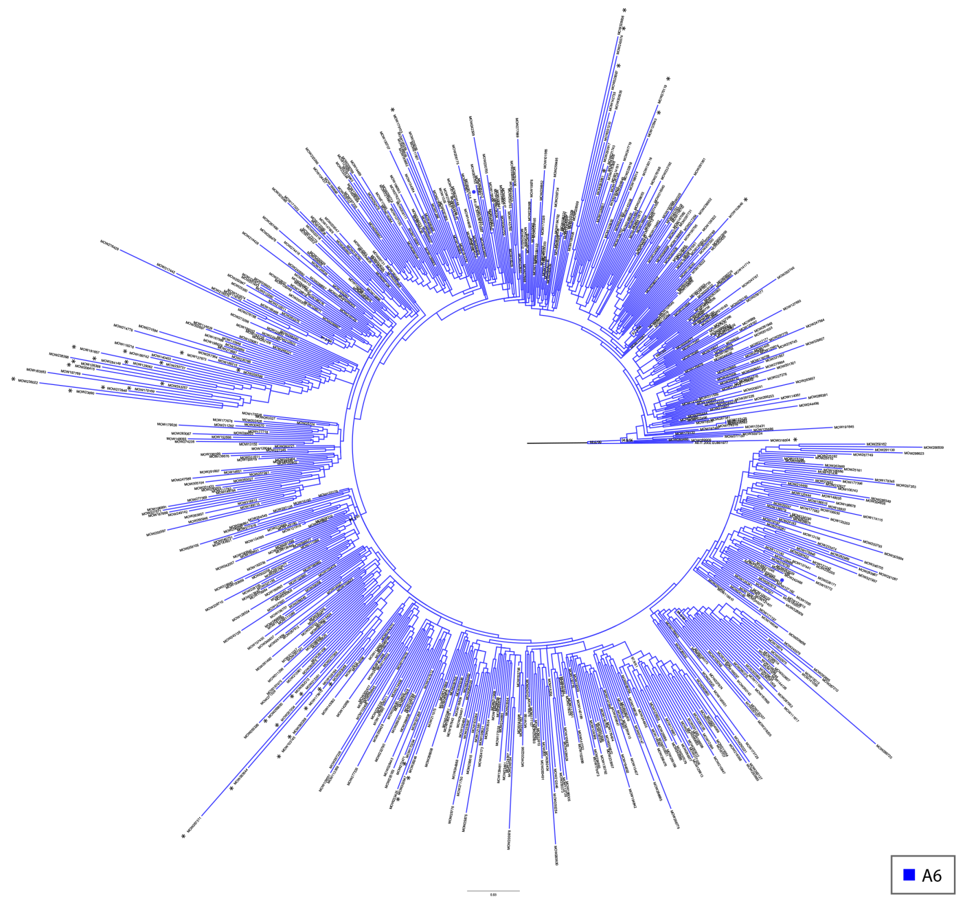

Supplemental Figure S1. Continued.

