Supplementary Material

Phylogeographic analyses of the East Asian endemic genus Prinsepia and the role of the East Asian monsoon system in shaping a north-south divergence pattern in China

Xiangguang Ma¹, Zhiwei Wang², Bin Tian^{1,3*}, Hang Sun^{1*}

* Correspondence:
Bin Tian
tianbinlzu@163.com
Hang Sun
sunhang@mail.kib.ac.cn

Supplementary Figures and Tables

Supplementary Figures
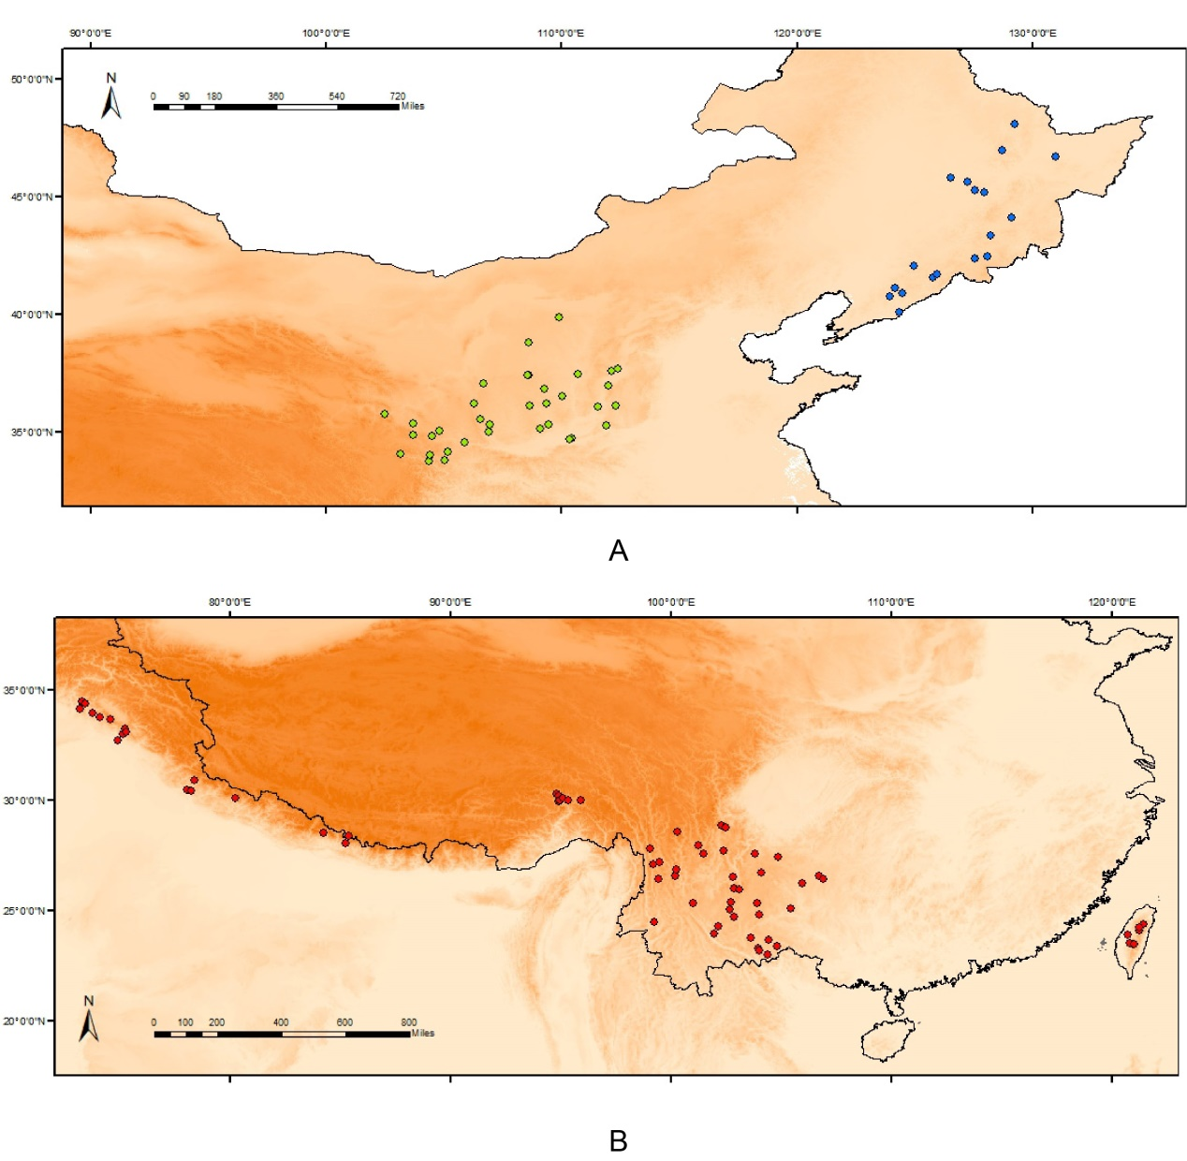
Figure S1 | The species occurrence points of Prinsepia species for species distribution modeling; blue: P. sinensis, green: P. uniflora, red: P. utilis and P. scandens.

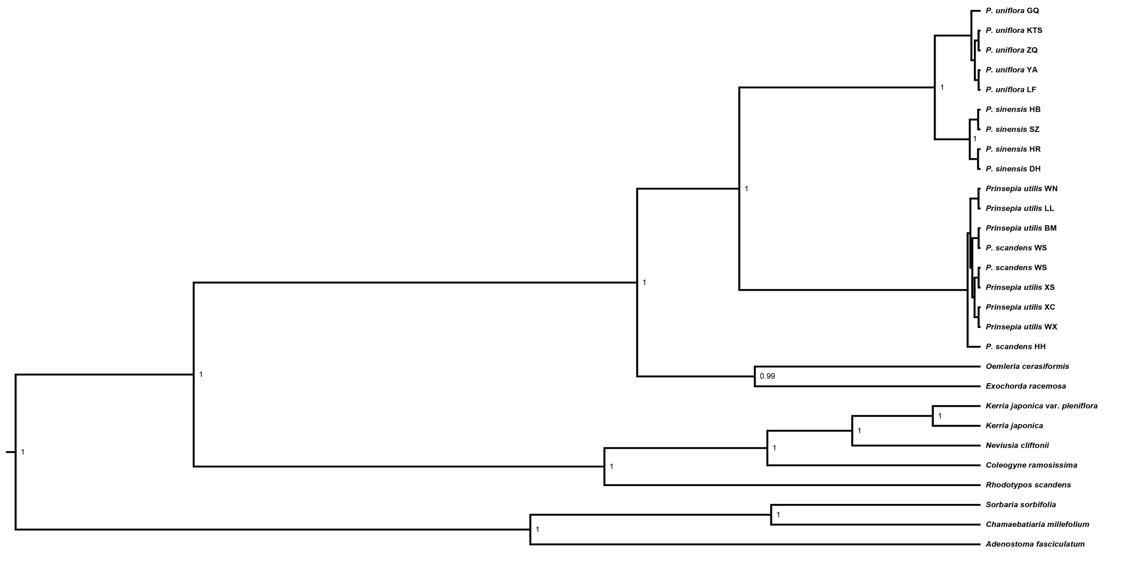
Figure S2 | Bayesian tree derived from BEAST analysis of the ITS dataset (Bayesian posterior probabilities < 0.5 are not shown at nodes).

Supplementary Tables

Appendix 1 Sample locations, sample sizes, genetic diversities and chlorotypes in each populations of Prinsepia.

species | code | Sample size | location | Lon. | Lat. | Haplotypes
North China
P. sinensis | DD | 13 | Dandong, Liaoning | 124.33 | 40.12 | H7, H8
P. sinensis | DH | 14 | Dunhua, Jilin | 128.23 | 43.37 | H7
P. sinensis | HB | 10 | Harbin, Heilongjiang | 126.53 | 45.80 | H7
P. sinensis | HR | 7 | Huanren, Liaoning | 125.78 | 41.57 | H7
P. sinensis | SZ | 8 | Shangzhi, Heilongjiang | 127.96 | 45.21 | H7
P. sinensis | TH | 9 | Tonghua, Jilin | 125.93 | 41.73 | H7
P. uniflora | CQG | 10 | Jingbian, Shaanxi | 108.60 | 37.45 | H2
P. uniflora | GQ | 8 | Ganquan, Shaanxi | 109.35 | 36.25 | H1,H2
P. uniflora | HT | 11 | Hongtong, Shanxi | 112.30 | 36.16 | H2
P. uniflora | HS | 6 | Heshui, Gansu | 108.66 | 36.13 | H1, H2
P. uniflora | JB | 9 | Jingbian, Shaanxi | 108.57 | 37.46 | H1, H2
P. uniflora | KL | 11 | Kangle, Gansu | 103.70 | 35.37 | H3
P. uniflora | KTS | 5 | Kongtongshan, Gansu | 106.52 | 35.56 | H1
P. uniflora | LF | 7 | Linfen, Shanxi | 111.52 | 36.10 | H4, H5
P. uniflora | LB | 6 | Leiba, Lixian, Gansu | 105.03 | 33.80 | H4
P. uniflora | LG | 5 | Liugou, Lixian, Gansu | 105.18 | 34.19 | H4
P. uniflora | LX | 14 | Longxi, Gansu | 104.63 | 35.05 | H4, H5, H6
P. uniflora | TC | 7 | Tongchuan, Shaanxi | 109.08 | 35.18 | H4, H5
P. uniflora | TS | 8 | Tianshui, Gansu | 105.89 | 34.57 | H4, H5
P. uniflora | YA | 5 | Yanan, Shaanxi | 109.28 | 36.85 | H1,H2
P. uniflora | TY | 4 | Tianlongshan, Taiyuan, Shanxi | 112.39 | 37.71 | H4, H5
P. uniflora | XH | 11 | Xunhua, Qinghai | 102.48 | 35.85 | H4
P. uniflora | ZQ | 9 | Zhouqu, Gansu | 104.37 | 33.79 | H4
P. uniflora | ZX | 12 | Zhangxian, Gansu | 104.47 | 34.51 | H3
South China
P. scandens | HH | 3 | Hehuanshan, Taiwan | 121.28 | 24.18 | H20
P. scandens | WS | 4 | Renai, Nantou, Taiwan | 121.24 | 24.12 | H20
P. scandens | XY | 2 | Xinyi, Nantou, Taiwan | 120.92 | 23.47 | H21
P. scandens | SYZ | 3 | Yilan, Taiwan | 121.40 | 24.30 | H20
P. utilis | AL | 2 | Anlong, Guizhou | 105.44 | 25.10 | H1
P. utilis | AZY | 9 | Aziying, Kunming, Yunnan | 102.72 | 25.40 | H2
P. utilis | BM | 15 | Bomi, Xizang | 95.34 | 29.99 | H3
P. utilis | DC | 12 | Daocheng, Sichuan | 100.30 | 28.58 | H4
P. utilis | ES | 6 | Eshan, Yunnan | 102.11 | 24.28 | H2
P. utilis | HD | 14 | Huidong, Yunnan | 102.78 | 26.55 | H2
P. utilis | HQ | 14 | Heqing, Yunnan | 100.18 | 26.56 | H4, H5, H6
P. utilis | HZ | 10 | Huize, Yunnan | 103.10 | 25.94 | H2
P. utilis | JA | 3 | Jingan, Zhaotong, Yunnan | 103.79 | 27.59 | H2
P. utilis | JL | 12 | Jilong, Xizang | 85.36 | 28.39 | H7
P. utilis | MJP | 13 | Majinpu, Chengjiang, Yunnan | 102.86 | 24.73 | H5
P. utilis | LD | 16 | Ludian, Lijiang, Yunnan | 99.46 | 27.18 | H5
P. utilis | LJ | 5 | Lijiang, Yunnan | 100.23 | 26.86 | H5
P. utilis | KY | 10 | Kaiyuan, Yunnan | 103.62 | 23.79 | H18
P. utilis | LJS | 15 | Laojunshan, Wenshan, Yunnan | 103.93 | 23.30 | H2, H17
P. utilis | LJW | 15 | Longjiawan, Anshan, Guizhou | 105.94 | 26.25 | H8
P. utilis | LL | 11 | Longli, Guizhou | 106.90 | 26.43 | H9
P. utilis | LP | 12 | Lanping, Yunnan | 99.42 | 26.46 | H4
P. utilis | MG | 12 | Maguan, Yunnan | 104.39 | 23.02 | H2
P. utilis | ML | 12 | Muli, Sichuan | 101.25 | 27.97 | H10
P. utilis | MN | 2 | Mianning, Sichuan | 102.28 | 28.85 | H2
P. utilis | NH | 10 | Nanhua, Yunnan | 101.01 | 25.33 | H5
P. utilis | QJ | 7 | Qujing, Yunnan | 103.91 | 25.36 | H11
P. utilis | QL | 6 | Qianlingshan, Guiyang, Guizhou | 106.69 | 26.60 | H9, H12
P. utilis | SZ | 12 | Shizong, Yunnan | 103.98 | 24.82 | H2
P. utilis | TM | 15 | Tongmai, Linzhi, Xizang | 94.79 | 30.27 | H3
P. utilis | WM | 14 | Wumeng, Luquan, Yunnan | 102.83 | 26.02 | H2
P. utilis | WN | 15 | Weining, Guizhou | 104.11 | 26.74 | H13
P. utilis | WX | 10 | Weixi, Yunnan | 99.02 | 27.80 | H5, H14
P. utilis | XC | 11 | Xichang, Sichuan | 102.35 | 27.70 | H15
P. utilis | XCX | 9 | Xichou, Yunnan | 104.79 | 23.38 | H2, H16
P. utilis | XJ | 15 | Xinjie, Wenshan, Yunnan | 104.00 | 23.20 | H2, H17
P. utilis | XP | 2 | Xinping, Yunnan | 101.95 | 23.96 | H2
P. utilis | XS | 4 | Xishan, Kunming, Yunnan | 102.66 | 25.04 | H5, H19
P. utilis | YG | 15 | Yigong, Linzhi, Xizang | 94.79 | 30.27 | H3
P. utilis | YX | 12 | Yuexi, Sichuan | 102.45 | 28.76 | H15
P. utilis | YY | 4 | Yanyuan, Sichuan | 101.46 | 27.60 | H4
P. utilis | YS | 15 | Yanshan, Wenshan, Yunnan | 104.42 | 23.69 | H2
P. utilis | ZX | 3 | Zhenxiong, Yunnan | 104.86 | 27.45 | H13

Appendix 2 The sequences downloaded from GenBank.
Species | ITS | cpDNA | References
Oemleria cerasiformis | AF318715 | KY419923 | Bortiri et al., 2001; Zhang et al., 2017
Exochorda racemosa | AF318740 | KY420012 | Bortiri et al., 2001;  Zhang et al., 2017
Kerria japonica | DQ886360 | / | Potter et al., 2007
K. japonica var. pleniflora | KC156645 | / | Unpublished
Neviusia cliftonii | MF963992 | / | Thornhill et al., 2017
Coleogyne ramosissima | MF963875 | / | Thornhill et al., 2017
Rhodotypos scandens | AY177141 | / | Bortiri et al., 2006
Sorbaria sorbifolia | JQ041771 | / | Unpublished
Chamaebatiaria millefolium | DQ886358 | / | Potter et al., 2007
Adenostoma fasciculatum | DQ886359 | / | Potter et al., 2007

Bortiri, E., Oh, S.H., Jiang, J., Baggett, S., Granger, A., Weeks, C., Buckingham, M., Potter, D. & Parfitt, D.E. (2001). Phylogeny and systematics of Prunus (Rosaceae) as determined by sequence analysis of ITS and the chloroplast trnL-trnF spacer DNA. Systematic Botany, 26, 797-807.
Bortiri, E., Heuvel, B.V. & Potter, D. (2006). Phylogenetic analysis of morphology in Prunus reveals extensive homoplasy. Plant Systematics & Evolution, 259, 53-71.
Potter, D., Eriksson, T., Evans, R.C., Oh, S., Smedmark, J.E.E., Morgan, D.R., Kerr, M., Robertson, K.R., Arsenault, M. & Dickinson, T.A. (2007). Phylogeny and classification of Rosaceae. Plant Systematics & Evolution, 266, 5-43.
Thornhill, A.H., Baldwin, B.G., Freyman, W.A., Nosratinia, S., Kling, M.M., Morueta-Holme, N., Madsen, T.P., Ackerly, D.D. & Mishler, B.D. (2017). Spatial phylogenetics of the native California flora. Bmc Biology, 15, 96.
Zhang, S.D., Jin, J.J., Chen, S.Y., Chase, M.W., Soltis, D.E., Li, H.T., Yang, J.B., Li, D.Z. & Yi, T.S. (2017). Diversification of Rosaceae since the Late Cretaceous based on plastid phylogenomics. New Phytologist, 214, 1355-1367.

Appendix 3 Selected bioclimatic variables with low correlations (r < 0.9) used in ecological niche modelling for different Prinsepia species.
Species | P. sinensis | P. uniflora | P. utilis & P. scandens
Variable* | Bio1 | Bio2 | Bio2
 | Bio2 | Bio3 | Bio3
 | Bio3 | Bio4 | Bio4
 | Bio4 | Bio6 | Bio8
 | Bio8 | Bio8 | Bio9
 | Bio12 | Bio12 | Bio12
 | Bio15 | Bio13 | Bio13
 |  | Bio14 | Bio14
 |  | Bio15 | Bio15
 |  | Bio16
*The Description of the bioclimatic variables can be found at the website (http://worldclim.org/bioclim).

