Supplement 1

ASTER night-time infrared thermal imagery of Bagana volcano showing summit lava dome and radiating lava flows: 2000 - 2016

Three aligned (from NE to SW) objects radiate brightly in many of these images: Billy Mitchell lake in the northeast, the lake to the northeast of Bagana in the middle and the lava flows and dome of Bagana to the southwest. They are used to mark flow and direction in fig. 5 of Wadge et al. “Persistent growth….”

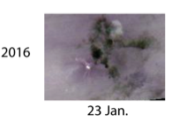
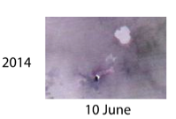

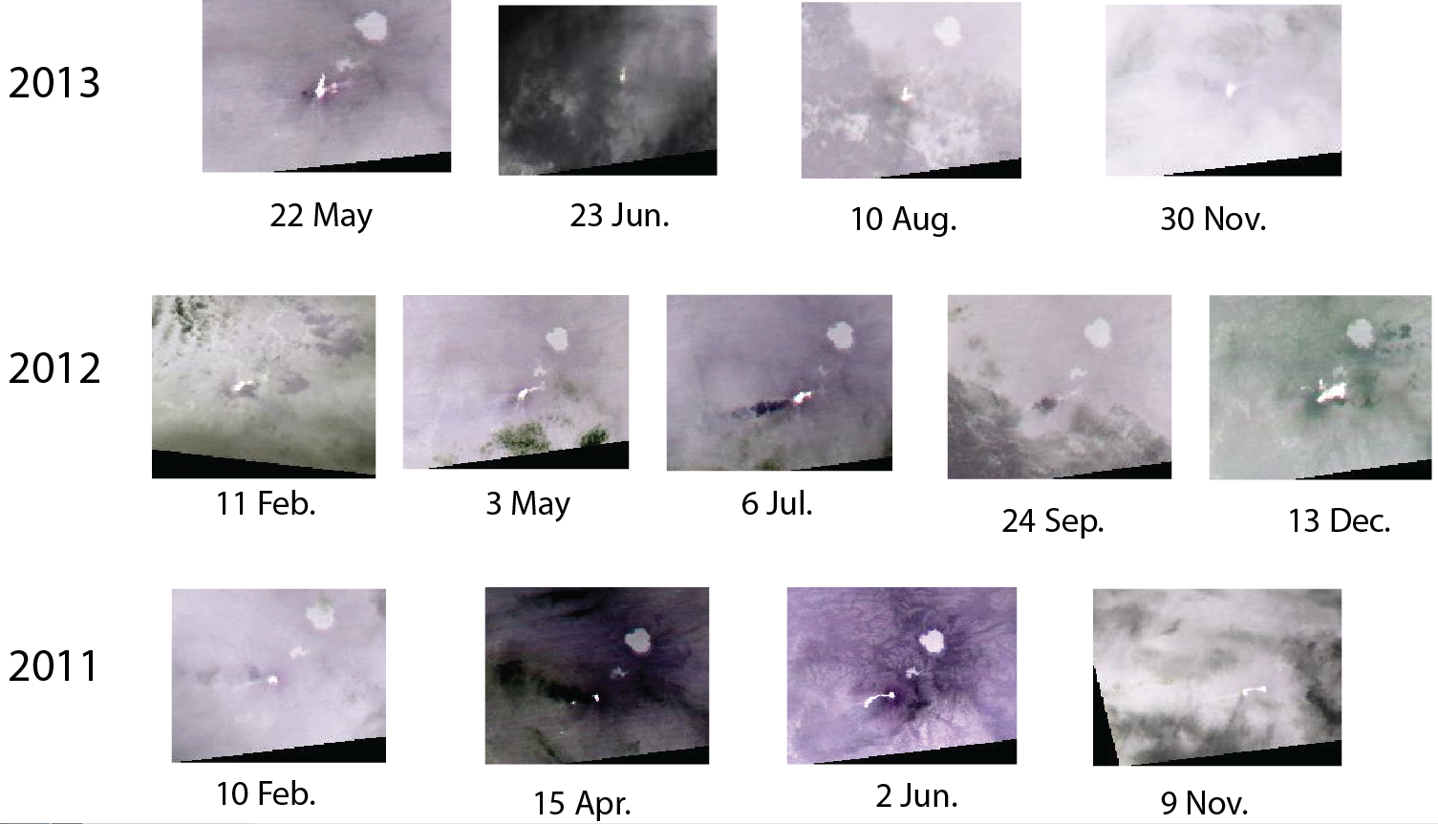

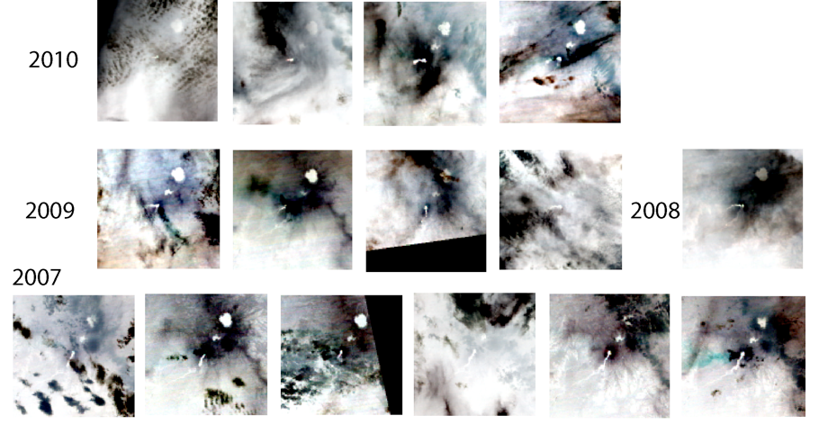

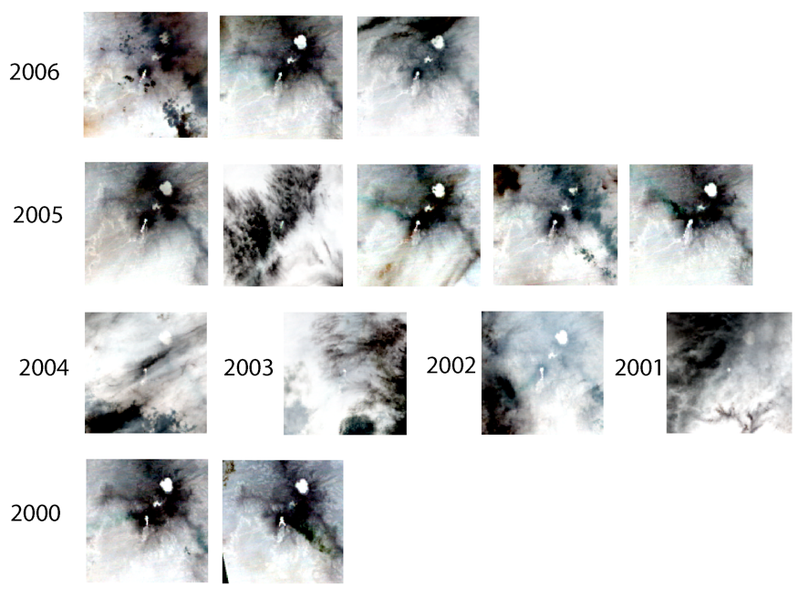
2010: 6 January, 7 February, 27 March, 30 May
2009: 24March, 12 June, 10 September, 16 September
2008: 29 September
2007: 22 May, 23 June, 25 July, 26 August, 29 October, 16 December
2006: 1 April, 20 June, 11 November
2005: 25 February, 16 May, 21 September, 24 November, 26 December
2004: 26 March
2003: 12 June
2002: 6 April
2001: 19 April
2000: 9 October, 12 December

