Supplementary data

Supplementary Figure S1
Individual values for each of the four replicates of serum AMH for each individual patient and at each of the three time points (n = 52); AMH, anti-Müllerian hormone; BL, baseline.
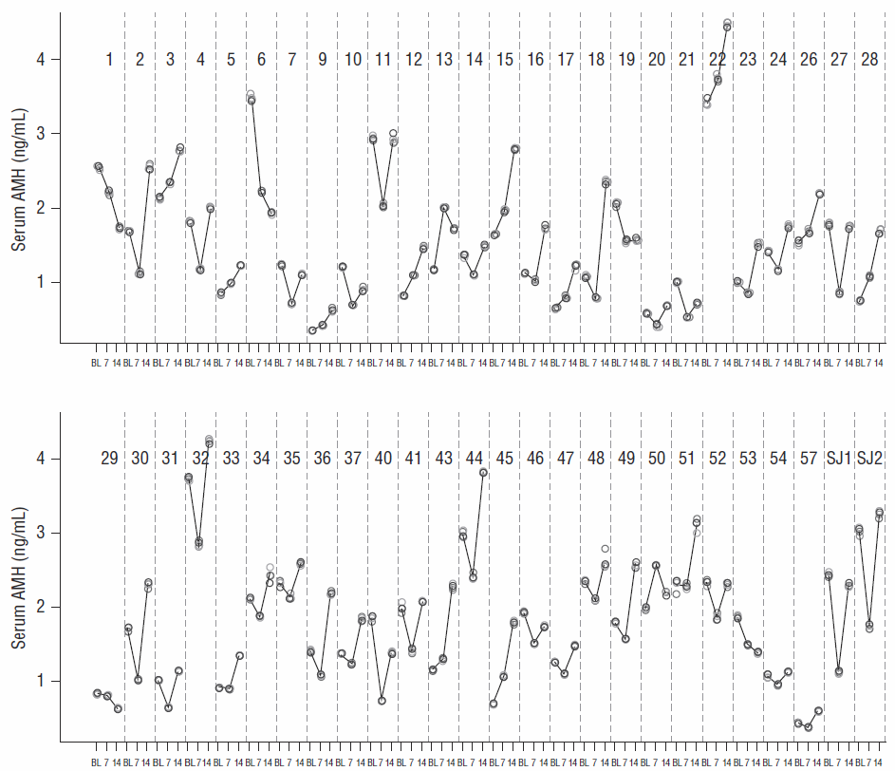

Supplementary Figure S2
Box plots of serum (a) FSH, (b) LH, (c) estradiol, and (d) progesterone, at baseline (prior to GnRH-agonist treatment) and on days 7 and 14 during GnRH-agonist treatment. Circles represent individual patient data (mean values calculated from the replicate measurements of the four aliquots for each sample at each visit); crosses are the mean value of all patients at each visit; horizontal lines summarize the median and the first and third quartiles (within the box) and 1.5x the interquartile range (whiskers). FSH, follicle-stimulating hormone, GnRH, gonadotropin-releasing hormone, LH, luteinizing hormone.

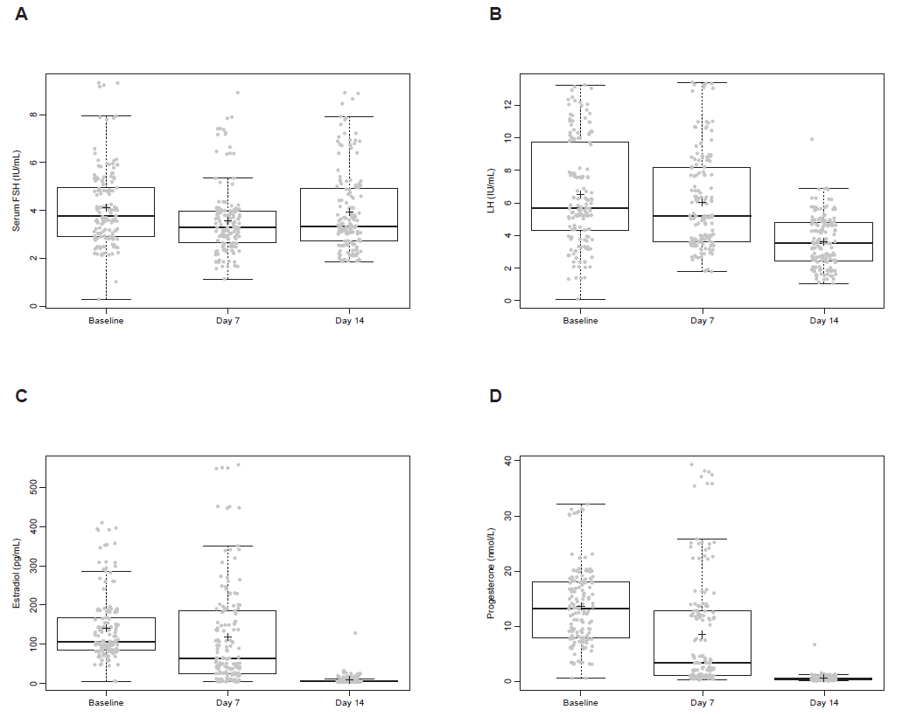

Supplementary Table S1
Mean ± SD and minimum–maximum serum levels of AMH, FSH, LH, estradiol, and progesterone at baseline (prior to GnRH-agonist treatment) and on days 7 and 14 during GnRH-agonist treatment.

Hormoneª | Baseline | Day 7 | Day 14
AMH, ng/mL | 1.65 ± 0.811  0.340–3.73 | 1.39 ± 0.700  0.363–3.74 | 1.94 ± 0.865  0.585–4.45
AMH, pmol/L | 11.8 ± 5.79  2.43–26.6 | 9.92 ± 5.00  2.59–26.7 | 13.9 ± 6.18  4.18–31.7
FSH, IU/L | 4.22 ± 1.77  0.319–9.25 | 3.72 ± 1.58  1.17–8.91 | 4.05 ± 1.67  1.92–8.72
LH, IU/L | 6.72 ± 3.66  0.100–14.8 | 6.17 ± 3.00  1.85–13.5 | 3.70 ± 1.92  1.06–9.92
Estradiol, pg/mL | 142 ± 87.9  5.00–410 | 125 ± 127  5.00–551 | 10.6 ± 18.0  5.00–129
Progesterone, nmol/L | 12.9 ± 7.35  0.569–32.1 | 8.90 ± 10.1  0.224–38.2 | 0.613 ± 0.914  0.089–6.67

ª Values are mean ± SD and minimum–maximum values and n = 52 for all measurements.
AMH, anti-Müllerian hormone; FSH, follicle stimulating hormone; GnRH, gonadotropin-releasing hormone; LH, luteinizing hormone; SD, standard deviation.

Supplementary Table S2
Change in AMH level at days 7 and 14 relative to baseline estimated by a linear mixed-effects model.
Fixed effects | Estimate | P value | 95% CI
Intercept | 1.9 | 0.1143 | –0.56, 4.36
Visit day 7 | –0.28 | 0.0002 | –0.41, –0.14
Visit day 14 | 0.3 | 0.0004 | 0.14, 0.45
Age | –0.02 | 0.58 | –0.07, 0.04
BMI | –0.02 | 0.39 | –0.07, 0.03
Baseline AFC | 0.08 | 0.0015 | 0.03, 0.13
Random effects | Variance | SD
Intercept | 0.48 | 0.70
Visit day 7 | 0.23 | 0.48
Visit day 14 | 0.28 | 0.53
Residual | 0.0008 | 0.03
AFC, antral follicle count; AMH, anti-Müllerian hormone; BMI, body mass index; CI, confidence interval; SD, standard deviation.

