Supplemental Table 1: NCBI-accession numbers of all the genes used for phylogenetic analysis of F3H. Numbers in bold are genes newly described in this study.
Species | GB Accession Number
Picea abies | MK256609
Picea sitchensis | MK256611
Picea glauca | MK256610
Pinus radiata | AGY80772
Pinus taeda | MK256612
Ginkgo biloba | AAU93347
Eucalyptus grandis | XP_010033486
Pyrus communis | AAX89399
Malus domestica | AAX89397
Fragaria X ananassa | AAU04792
Vitis vinifera | NP_001268034
Theobroma cacao | XP_007046698
Gossypum hirsitum | XP_016735424
Petunia X hybrida | AAC49929
Nicotinia tabacum | NP_001312012
Populus trichocarpa | ABK94757
Medicago truncatula | AFK41061
Petroselinum crispum | Q7XZQ7
Arabidopsis thaliana | NP_190692
Brassica napus | XP_022546782
Citrus sinensis | NP_001275816
Citrus clementina | XP_006425499

Supplemental Table 2: List of all the phenolic compounds analysed in the cambial region of the Norway spruce clone clone S21K0420232 7 days after wounding the stem with a cork borer. Mean concentrations of analytes were calculated from 5 biological replicates.

Analyte | Concentration (mg/g) | Standard Error (n=5)
Stilbenes
Astringin | 7.468 | 1.769
Isorhapontin | 0.539 | 0.124
Piceid | 0.079 | 0.010
Piceatannol | nd | -
Rhapontigenin | nd | -
Resveratrol | nd | -
Flavonoids
Taxifolin glucoside | 1.563 | 0.312
Catechin | 0.507 | 0.053
Procyanidin B1 | 0.485 | 0.078
Taxifolin | 0.305 | 0.038
Naringenin | 0.028 | 0.006
Eriodictyol | 0.027 | 0.005
Gallocatechin | 0.007 | 0.003
Catechin-gallocatechin dimers | nd | -
Quercetin glucoside | nd | -
Quercetin galactoside | nd | -
Quercetin | nd | -
Myricetin glucoside | nd | -
Myricetin | nd | -
Dihydromyricetin | nd | -
Lignans
Lariciresinol | 0.008 | 0.000
Matairesinol | 0.001 | 0.000
Nortrachelogenin | 0.007 | 0.002
Pinoresinol | 0.008 | 0.001
Secoisolariciresinol | 0.001 | 0.000

Supplemental Table 3: Accumulation of dihydrokaempferol and taxifolin after addition of 0.2 mg/mL of the respective substrates naringenin and eriodictyol to E. coli cultures transformed with PaF3H. The total culture volume was 105 ml.
Substrate | Product accumulation (mg/h)
Naringenin | 0.332 ± 0.19
Eriodictyol | 0.281 ± 0.13

Supplemental Figures:
Supplemental Figure 1: Alignment of the F3H open reading frames from Picea abies, P. glauca, P. sitchensis and Pinus taeda.
PaF3H atggcgcccgcagcagtggtggttagcgatcgacccgatttccttgtaacagcggaggag
PsF3H atggcgcccgcagcagtggtggttagcgatcgacccgatttccttgtaacagcggaggag
PgF3H atggcacccacatcagtcgtggtaagcgatcgaccggatttcctagtaacggcggaggta
PtF3H atggcgcccgcagcagtggtggctagcgatcgaccggatttccttgtaacagcagaggag

PaF3H ccgaagtccctgcaatccatcttcatccgagacgaggacgagcgccccaaggtggcttac
PsF3H ccgaagtccctgcaatccatcttcatccgagacgaggacgagcgccccaaggtggcttac
PgF3H ccgaagtccctgcagtccatcttcatccgagacgaggacgagcgccccaaggtagcttac
PtF3H ccgaagtccctgcagtccatcttcgtgcgagacgaggacgagcggcccaaggtggcttac

PaF3H aaccaattcagcaaagacattcccgtcatttccctttctggtattgaaggggcagagagg
PsF3H aaccaattcagcaaagacattcccgtcatttccctctctggtattgaaggggcagagagg
PgF3H aaccaattcagcaaagacattcccgtgatttccctctctggtatcgaaggggcagagagg
PtF3H aatcaattcagcaaagacattcccgtcatttccctctctggtatcgctggggaagaaagg

PaF3H ggccgagtgatagacgaggtgagcaaggcctgttctgaatggggaatattccaggtggtt
PsF3H ggccgagtgatagacgaggtgagcaaggcctgttctgaatggggattattccaggtggtt
PgF3H ggccgagtgatagacgaggtgagcaaggcctgttctgaatggggaatattccaggtggtt
PtF3H ggccgcgtgagagacgaggtgagcaaggcttgttctgaatggggaattttccaggtggtt

PaF3H gatcacggtgttcccaaggagctggtggattccatgactcggctctccagggacttcttc
PsF3H gatcacggtgttcccaaggagctggtggattccatgactcggctctccagggacttcttc
PgF3H gatcacggtgttcccaaggagctggtggattccatgactcggctctccaaggacttcttc
PtF3H gatcatggtgttccccaggaactggtggattccatgactcagctctccagggctttcttc

PaF3H gccctccctgcagaggagaagctcaaatacgacatgagaggtggagagcctggaggattt
PsF3H gctctccctgcagaggagaagctcaaatacgacatgagaggtggagagcctggaggattt
PgF3H gccctccccgcagaggagaagctcaaatacgacatgagaggtggaaagcgtggaggattt
PtF3H gcgctcccagcagaggagaagctcaaatacgacatgagaggtggaaagcgtggaggattt

PaF3H gtggtgagcagccatctccaaggcgaaagcgtcttcgactggagagagctctgcatttac
PsF3H gtggtgagcagccatctccaaggcgaaagcgtcttcgactggagagagctctgcatttac
PgF3H gtggtgagcagccatctccagggcgaaagcgtcctcgactggagagagatctgcacttac
PtF3H gtggtgagcagccatctgcagggcgaagccgttctggattggagagaaatctgcacttac

PaF3H ttctcatatccccttcaccagcgcgattacagtaggtggcctgtcaagcccgatggctgg
PsF3H ttctcatatccccttcaccagcgcgattacagtaggtggcctgtcaagcccgatggctgg
PgF3H ttctcctatccccttcaccagcgcgattacagtaggtggcctgtcaagcccgatggctgg
PtF3H ttctcttatccccttcaccagcgtgattacacaaggtggcctgtcaagcccgatggctgg

PaF3H agggagattgtggagaaatacagcgaagccctgatgggtttggcatgcaatatgttggcg
PsF3H agggagattgtggagaaatacagcgaagccctgatgggtttggcatgcaatatgttggcg
PgF3H agggagattgtggagaaatacagcgaagccctgatgggtttggcatgcaatatgttggcg
PtF3H agggacgttgtggagaaatacagcgaatcccttatgggtttggcatgcaagctgttgggg

PaF3H atagtatcagaggcattgggattggaatcggatgcagtgacgaaggcttgcgtggagatg
PsF3H atagtatcagaggcattgggattggaatcggatgcagtgacgaaggcttgcgtggagatg
PgF3H atagtatcagaggcattgggattggaatcggatgcagtgacgaaggcttgcgtggagatg
PtF3H ataatatcagaggcgttgggattggaaactgaagcagtgaccaatgcttgtgtggagatg

PaF3H gaccagaaagtggtggtaaacttctatccgaaatgcccagagccagacatgacgttggga
PsF3H gaccagaaagtggtggtaaacttctatccgaaatgcccagagccagacatgacgttggga
PgF3H gaccagaaagtggtggtaaacttctatccgaaatgcccagagccagacatgacgttggga
PtF3H gaccagaaagtggtgataaacttctatcccaaatgcccacaaccagacatgacactgggg

PaF3H ctgaagaggcacacagatccgggcaccatcactcttctcctccaagaccaagttggaggc
PsF3H ctgaagaggcacacagatccggtcaccatcactcttctcctccaagaccaagttggaggc
PgF3H ctgaagaggcacacagatccgggcaccatcactcttctcctccaagaccaagttggaggc
PtF3H ctgaaaaggcacaccgatccgggcaccatcactcttctcctgcaagaccaagttggaggg

PaF3H ctacaggctaccaaggacgatggcaaaaactggatcactgttgagcccattgaaggagcc
PsF3H ctacaggctaccaaggacgatggcaaaaactggatcactgttgagcccattgaaggagcc
PgF3H ctacaggctaccaaggacgatggcaaaaactggatcactgttgagcccattgaaggagcc
PtF3H ctacaagctactaaggacgatggaaaaaattggattactgtggagcccattcaaggagcc

PaF3H tttgttgtcaatttgggtgatcatatgcattatctgagcaatggcaagttcaagagcgcg
PsF3H tttgttgtcaatttgggtgatcatatgcattatctgagcaatgggaagttcaagagcgcg
PgF3H tttgttgtcaatttgggtgatcatatgcattatctgagcaatggcaagttcaagagcgcg
PtF3H tttgttgtcaatttgggtgatcatatgcattatctgagcaatggcaagttcaagagcgcg

PaF3H gaccatcaggcggtggtgaattcgaacagcagcaggctgtcgattgcgacctttcatagt
PsF3H gaccatcaggcggtggtgaattcgaacagcagcaggctgtcgattgcgacctttcataat
PgF3H gaccatcaggcggtggtgaattcgaacagcagcaggttgtcgattgcgacctttcagaat
PtF3H gaccatcaagcggtggtgaactcgaacagcagcaggctgtcgattgcgacgtttcagaat

PaF3H ccagcgccggagggcatcgtttacccgttggatggagttgtgaaggaggcggaaggcgag
PsF3H ccagcgccggagggaatcgtttacccgttggatggagttgtgaaggaggcggaaggcgag
PgF3H ccagcgcaggagggaatcgtgtacccgttggatggagttgtgaaggaggcggaaggcgag
PtF3H ccagcgcaggaggccatcgtgtacccgttggatggagtcgtgaaggaggcggaaggcgag

PaF3H aagtgcttcatggaagagcccatcacttacgctcagatgtactccagaaagatgagccta
PsF3H aagtgcttcatggaagagcccatcacttacgctcagatgtactccagaaagatgagccga
PgF3H aagtgcttcatggaagagcccatcactttcgctcagatgtacaccagaaagatgagccga
PtF3H aagtgcttcatggaagagcccatcacttttgctcagatgtactccagaaagatgagccga

PaF3H gacatagagctcgcccgccagaagaagatggccaaagttgctgagcaggaaaagtcgtga
PsF3H gacatcgagctcgcccgccagaagaagatggccaaagttgctgagcaggaaaagtcgtga
PgF3H gacatcgagctcgcccgccagaagaagatggccaaagttgctgagcaggaaaagtcgaga
PtF3H gacatcgagctcgctcgccagaagaagattgctaaacttcaagcgcaggagccggaagga

PaF3H ------------------
PsF3H ------------------
PgF3H gatcttccaatgatgtga
PtF3H g------caaaagcctaa

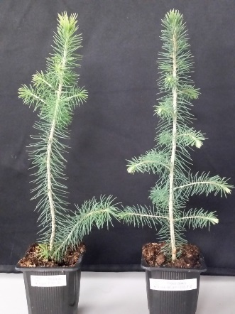
Supplemental Figure 2: Two-year old spruce samplings (left, PaF3H-RNAi line; right, vector-control) grown in 1 L pot.

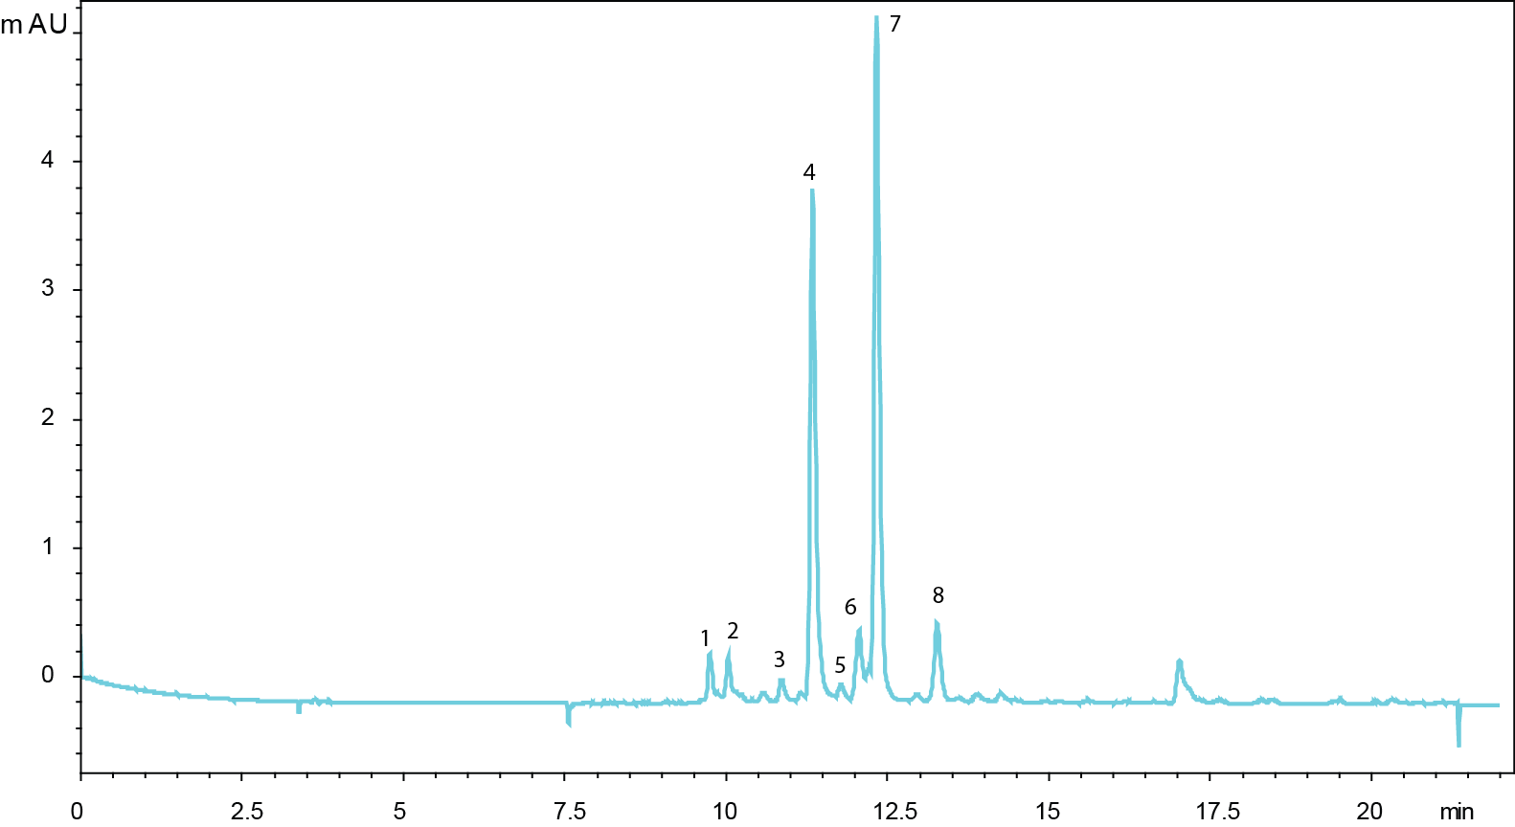

Supplemental Figure 3: Representative UV chromatogram (320 nm) of phenolics extracted from the bark and cambial region of a 40-year-old Norway spruce tree. (1) gallocatechin, (2)m/z 389, (3) catechin (4) E-astringin, (5) Z-astringin, (6) taxifolin-3-O-glucoside, (7) E-isorhapontin and piceid, (8) taxifolin

