**Psychological and Brain Connectivity Changes Following Trauma-Focused CBT and EMDR Treatment in Single-Episode PTSD Patients**

Emiliano Santarnecchi1-2, Letizia Bossini3, Giampaolo Vatti1, Andrea Fagiolini3, Patrizia La Porta3, Giorgio Di Lorenzo4, Alberto Siracusano4, Simone Rossi1, Alessandro Rossi5

1 Siena Brain Investigation & Neuromodulation Lab, Department of Medicine, Surgery and Neuroscience, Neurology and Clinical Neurophysiology Section, University of Siena, Italy

2 Berenson-Allen Center for Non-Invasive Brain Stimulation, Beth Israel Deaconess Medical Center, Harvard Medical School, Boston, MA, USA

3 Psychiatry Department, University of Siena, Siena, Italy

4 Psychiatry and Clinical Psychology Unit, Department of Neurosciences, Fondazione Policlinico “Tor Vergata”, Rome, Italy

5 Department of Medicine, Surgery and Neuroscience, University of Siena School of Medicine, Siena, Italy



**Table S1. Regions of interest for connectivity analysis.** The cortical and subcortical anatomical regions included in the fMRI analysis are listed with their corresponding spatial coordinates in MNI space. Note: L=left; R=right; ant=anterior; post=posterior; sup=superior; inf=inferior; MNI= Montreal Neurological Institute.

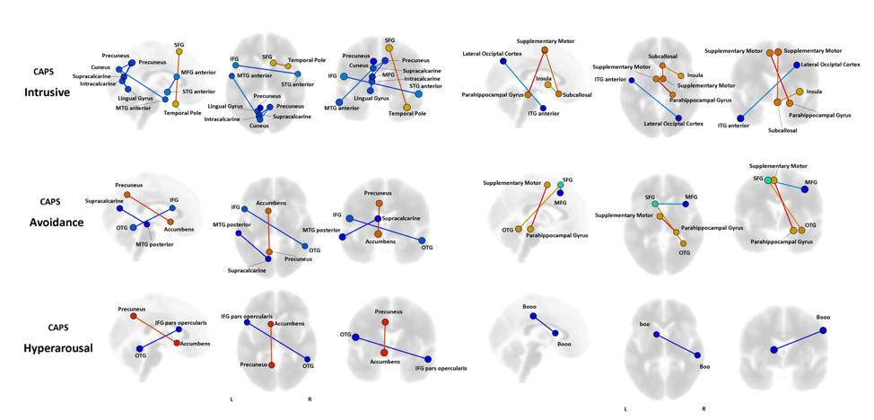

**Figure S1. Functional connectivity and CAPS subscales.** Results of the repeated measures ANCOVA on pairwise connectivity and changes in each subscale of the CAPS are displayed for patients in the EMDR and TF-CBT groups. Significant increased (red) and decreased (blue) edges represent connections with a p.<0.05 FDR corrected.Images are displayed in neurological convention. Note: SFG=Superior Frontal Gyrus; MTG=Middle Temporal Gyrus; ITG= Inferior Temporal Gyrus; Inferior Frontal Gyrus; Middle Temporal Gyrus; Superior Temporal Gyrus; FDR=False Discovery Rate**.**