Supplementary Material

“Homework should be…but we do not live in an ideal world”: Mathematics teachers’ perspectives on quality homework and on homework assigned in elementary and middle schools
Pedro Rosário*, Jennifer Cunha, Tânia Nunes, Ana Rita Nunes, Tânia Moreira, José Carlos Núñez
* Correspondence: Pedro Rosário: prosario@psi.uminho.pt

Supplementary Figure
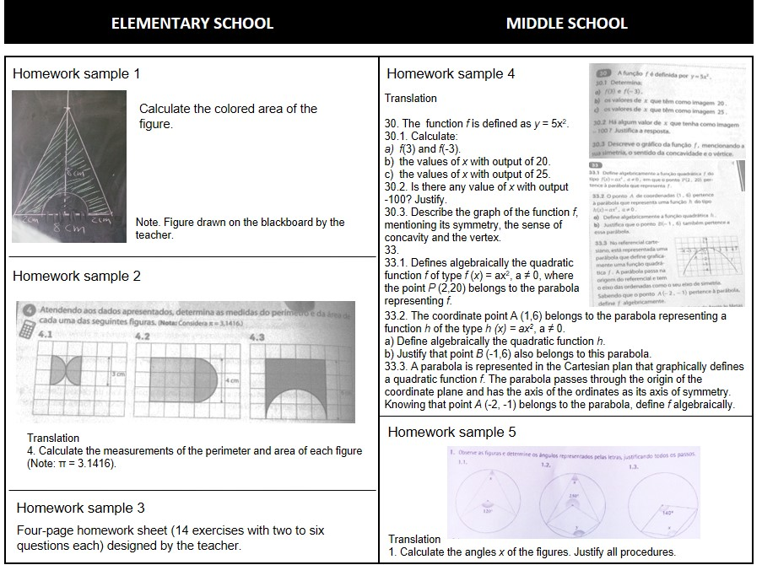
Figure 1. Homework samples by school level

