Supplementary Material

Transcriptomics Identifies Modules of Differentially Expressed Genes and Novel Cyclotides in Viola pubescens

Anne L. Sternberger, Megan J. Bowman, Colin P.S. Kruse, Kevin L. Childs, Harvey E. Ballard, and Sarah E. Wyatt*
* Correspondence: Dr. Sarah Wyatt: wyatts@ohio.edu

Supplementary Figures and Tables

Supplementary Figures

Supplementary Figure 1
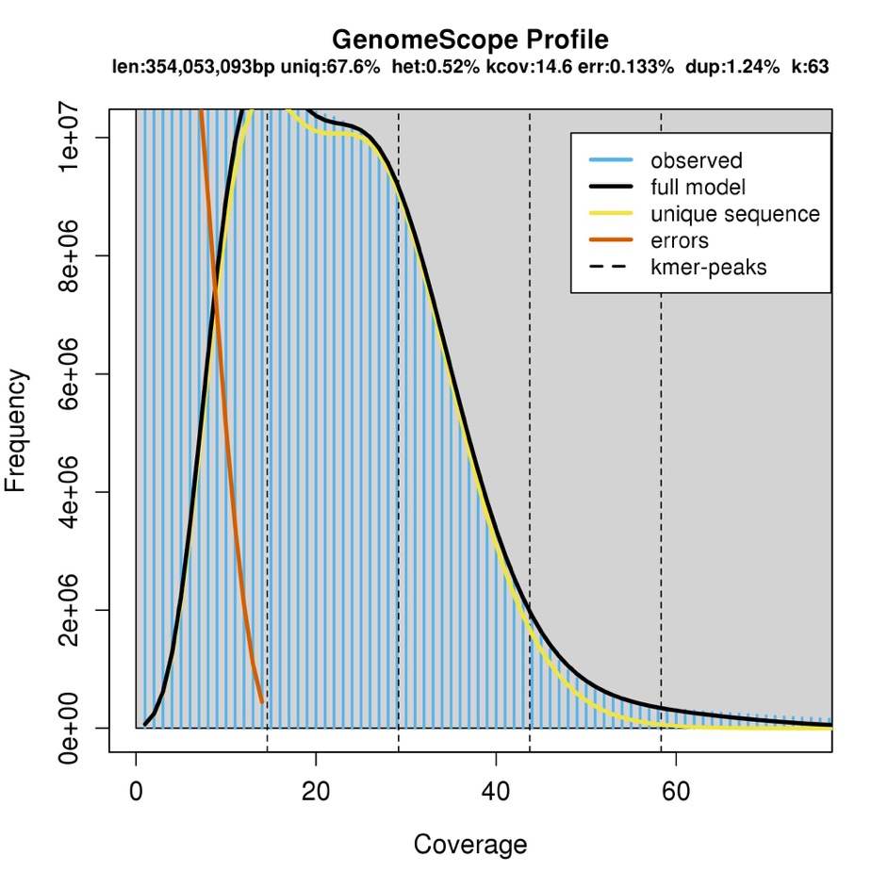
Figure S1. Estimation of total genome length (len), unique reads (uniq), heterozygosity (het), coverage for heterozygous bases (kcov), read error rate (err), and average rate of read duplications (dup) through GenomeScope (Vurture et al., 2017) using a Jellyfish (Marçais and Kingsford, 2011) k-mer distribution approach and a k-mer size (k) of 63.

Supplementary Figure 2
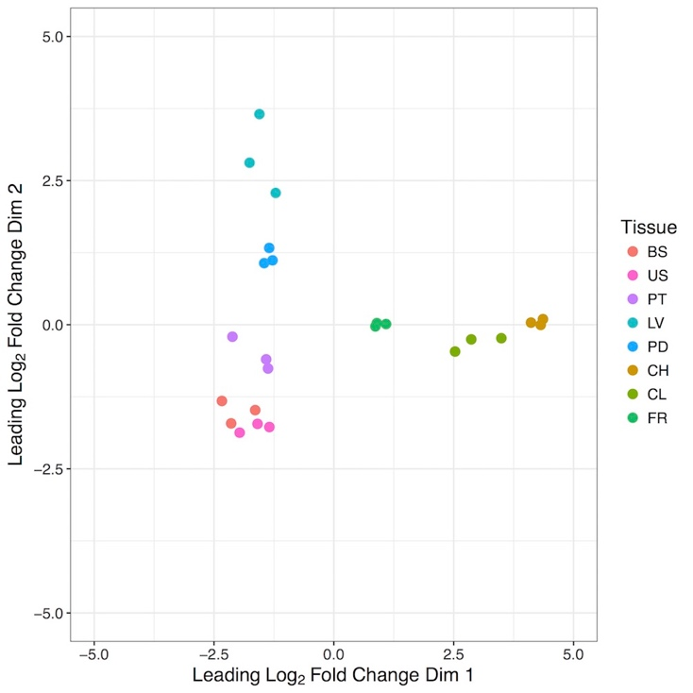
Figure S2. Analysis of variation in gene expression across eight Viola pubescens tissues through principal component analysis (PCA) of log₂CPM values for each tissue replicate. Expression values from 7,815 predicted genes were included in the PCA. BS=basal stem, US=upper stem, PT=petiole, LV=leaf , PD=peduncle, CH=chasmogamous flower, CL=cleistogamous flower, FR=fruit.

Supplementary Figure 3
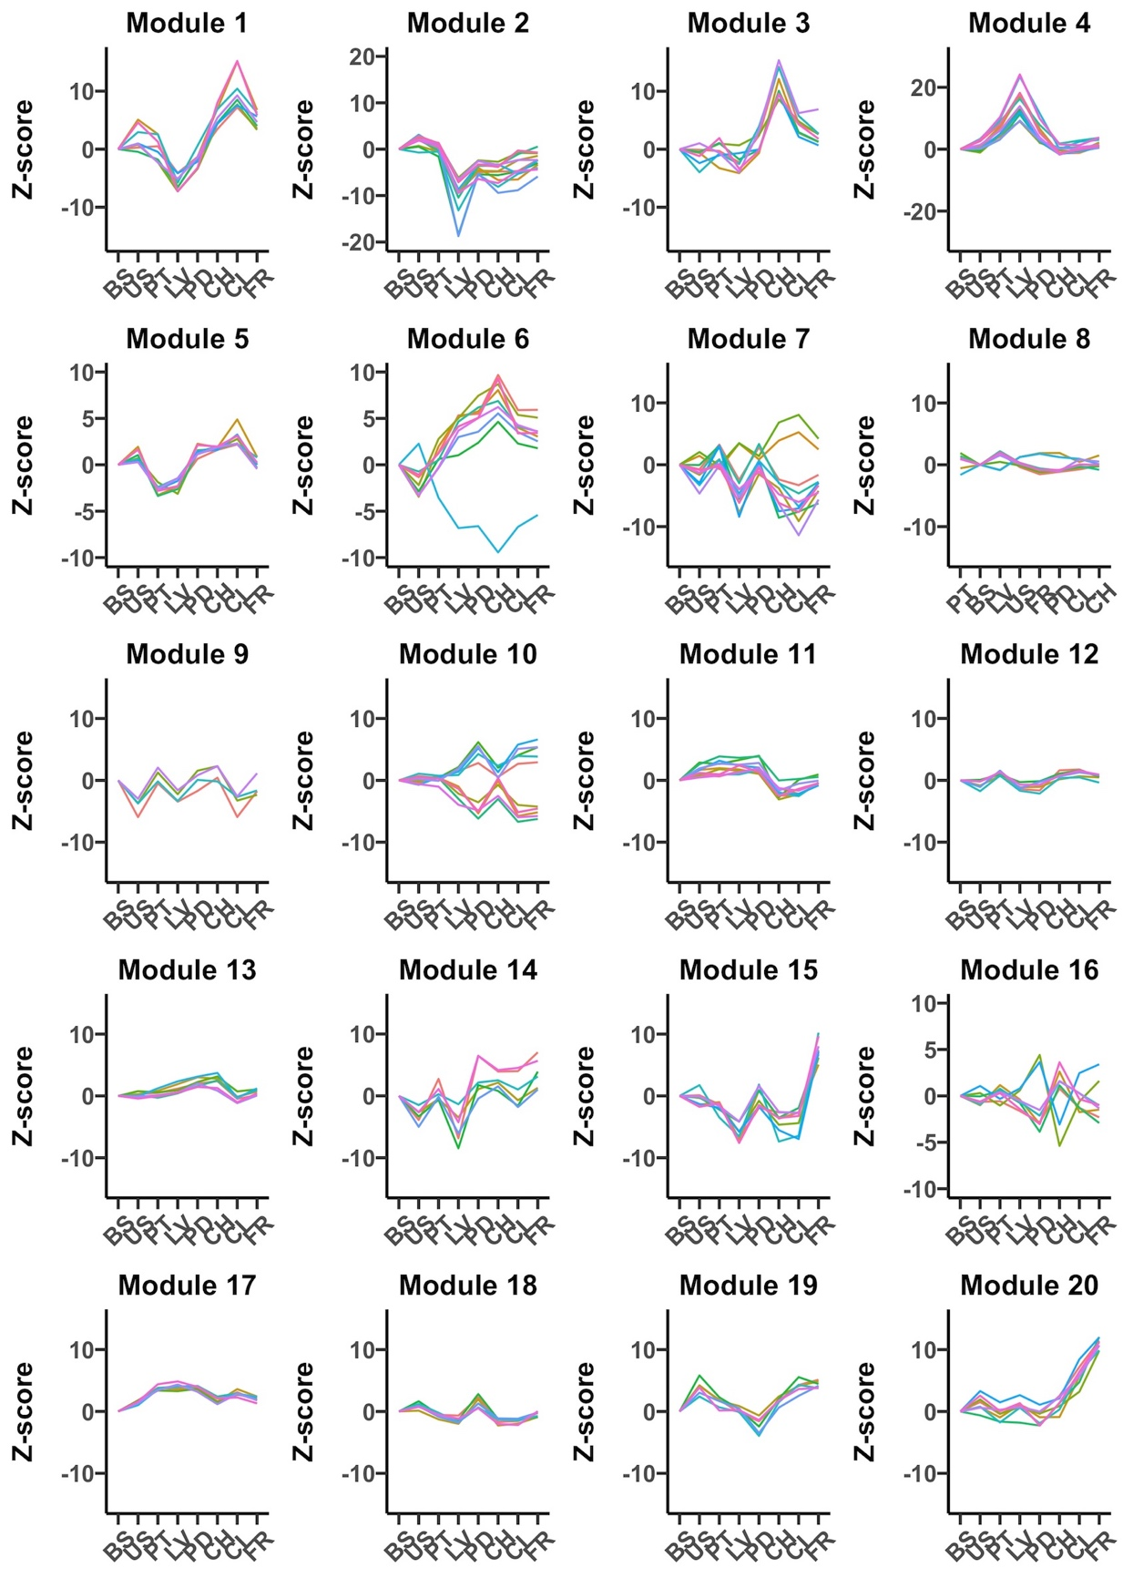
Figure S3. Trend plots of normalized gene expression values (z-scores) for the hub genes in each of 20 co-expression modules identified through weighted gene co-expression analyses on 7,815 V. pubescens genes (CPM > 40 in ≥ 3 samples). BS = basal stem, US = upper stem, PT = petiole, LV = leaf, CH = chasmogamous, CL = cleistogamous, FR = fruit.

Supplementary Figure 4
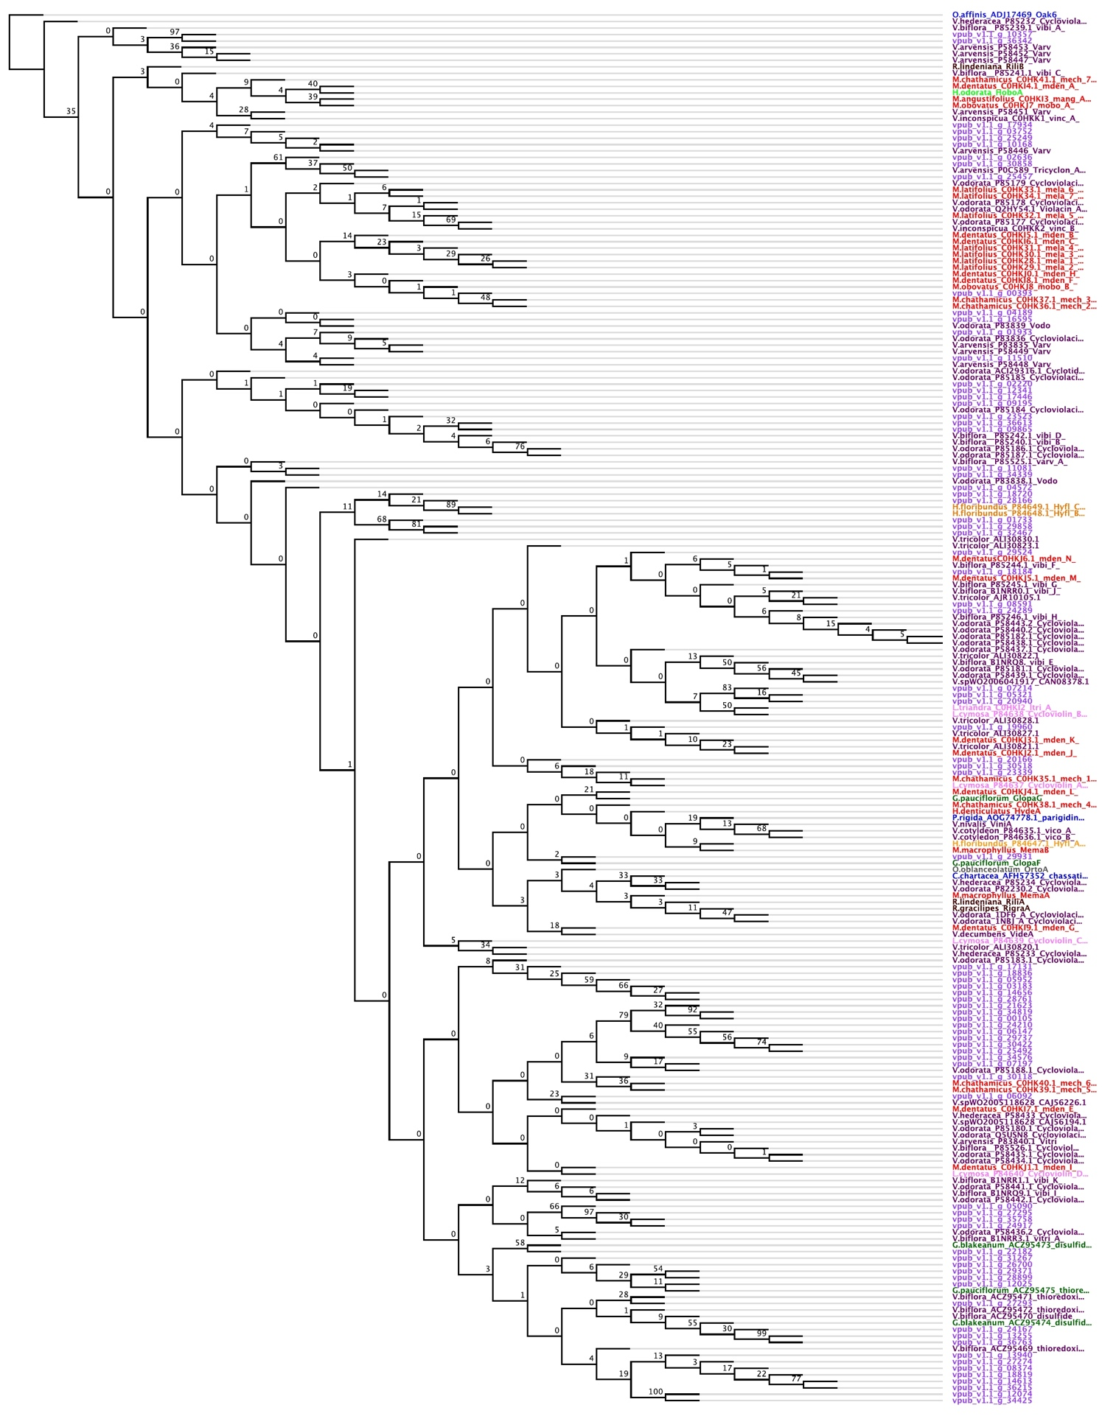
Figure S4: Maximum-likelihood protein cladogram containing 215 cyclotide sequences from eight Violaceae genera, including 27 diverse violet species, as well as three Rubiaceae genera/species used as cladogram outgroups. The cladogram was generated through PhyML using the VT amino acid substitution model, estimated portions of invariable sites, estimated Γ-distribution shape parameter, eight substitution rate categories, estimated amino acid frequencies, 100 bootstrap replicates, and the best of nearest neighbor interchange (NNI) and subtree pruning and regrafting (SPR). The cladogram was visualized and color-coded in Geneious with different colors representing each genera (color key listed in Table S1). Branches represent bootstrap support and are not proportional to amino acid changes.

Supplementary Tables

Table S1
Table S1. Species names and corresponding NCBI accession numbers of nine, publicly available Viola transcriptomes.
Species | NCBI Accession
Viola acuminata | GFWD00000000
Viola albida | GFWC00000000
Viola baoshanensis | PRJNA268667
Viola canadensis | ERX2099460
Viola mandshurica | GFWG00000000
Viola orientalis | GFXR00000000
Viola tricolor | ERX2099459
Viola uliginosa | PRJNA257024
Viola verecunda | GFWF00000000

Table S2
Table S2. Estimations of V. pubescens genome heterozygosity, haploid length, repeat length, unique reads length, model fit, and read error rate generated through GenomeScope (Vurture et al., 2017) using a k-mer distribution approach via Jellyfish (Marçais and Kingsford, 2011). K-mer sizes 17, 31, 49, 63, and 79 were tested and 63 was selected based on model fit.
 | k17 | k31 | k49 | k63 | k79
Heterozygosity (%) | 0.69 | 0.63 | 0.54 | 0.52 | 0.64
Genome haploid length (bp) | 326,879,345 | 350,122,653 | 350,914,765 | 353,790,935 | 361,718,559
Genome repeat length (bp) | 192,410,454 | 151,066,652 | 121,846,052 | 114,746,721 | 120,826,214
Genome unique length (bp) | 134,468,891 | 199,056,001 | 229,068,713 | 239,044,214 | 240,892,345
Model fit (%) | 86.09 | 90.73 | 93.89 | 95.70 | 92.96
Read error rate (%) | 0.14 | 0.15 | 0.14 | 0.13 | 0.10

Table S3
Table S3. Species with published cyclotide sequences used as queries for in silico identification of cyclotide sequences in the V. pubescens genome and phylogenetic analysis through PhyML.
Genus | Species | GenBank Accessions or Publication | Color in Fig. S3
*Chassalia | chartacea | AFH57352 | Blue
Gloeospermum | blakeanum | ACZ95473, ACZ95474 | Green
Gloeospermum | pauciflorum | Glopa F and Glopa G in Burman et al. (2015), ACZ95475 | Green
Hybanthus | denticulatus | Hyde A in Burman et al., 2015 | Orange
Hybanthus | floribundus | P84647, P84648, P84649 | Orange
Hymenanthera | oborata | Hobo A in Burman et al. (2015) | Light green
Leonia | cymosa | P84637, P84638, P84639, P84640 | Pink
Leonia | triandra | C0HKI2 | Pink
Melicytus | angustifolius | C0HKI3 | Red
Melicytus | chathamicus | C0HK35, C0HK36, C0HK37, C0HK38, C0HK39, C0HK40, C0HK41 | Red
Melicytus | dentatus | C0HKJ0, C0HKJ1, C0HKJ2, C0HKJ3, C0HKJ4, C0HKJ5, C0HKJ6, C0HKI4, C0HKI5, C0HKI6, C0HKI7, C0HKI8, C0HKI9 | Red
Melicytus | latifolius | C0HK28, C0HK29, C0HK30, C0HK31, C0HK32, C0HK33, C0HK34 | Red
Melicytus | macrophyllus | Mema A and Mema B in Burman et al. (2015) | Red
Melicytus | obovatus | C0HKJ7, C0HKJ8 | Red
*Oldenlandia | affinis | ADJ17469 | Blue
Orthion | oblanceolatum | Orto A in Burman et al., 2015 | Gray
*Palicourea | rigida | AOG74778 | Blue
Rinorea | gracilipes | Rigra A in Burman et al., 2015 | Black
Rinorea | lindeniana | Rili A and Rili B in Burman et al., 2015 | Black
Viola | arvensis | P0C589, P58446, P58447, P58448, P58449, P58451, P58452, P58453, P83835, P83840 | Brown
Viola | biflora | ACZ95469, ACZ95470, ACZ95471, ACZ95472, B1NRQ8, B1NRQ9, B1NRR0, B1NRR1, B1NRR3, P85239, P85240, P85241, P85242, P85244, P85245, P85246, P85525, P85526 | Brown
Viola | cotyledon | P84635, P84636 | Brown
Viola | decumbens | Vide A in Burman et al., 2015 | Brown
Viola | hederacea | P58433, P85232, P85233, P85234 | Brown
Viola | inconspicua | C0HKK1, C0HKK2 | Brown
Viola | nivalis | Vini A in Burman et al. (2015) | Brown
Viola | odorata | 1DF6_A, 1NBJ_A, ACI29316, P58434, P58435, P58436, P58437, P58438, P58439, P58440, P58441, P58442, P58443, P82230, P83836, P83838, P83839, P85177, P85178, P85179, P85180, P85181, P85182, P85183, P85184, P85185, P85186, P85187, P85188, Q2HY54, Q5USN8 | Brown
Viola | pubescens | Gene IDs and expression data are listed in Supplementary Data Sheet 2 | Purple
Viola | sp. WO2005118628 | CAJ56194, CAJ56226 | Brown
Viola | sp. WO2006041917 | CAN08378 | Brown
Viola | tricolor | AJR10105, ALI30820, ALI30821, ALI30822, ALI30823, ALI30827, ALI30828, ALI30830 | Brown
* denote Rubiaceae species used as outgroups in phylogenetic analyses

Table S4
Table S4. ABySS output comparing V. pubescens genome assemblies comprised of all four sequenced libraries vs. only two superior libraries that passed FastQC. K-mer sizes 69, 79, and 89 were tested, and a k-mer of 79 was selected for the final assembly.
 | All Four Libraries (>500 bp) |  |  | Two Libraries (>500 bp)
 | k69 | k79 | k89 | k69 | k79 | k89
# of scaffolds | 146,872 | 163,177 | 168,108 | 143,732 | 157,722 | 163,792
Total size of scaffolds (bp) | 268,989,943 | 314,048,987 | 346,081,115 | 273,924,499 | 318,370,682 | 312,927,578
Longest scaffold (bp) | 58,077 | 66,219 | 66,239 | 72,290 | 86,685 | 61,315
Number of scaffolds >1kb | 71,091 | 81,676 | 89,402 | 70,814 | 80,885 | 87,740
Number of scaffolds > 10kb | 2,810 | 3,555 | 4,195 | 3,201 | 3,992 | 2,956
Number of scaffolds > 100kb | 0 | 0 | 0 | 0 | 0 | 0
N50 length (bp) | 2,971 | 3,209 | 3,519 | 3,196 | 3,500 | 2,980
Average length of breaks (>25 Ns) between contigs in scaffold | 46 | 46 | 44 | 46 | 45 | 46
Scaffold %N | 0.14 | 0.08 | 0.03 | 0.12 | 0.06 | 0.03
% in scaffolded contigs | 5.7 | 3.8 | 1.5 | 5.4 | 3.2 | 1.6

