Supplementary Tables and Figures
Table S1. Focal Species list prior to filtering for minimum observation requirements.
Species | Observations
Paralabrax clathratus | 993
Semicossyphus pulcher | 991
Kelletia kelletii | 855
Megathura crenulata | 853
Sebastes atrovirens | 787
Mesocentrotus franciscanus | 759
Panulirus interruptus | 756
Sebastes mystinus | 619
Macrocystis pyrifera | 573
Sebastes serranoides | 571
Sebastes serriceps | 563
Haliotis corrugata | 515
Haliotis fulgens | 481
Haliotis rufescens | 447
Sebastes chrysomelas | 411
Sebastes carnatus | 330
Scorpaenichthys marmoratus | 318
Paralabrax nebulifer | 263
Sebastes caurinus | 262
Ophiodon elongatus | 237
Sebastes miniatus | 180
Scorpaena guttata | 163
Haliotis sorenseni | 162
Sebastes paucispinis | 123
Sebastes auriculatus | 112
Sebastes rastrelliger | 99
Sebastes melanops | 80
Stereolepis gigas | 45
Sebastes dallii | 35
Triakis semifasciata | 13
Sebastes umbrosus | 10
Sebastes pinniger | 10
Sebastes hopkinsi | 10
Haliotis kamtschatkana assimilis | 10
Sebastes semicinctus | 9
Sebastes entomelas | 3
Sebastes constellatus | 3
Sebastes rubrivinctus | 1
Sebastes levis | 1
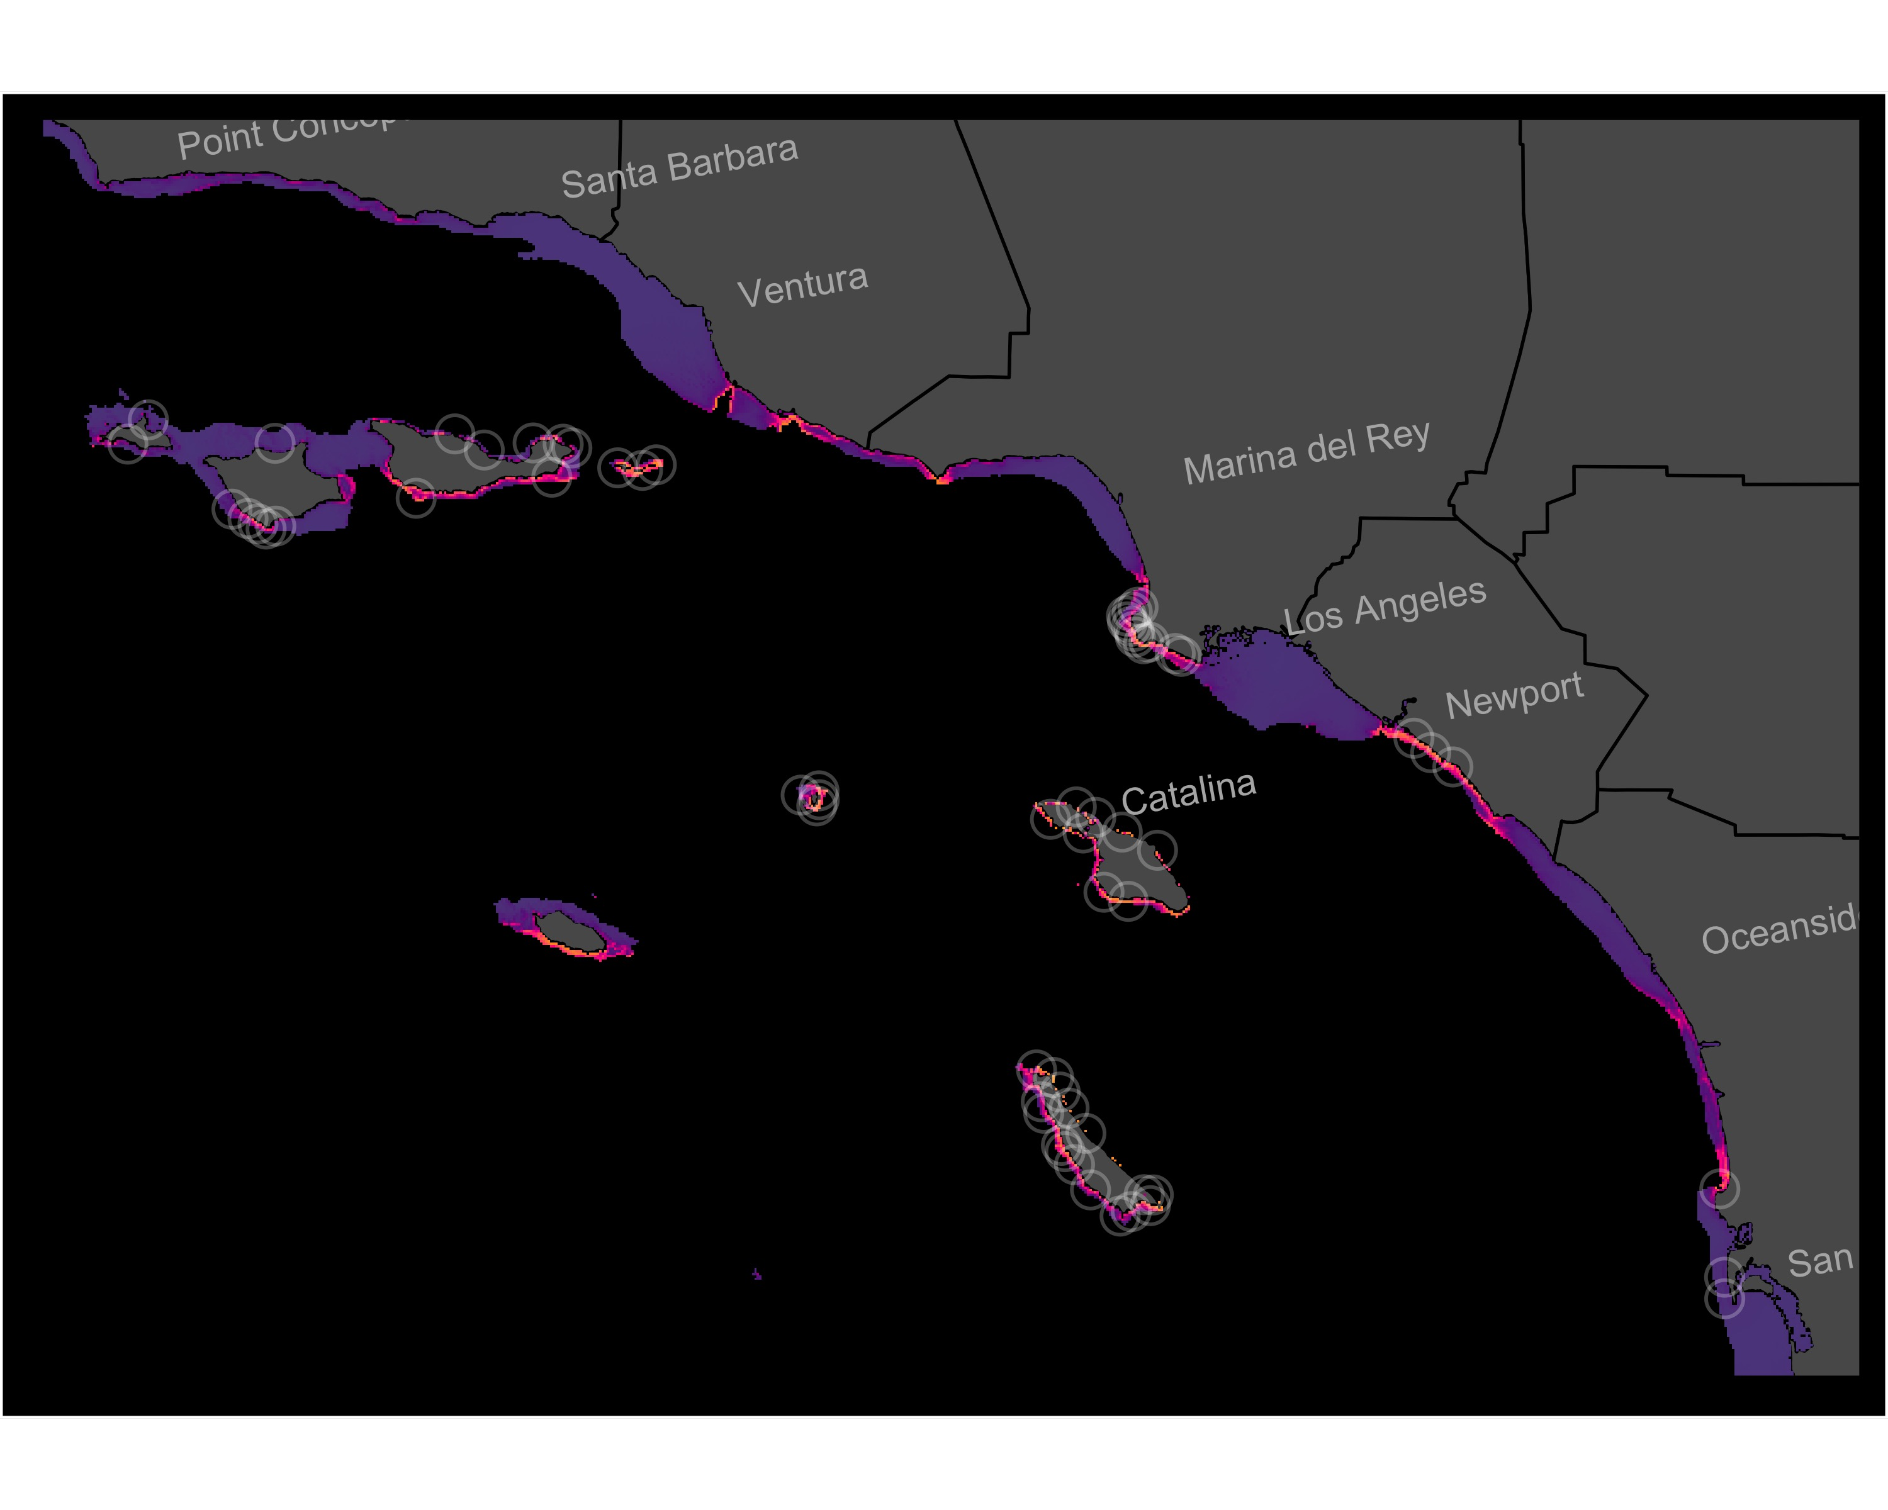
Figure S1. Individual-SDM for Haliotis corrugata in the SCB. Model shown is the best-fit model (Table 1) of 12 candidate models. White circles show all observations from natural reefs included in the training and test datasets.
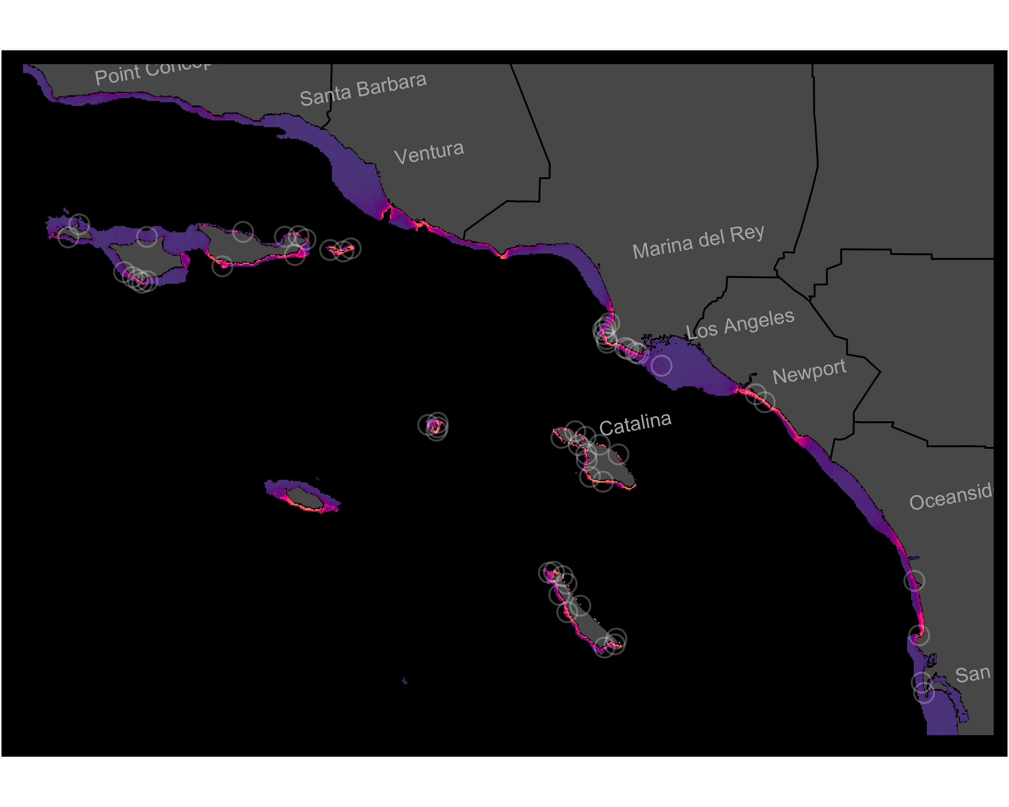
Figure S2. Individual-SDM for Haliotis fulgens in the SCB. Model shown is the best-fit model (Table 1) of 12 candidate models. White circles show all observations from natural reefs included in the training and test datasets.
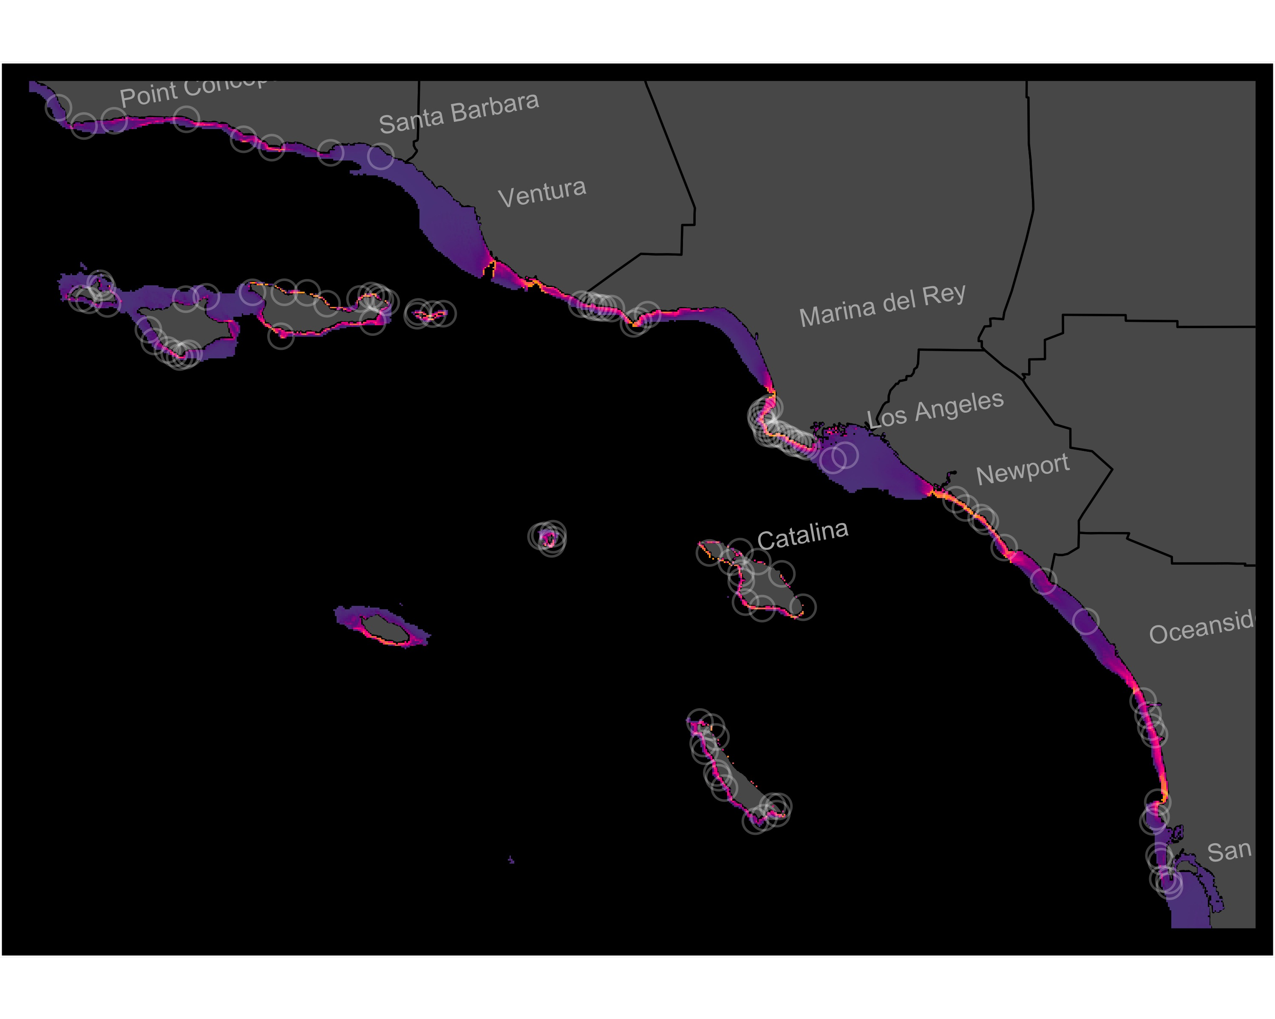
Figure S3. Individual-SDM for Kelletia kelletii in the SCB. Model shown is the best-fit model (Table 1) of 12 candidate models. White circles show all observations from natural reefs included in the training and test datasets.
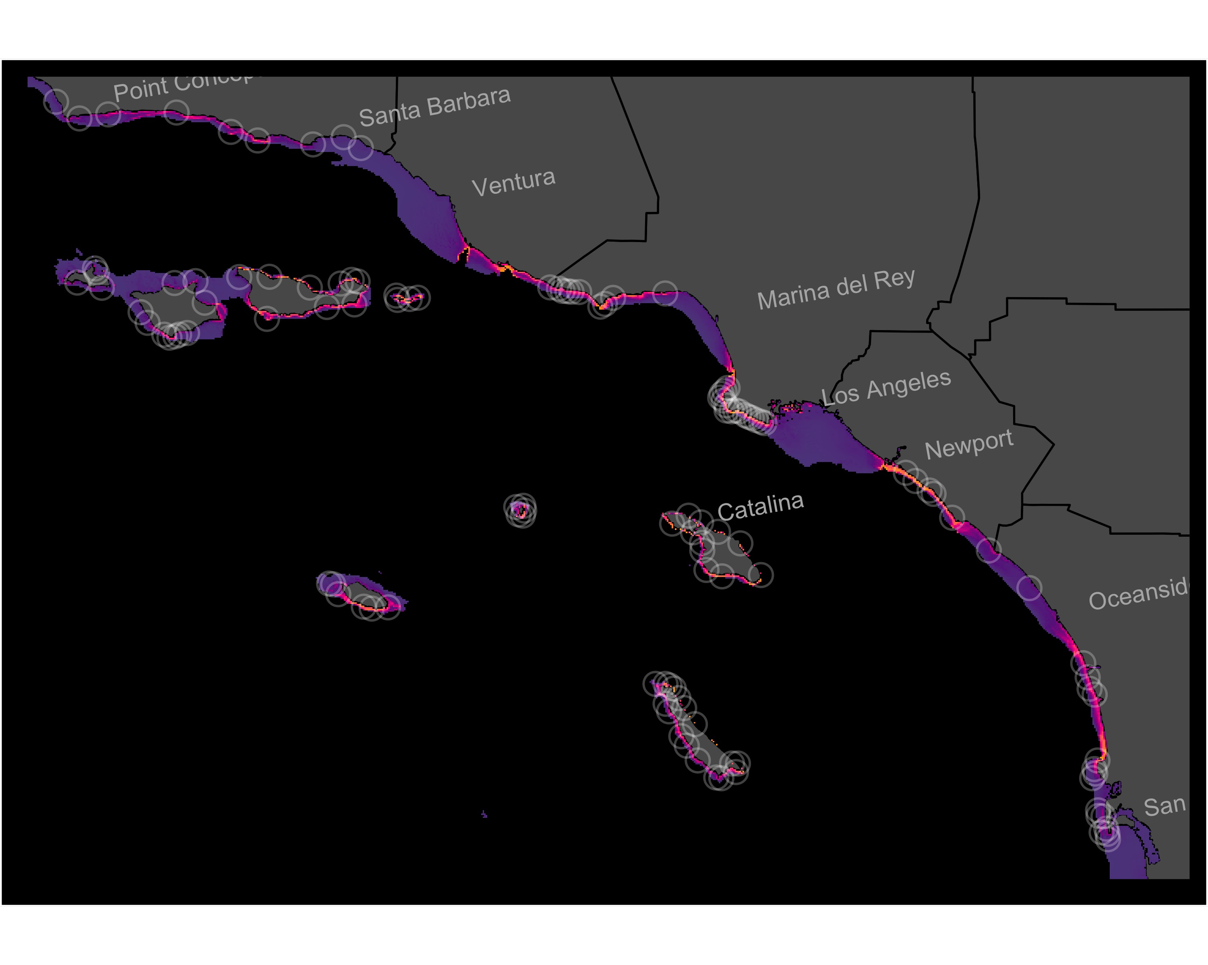
Figure S4. Individual-SDM for Macrocystis pyrifera in the SCB. Model shown is the best-fit model (Table 1) of 12 candidate models. White circles show all observations from natural reefs included in the training and test datasets.
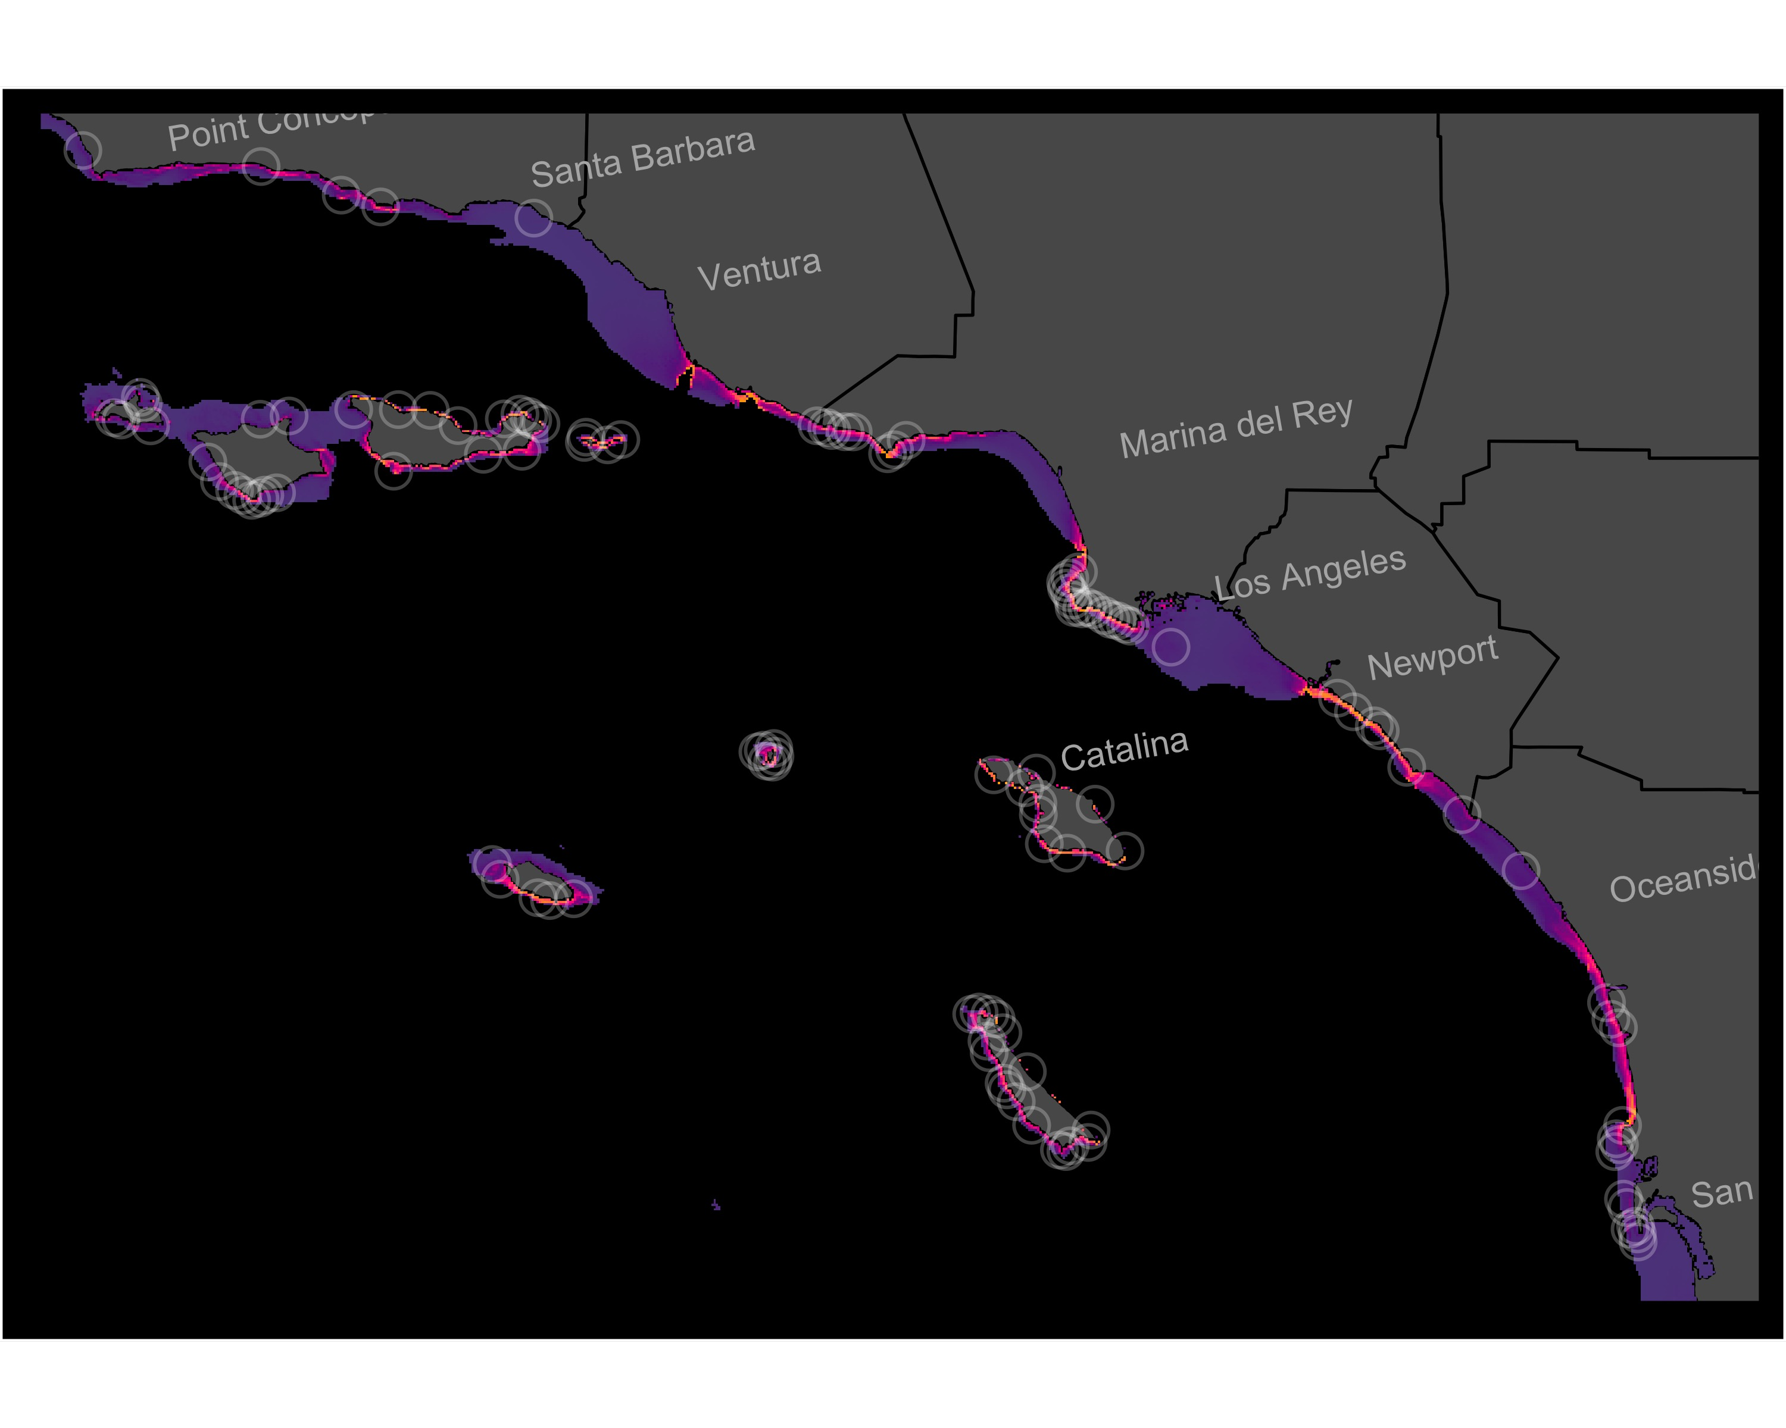
Figure S5. Individual-SDM for Megathura crenulata in the SCB. Model shown is the best-fit model (Table 1) of 12 candidate models. White circles show all observations from natural reefs included in the training and test datasets.
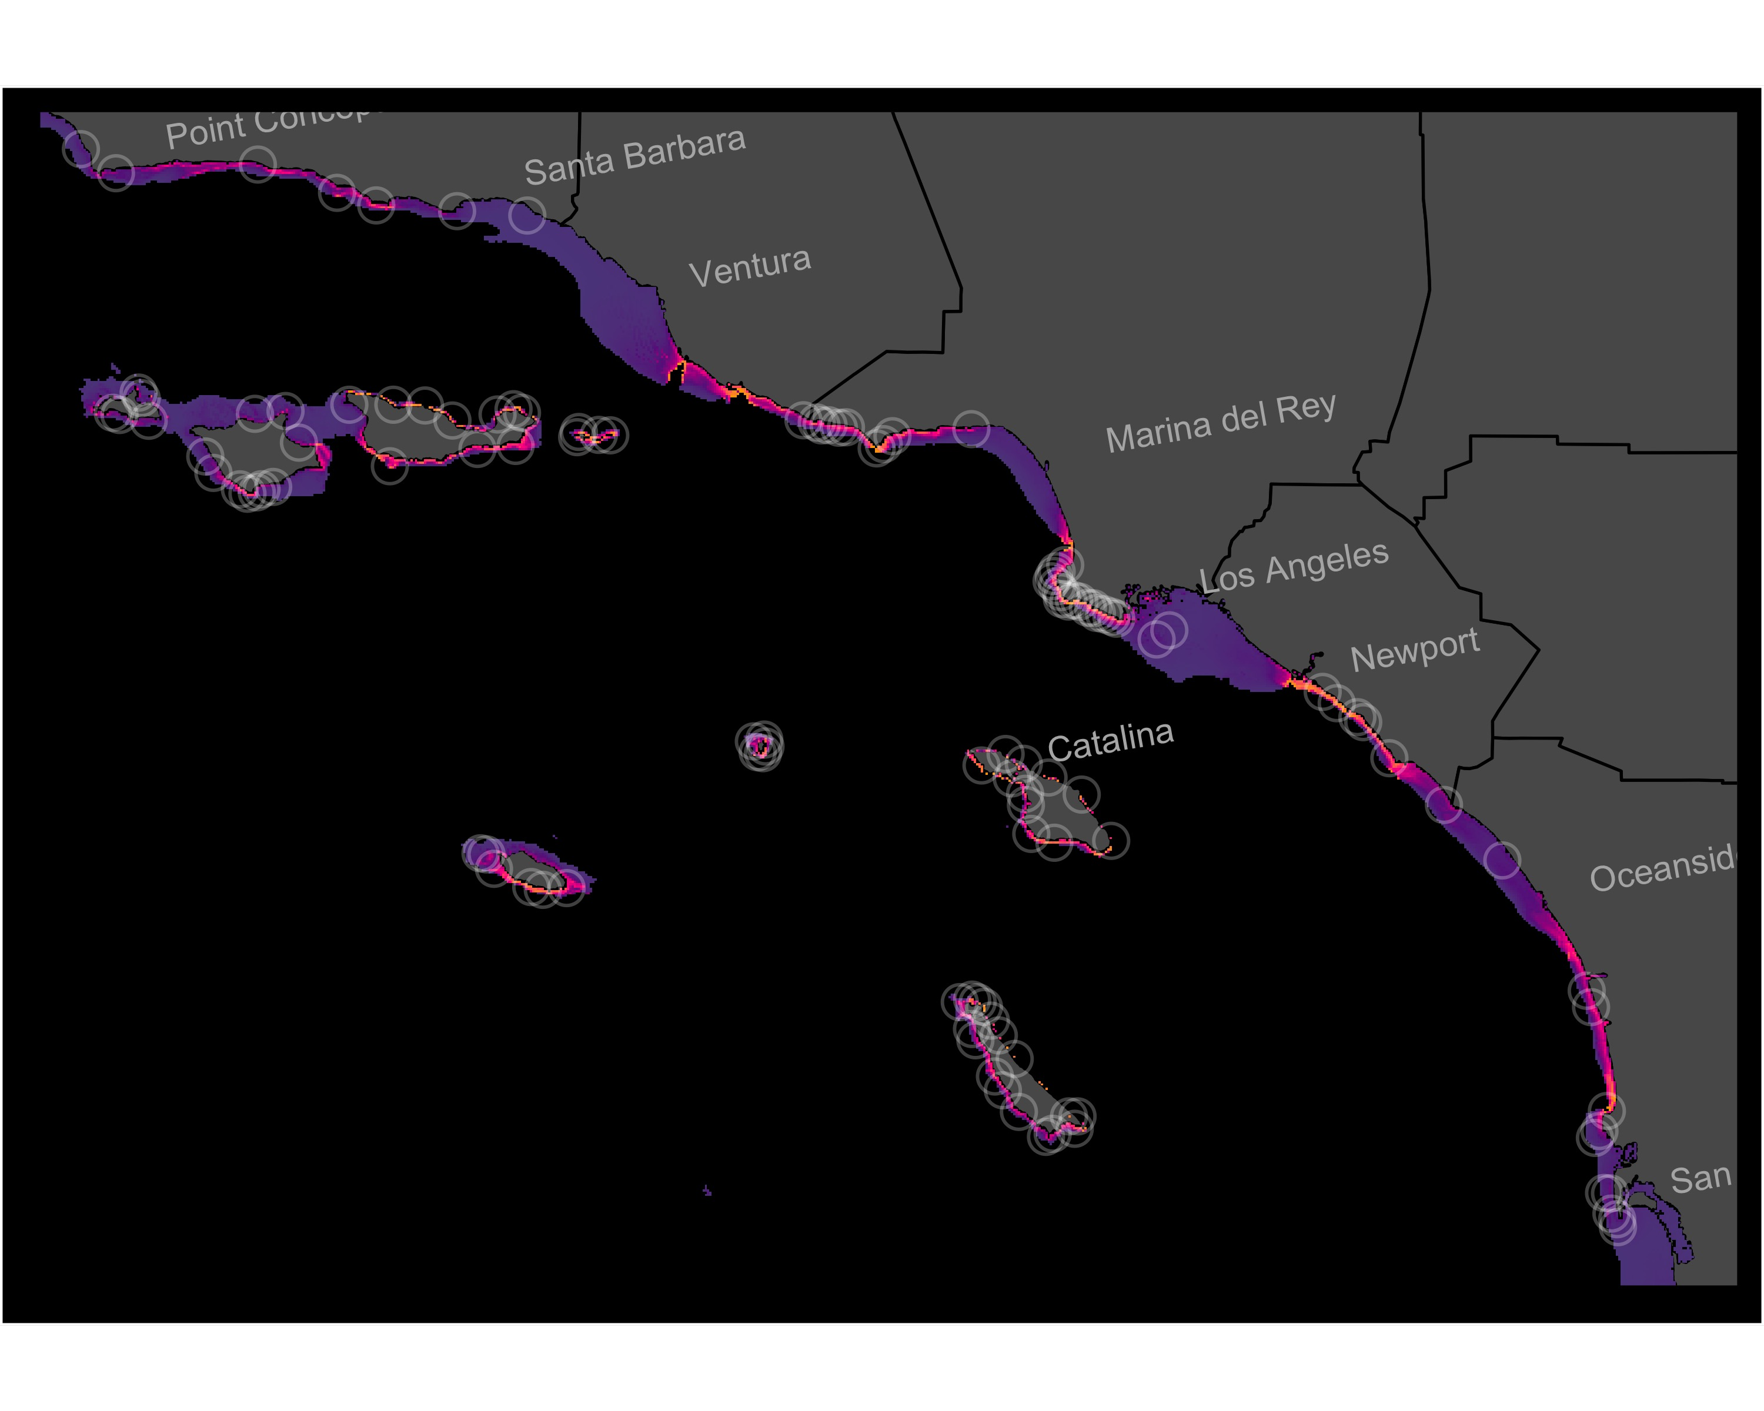
Figure S6. Individual-SDM for Mesocentrotus franciscanus in the SCB. Model shown is the best-fit model (Table 1) of 12 candidate models. White circles show all observations from natural reefs included in the training and test datasets.
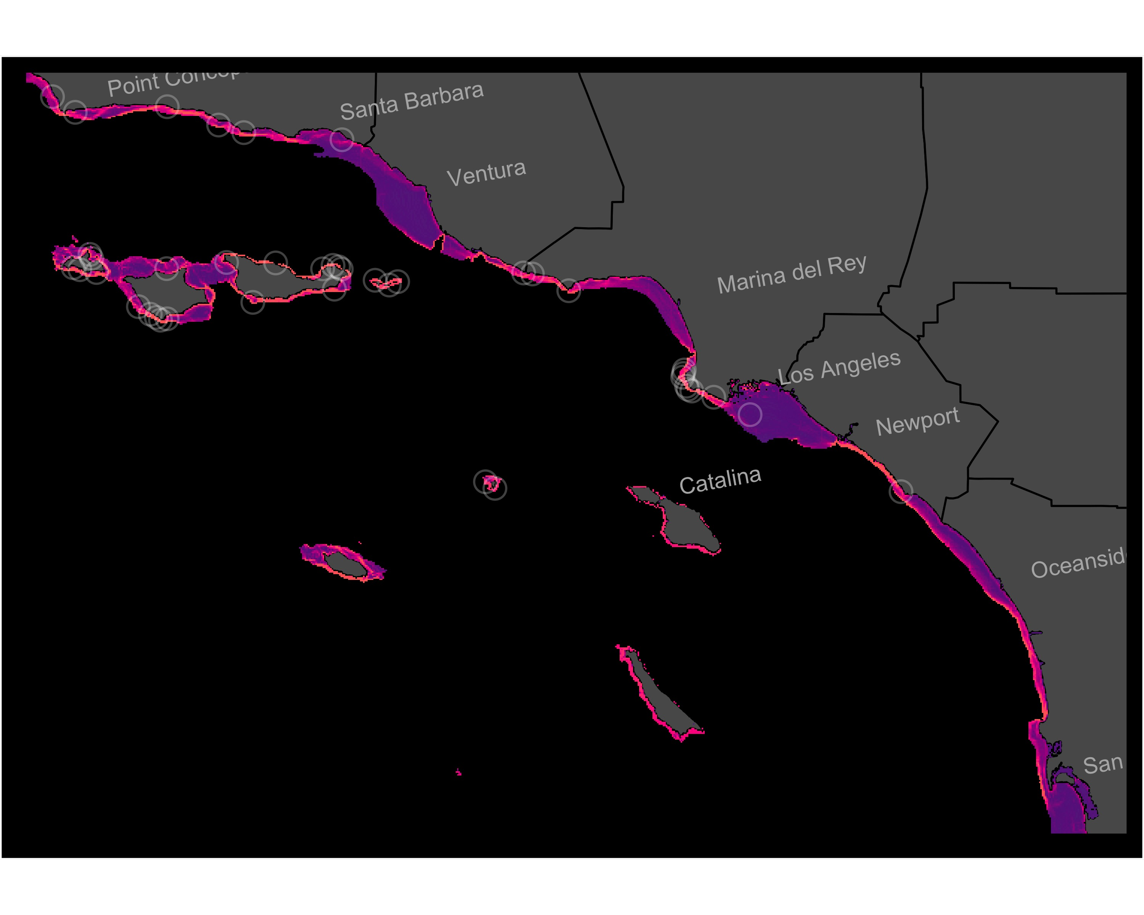
Figure S7. Individual-SDM for Ophiodon elongatus in the SCB. Model shown is the best-fit model (Table 1) of 12 candidate models. White circles show all observations from natural reefs included in the training and test datasets.
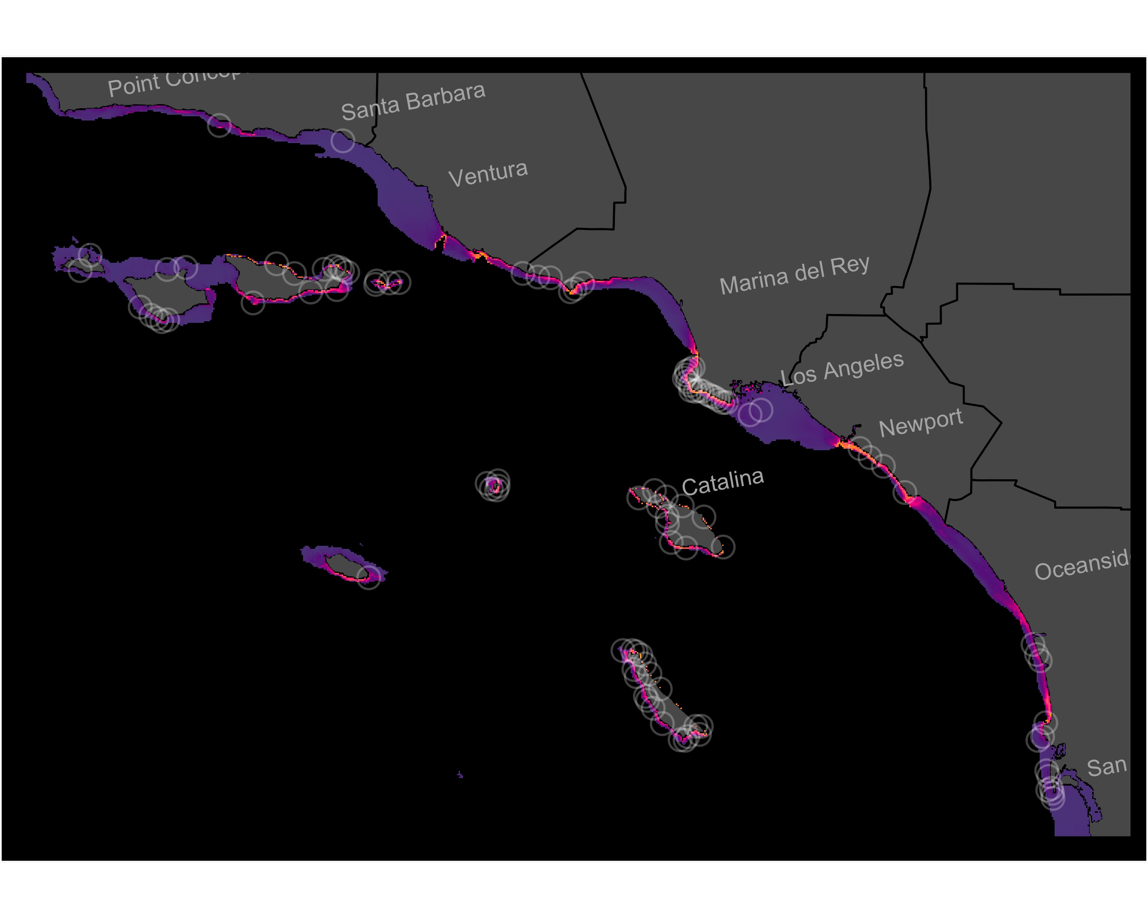
Figure S8. Individual-SDM for Panulirus interruptus in the SCB. Model shown is the best-fit model (Table 1) of 12 candidate models. White circles show all observations from natural reefs included in the training and test datasets.
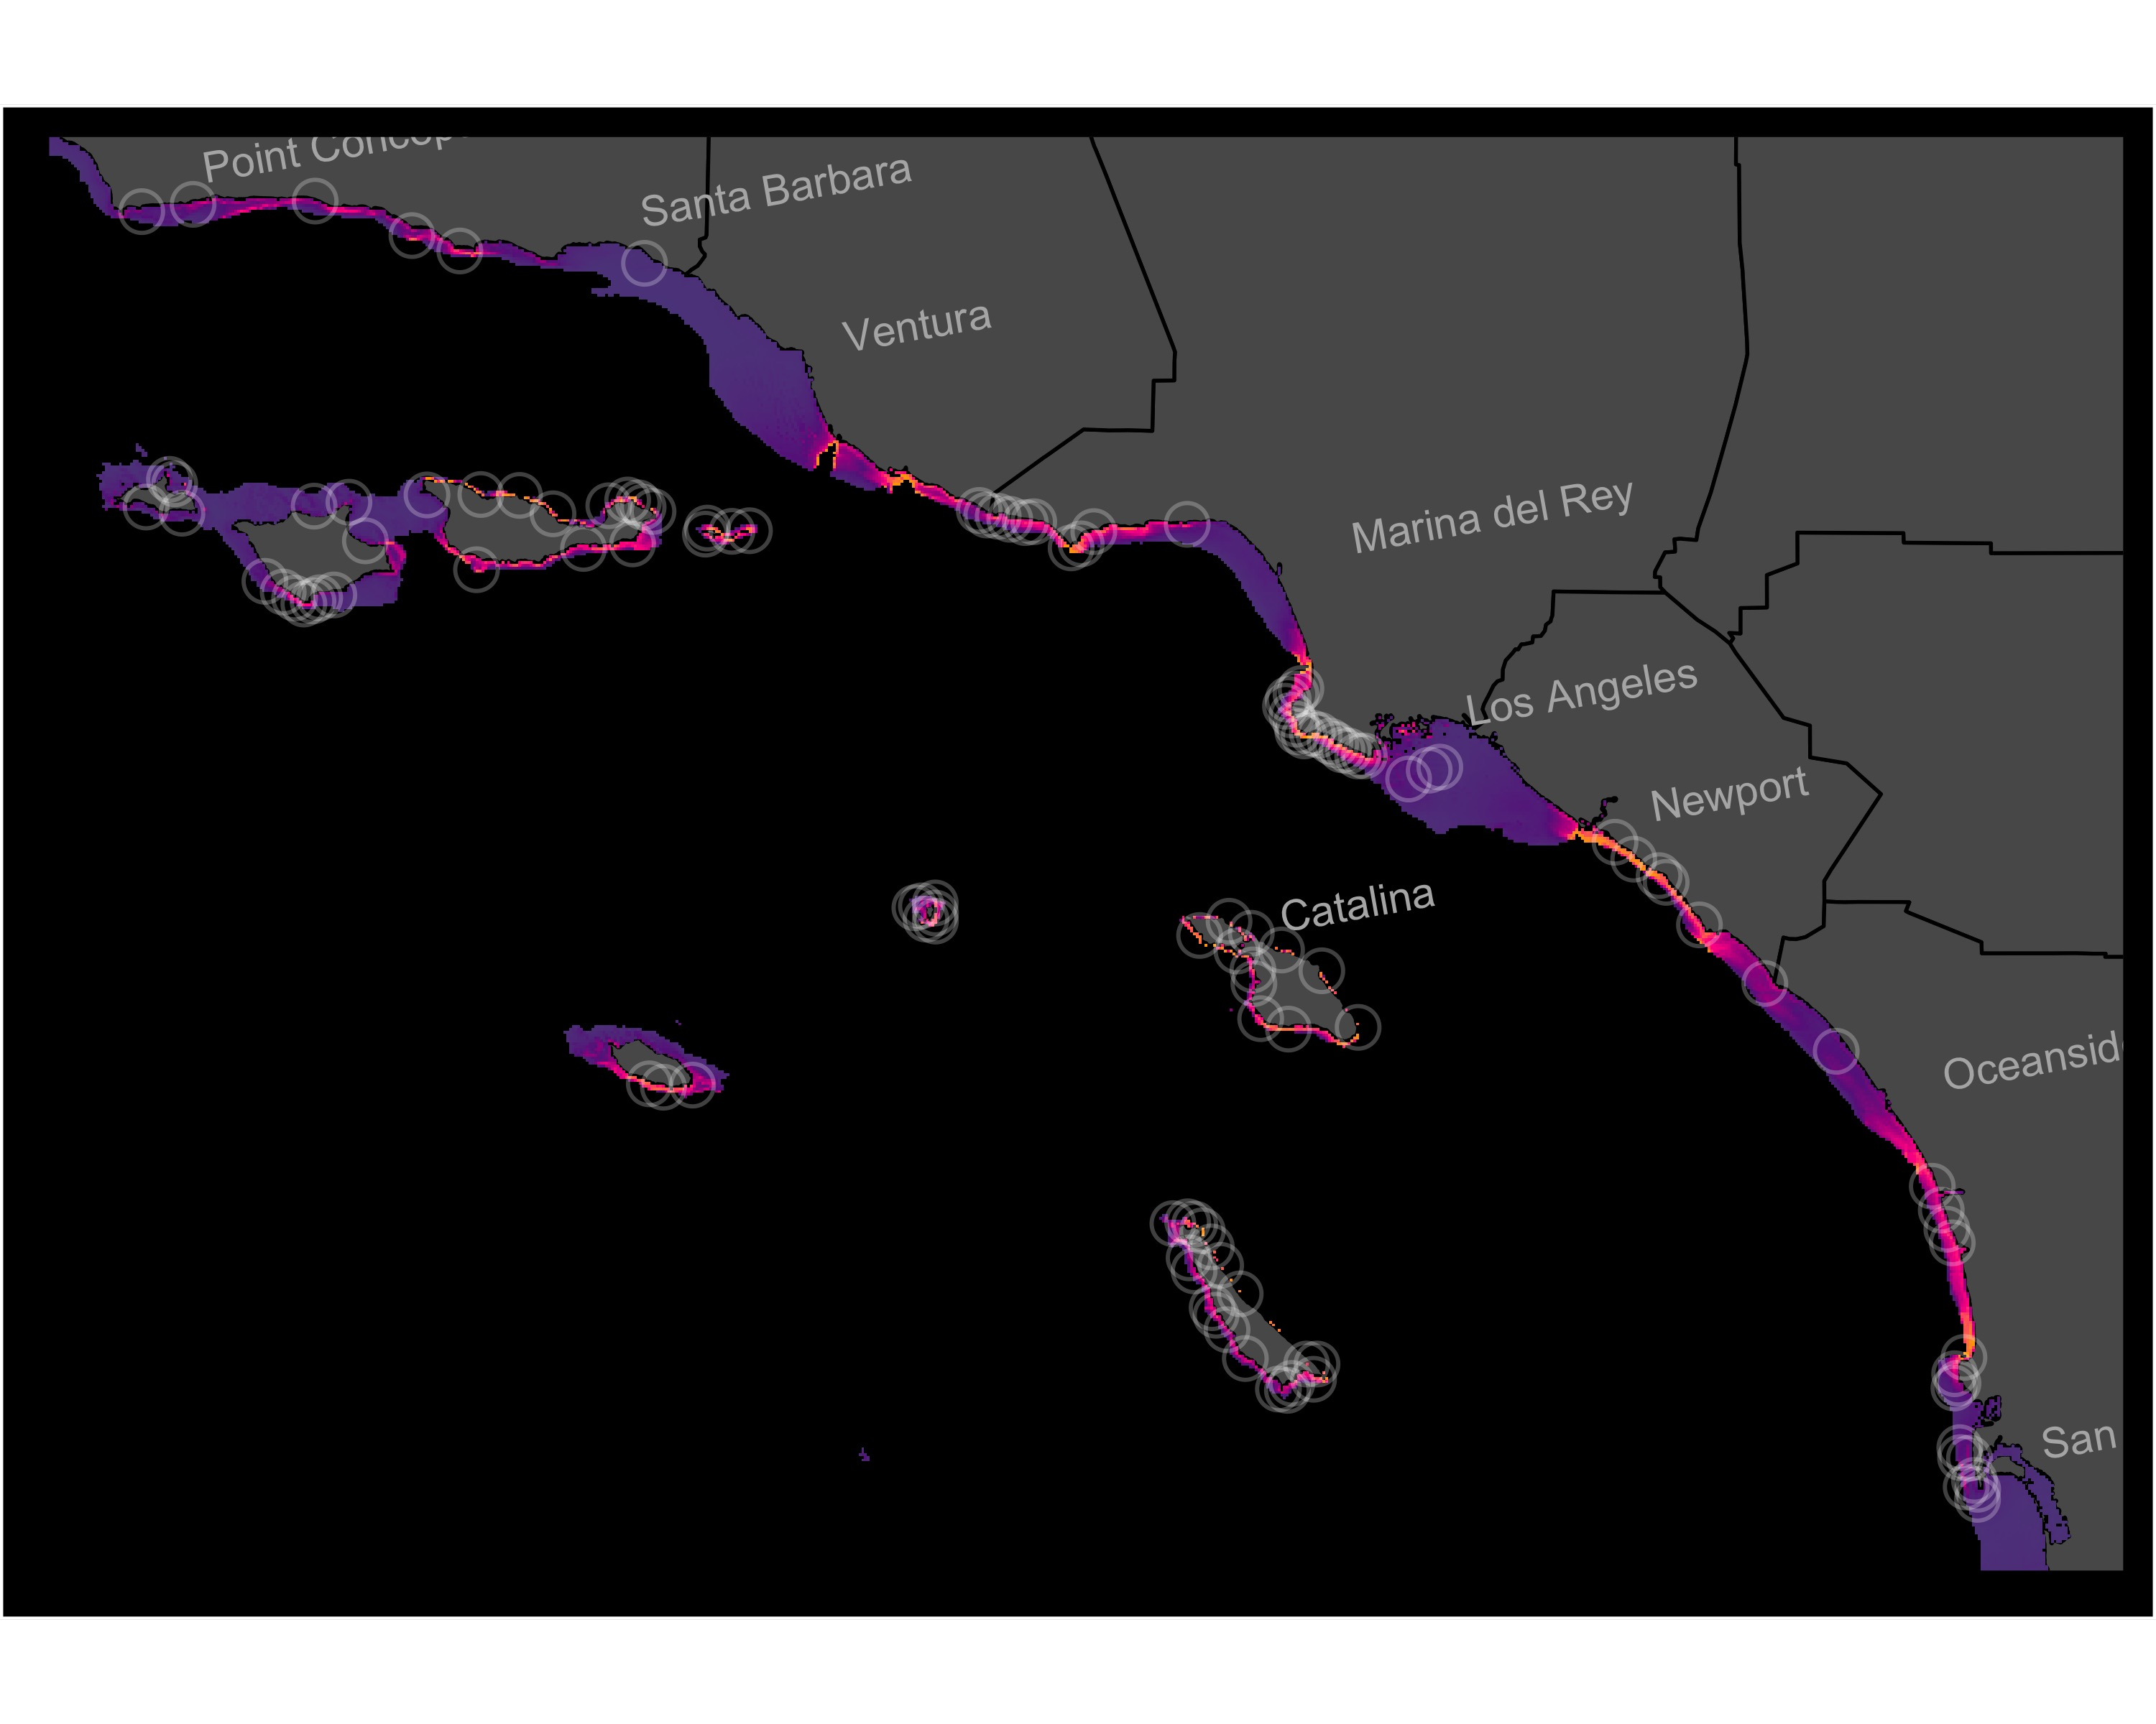
Figure S9. Individual-SDM for Paralabrax clathratus in the SCB. Model shown is the best-fit model (Table 1) of 12 candidate models. White circles show all observations from natural reefs included in the training and test datasets.
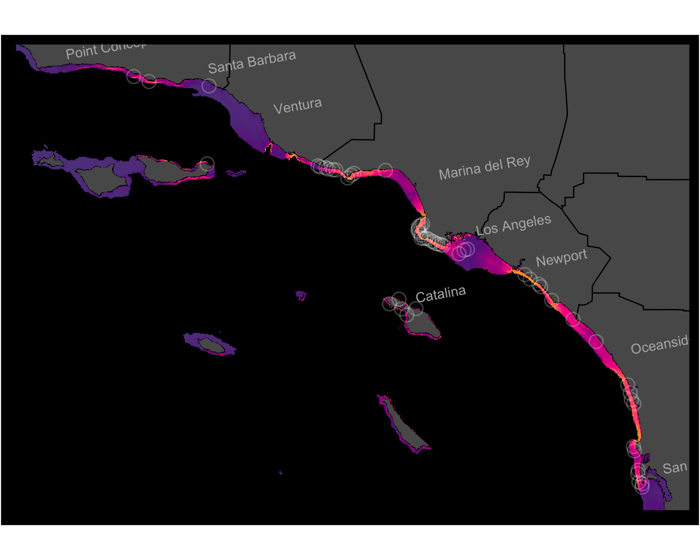
Figure S10. Individual-SDM for Paralabrax nebulifer in the SCB. Model shown is the best-fit model (Table 1) of 12 candidate models. White circles show all observations from natural reefs included in the training and test datasets.
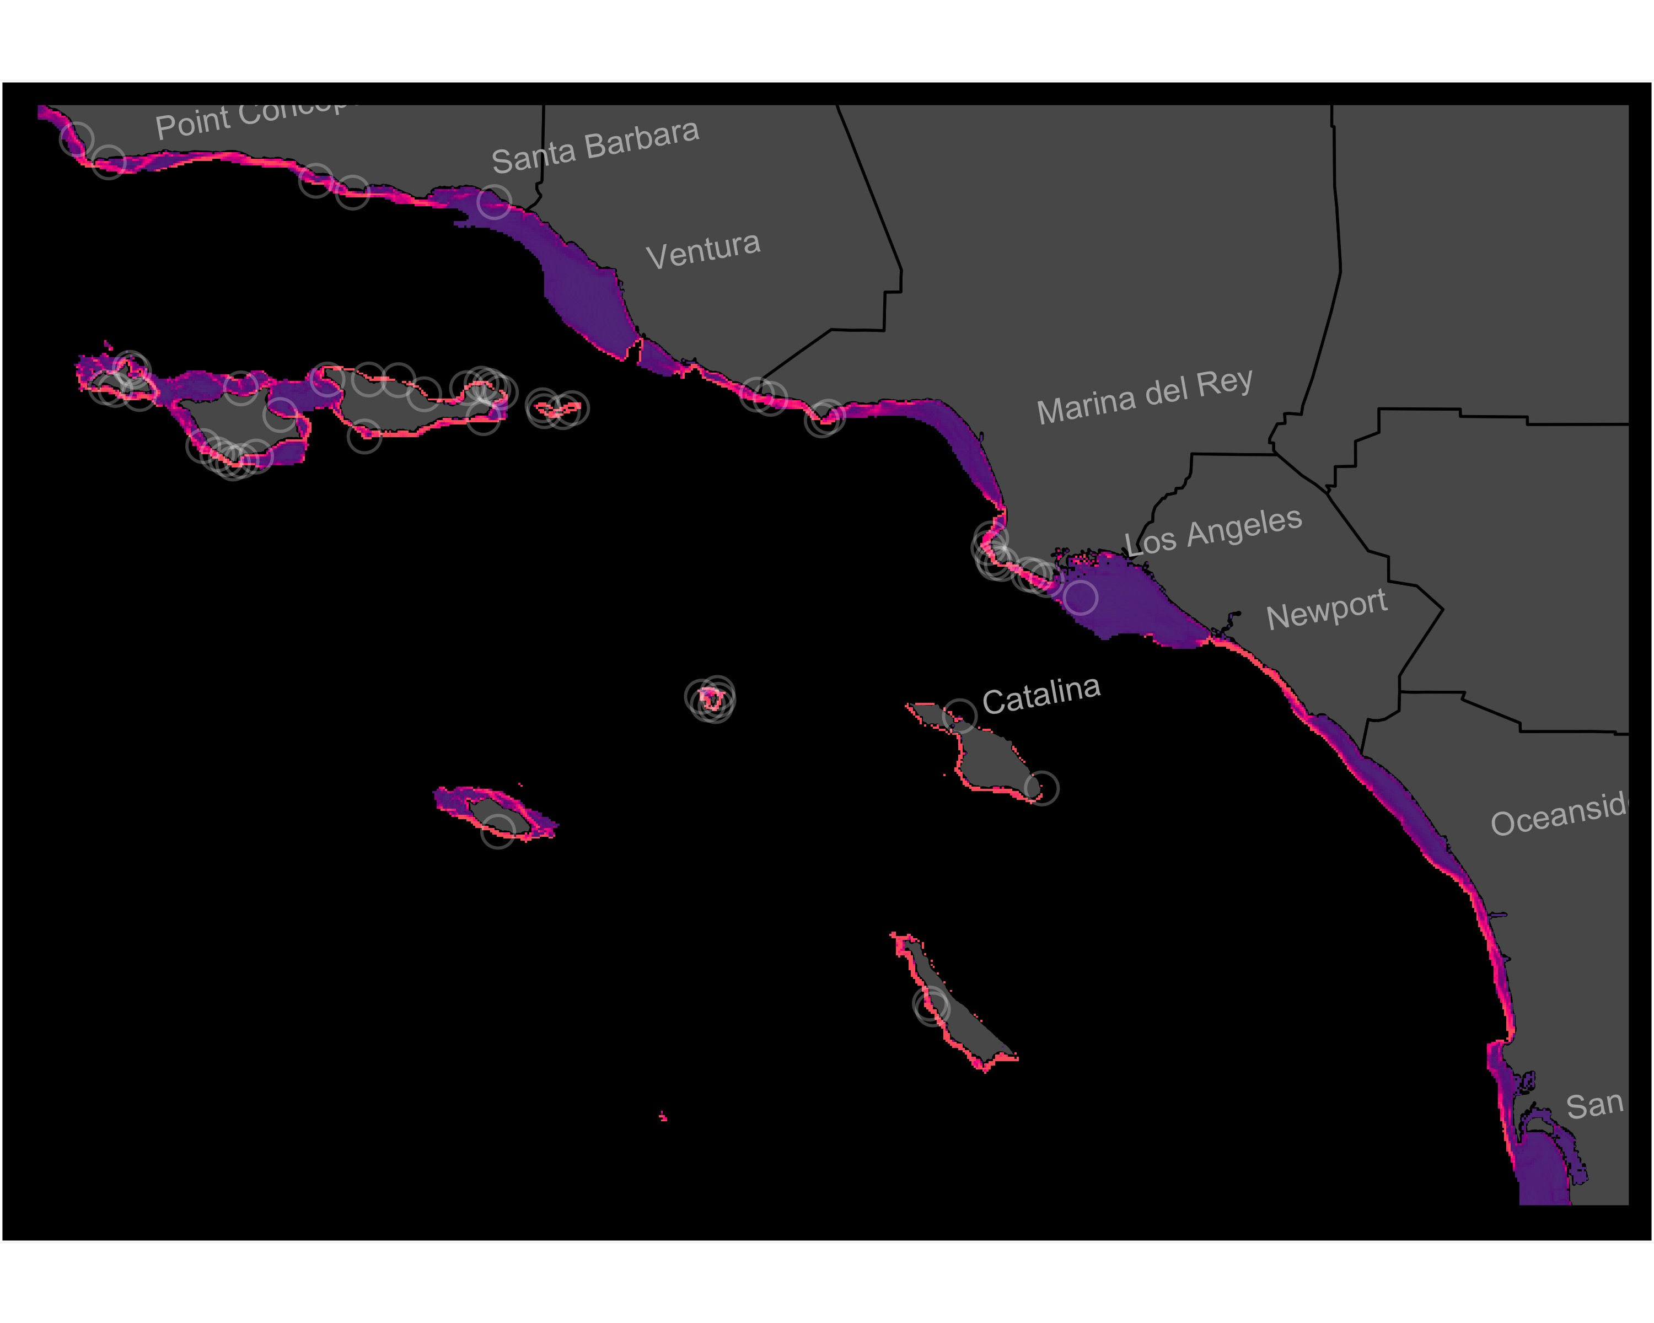
Figure S11. Individual-SDM for Scorpaenichthys marmoratus in the SCB. Model shown is the best-fit model (Table 1) of 12 candidate models. White circles show all observations from natural reefs included in the training and test datasets.
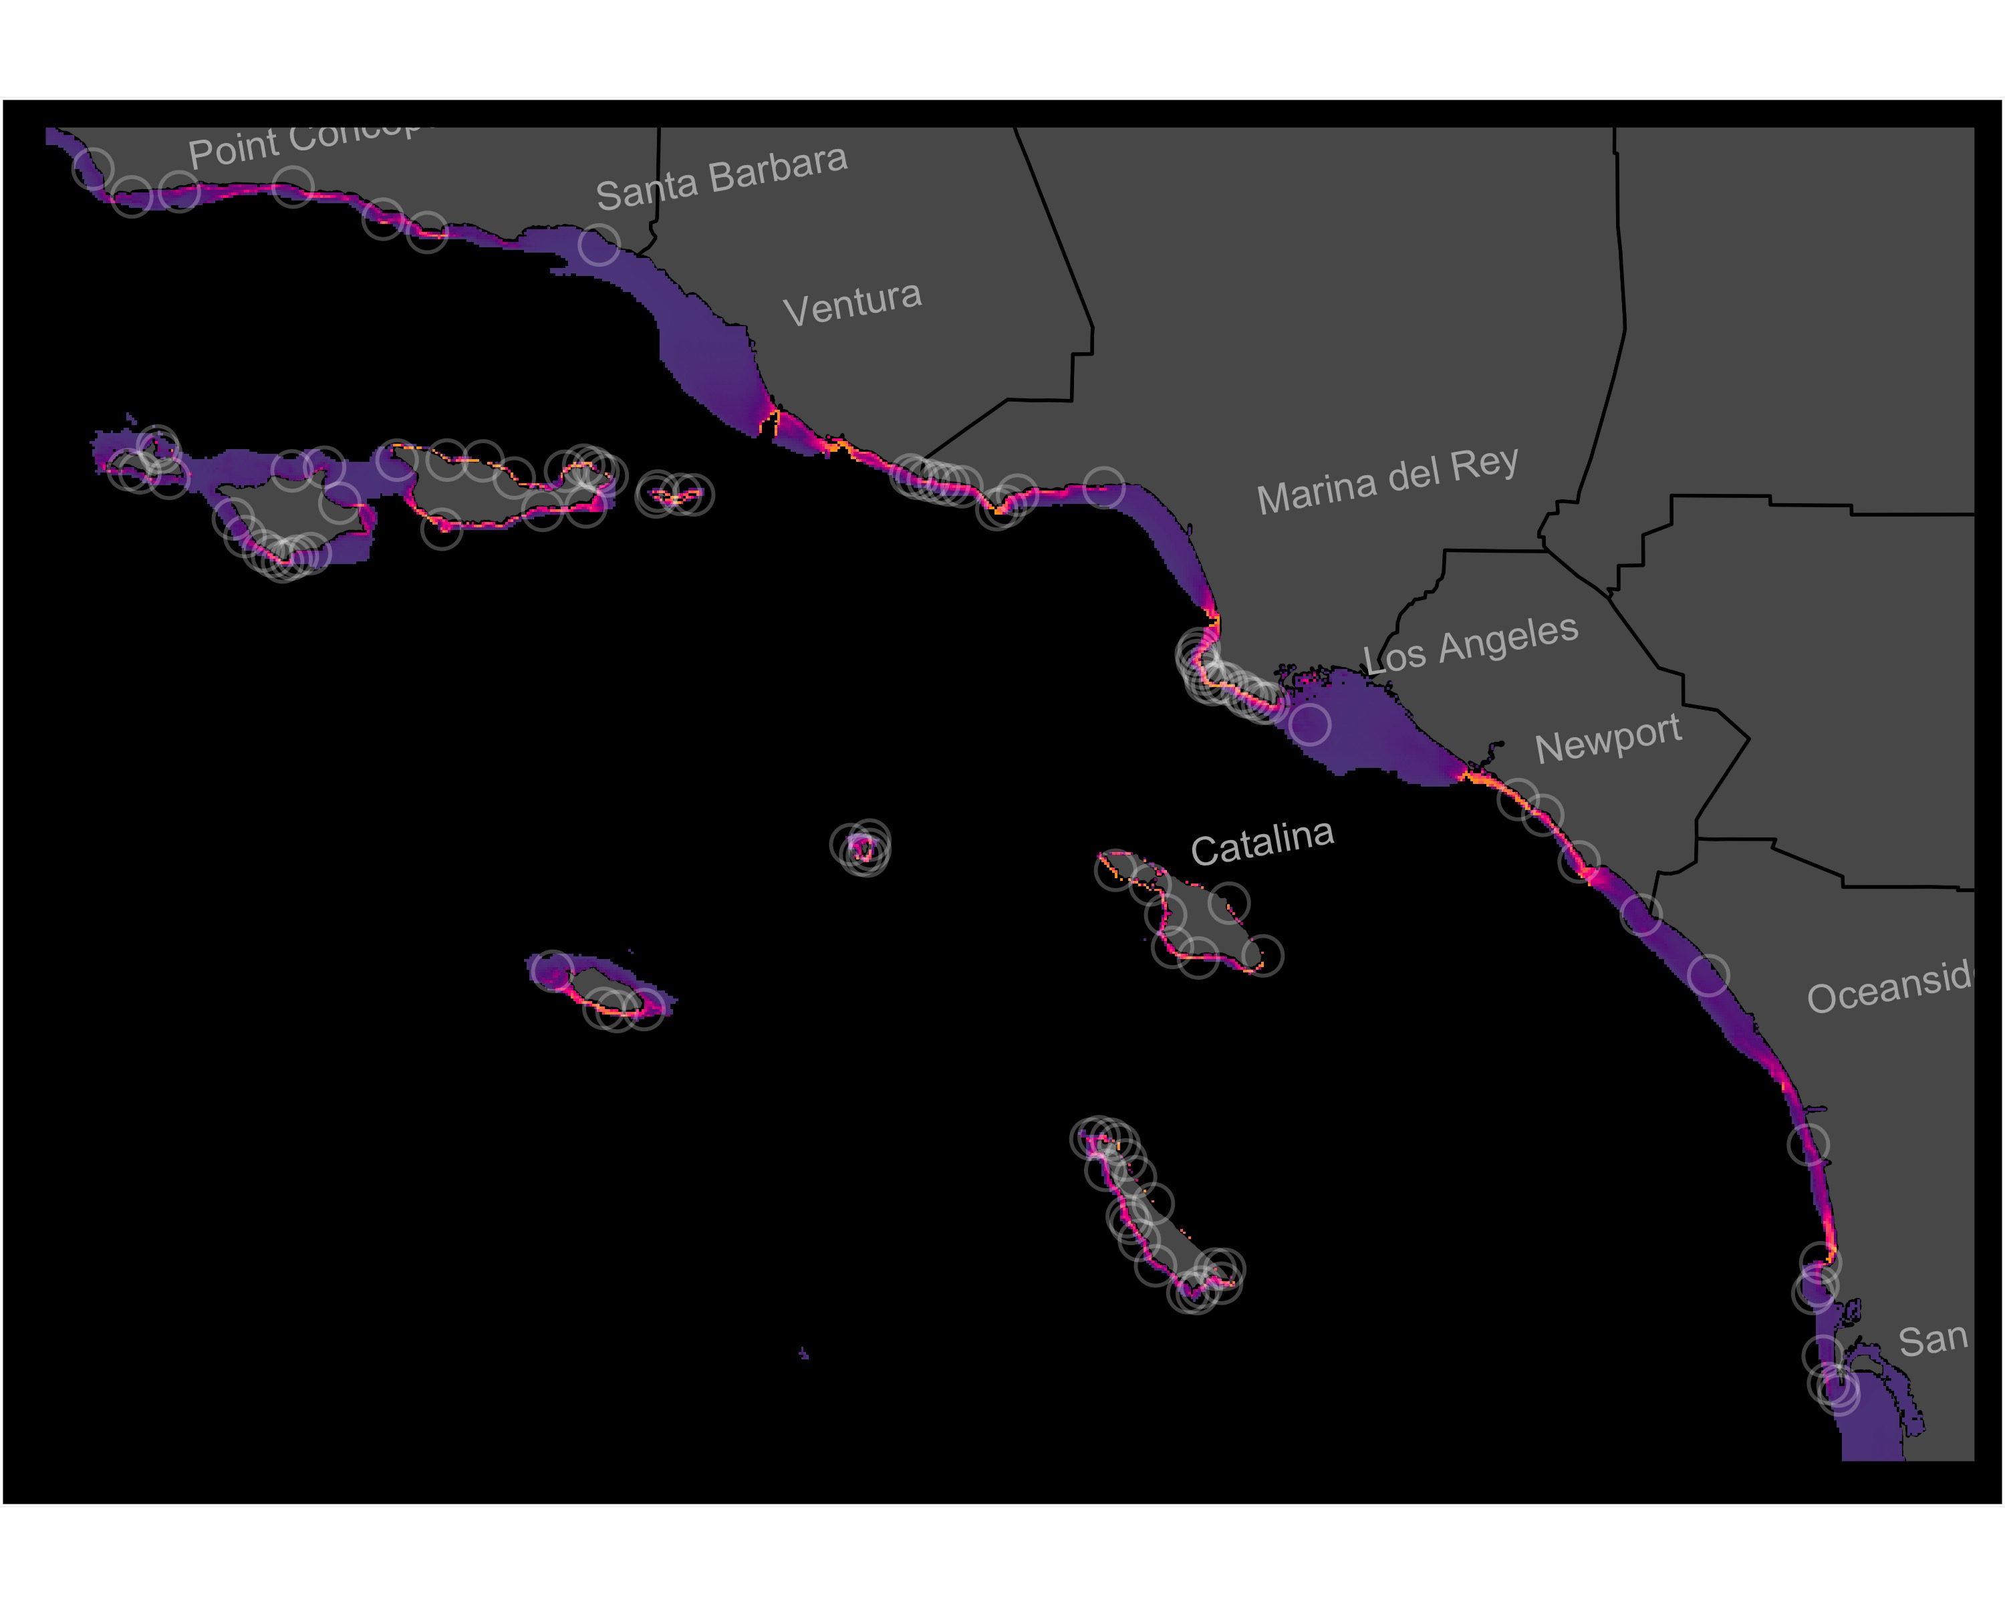
Figure S12. Individual-SDM for Sebastes atrovirens in the SCB. Model shown is the best-fit model (Table 1) of 12 candidate models. White circles show all observations from natural reefs included in the training and test datasets.
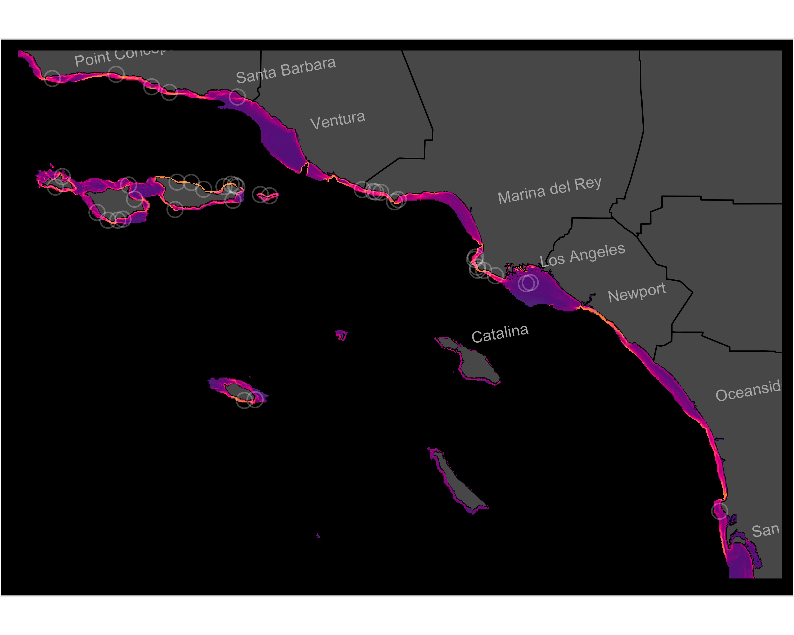
Figure S13. Individual-SDM for Sebastes auriculatus in the SCB. Model shown is the best-fit model (Table 1) of 12 candidate models. White circles show all observations from natural reefs included in the training and test datasets.
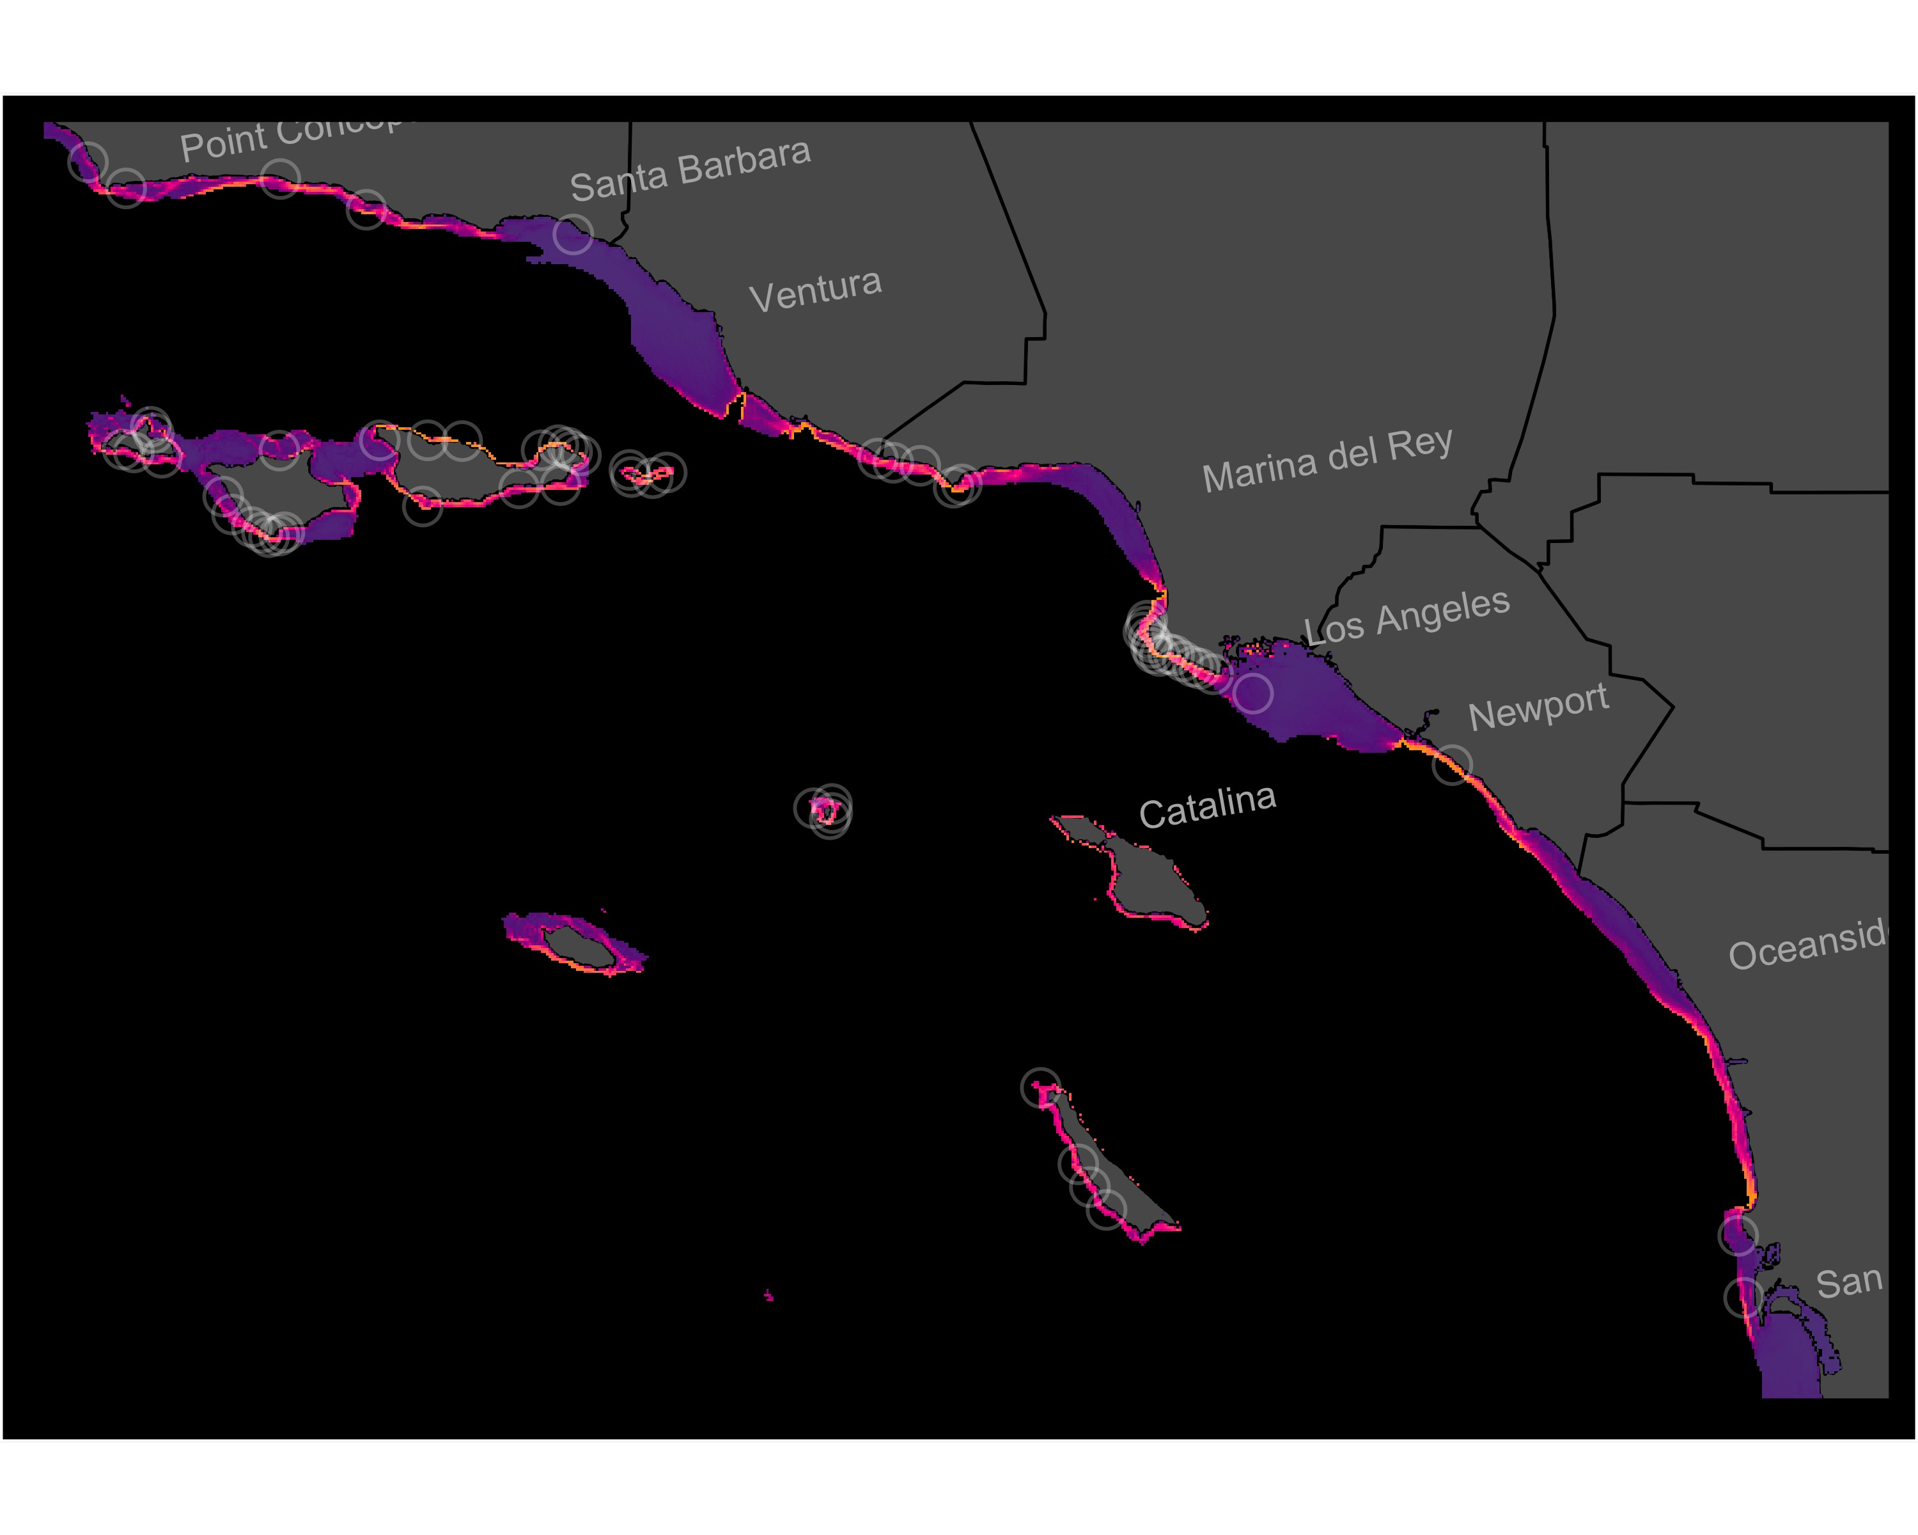
Figure S14. Individual-SDM for Sebastes carnatus in the SCB. Model shown is the best-fit model (Table 1) of 12 candidate models. White circles show all observations from natural reefs included in the training and test datasets.
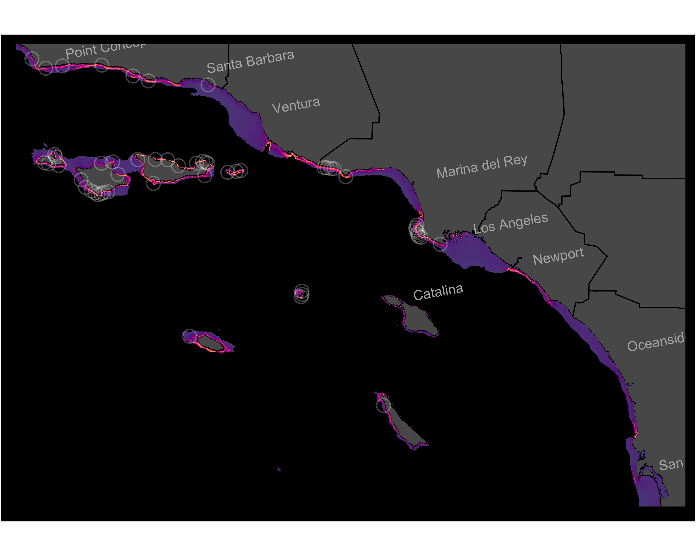
Figure S15. Individual-SDM for Sebastes caurinus in the SCB. Model shown is the best-fit model (Table 1) of 12 candidate models. White circles show all observations from natural reefs included in the training and test datasets.
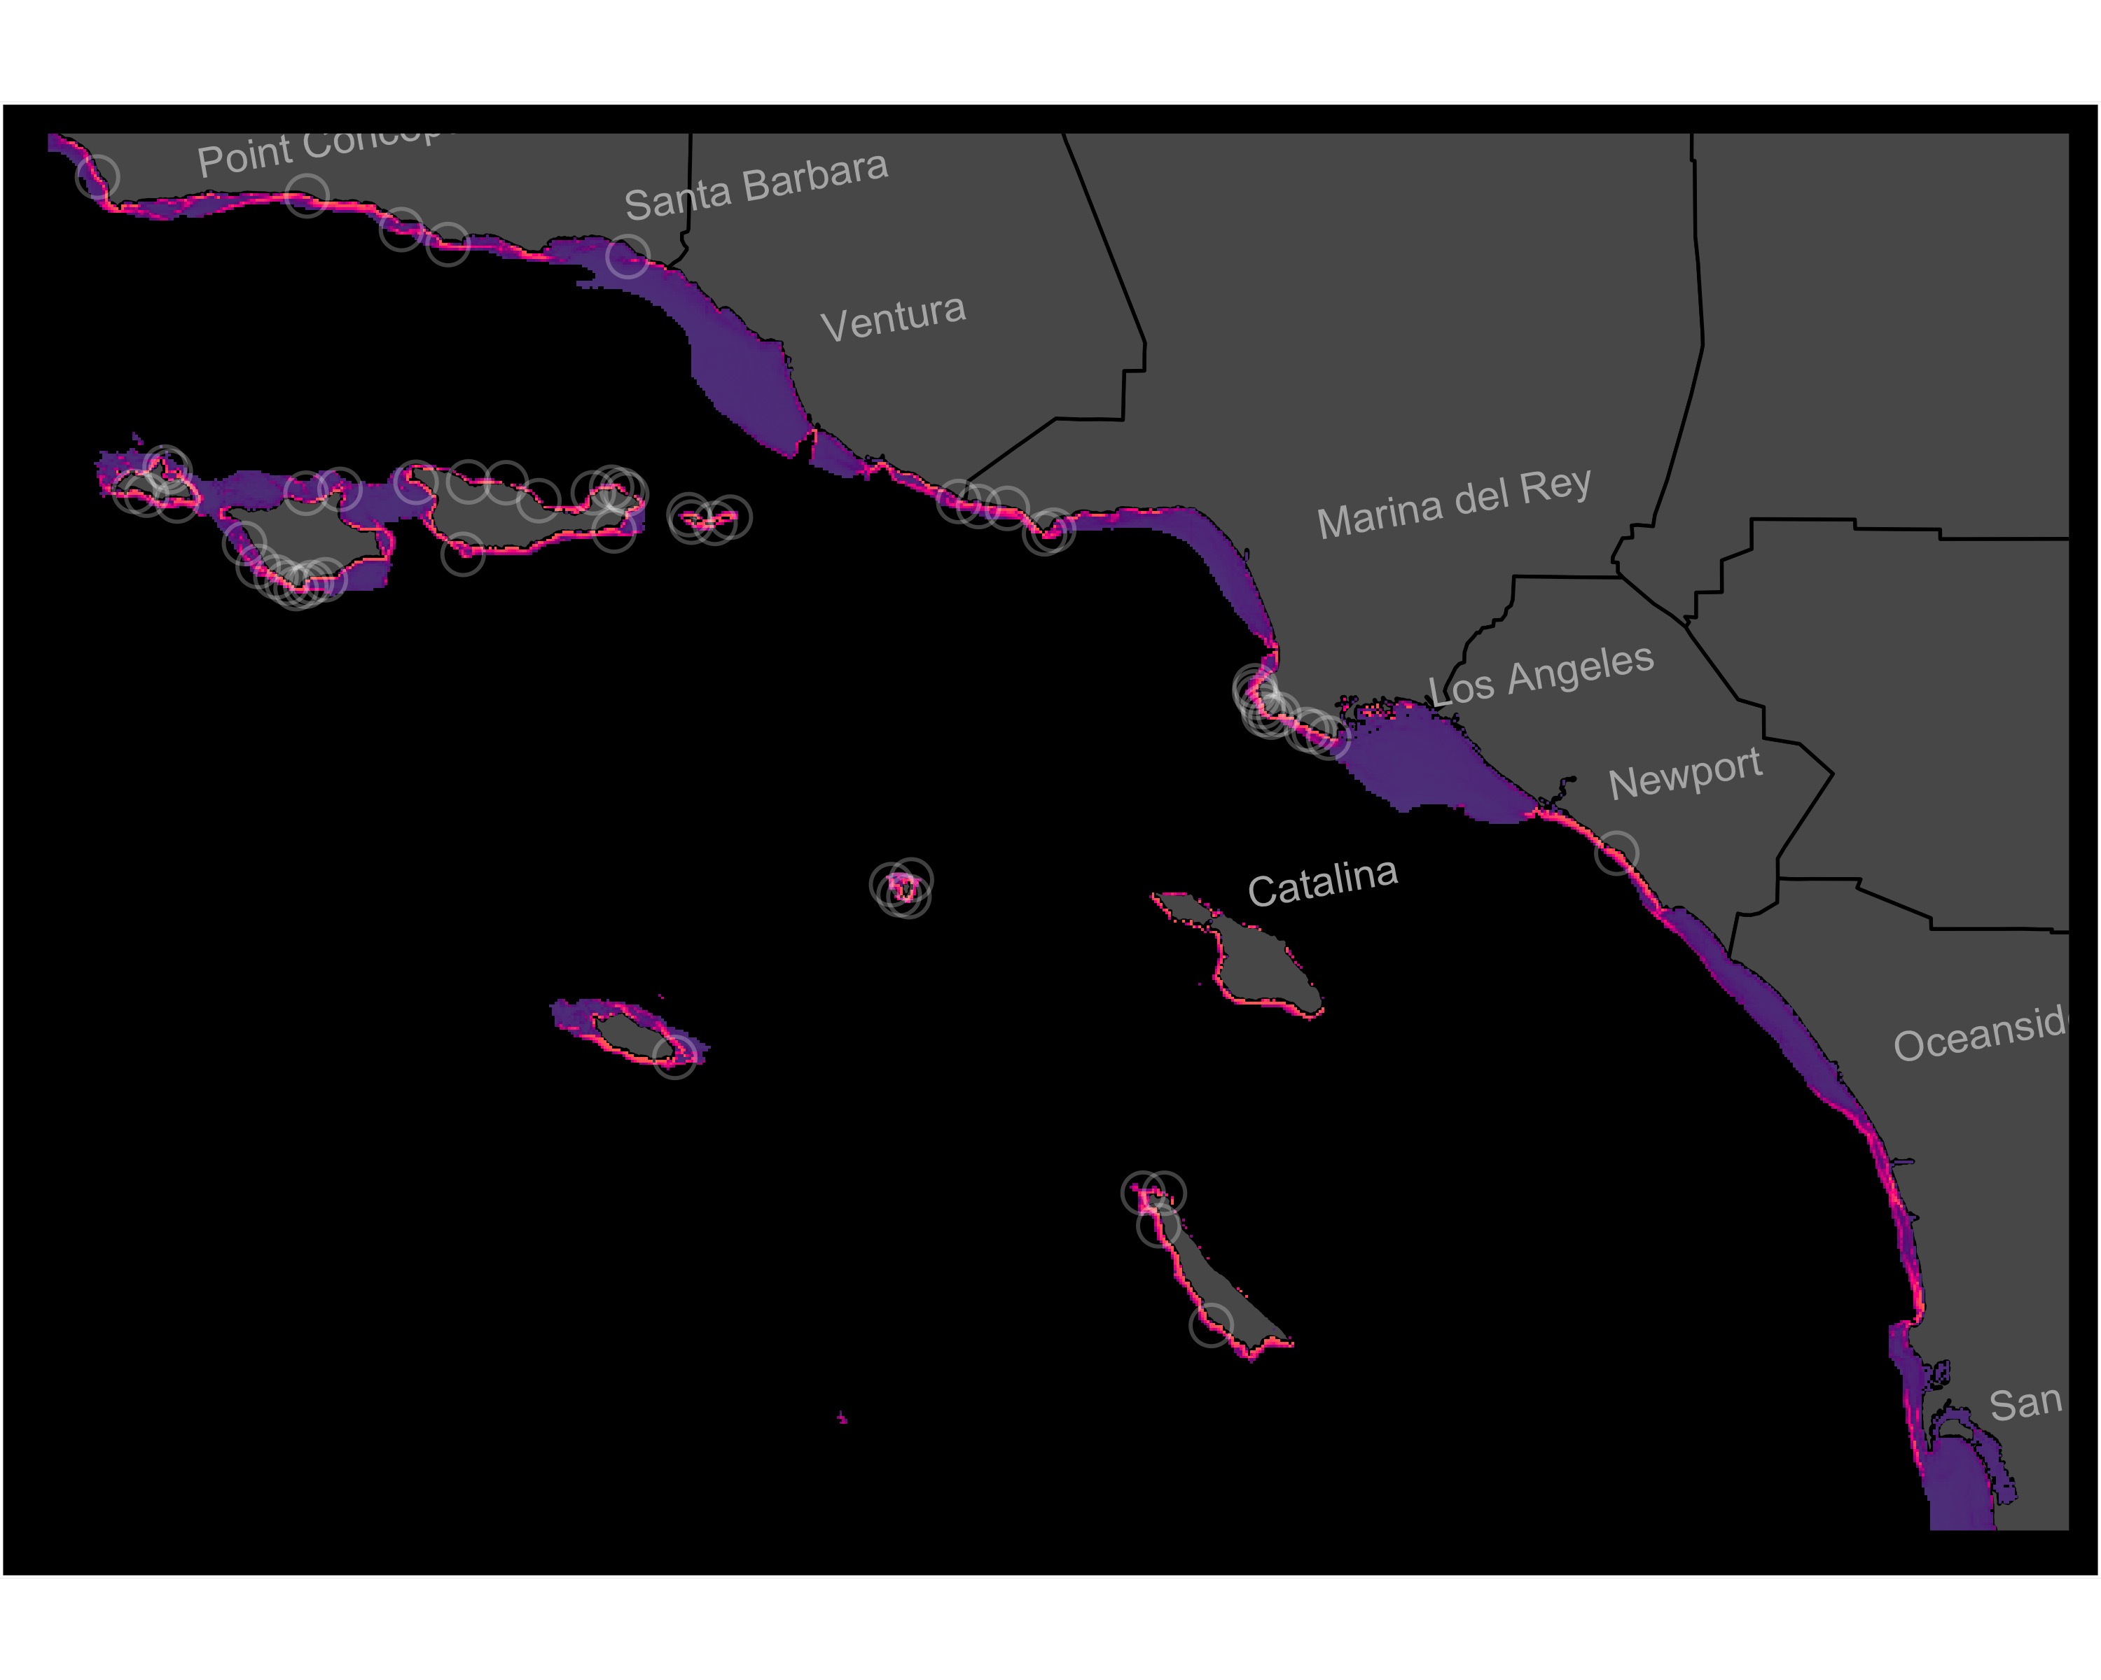
Figure S16. Individual-SDM for Sebastes chrysomelas in the SCB. Model shown is the best-fit model (Table 1) of 12 candidate models. White circles show all observations from natural reefs included in the training and test datasets.
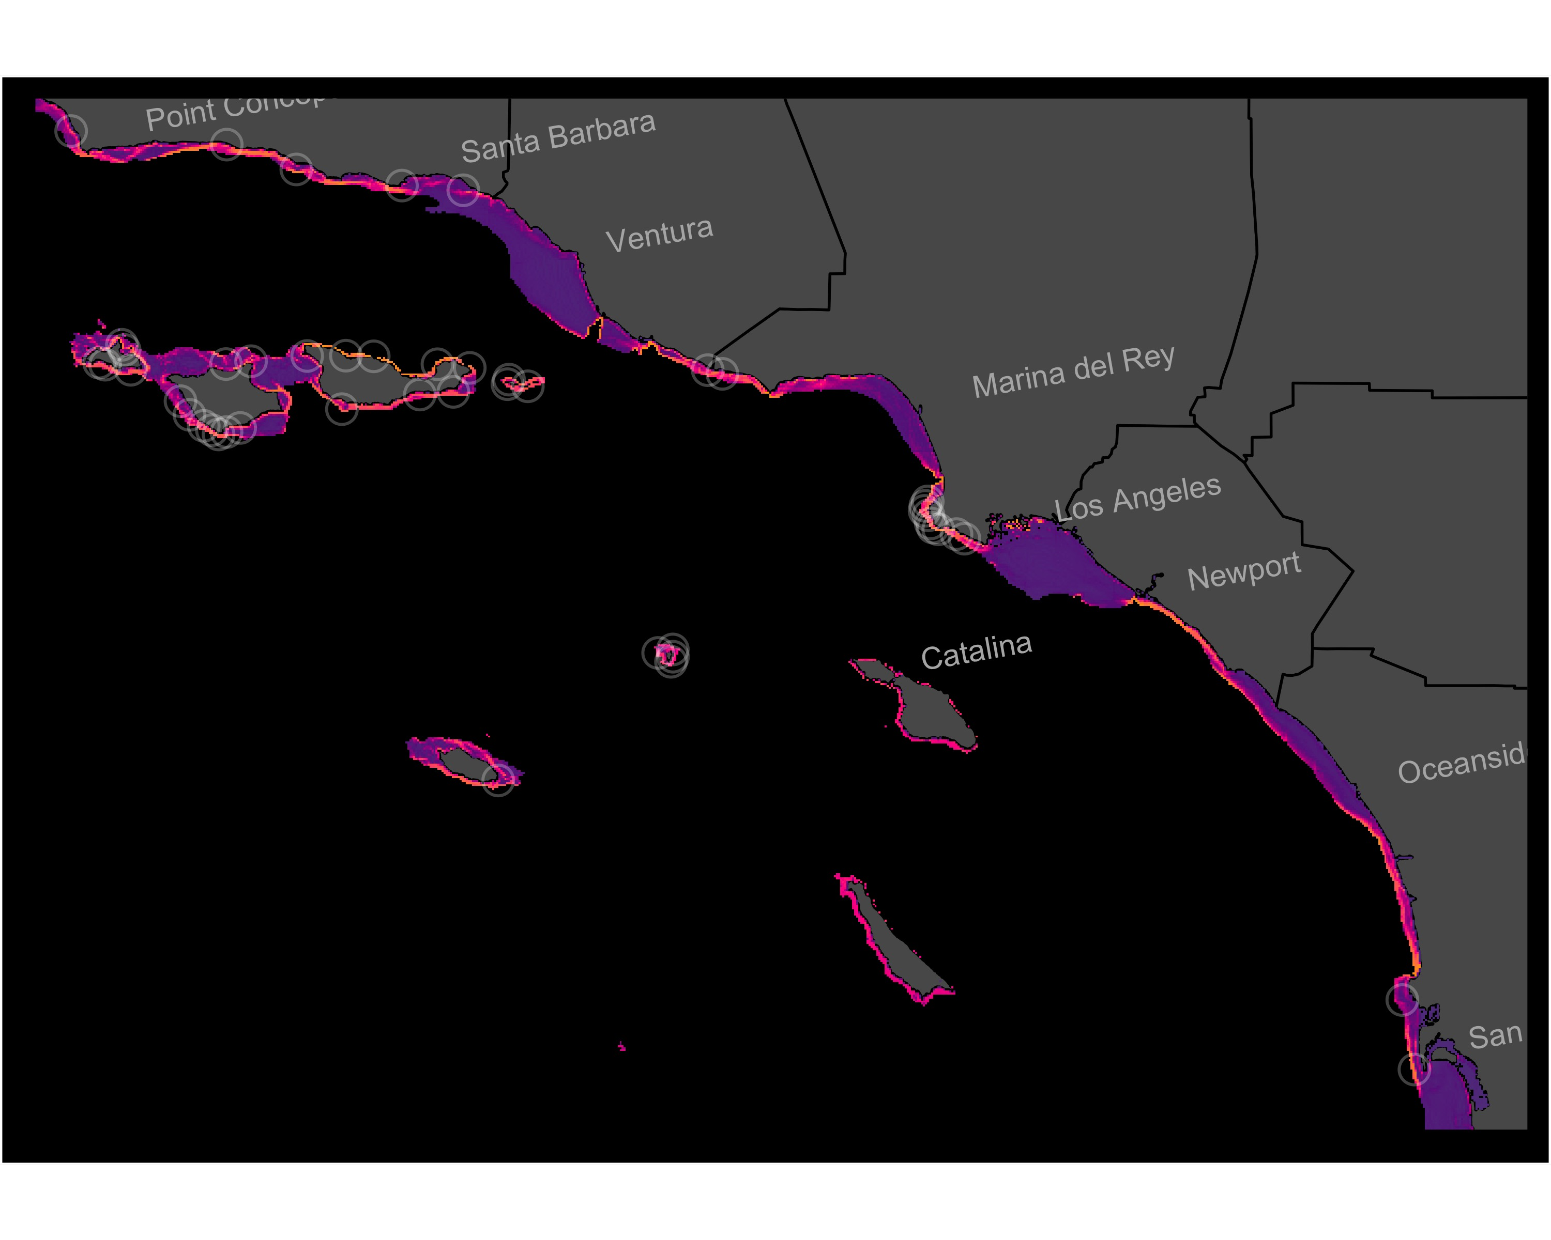
Figure S17. Individual-SDM for Sebastes miniatus in the SCB. Model shown is the best-fit model (Table 1) of 12 candidate models. White circles show all observations from natural reefs included in the training and test datasets.
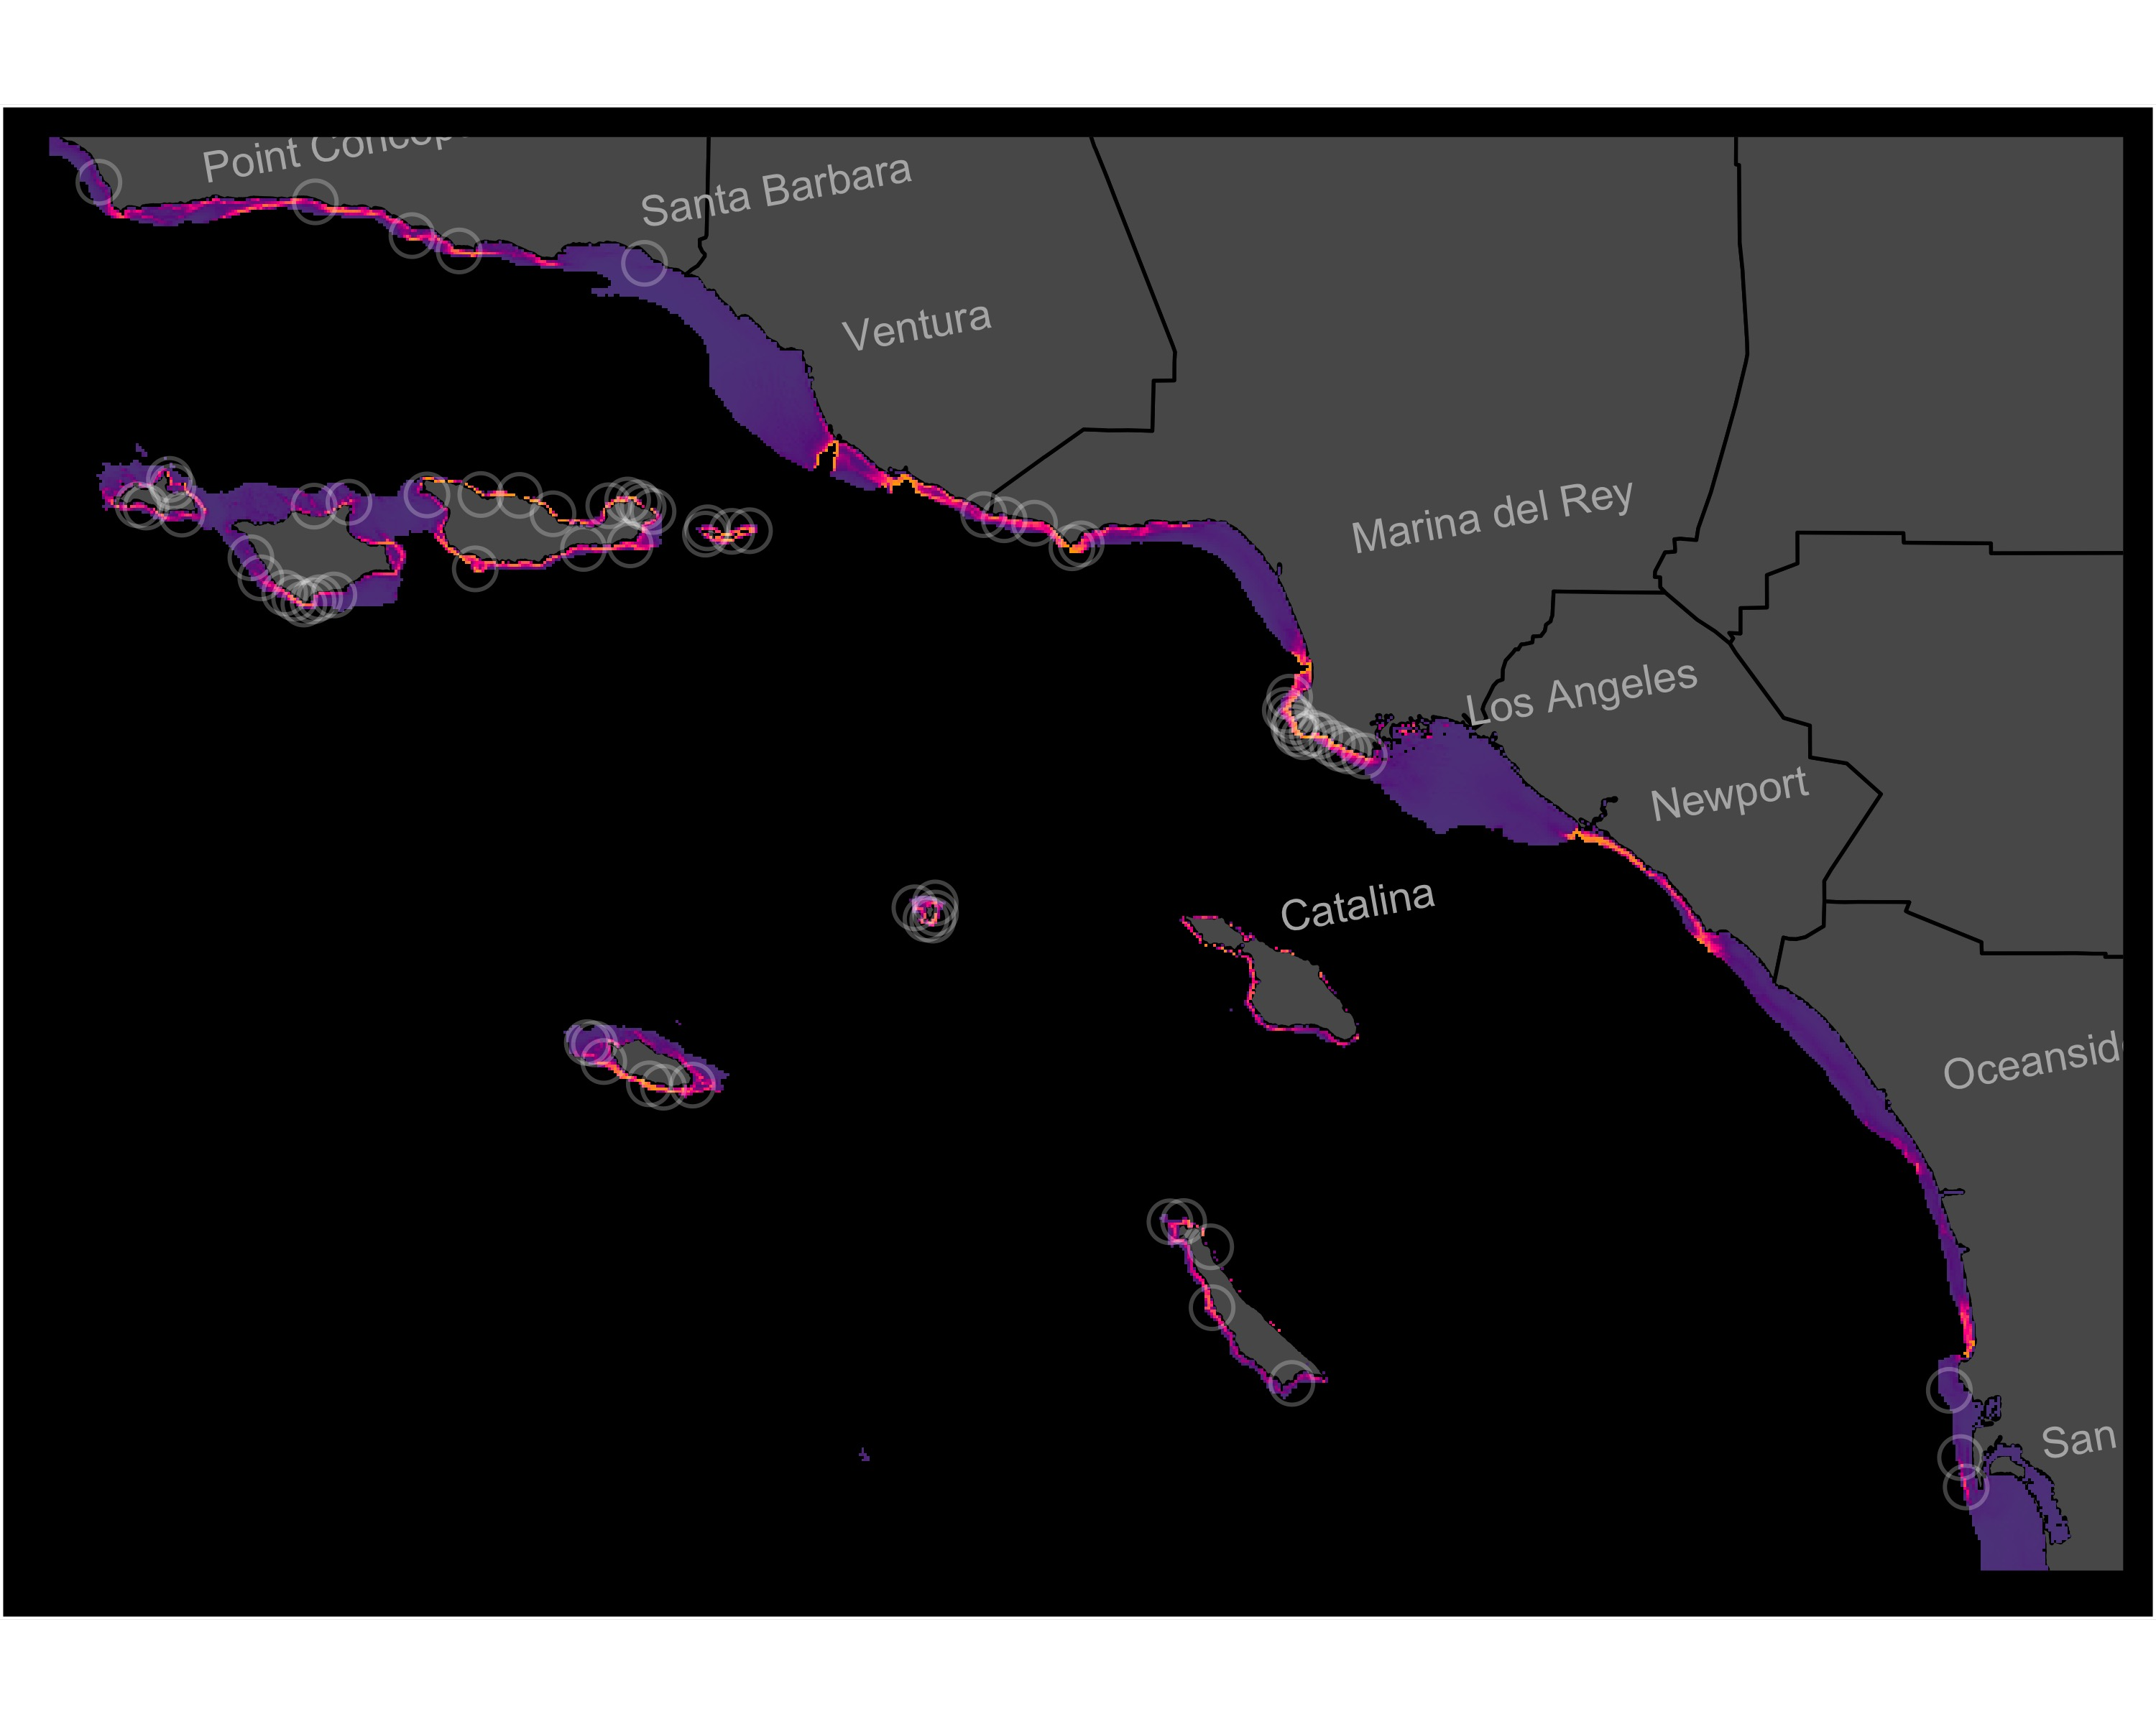
Figure S18. Individual-SDM for Sebastes mystinus in the SCB. Model shown is the best-fit model (Table 1) of 12 candidate models. White circles show all observations from natural reefs included in the training and test datasets.
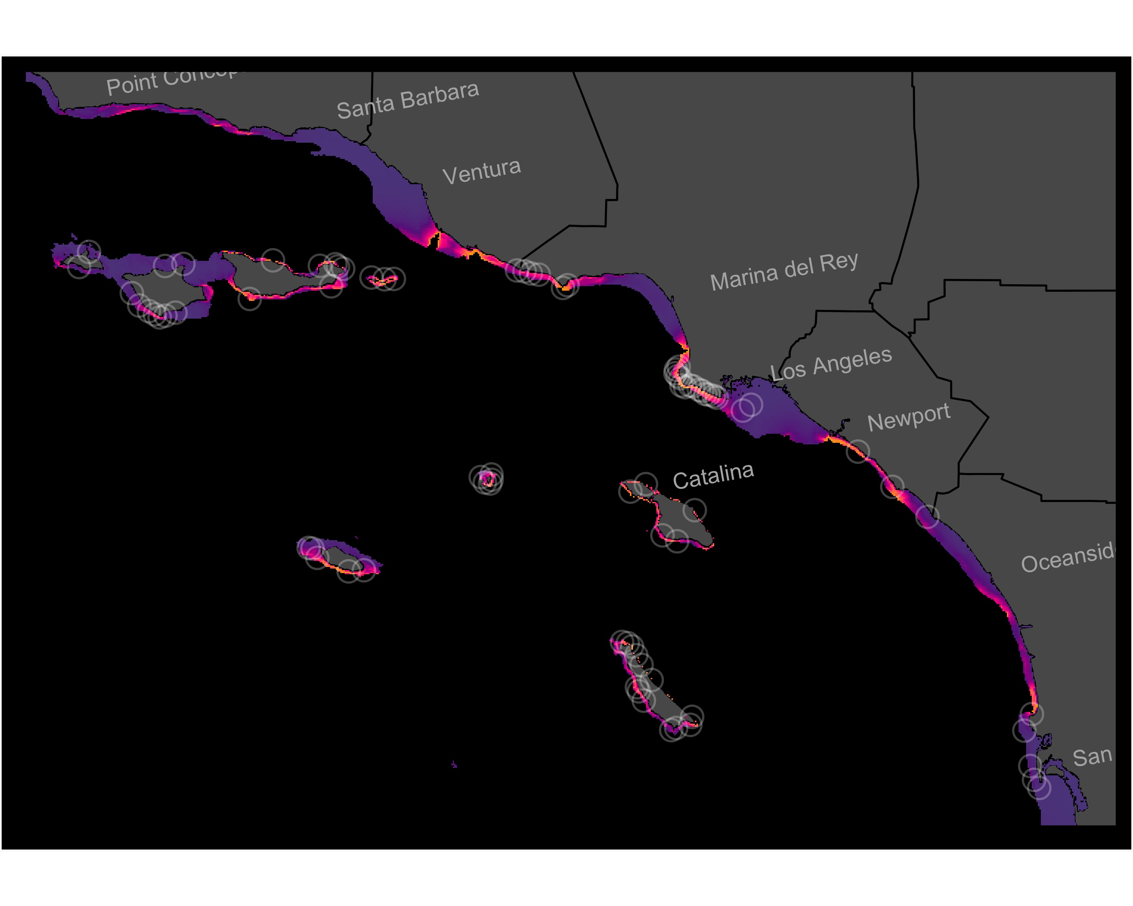
Figure S19. Individual-SDM for Sebastes serranoides in the SCB. Model shown is the best-fit model (Table 1) of 12 candidate models. White circles show all observations from natural reefs included in the training and test datasets.
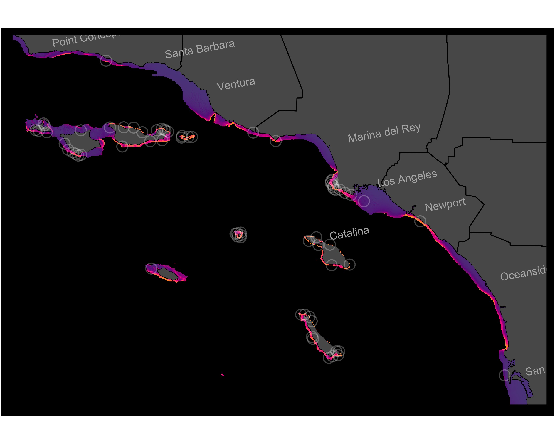
Figure S20. Individual-SDM for Sebastes serriceps in the SCB. Model shown is the best-fit model (Table 1) of 12 candidate models. White circles show all observations from natural reefs included in the training and test datasets.
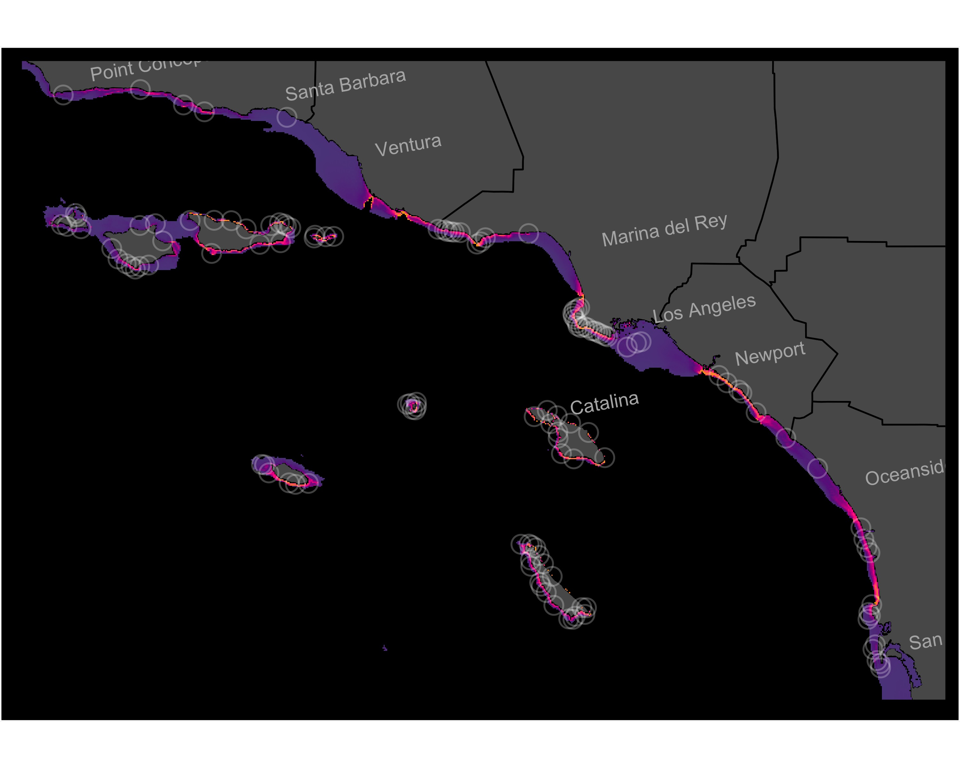
Figure S21. Individual-SDM for Semicossyphus pulcher in the SCB. Model shown is the best-fit model (Table 1) of 12 candidate models. White circles show all observations from natural reefs included in the training and test datasets.

