Supplementary material
MKRN3 interacts with proteins implicated in puberty timing including OTUD4 and LIN28B and does not directly influence GNRH1 expression
Venkatram Yellapragada, Xiaonan Liu, Carina Lund, Johanna Känsäkoski, Kristiina Pulli, Sanna Vuoristo, Karolina Lundin, Timo Tuuri, Markku Varjosalo*, Taneli Raivio*
*Authors contributed equally
Correspondence: taneli.raivio@helsinki.fi

- Supplementary data

  - Guide RNA production (gRNA-PCR)
The gRNA PCR components used are 1 ng of U6 promoter, 1 ng of U6 terminator, 50 pmol of forward and reverse primer together with 2 pmol guide oligo in a 100 µl reaction. The conditions for PCR program are 35 cycles of 98°C for 10 s, 52°C for 30 s and 72°C for 12 s. The PCR amplified guides were then purified and concentration was measured before transfection.
  - MKRN3 KO Screening PCRs
All the screening PCRs were performed using Amplitaq gold DNA polymerase and a regular PCR program consisting 40 cycles of 98°C for 1 min, 60°C for 1 min and 72°C for 1 min.
  - Real-time quantitative PCR (qPCR)
Real-time quantitative PCR included 25ng of first-strand cDNA, HOT FIREPol® EvaGreen® qPCR Mix Plus (Solis BioDyne), and 0.5 µM forward and reverse primers. Reactions were performed in a LightCycler® 480 (Roche) for 45-50 cycles of 95°C for 15 s, 60°C for 20 s and 72°C for 20 s.
  - RT-PCR
RT PCRs were performed as per the manufacturer’s instructions (BIO-RAD iScript™) and 5 min at 25°C, 20 min at 46°C and 1 min at 95°C as PCR conditions

- Supplementary Figures and Tables
2.1 Supplementary Figures

2.1.1 Supplementary Figure 1.
An alignment image from the IGV software. WT MKRN3 gene is shown at the bottom (blue bar), alignment of targeted sequence reads indicates the presence of bi-allelic deletion of MKRN3 (indicated by blue block arrows) in Del 1 MKRN3 KO human pluripotent stem cell line.

2.1.2 Supplementary Figure 2.
An alignment image from the IGV software. WT MKRN3 gene is shown at the bottom (blue bar), alignment of targeted sequence reads indicates the presence of bi-allelic deletion of MKRN3 (indicated by blue block arrows) in Del 2 MKRN3 KO human pluripotent stem cell line.

2.1.3 Supplementary Figure 3.
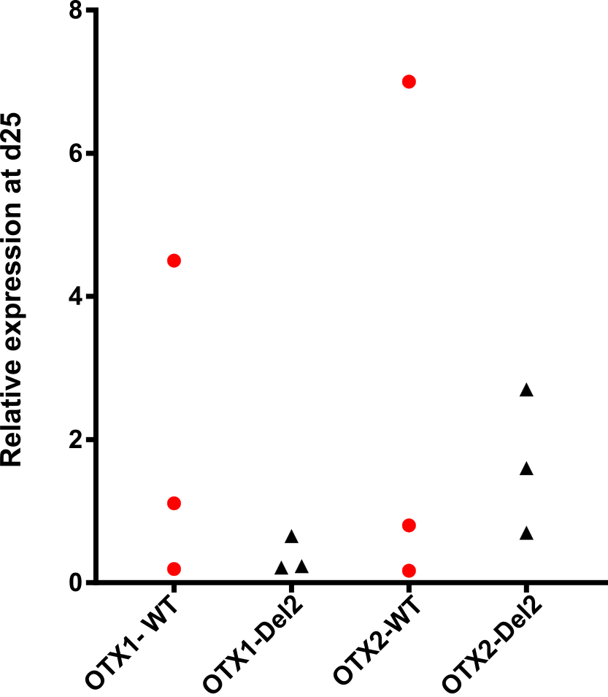

Relative OTX1 and OTX2 expression levels from the WT (n=3) and MKRN3 KO (Del 2) (n=3) cells at day 25 of GnRH differentiation protocol.

2.2 Supplemental Tables
2.2.1 Supplementary table 1
CRISPR/Cas9 related RNA oligos, U6 components and primers
2.2.2 Supplementary table 2
All the primers used for targeted sequencing, KO screening and qPCRs
2.2.3 Supplementary table 3
Antibodies used in the study
2.2.4 Supplementary table 4
Complete list of MKRN3 HCIs

All the four supplementary tables are appended in the supplementary tables excel sheet.

