SUPPLEMENTARY MATERIALS

Isolation and purification of S. aureus type 5 and type 8 capsular polysaccharides
S. aureus was grown in solid medium to provide a bacterial suspension of 600-800 mL. 30-50 g of wet cell pellet was collected by centrifugation at 8,000 rpm. The harvested pellet was washed three times with 50 mM Tris+2 mM MgSO₄ pH 7.5, suspended in MilliQ water (0.5-0.6 g/mL) and stirred vigorously while the temperature was increased to 100ºC. Acetic acid was then added to a final concentration of 1% and the mixture was incubated at 100ºC for 2 hours. The mixture was neutralized with 1 M NaOH and centrifuged at 8,000 rpm. The supernatant was separated and added to 0.05 mg/ml of DNase/RNase (Sigma-Aldrich). The mixture was incubated for 5-7 hours at 37°C, and the supernatant was recovered by centrifugation at 8,000 rpm. 180 U/ml of mutanolysin (Sigma-Aldrich) was added to the suspension and the mixture incubated overnight (~16 hours) at 37°C with gentle stirring. The supernatant was recovered by centrifugation at 8,000 rpm and dia-filtered by tangential flow filtration (TFF) using a Tandem mod. 1082 SartoriusTM system 5 and a 30 kDa cut-off membrane (Hydrosart Sartocon Slice 200, Sartorius), against 10 volumes of 1 M NaCl followed by 10 volumes of 10 mM sodium phosphate pH 7.2 buffer.
The dia-filtration retentate solution was further purified by anionic exchange chromatography, using a DEAE SepharoseTM Fast Flow resin (G&E Healthcare) equilibrated with 10 mM sodium phosphate buffer pH 7.2. The sample was loaded at a concentration of 10 mM sodium phosphate pH 7.2, and 0-1 M NaCl gradient in 20 column volumes was applied for material elution. Chromatographic fractions were analyzed by ¹H-NMR and those containing capsular polysaccharide were dia-filtered by TFF using a Tandem mod. 1082 SartoriusTM system 5 and a 30 kDa cut-off membrane (Hydrosart Sartocon Slice 200, Sartorius), against 10 volumes of distilled water to remove residual salts. Purified polysaccharide was characterized for protein, nucleic acid, and peptidoglycan residual content.

Characterization of S. aureus type 5 and type 8 capsular polysaccharides

Protein and nucleic acid content
The protein concentration was estimated by MicroBCA, Lowery and Bradford protein assay kits, using bovine serum albumin (BSA) as a reference (Thermo Scientific).
Nucleic acid content was determined by UV spectroscopy at a wavelength of 260 nm.

Identity and conformity
The structure of collected polysaccharides was determined by ¹H-NMR. Samples were dissolved in deuterium oxide (D₂O, 99.9% atom D, Aldrich). ¹H spectra were recorded by a Bruker Avance III 400 MHz at 25°C, using a 5-mm broadband probe (Bruker). The transmitter was set at the HDO frequency which was also used as a reference signal (4.79 ppm). Monodimensional proton NMR spectra were collected using a standard one-pulse experiment. The TOPSPIN 2.1 software package (Bruker) was used for data acquisition and processing of spectra.

Peptidoglycan content
Peptidoglycan content was quantified by amino acid analysis, performed using a High Performance Anionic Exchange Chromatography-Pulsed Amperometric Detection (HPAEC-PAD) method. Briefly, this analysis consisted of an acid hydrolysis “in vacuum” with 6 M HCl for 24 hours at 112°C, followed by chromatographic analysis using HPAEC-PAD equipped with AminoPac PA1 (Thermo) column and gradient elution in sodium acetate/NaOH. The chromatographic quantification was performed using a standard solution of amino acids in the concentration range 2.5-50 μM.

Staphylococcal Protein Microarray construction, imaging and data analysis
A protein array of recombinant S. aureus antigens was generated as previously described (Scietti L., et al 2016). Briefly, S. aureus antigens were expressed in Escherichia coli as His6- or GST-tagged recombinant proteins, purified from the cytoplasmic fraction as soluble forms as previously described (Bagnoli 2015; Scietti 2016; Roche 2003; O’Connell 1998). Recombinant antigens were spotted in 8 replicates on nitrocellulose-coated slides (FAST slides, Maine Manufacturing) using the no-contact Marathon Spotter (Arrayjet, Edinburgh, UK) resulting in spots of ~100 μm in diameter. A standard curve made of eight concentrations (twofold dilution from 0.5 to 0.004 mg/ml) of fluorescent Human IgG was used to assess comparison of replicate experiments.
Preliminary slide validation experiments, in which the slides were probed with mouse anti-GST and anti-6xHis monoclonal antibodies followed by detection with AlexaFluor®647-conjugated anti-mouse IgG secondary antibody (Jackson Immunoresearch), were performed to confirm the efficiency and reproducibility of the protein deposition on the chips. Nonspecific binding was minimized by preincubating protein or peptide microarray slides with a blocking solution (BlockIt, ArrayIt) for 1 hour. Sera were diluted 1:1000 in BlockIt buffer and overlaid on the protein and peptide arrays, respectively, for 1 h, at room temperature. AlexaFluor®647-conjugated anti-human IgG secondary antibody (Jackson Immunoresearch) was added for 1 h at room temperature in the dark, before proceeding with slide scanning. Fluorescence signals were detected using a confocal laser scanner (Power Scanner, Tecan Trading AG, Switzerland), and the 16-bit images were generated with PowerScanner software v1.2 at 10 μm/pixel resolution and processed using ImaGene 9.0 software (Biodiscovery Inc, CA). Elaboration and analysis of image raw fluorescence Intensity (FI) data were performed using in-house developed software and R scripts version 3.3.3 (https://cran.r-project.org/). For each serum sample the mean fluorescence intensity (MFI) of replicate spots was determined by subtraction of the background value surrounding each spot.

Calibration, dimensionality reduction and background filtering of protein chip MFI raw data

Calibration
Let MFI_{ijr} be replicate r=1,...,R mean fluorescence intensity (MFI) measured from the serum of subject i=1,...,I against antigen j=1,...,J. These measurements were generated for all subjects at the fixed serum dilution 1:1000. A total of 8 replicate measurements were obtained for each S. aureus antigen. Also, let MFI_{ird} denote the MFI of the secondary human IgG antibodies diluted by a factor d=1,...,D. Secondary IgG MFIs were measured at each of eight dilution points and for each subject over 12 replicates. Calibration consisted in: i) fitting a dilution-MFI curve to the secondary IgG MFIs of each subject and b) mapping the MFIs measured against the S. aureus antigens onto their fitted subject-specific secondary IgG concentration. Dilution-response curves of different subjects can be different, due to the combination of technical factors including the characteristics of secondary IgGs used to measure different subjects as well as the variation in performance of the photo-detectors over time. Mapping of each antigen’s MFI onto its corresponding secondary IgG concentration normalized the mapped concentrations with respect to these sources of subject-to-subject variations.
The dilution-MFI model used for calibration was:
log₂(MFI_{ird}) ~ Normal(M_{id},SD_{id}) , (1)
where Normal(M,SD) denotes a Gaussian random variable with mean M and standard deviation SD and the mean was specified using the 4-parameters Emax model
M_{id} = α_{i} + (β_{i} -α _{i})/(1+e^{(γi-log2(d))/δi}), (2)
where the subject-specific calibration parameters define the lower and upper asymptotes (α_{i} and β_{i} respectively), mid-point (γ_{i}) and slope (δ_{i}) of the mean MFI function. The standard deviation was defined as being proportional to the derivative of the mean function with respect to its dilution factor
SD_{id} = h_{i} ∂ M_{id}/∂d, (3)
reflecting a serum-specific reduction in MFI variability due to assay saturation. Numerical maximum likelihood estimates of the calibration model parameters (α_{i}, β_{i}, γ_{i}, δ_{i}, h_{i}) were calculated by letting the 12 replicate measurements at each dilution be conditionally independent random variables. Figure S.1 illustrates the results of this calibration process using the measured anti-human IgG MFIs for two illustrative subjects. MFI data are depicted in black in Figure 1, showing more variability away from the asymptotes of the calibration curve consistent with (3). Dashed lines in Figure S.1 delimit the point-wise 95% probability bands around the central estimate of the mean function.
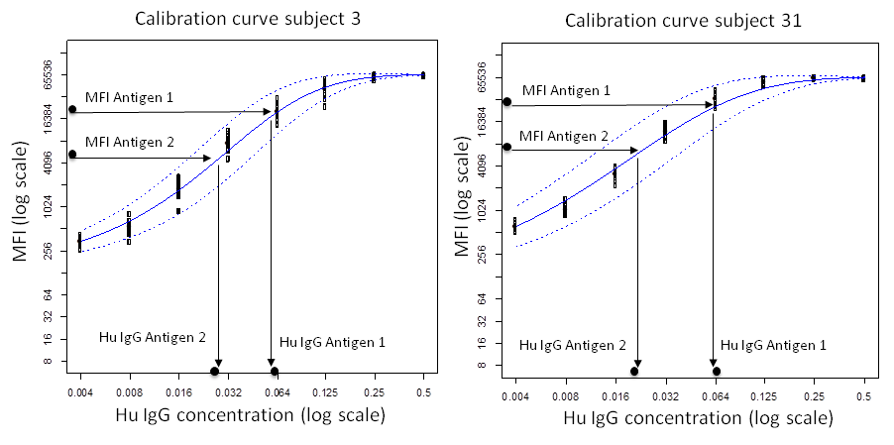
Figure S.1: Calibration of raw MFI data through mapping onto their corresponding human IgG secondary antibody concentration for the two illustrative study subjects 3 and 31.

Dimensionality reduction
Let c_{ijr} = M_{id}⁻¹(MFI_{ijr} | α_{i}, β_{i}, γ_{i}, δ_{i}) be the calibrated IgG level of replicate r=1,...,R MFI for subject i=1,...,I against antigen j=1,...,J. The superscript “-1” here is used to denote the inverse of the mean calibration function (2). Dimensionality reduction consisted in mapping the values (c_{ij1},...,c_{ij8}) into one value c_{ij} of the IgG level for subject i against antigen j using the median of the eight replicate IgG levels. Median levels were used due to their robustness to outlying values compared to mean estimates.

Background filtering
Calibration and dimensionality reduction were performed both for the MFI measurements taken from the centre of each protein array spot and from its outer ring. Calibrated outer ring IgG levels were then used to assess the level of background noise affecting the measurements taken from the centre of the array spots. To this end, for each antigen, if an IgG level was smaller or equal to the 95th percentile of the background distribution (depicted in Figure S.2) it was excluded from further analysis.
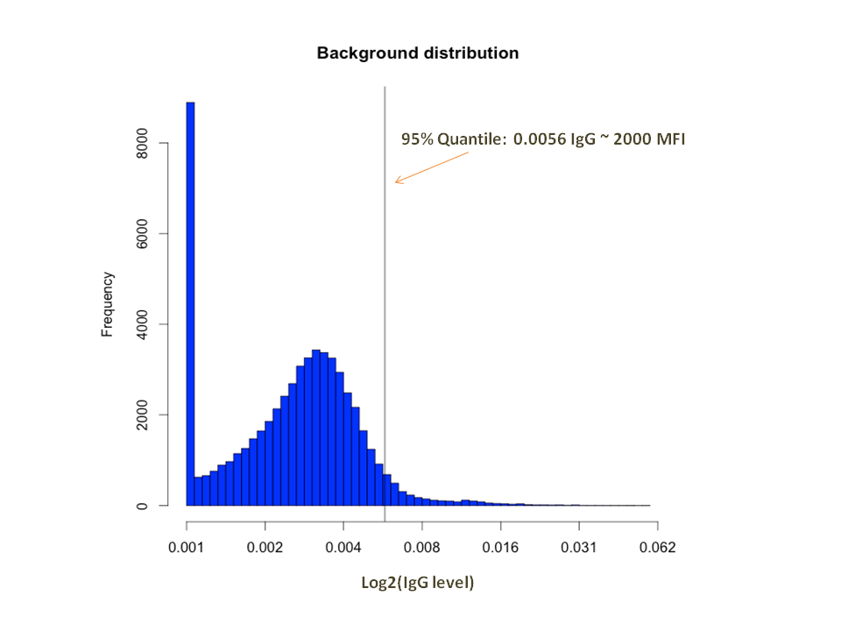
Figure S.2: Frequency distribution of the background IgG levels measured from the outer ring of each protein array spot. The background filtering level of 0.0056 μg/mL applied to the data was the estimated 95% quantile of this background distribution

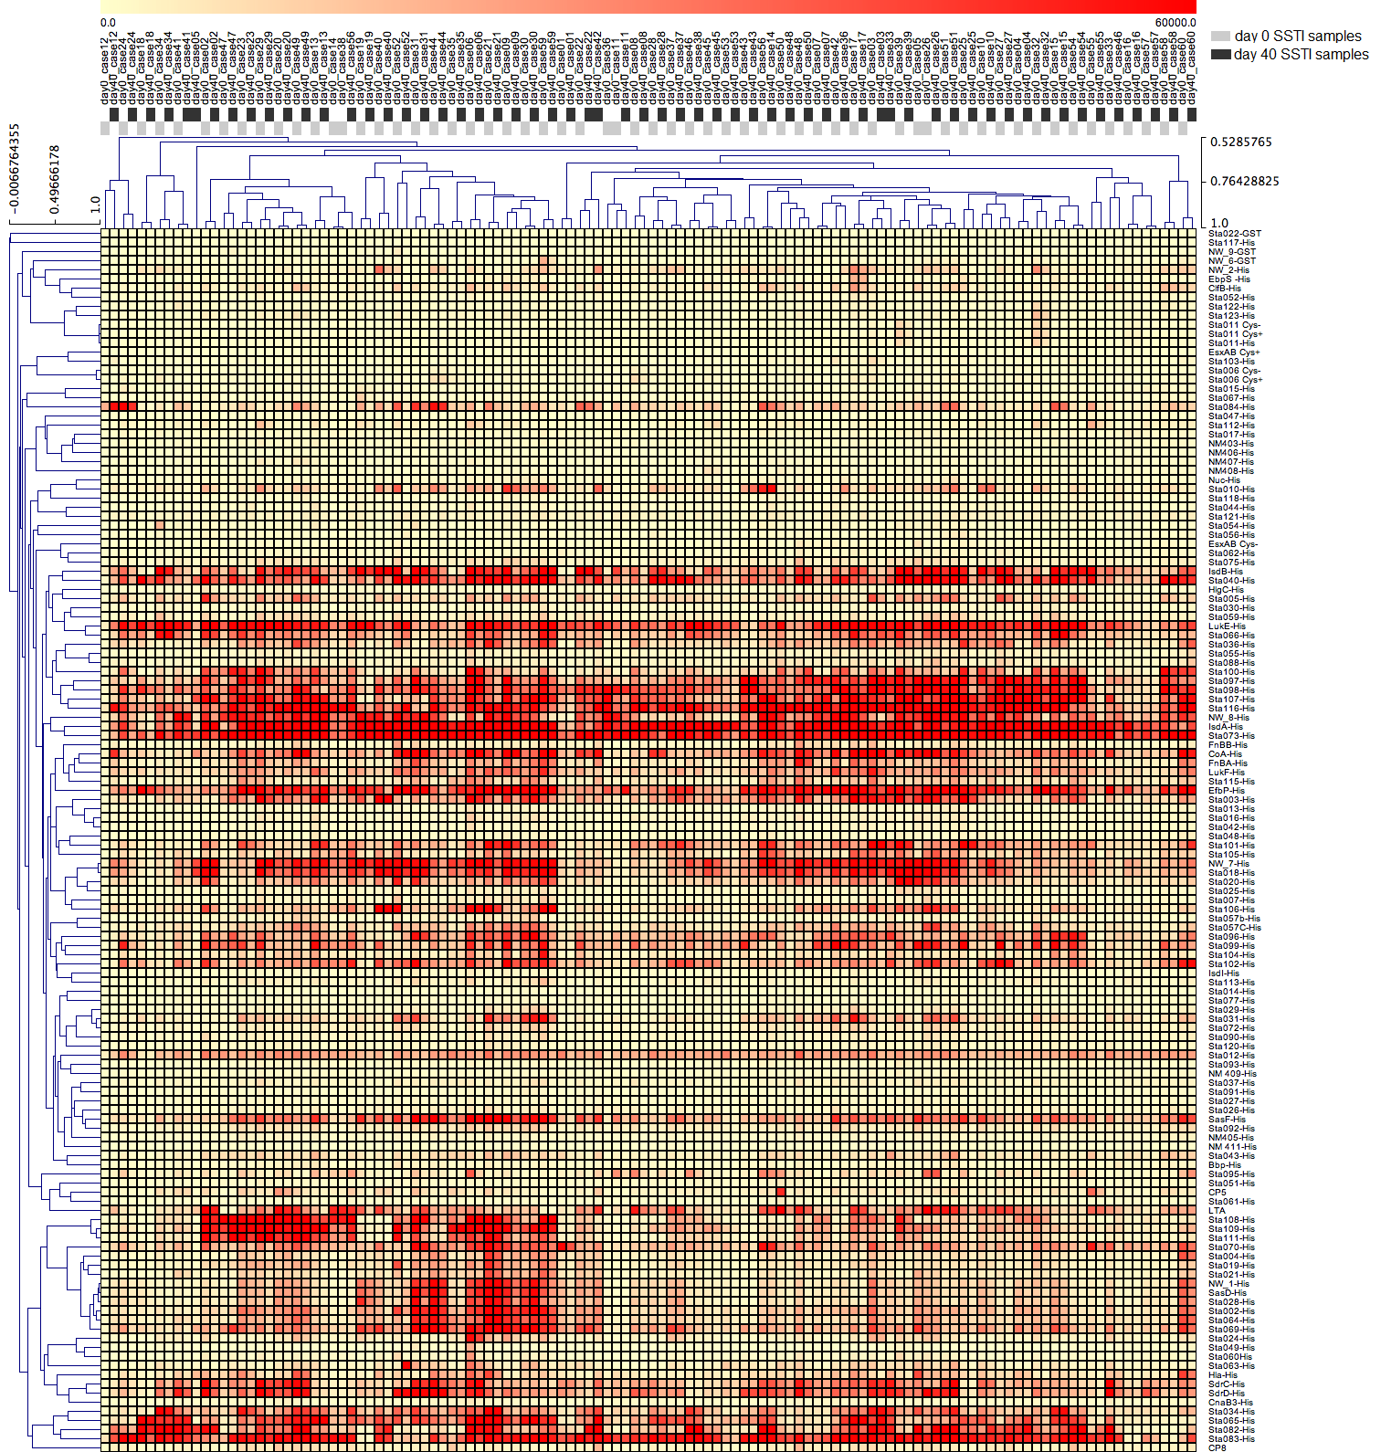
Figure S.3: Agglomerative clustering of the 60 SSTI samples at D0 (grey at the top of this figure) and D40 (black at the top of this figure) showing that the MFI data measured across all antigens in samples pertaining to the same subject were more similar to each other compared to the MFIs measured from different individuals for 53/60 ≈ 88% subjects (dendrogram at top of the figure). Also, horizontal red bands showed reactivity of the SSTI case sera with many of the 134 S. aureus antigens on the MFI scale

Table S.1: Antigens presented in Figure 3, indicating serum groups (case D0 and D40, and controls) differing in IgG levels and for each antigen, the locus tag, product name, and location in bacterial cell
Association | Locus_tag | Protein Product | Localization
D0-Controls | HlgC (SAOUHSC_02709 | Gamma-hemolysin component C (Leukocidin s subunit) | SUBCELLULAR LOCATION: Secreted {ECO:0000269|PubMed:20472795}.
D0-Controls | LTA
D0-Controls | Nuc  (SAOUHSC_01316) | Uncharacterized protein
D0-Controls | SAOUHSC_00661 | Uncharacterized protein
D0-Controls | SAOUHSC_01085 | High-affinity heme uptake system protein IsdE (Iron-regulated surface determinant protein E) (Staphylococcal iron-regulated protein F) | SUBCELLULAR LOCATION: Cell membrane {ECO:0000255|PROSITE-ProRule:PRU00303}; Lipid-anchor {ECO:0000255|PROSITE-ProRule:PRU00303}.
D0-Controls | SAOUHSC_01920 | Uncharacterized protein | Unknown
D0-Controls | SAOUHSC_00391 | Uncharacterized protein | Unknown
D0-Controls | SAOUHSC_00354 | Uncharacterized protein | Unknown
D0-Controls & D0-D40 | SAOUHSC_01127 | Uncharacterized protein | Unknown
D0-Controls & D0-D40 | SAOUHSC_00808 | Uncharacterized protein | Unknown
D0-Controls & D0-D40 | SAOUHSC_00390 | Uncharacterized protein | Unknown
D0-D40 | Coa  (SAOUHSC_00192) | Coagulase | Unknown
D0-D40 | FnBB  (SAOUHSC_02802) | Fibronectin binding protein B, putative | SUBCELLULAR LOCATION: Secreted, cell wall {ECO:0000256|SAAS:SAAS00753613}; Peptidoglycan-anchor {ECO:0000256|SAAS:SAAS00753613}.
D0-D40 | Csa3F  (NWMN_0408) | Staphylococcal tandem lipoprotein | Unknown
D0-D40 | SasF  (SAOUHSC_02982) | Uncharacterized protein | Unknown
D0-D40 | SAOUHSC_00171 | Gamma-glutamyltranspeptidase, putative (EC 2.3.2.2) | Unknown
D0-D40 | Csa3B  (SAOUHSC_00404) | Uncharacterized lipoprotein SAOUHSC_00404 | SUBCELLULAR LOCATION: Cell membrane {ECO:0000255|PROSITE-ProRule:PRU00303}; Lipid-anchor {ECO:0000255|PROSITE-ProRule:PRU00303}.
D0-D40 | SAOUHSC_02463 | Hyaluronate lyase (EC 4.2.2.1) (Hyaluronidase) (HYase) | SUBCELLULAR LOCATION: Secreted.
D0-D40 | SAOUHSC_00395 | Uncharacterized protein | Unknown
D0-D40 & D40-Controls | LukF  (SAOUHSC_02241) | Uncharacterized leukocidin-like protein 1 | SUBCELLULAR LOCATION: Secreted {ECO:0000269|PubMed:20472795}.
D0-D40 & D40-Controls | Csa1B  (SAOUHSC_00053) | Uncharacterized lipoprotein SAOUHSC_00053 | SUBCELLULAR LOCATION: Cell membrane {ECO:0000255|PROSITE-ProRule:PRU00303}; Lipid-anchor {ECO:0000255|PROSITE-ProRule:PRU00303}.
D40-Controls | IsdB  (SAOUHSC_01079) | Iron-regulated surface determinant protein B (Fur-regulated protein B) (Staphylococcal iron-regulated protein H) (Staphylococcus aureus surface protein J) | SUBCELLULAR LOCATION: Secreted, cell wall {ECO:0000255|PROSITE-ProRule:PRU00477}; Peptidoglycan-anchor {ECO:0000255|PROSITE-ProRule:PRU00477}.
D40-Controls | SAOUHSC_00170 | Uncharacterized protein | Unknown
D40-Controls | SAOUHSC_01972 | Foldase protein PrsA (EC 5.2.1.8) | SUBCELLULAR LOCATION: Cell membrane {ECO:0000255|HAMAP-Rule:MF_01145}; Lipid-anchor {ECO:0000255|HAMAP-Rule:MF_01145}.
HP, hypothetical protein
*D0 IgG<controls IgG; #D0 IgG<D40 IgG; $D40 IgG<controls IgG
Summary Table S.2: list of antigens whose IgG levels decreased the SSTI probabilities estimated by logistic regression when comparing D0-controls and D40-controls data, presented in rank order

Antigen IDs |  | Protein Product | Localization
all 60 SSTI cases | 30 culture-confirmed S. aureus SSTI cases
SAOUHSC_00107 |  | Uncharacterized protein | Unknown
Csa1D  (SAOUHSC_00055) |  | Uncharacterized lipoprotein SAOUHSC_00055 | SUBCELLULAR LOCATION: Cell membrane {ECO:0000255|PROSITE-ProRule:PRU00303}; Lipid-anchor {ECO:0000255|PROSITE-ProRule:PRU00303}.
SAOUHSC_00872 |  | Extramembranal protein | Unknown
SAOUHSC_02767 | SAOUHSC_02767 | Peptide ABC transporter, peptide-binding protein, putative | Unknown
SAOUHSC_02554 |  | Uncharacterized protein | Unknown
SAOUHSC_00808 |  | Uncharacterized protein | Unknown
SAOUHSC_01854 |  | Uncharacterized protein | Unknown
SAOUHSC_00137 |  | Uncharacterized protein | Unknown
CnaB3  (NWMN_0525) |  | Serine-aspartate repeat-containing protein E | SUBCELLULAR LOCATION: Secreted, cell wall {ECO:0000255|PROSITE-ProRule:PRU00477}; Peptidoglycan-anchor {ECO:0000255|PROSITE-ProRule:PRU00477}.
SAOUHSC_00817 |  | Uncharacterized protein
SAOUHSC_01150 | SAOUHSC_01150 | Cell division protein FtsZ | SUBCELLULAR LOCATION: Cytoplasm {ECO:0000255|HAMAP-Rule:MF_00909}. Note=Assembles at midcell at the inner surface of the cytoplasmic membrane. {ECO:0000255|HAMAP-Rule:MF_00909}.
Csa3G  (NWMN_0409) | Csa3G  (NWMN_0409) | Staphylococcal tandem lipoprotein | Unknown
SAOUHSC_01084 |  | Uncharacterized protein | Unknown
SAOUHSC_02708 |  | Gamma-hemolysin h-gamma-ii subunit, putative | Unknown
SAOUHSC_00389 |  | Uncharacterized protein | Unknown
SAOUHSC_01112 | SAOUHSC_01112 | FPRL1 inhibitory protein (FLIPr) | SUBCELLULAR LOCATION: Secreted {ECO:0000250}.
NWMN_1877 |  | Chemotaxis inhibitory protein (CHIPS) | SUBCELLULAR LOCATION: Secreted {ECO:0000269|PubMed:14993252}.
IsdI  (SAOUHSC_00130) |  | Heme oxygenase (staphylobilin-producing) 2 (EC 1.14.99.48) (Heme-degrading monooxygenase 2) (Iron-regulated surface determinant 2) (Iron-responsive surface determinant 2) | SUBCELLULAR LOCATION: Cytoplasm {ECO:0000255|HAMAP-Rule:MF_01272}.
NWMN_0757 | NWMN_0757 | Secreted von Willebrand factor-binding protein | Unknown
SAOUHSC_02979 |  | N-acetylmuramoyl-L-alanine amidase domain-containing protein SAOUHSC_02979 | SUBCELLULAR LOCATION: Secreted {ECO:0000269|PubMed:18621893, ECO:0000269|PubMed:20472795}.
Nuc  (SAOUHSC_01316) |  | Uncharacterized protein
SAOUHSC_00391 |  | Uncharacterized protein
Csa1A  (SAOUHSC_00052) |  | Uncharacterized lipoprotein SAOUHSC_00052 | SUBCELLULAR LOCATION: Cell membrane {ECO:0000255|PROSITE-ProRule:PRU00303}; Lipid-anchor {ECO:0000255|PROSITE-ProRule:PRU00303}.
SAOUHSC_00248 | SAOUHSC_00248 | Glycyl-glycine endopeptidase LytM (EC 3.4.24.75) (Autolysin LytM) | SUBCELLULAR LOCATION: Secreted {ECO:0000269|PubMed:10220159, ECO:0000269|PubMed:20472795}.
SdrC  (SAOUHSC_00544) |  | Serine-aspartate repeat-containing protein C | SUBCELLULAR LOCATION: Secreted, cell wall {ECO:0000255|PROSITE-ProRule:PRU00477}; Peptidoglycan-anchor {ECO:0000255|PROSITE-ProRule:PRU00477}.
IsdA  (SAOUHSC_01081) |  | Iron-regulated surface determinant protein A (Fur-regulated protein A) (Staphylococcal transferrin-binding protein A) | SUBCELLULAR LOCATION: Secreted, cell wall {ECO:0000305|PubMed:11952908}; Peptidoglycan-anchor {ECO:0000305|PubMed:11952908}.
Csa3I  (NWMN_0411) | Csa3I  (NWMN_0411) | Staphylococcal tandem lipoprotein | Unknown
Csa2A  (SAOUHSC_00172) | Csa2A  (SAOUHSC_00172) | Uncharacterized protein SAOUHSC_00172 | SUBCELLULAR LOCATION: Cell membrane {ECO:0000305}; Single-pass membrane protein {ECO:0000305}.
Csa3C(  NWMN_0405) | Csa3C  (NWMN_0405) | Truncated staphylococcal tandem lipoprotein | Unknown
SAOUHSC_01180 | SAOUHSC_01180 | Uncharacterized protein | Unknown
SAOUHSC_02571 | SAOUHSC_02571 | Staphylococcal secretory antigen ssaA2 | SUBCELLULAR LOCATION: Secreted {ECO:0000269|PubMed:20472795}.
SAOUHSC_00137 | SAOUHSC_00137 | Uncharacterized protein | Unknown
SAOUHSC_00106 | SAOUHSC_00106 | Uncharacterized protein | Unknown

Summary Table S.3: list of 134 antigens belonging to the S. aureus strain NCTC 8325 or Newman, produced in E. coli as recombinant His6- or GST-tagged proteins.

Locus_tag | Product Name UniprotDB | Psort-B | Gi | Product Name
CnaB  (NWMN_0525) | Protein domain clones from Serine-aspartate repeat-containing (SdrE) | Cell wall | 151220737 | Ser-Asp rich fibrinogen/bone sialoprotein-binding protein SdrE
NWMN_0757 | secreted von Willebrand factor-binding protein | Extracellular | 151220969 | secreted von Willebrand factor-binding protein precursor
NWMN_0958 | Uncharacterized protein | Unknown | 151221170 | putative lipoprotein
NWMN_1876 | Staphylococcal complement inhibitor (SCIN) | Unknown | 151222088 | staphylococcal complement inhibitor SCIN
NWMN_1877 | Chemotaxis inhibitory protein (CHIPS) | Unknown | 151222089 | chemotaxis-inhibiting protein CHIPS
NWMN_1883 | Enterotoxin type A |  | 151222136
NWMN_1924 | Uncharacterized protein |  | 151222095
SAOUHSC_00051 | 1-phosphatidylinositol phosphodiesterase | Extracellular | 88193871 | 1-phosphatidylinositol phosphodiesterase precursor, putative
Csa1A  (SAOUHSC_00052) | Uncharacterized lipoprotein SAOUHSC_00052 | Unknown | 88193872 | putative lipoprotein
Csa1A  (SAOUHSC_00052) | Uncharacterized lipoprotein SAOUHSC_00052 | Unknown | 88193872 | putative lipoprotein
Csa1A  (SAOUHSC_00052) | Uncharacterized lipoprotein SAOUHSC_00052 | Unknown | 88193872 | putative lipoprotein
Csa1B  (SAOUHSC_00053) | Uncharacterized lipoprotein SAOUHSC_00053 | Unknown
Csa1C  (SAOUHSC_00054) | Uncharacterized lipoprotein SAOUHSC_00054 | Unknown
Csa1D  (SAOUHSC_00055) | Uncharacterized lipoprotein SAOUHSC_00055 | Unknown
SasD  (SAOUHSC_00094) | Uncharacterized protein SAOUHSC_00094 | Cell wall | 88193909 | SasD protein SAOUHSC_00094
SAOUHSC_00106 | Uncharacterized protein | Unknown | 88193919 | hypothetical protein , leader
SAOUHSC_00107 | Uncharacterized protein | Extracellular | 88193920 | putative poly-gamma-glutamate capsule biosynthesis protein
IsdI  (SAOUHSC_00130) | Heme oxygenase (staphylobilin-producing) 2 | Unknown | 88193943 | heme-degrading monooxygenase IsdI
SAOUHSC_00137 | Uncharacterized protein | Unknown | 88193950 | putative lipoprotein
SAOUHSC_00170 | Uncharacterized protein | Unknown | 88193980 | extracellular solute-binding protein, RGD containing lipoprotein
SAOUHSC_00171 | gamma-glutamyltranspeptidase, putative | Extracellular | 88193981 | gamma-glutamyltranspeptidase, putative
Csa2A  (SAOUHSC_00172) | Uncharacterized protein SAOUHSC_00172 | Unknown | 88193982 | hypothetical protein SAOUHSC_00172
SAOUHSC_00174 | M23/M37 peptidase domain protein | Extracellular | 88193984 | M23/M37 peptidase domain protein
SAOUHSC_00176 | Bacterial extracellular solute-binding protein, putative | Unknown | 88193986 | bacterial extracellular solute-binding protein, putative
SAOUHSC_00186 | lipoprotein, putative | Unknown | 88193996 | lipoprotein, putative
CoA  (SAOUHSC_00192) | coagulase | Extracellular | 88194002 | coagulase Coa
SAOUHSC_00201 | Uncharacterized protein | Cell wall | 88194011 | putative extracellular solute-binding protein
SAOUHSC_00248 | Glycyl-glycine endopeptidase LytM | Extracellular | 88194055 | peptidoglycan hydrolase, putative
SAOUHSC_00253 | Uncharacterized protein | Unknown | 88194059 | putative exported protein (hypo)
SAOUHSC_00256 | Uncharacterized protein | Unknown | 88194062 | secretory antigen SsaA-like protein
EsxA  (SAOUHSC_00257) | ESAT-6 secretion system extracellular protein A (Ess extracellular protein A) ; ESAT-6 secretion system extracellular protein B (Ess extracellular protein B) | Unknown | 88194063 | hypothetical protein SAOUHSC_00257
EsxB  SAOUHSC_00265 | ESAT-6 secretion system extracellular protein A (Ess extracellular protein A) ; ESAT-6 secretion system extracellular protein B (Ess extracellular protein B) | Unknown | 88194070 | hypothetical protein SAOUHSC_00265 esxB
SAOUHSC_00279 | Uncharacterized protein | Unknown | 88194083 | putative lipoprotein
SAOUHSC_00300 | lipase 2 | Extracellular | 88194101 | lipase precursor
SAOUHSC_00354 | Uncharacterized protein | Unknown | 88194153 | staphylococcal enterotoxix, putative
SAOUHSC_00356 | Uncharacterized protein | Unknown | 88194155 | putative lipoprotein
SAOUHSC_00362 | Uncharacterized protein | Unknown | 88194160 | putative lipoprotein
SAOUHSC_00365 | Alkyl hydroperoxide reductase C | Cytoplasmic
SAOUHSC_00383 | Uncharacterized protein | Unknown | 88194180 | superantigen-like protein
SAOUHSC_00384 | Uncharacterized protein | Unknown | 88194181 | superantigen-like protein
SAOUHSC_00386 | Uncharacterized protein | Extracellular | 88194182 | superantigen-like protein
SAOUHSC_00389 | Uncharacterized protein | Extracellular | 88194184 | superantigen-like protein
SAOUHSC_00390 | Uncharacterized protein | Extracellular | 88194185 | superantigen-like protein 5
SAOUHSC_00391 | Uncharacterized protein | Extracellular | 88194186 | superantigen-like protein
SAOUHSC_00392 | Uncharacterized protein | Extracellular | 88194187 | superantigen-like protein 7
SAOUHSC_00393 | Uncharacterized protein | Extracellular | 88194188 | superantigen-like protein
SAOUHSC_00394 | Uncharacterized protein | Extracellular | 88194189 | superantigen-like protein
SAOUHSC_00395 | SAOUHSC_00817 | Extracellular | 88194190 | superantigen-like protein
SAOUHSC_00399 | Uncharacterized protein | Extracellular | 88194194 | superantigen-like protein
SAOUHSC_00400 | Uncharacterized protein | Unknown | 88194195 | putative surface protein (hypo)
Csa3B  (SAOUHSC_00404) | Uncharacterized lipoprotein SAOUHSC_00404 | Unknown | 88194198 | putative lipoprotein
SAOUHSC_00427 | N-acetylmuramoyl-L-alanine amidase sle1 | Cell wall | 88194219 | autolysin precursor, putative
SdrC  S(AOUHSC_00544) | Serine-aspartate repeat-containing protein C | Cell wall | 88194324 | sdrC protein, putative
SdrD  (SAOUHSC_00545) | Serine-aspartate repeat-containing protein D | Cell wall | 88194325 | sdrD protein, putative
SAOUHSC_00634 | ABC transporter, substrate-binding protein, putative | Unknown | 88194402 | ABC transporter, substrate-binding protein, putative \lipoprotein
SAOUHSC_00661 | Uncharacterized protein | Unknown | 88194426 | probable lipase
SAOUHSC_00671 | secretory antigen SsaA-like protein | Extracellular | 88194436 | secretory antigen SsaA-like protein
SAOUHSC_00685 | putative lipoprotein | Unknown | 88194450 | putative lipoprotein
SAOUHSC_00717 | Uncharacterized protein | Unknown | 88194482 | lipoprotein
SAOUHSC_00728 | Lipoteichoic acid synthase | Cytoplasmic Membrane | 88194493 | Predicted membrane-associated, metal-dependent hydrolase
SAOUHSC_00749 | Uncharacterized protein | Unknown | 88194514 | Siderophore binding protein FatB
SAOUHSC_00754 | Uncharacterized protein | Extracellular | 88194518 | ferrichrome binding protein
SAOUHSC_00754 | Uncharacterized protein | Unknown | 88194617 | 5-nucleotidase family protein
SAOUHSC_00773 | LysM domain protein | Unknown | 88194535 | immunogenic secreted precursor-like protein (truncated)
SAOUHSC_00808 | Uncharacterized protein | Unknown | 88194568 | putative lipoprotein
SAOUHSC_00817 | Uncharacterized protein | Cytoplasmic | 88194576 | von willebrand truncated
SAOUHSC_00872 | extramembranal protein | Cytoplasmic | 88194629 | extramembranal protein
SAOUHSC_00988 | Glutamyl endopeptidase | Extracellular | 88194745 | glutamyl endopeptidase precursor, putative
SAOUHSC_00994 | Bifunctional autolysin | Extracellular | 88194750 | bifunctional autolysin precursor, putative
SAOUHSC_01005 | Uncharacterized protein | Unknown | 88194760 | chitinase
IsdB  (SAOUHSC_01079) | Iron-regulated surface determinant protein B | Cell wall | 88194828 | neurofilament protein isdB
IsdA  (SAOUHSC_01081) | Iron-regulated surface determinant protein A | Cell wall | 88194829 | IsdA protein
SAOUHSC_01084 | Uncharacterized protein | Unknown | 88194831 | hypothetical iron-regulated protein, leader
SAOUHSC_01085 | High-affinity heme uptake system protein IsdE | Cytoplasmic | 88194832 | iron ABC transporter, iron -binding protein IsdE
SAOUHSC_01112 | FPRL1 inhibitory protein | Unknown | 88194858 | formyl peptide receptor-like 1 inhibitory protein
EfbP  (SAOUHSC_01114) | fibrinogen-binding protein | Cell wall | 88194860 | fibrinogen-binding protein truncated
SAOUHSC_01115 | Uncharacterized protein | Unknown | 88194861 | hypothetical protein SAOUHSC_01115
Hla  (SAOUHSC_01121) | Alpha-hemolysin | Unknown | 88194865 | alpha-hemolysin precursor
SAOUHSC_01125 | Uncharacterized protein | Extracellular | 88194869 | superantigen-like protein
SAOUHSC_01127 | Uncharacterized protein | Extracellular | 88194870 | superantigen-like protein
SAOUHSC_01150 | cell division protein FtsZ | Cytoplasmic | 88194892 | cell division protein FtsZ
SAOUHSC_01180 | Uncharacterized protein | Unknown | 88194919 | putative lipoprotein
SAOUHSC_01219 | Probable cell wall hydrolase LytN | Cell wall | 88194955 | cell wall hydrolase, putative
SAOUHSC_01256 | Uncharacterized protein | Unknown | 88194989 | insulysin, peptidase family M16
Nuc  (SAOUHSC_01316) | thermonuclease precursor /Uncharacterized protein | Extracellular | 88195046 | thermonuclease precursor
SAOUHSC_01317 | Uncharacterized protein | Unknown | 88195047 | hypothetical protein leader?
EbpS  (SAOUHSC_01501) | elastin binding protein EbpS | Cell wall | 88195217 | elastin binding protein EbpS
SAOUHSC_01508 | Uncharacterized protein | Unknown | 88195223 | putative lipoprotein
SAOUHSC_01854 | Uncharacterized protein | Cell wall | 88195552 | hypothetical protein SAOUHSC_01854
SAOUHSC_01920 | Uncharacterized protein | Unknown | 88195615 | putative lipoprotein
SAOUHSC_01939 | serine protease SplC | Extracellular | 88195634 | serine protease SplC
SAOUHSC_01941 | serine protease SplB | Extracellular | 88195635 | serine protease SplB
SAOUHSC_01942 | serine protease SplA | Extracellular | 88195636 | serine protease SplA
SAOUHSC_01949 | intracellular serine protease, putative | Extracellular | 88195642 | intracellular serine protease, putative
LukE  (SAOUHSC_01955) | Leucotoxin LukEv | Extracellular | 88195648 | leukotoxin, LukE, putative
SAOUHSC_01972 | Foldase protein PrsA | Unknown | 88195663 | protein export protein PrsA, putative
SAOUHSC_02147 | Uncharacterized protein | Unknown | 88195827 | hypothetical protein, putative leader
SAOUHSC_02240 | Phospholipase C | Cell wall | 88195913 | truncated beta-hemolysin
LukF  (SAOUHSC_02241) | Uncharacterized leukocidin-like protein 1 | Extracellular | 88195914 | Leukocidin/Hemolysin toxin family LukF
SAOUHSC_02246 | Uncharacterized protein | Unknown | 88195918 | ferric hydroxamate receptor 1
SAOUHSC_02333 | Probable transglycosylase SceD | Extracellular | 88195999 | Probable transglycosylase isaA precursor
SAOUHSC_02448 | Uncharacterized protein | Unknown | 88196100 | putative surface hydrolase
SAOUHSC_02463 | hyaluronate lyase | Extracellular | 88196115 | hyaluronate lyase
SAOUHSC_02554 | Uncharacterized protein | Unknown | 88196199 | ferrichrome-binding protein
SAOUHSC_02554 | Uncharacterized protein | Unknown | 88196199 | ferrichrome-binding protein
SAOUHSC_02571 | Staphylococcal secretory antigen ssaA2 | Extracellular | 88196215 | secretory antigen precursor, putative
SAOUHSC_02576 | secretory antigen precursor SsaA, putative | Unknown | 88196220 | secretory antigen precursor SsaA, putative
SAOUHSC_02576 | secretory antigen precursor SsaA, putative | Unknown | 88196220 | secretory antigen precursor SsaA, putative
SAOUHSC_02708 | gamma-hemolysin h-gamma-ii subunit, putative | Extracellular | 88196348 | gamma-hemolysin h-gamma-ii subunit, putative
HglC  (SAOUHSC_02709) | Gamma-hemolysin component C (Leukocidin s subunit) | Extracellular | 88196349 | leukocidin s subunit precursor, putative HlgC
SAOUHSC_02767 | Peptide ABC transporter, peptide-binding protein, putative | Cell wall | 88196403 | peptide ABC transporter, peptide-binding protein, putative
Csa4A  (SAOUHSC_02783) | Uncharacterized protein SAOUHSC_02783 | Unknown | 88196419 | hypothetical protein, putative leader
Csa4B  (SAOUHSC_02788) | Uncharacterized lipoprotein SAOUHSC_02788 | Unknown | 88196424 | hypothetical protein, putative leader
FnBB  (SAOUHSC_02802) | fibronectin binding protein B FnBPB | Cell wall | 88196437 | fibronectin binding protein B FnBPB
FnBA  (SAOUHSC_02803) | fibronectin-binding protein A FnBPA | Cell wall | 88196438 | fibronectin-binding protein A precursor FnBPA
SAOUHSC_02844 | Uncharacterized protein | Cytoplasmic | 88196477 | putative esterase, leader?
SAOUHSC_02883 | Staphylococcal secretory antigen SsaA | Extracellular | 88196512 | LysM domain protein
SAOUHSC_02887 | Probable transglycosylase IsaA | Unknown | 88196515 | immunodominant antigen A, putative
SAOUHSC_02963 | clumping factor B, putative | Cell wall | 88196585 | clumping factor B, putative
SAOUHSC_02971 | Aureolysin, putative | Extracellular | 88196592 | aureolysin, putative
SAOUHSC_02979 | N-acetylmuramoyl-L-alanine amidase domain-containing protein SAOUHSC_02979 | Extracellular | 88196599 | N-acetylmuramoyl-L-alanine amidase
SAOUHSC_02982 | Uncharacterized protein | Cell wall | 88196601 | sasF protein
SAOUHSC_03006 | Lipase 1 | Extracellular | 88196625 | lipase
Bbp | bone sialoprotein-binding protein | Extracellular
CP5 | Capsular polysaccharide type 5
CP8 | Capsular polysaccharide type 8
LTA | Catalog number ti tlrl-slta, Invivo, USA
Csa3A  (NWMN_0403) | Staphylococcal tandem lipoprotein | Unknown
Csa3C  (NWMN_0405) | Staphylococcal tandem lipoprotein | Unknown
Csa3D  (NWMN_0406) | Staphylococcal tandem lipoprotein | Unknown
Csa3E  (NWMN_0407) | Staphylococcal tandem lipoprotein | Unknown
Csa3F  (NWMN_0408) | Staphylococcal tandem lipoprotein | Unknown
Csa3G  (NWMN_0409) | Staphylococcal tandem lipoprotein | Cytoplasmic
Csa3I  (NWMN_0411) | Staphylococcal tandem lipoprotein | Unknown

Supplementary Data References
Bagnoli F, Fontana MR, Soldaini E, Mishra RP, Fiaschi L, Cartocci E, Nardi-Dei V, Ruggiero P, Nosari S, De Falco MG, Lofano G, Marchi S, Galletti B, Mariotti P, Bacconi M, Torre A, Maccari S, Scarselli M, Rinaudo CD, Inoshima N, Savino S, Mori E, Rossi-Paccani S, Baudner B, Pallaoro M, Swennen E, Petracca R, Brettoni C, Liberatori S, Norais N, Monaci E, Bubeck Wardenburg J, Schneewind O, O'Hagan DT, Valiante NM, Bensi G, Bertholet S, De Gregorio E, Rappuoli R, Grandi G. Vaccine composition formulated with a novel TLR7-dependent adjuvant induces high and broad protection against Staphylococcus aureus. Proc Natl Acad Sci U S A. 2015 Mar 24;112(12):3680-5.

Moraschini L, Passalacqua I, Fabbrini M, Margarit Y Ros I, Rigat F. Threshold-free estimation of functional antibody titers of a group B streptococcus opsonophagocytic killing assay. Pharm Stat. 2015 May-Jun;14(3):189-97.

O'Connell DP, Nanavaty T, McDevitt D, Gurusiddappa S, Höök M, Foster TJ. The fibrinogen-binding MSCRAMM (clumping factor) of Staphylococcus aureus has a Ca2+-dependent inhibitory site. J Biol Chem. 1998 Mar 20;273(12):6821-9.

Roche FM, Massey R, Peacock SJ, Day NP, Visai L, Speziale P, Lam A, Pallen M, Foster TJ. Characterization of novel LPXTG-containing proteins of Staphylococcus aureus identified from genome sequences. Microbiology. 2003 Mar;149(Pt 3):643-54.

Scietti L, Sampieri K, Pinzuti I, Bartolini E, Benucci B, Liguori A, Haag AF, Lo Surdo P, Pansegrau W, Nardi-Dei V, Santini L, Arora S, Leber X, Rindi S, Savino S, Costantino P, Maione D, Merola M, Speziale P, Bottomley MJ, Bagnoli F, Masignani V, Pizza M, Scharenberg M, Schlaeppi JM, Nissum M, Liberatori S. Exploring host-pathogen interactions through genome wide protein microarray analysis. Sci Rep. 2016 Jun 15;6:27996.

