Supplementary Data1
The alignments of target genes.
Sequences comparisons were performed using DNAman software. Target genes were alignment with the homologous gene from the representatives species of Diptera (Drosophila melanogaster), Lepidoptera (Helicoverpa armigera), Coleoptera(Tribolium castaneum), Hymenopteran (Apis mellifera), Hemiptera (Acyrthosiphon pisum) and the species of maize, soybean and humans. dsRNAs design area marked with blue box.

β-actin
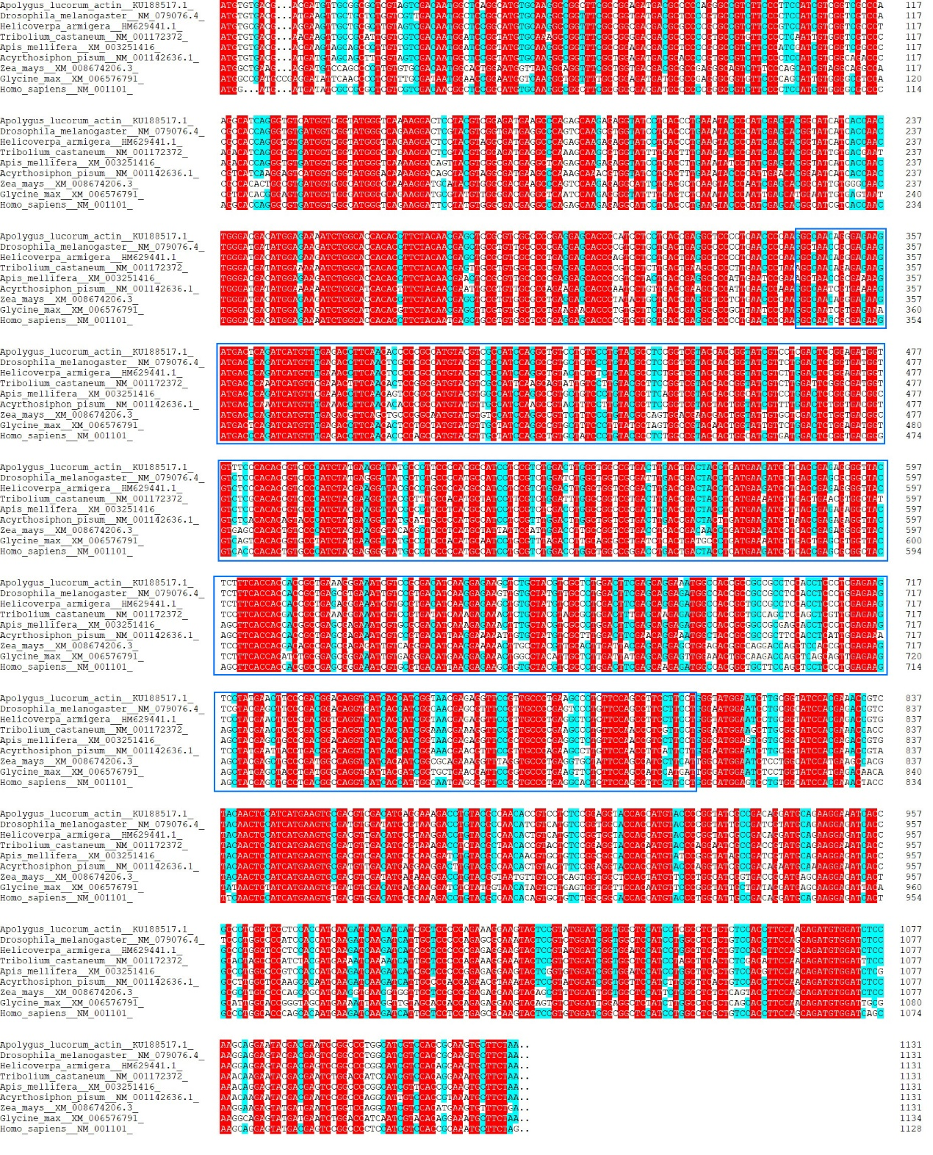

V-ATPase-A
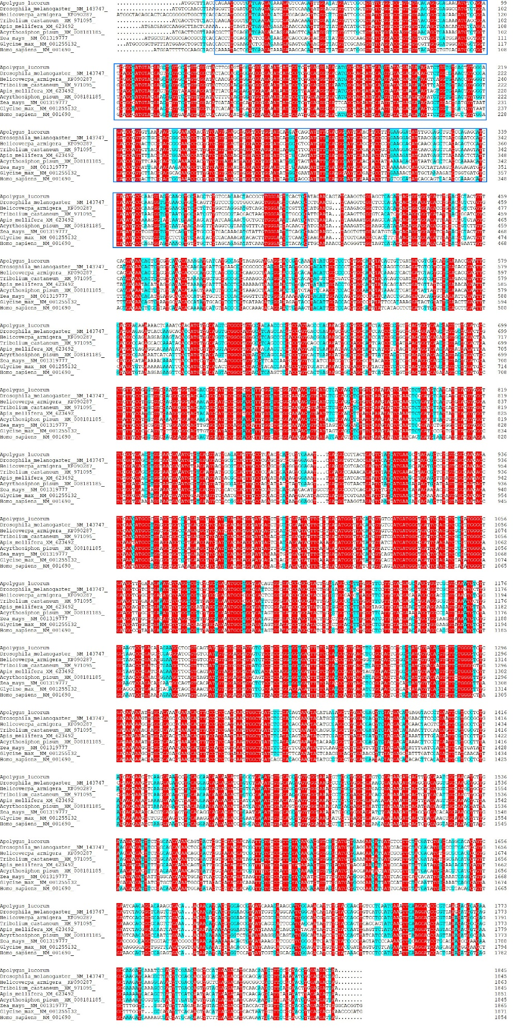

V-ATPase-D
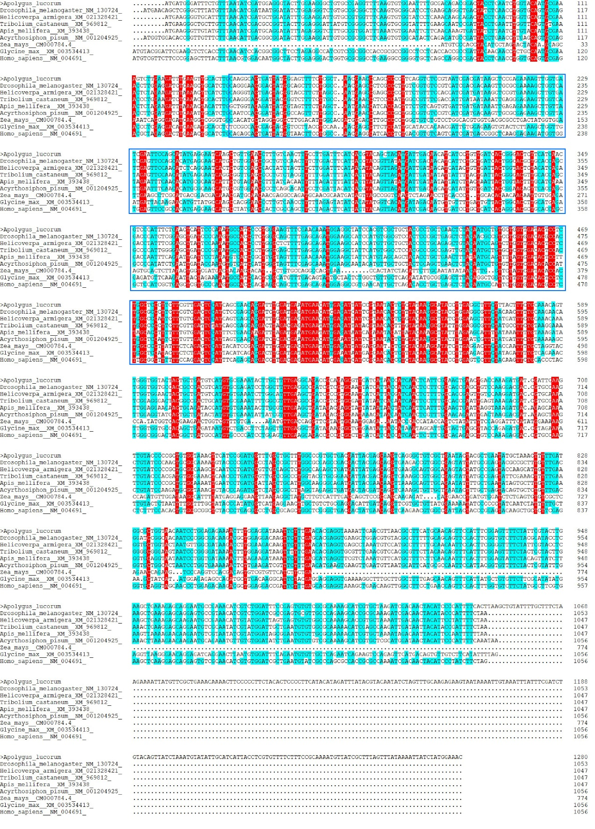

V-ATPase-E
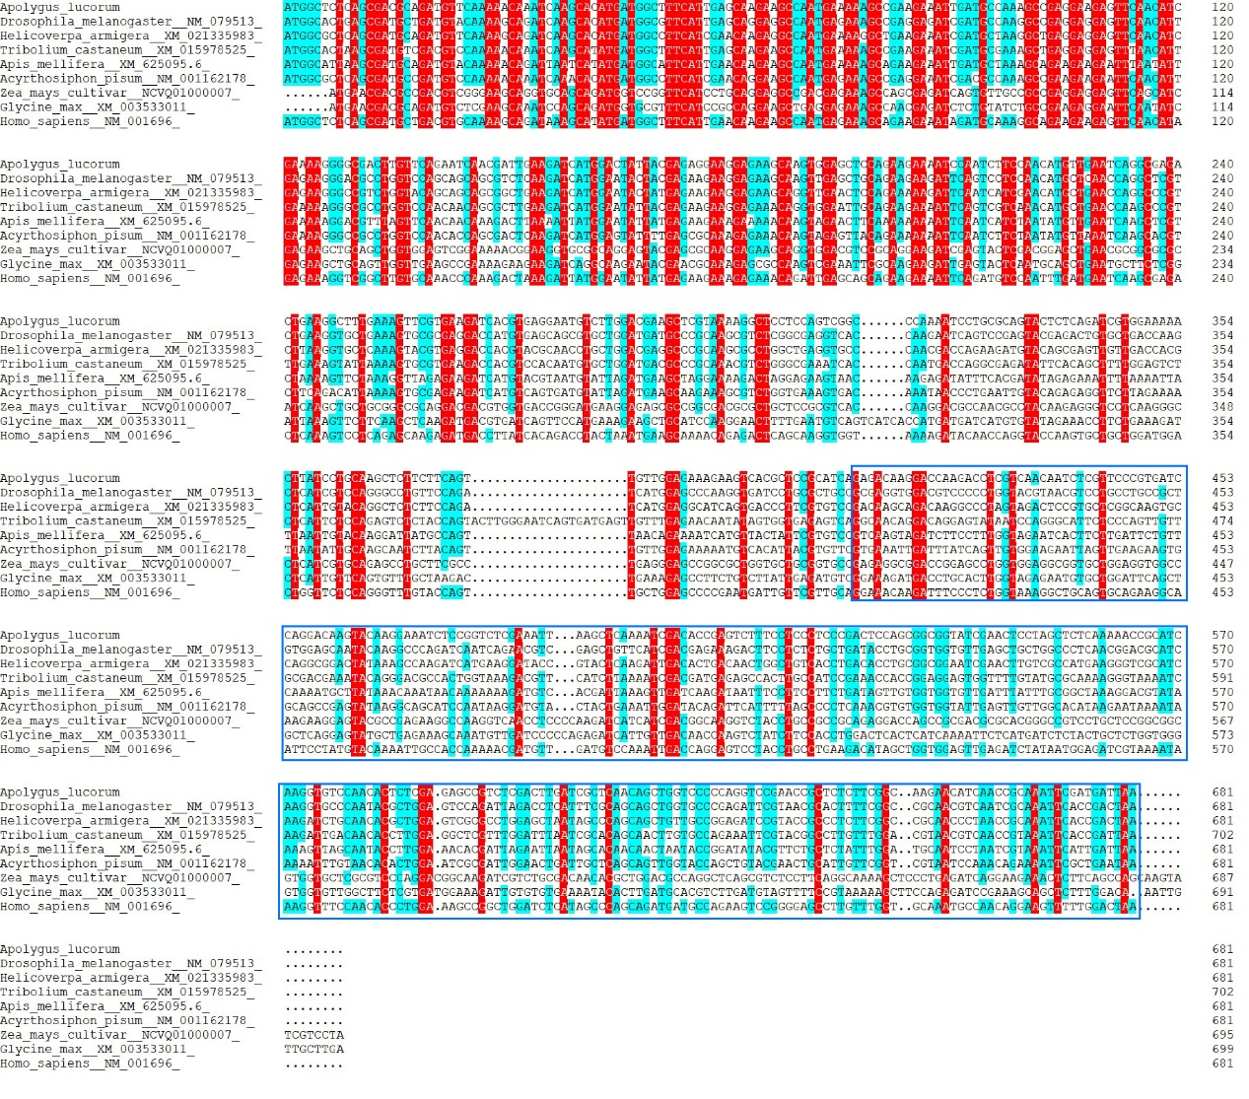

EiF-5A
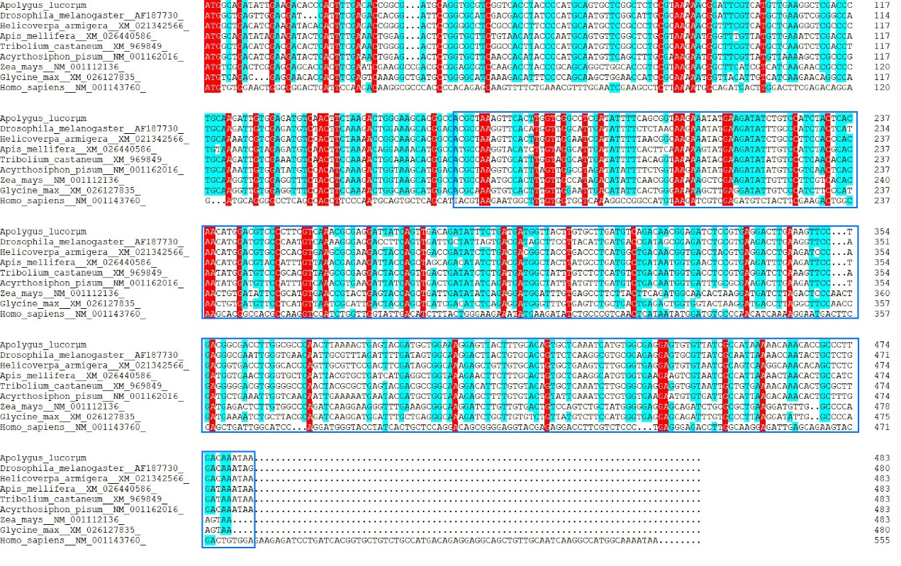

EcR
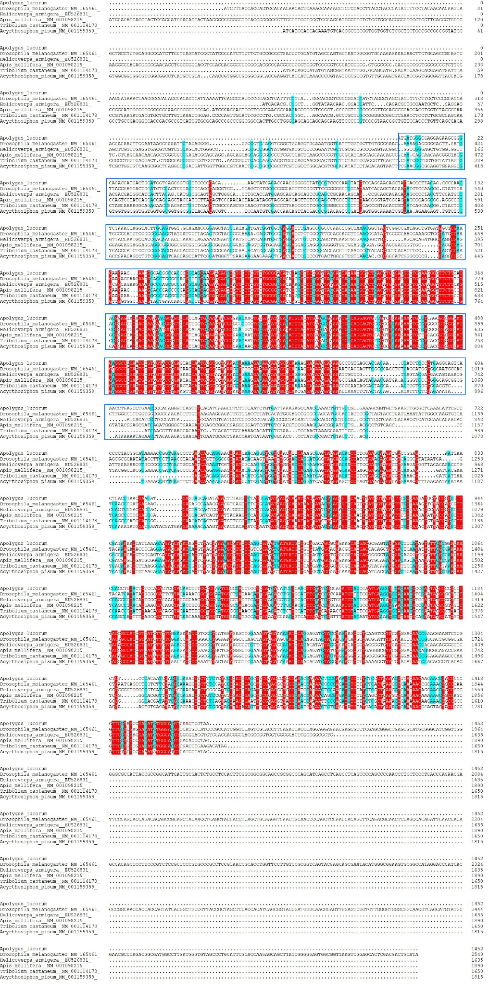
IAP
