Supplementary FIG. 1. Spot assay of S. epidermidis RP62A in the absence (control) and presence (1.25 µg/mL to 0.375 µg/mL) of α-MG. MIC (1.25 µg/mL) of α-MG shown approximately ˂ 2 log reduction in S. epidermidis growth within 10 min. Hence, 0.7 MIC (0.875 µg/mL) of α-MG was used for antibacterial challenge with S. epidermidis.

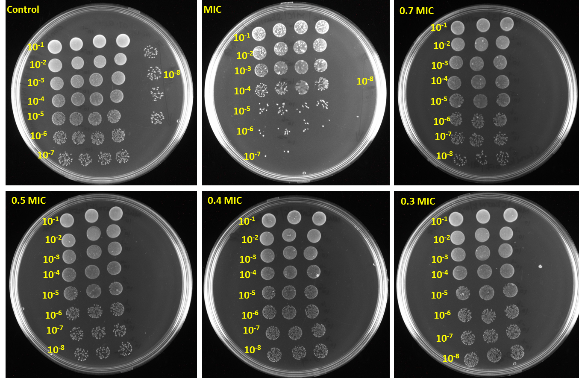

Supplementary FIG. 2. CELLO2GO analysis. GO annotation of differentially expressed genes upon α-MG treatment which are identified using RNA-sequencing. Biological process (A), Molecular function (B) and Cellular component (C).
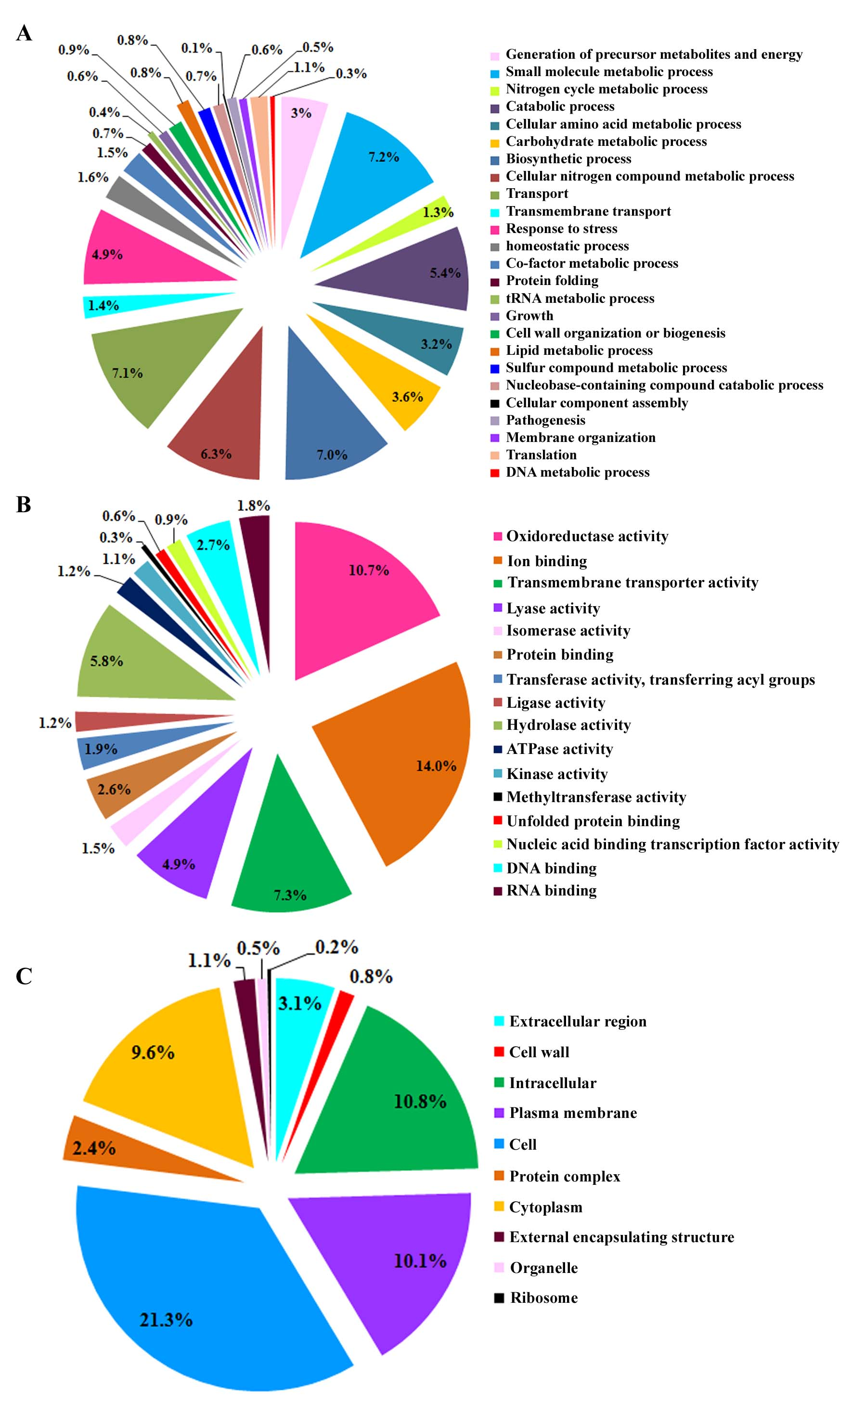
Supplementary FIG. 3. Venn diagram representing the overlapped proteins identified by LC-MS/MS in S. epidermidis RP62A with presence and absence α-MG (0.7 MIC for 10 min and 30 min of exposure).
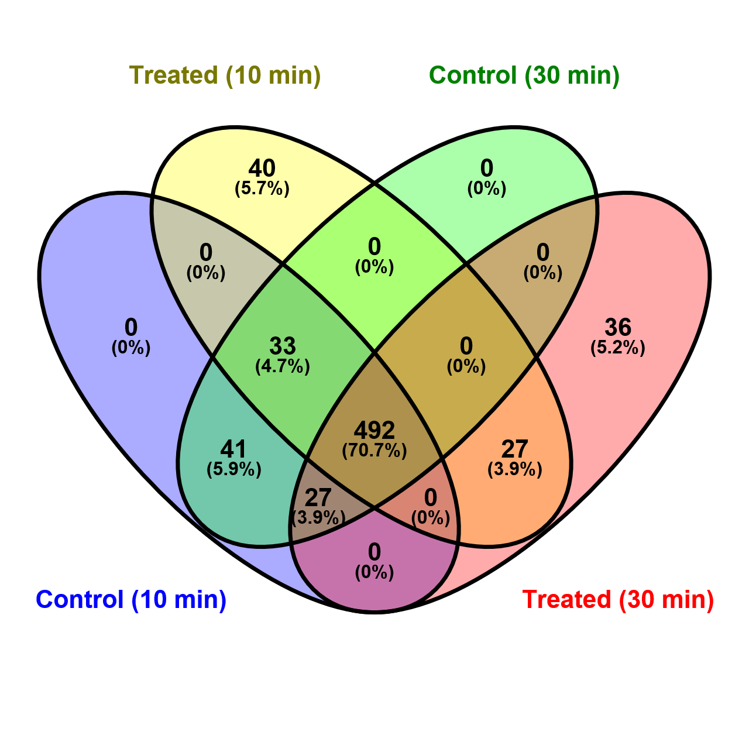

Supplementary FIG. 4. STRING_{10.5} predicted the protein-protein interactions (high confidence score 0.700) of upregulated (A) and downregulated (B) proteins of S. epidermidis RP62A upon α-MG treatment.
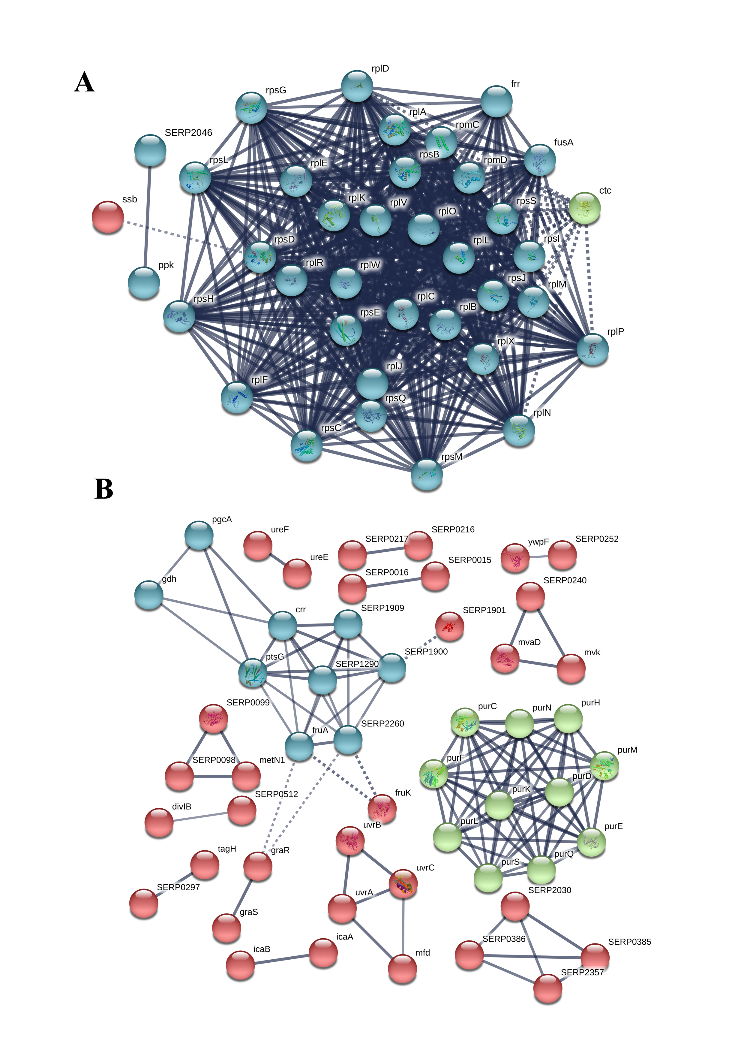
Supplementary FIG. 5. CELLO2GO analysis. GO annotation of differentially expressed proteins upon α-MG treatment that were identified using LC-MS/MS. Biological process (A), Molecular function (B) and Cellular component (C).


