**Supplementary material**

**SENSITIVITY ANALYSIS**

Firstly, a sensitivity analysis was carried out with respect to the 2014 grain yield data considering changes in selected model input variables within the range of ±75%. The variables considered were (1) soil chemical properties (SOC, total N and NO3 content in the top 0.40 m), and (2) physical properties (runoff curve number, drainage rate and water content at field capacity in the top 0.40 m) and (3) manure and fertilizer placement method (broadcasting without and with incorporation, or banding/hole placement at surface or 0.10 m beneath the surface). Each variable was varied individually, keeping all others constant.

**Soil chemical and physical properties**

Grain yield was generally more sensitive to variations in the soil chemical properties in the low input treatments (NM-NF, NM-50F and 3M-NF) compared to the others (Supplementary figure S2). This suggests that the amount of N applied was sufﬁcient in the latter treatments to mask the effect of the soil chemical properties on grain yield, as also reported by MacCarthy et al. (2012). SOC was the most sensitive chemical variable, followed by NO3. Increasing SOC and initial NO3 resulted in increased grain yields, with the highest sensitivity on NM-NF plots for SOC and on 3M-NF plots for NO3.

Regarding the physical properties, grain yield was most sensitive to variations in ﬁeld capacity (DUL). A decrease in DUL resulted in lower yield, but this decrease was most marked in the fertilized treatments. In general, grain yield was least sensitive to changes in runoff curve number and drainage rate.

**Fertilizer application rate and methods**

The model was strongly sensitive to mineral fertilizer N application rate. Grain yields increased with increasing fertilizer rate, up to a maximum corresponding to 60 and 40 kg N ha-1 application under NM and 3M, respectively (Supplementary figure S2). Crop response to N fertilizer inputs was much stronger for NM treatments than for 3M treatments. The model simulations were slightly sensitive to the method of fertilizer placement at low application rates, band placement leading to grain yield increases of +208 to +373 kg ha-1 compared to broadcast fertilizer application (Supplementary figure S2). The model was more sensitive to depth of placement (0.10-m depth) when fertilizer was broadcasted (+40 to +745 kg grain ha-1 compared to surface broadcasting) than when fertilizer was banded (no effect of depth of placement). There was no difference between the ‘fertilizer banding’ and ‘bottom-of-the-hole’ options (i.e. hole placement) in DSSAT (data not shown).



**SUPPLEMENTARY FIGURE S1** Daily rainfall, solar radiation, maximum and minimum temperatures in 2014 and 2015. The horizontal red line shows the growing period (from planting to harvest).



**SUPPLEMENTARY FIGURE S2** Sensitivity of grain yield to: (**A-D**) selected soil chemical and physical variables for four selected treatments and (**E-F**) application method and depth of fertilizer N rates under 0 (NM) or 3 (3M) t ha-1 of manure in the 2014 growing season. **A-D**: SOC (Soil organic carbon), TN (soil total N), and NO3 (Soil mineral NO3), RCN (Runoff curve number), DUL (ﬁeld capacity); **E-F**: BR-0=Broadcast, not incorporated; BR-10=Broadcast, incorporated at 0.10 m depth; BD-0=Banded on the surface; BD-10= Banded 0.10 m beneath surface or bottom of the hole.

**F**

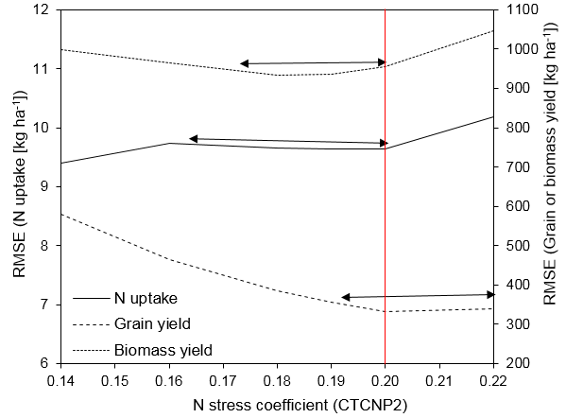

**SUPPLEMENTARY FIGURE S3** Evolution of RMSE values of N uptake (principal axis), yield and aboveground biomass (secondary axis) at harvest to incremental changes in the N stress coefficient for MD1 and MD2 treatments over the two years during the optimization process. The vertical red line shows the optimal CTCNP2 value.

**SUPPLEMENTARY TABLE S1** Soil physical and chemical characteristics at the experimental sites used for calibrating and evaluating the CERES-Maize model.

|  |  |  |  |  |  |  |  |  |  |  |  |  |  |  |  |  |  |
| --- | --- | --- | --- | --- | --- | --- | --- | --- | --- | --- | --- | --- | --- | --- | --- | --- | --- |
| Depth |  | BD |  | LL | DUL | SAT |  | OC | Clay | Silt | Sand |  | NO3-N | NH4-N |  | pH | SGRF |
| cm |  | g cm-1 |  | m3 m-3 | | |  | % | | | |  | µg/g | | - | | |
| 5-10 |  | 1.6 |  | 0.06 | 0.16 | 0.35 |  | 0.45 | 3.9 | 13.8 | 82.3 |  | 3.4 | 1.4 |  | 5.7 | 1.0 |
| 15-20 |  | 1.6 |  | 0.06 | 0.17 | 0.35 |  | 0.45 | 3.9 | 13.8 | 82.3 |  | 3.4 | 1.4 |  | 5.7 | 1.0 |
| 20-30 |  | 1.7 |  | 0.06 | 0.18 | 0.35 |  | 0.45 | 3.9 | 13.8 | 82.3 |  | 2.1 | 1.3 |  | 5.6 | 1.0 |
| 30-40 |  | 1.6 |  | 0.12 | 0.20 | 0.38 |  | 0.18 | 8.1 | 13.1 | 78.8 |  | 2.1 | 1.3 |  | 5.4 | 0.8 |
| 40-50 |  | 1.6 |  | 0.12 | 0.20 | 0.38 |  | 0.18 | 8.1 | 13.1 | 78.8 |  | 0.5 | 0.1 |  | 5.4 | 0.8 |
| 50-60 |  | 1.7 |  | 0.15 | 0.23 | 0.31 |  | 0.13 | 25.5 | 15.0 | 59.5 |  | 0.5 | 0.1 |  | 5.1 | 0.4 |
| 60-70 |  | 1.7 |  | 0.15 | 0.23 | 0.31 |  | 0.13 | 25.5 | 15.0 | 59.5 |  | 0.5 | 0.1 |  | 5.1 | 0.4 |
| 70-80 |  | 1.7 |  | 0.15 | 0.25 | 0.31 |  | 0.12 | 31.7 | 15.2 | 53.1 |  | 0.5 | 0.1 |  | 5.1 | 0.2 |
| 80-100 |  | 1.6 |  | 0.15 | 0.25 | 0.31 |  | 0.10 | 30.5 | 15.5 | 54.0 |  | 0.5 | 0.1 |  | 5.1 | 0.1 |

LL = lower limit, DUL = field capacity, SAT = saturated water content, BD = bulk density, OC = organic carbon, SGRF= Root growth factor