SI Table 1. Raw responses of candidate acts of heroism from Study 1 (428 total).

A ballet dancer jumped onto subway tracks to lift a man to safety. | going to get your fellow soldier who is wounded under enemy fire | Rushing into a fire
A boy is pulled from beneath a collapsed wall at the Plaza Towers Elementary School | Great teachers who could have been anything but chose to dedicate their lives to the future | Sacrifice
a dog fighting off a wild animal to safe his or her owner | Harvey Randolph | sacrifice ones self
A French philosopher who praised risk-taking died while saving drowning children. | Harvey Randolph | Sacrificing for your children.
A homeless man aided children wounded in a terrorist attack in England. | Having courage to achieve good things | Sacrificing self for others
A man helping his wife deliver their child | Hazardous occupations | sacrificing your life to save another
A man jumping on a grenade to save his fellow soldiers | help someone grab something from a high shelf | Sacrificing yourself so another may live.
a man shielded his wife during a shooting | helping a choking victum | Safely landing a passenger plane with no landing gear
A parent giving up own life to save a family member. | helping a friend | save someone from a burning building
a woman saved a girl from being kidnapped by pretending to be her mother | helping an elderly person | saves others
A woman who overcame a tough childhood adopted and raised three foster children on her own. | Helping at a car accident | Saving a baby
act of bravery | Helping elderly people. | saving a cat from a tree
Admitting mistakes | helping homeless | Saving a cat's life.
adopting a child in a terrible situation | Helping less fortunate people | saving a child from a burning building
Adopting a child in need. | Helping others | saving a child from a kidnapper
Adopting or taking care of a foster child | helping out at an animal shelter | saving a child from danger
Adoption | helping people escape a fire | SAVING A CHILD FROM DROWNING.
Adoption | Helping someone after a traumatic event | Saving a child from fire
affection | Helping someone after an accident | Saving a child's life.
Alek Skarlatos | Helping someone get from a abusive situation. | saving a dog from a hard life
all of the first responders during 911 | Helping someone in need | saving a dog from a hot car
always having extra tampoons if someone needs them | hero | Saving a dog's life.
American soldiers in battle | Holding open a door so children can escape from oncoming fire | Saving a drowning person
An illustrator from Colombia jumped onto subway tracks in Manhattan to help a homeless man who had fallen. | Holding the hand of a hospice patient | saving a drowning person
An usher confronted a gunman who opened fire at a church in Tennessee. | Hollywood Bank Heist Shootout | Saving a family from a fire.
Angela Pierce | Inmate firefighters prepare to battle the Rim Fire near Yosemite National Park, California | Saving a friend from an accident
Angela Pierce | inspiration | saving a kitten from a burning building
anyone standing up for what's good and kind | Intervening when it's uncomfortable | saving a life
Assisting the elderly | investigating someone for conspiracy | Saving a life.
becoming a firefighter or policeman | Jeremy Wuitschick And Johnny Wood | Saving a person from a burning building
Being a firefighter | Jeremy Wuitschick And Johnny Wood | Saving a person from a fire
Being a friefighter | Jeremy Wuitschick And Johnny Wood | saving a person from drowning
being a good parent | Jim Gard from Parkland High | saving a person's life
Being a policeman | job | Saving a person's life.
being a really good friend for someone with depression | joining armed forces | Saving a pet from a rescue center
Being in a search party | Joining the military | Saving an animal's life
Being kind to others. | joining the military | SAVING CHILD FROM BURNING BUILDING
Being selfless | Jon Meis | saving hostages
boldness | Jon Meis | saving lives in a storm
brave | jumping in front of someone to take a bullet for them | saving people out of a burning building
Bravery | jumping into dangerous waters to save someone drowning | saving someone drowning
Bringing food or medicine to the elderly or handycap | Jumping into the water to save a drowning person. | Saving someone from a burning building
bringing someone food | Jumping on train tracks to save fallen person. | Saving someone from a burning building
Bystanders dragging driver out of burning car. | Keenia Williams | Saving someone from a burning building
Cancer patients fighting for their lives. | Keenia Williams | Saving someone from a burning building.
carrying | Keeping others calm in the face of danger | saving someone from a burning car
catching a baby | Kyle Carpenter | Saving someone from a fire
catching a robber | Lauren Prezioso | Saving someone from a fire
child standing up for someone being bullied | Lauren Prezioso | saving someone from a fire
Childbirth | Lauren Prezioso | Saving someone from a heart attack
Children with cancer | leadership | Saving someone from a house fire
climbing a tree to rescue a pet | leaving a negative situation to better everyone | saving someone from a kidnapper
Coast Guard | Lending an ear to help comfort someone. | Saving someone from being raped or mugged.
Colton Haab from Parkland High | Lewis Thomas | saving someone from burning building
confronting a abusive spouse | Lewis Thomas | saving someone from drowning
Conscientious objectors. | Lewis Thomas | saving someone from drowning
Courage | Life sacrifice for the benefit of others. | saving someone from drowning
courage | Lifeguard jumping in to save someone drowing | saving someone from drowning
covering your loved ones with your body as a tornado hits your home | love | saving someone in a combat situation
Crew men restoring power in the middle of a major stom during the weekend noreaster | Man throws himself in front of active shooter to save children. | saving someone who is choking
danger | Man thwarts a would-be rapist. | saving someone who is choking
Daniel Konzelman helped the injured out of a derailed Amtrak train. | marines enlisting and going to falujia | saving someone who is drowning
Darnell Barton | Martin Luther King | Saving someone's life
Darnell Barton | Martin Luther King | saving someone's life
Defending an innocent person | Martin Luther King Jr. fighting for black rights | Saving someone's life
Defending someone from abusive authority figures. | Members of the millitary | saving someones life in any manner
Defending someone from harm. | Military members going into combat for America. | saving someone's life when it is not your job
Doctor | Military service | Schindler saving Jews
Doctors and nurses calmly did their jobs after a gunman stormed the hospital where they work. | Miracle on the Hudson | Search and rescue by sea
dodging in front of a bullet to save another person. | Moments of hope and inspiration rose above the chaos of Hurricanes Harvey and Irma. | Search and rescue in the mountains
Donating a kidney. | Mother Teresa's entire life | Selflessness
Donating an organ | MY husband staying up all night making sure my dad's oxygen tank didn't run out | serving in the army
donating an organ | Nelson Mandela | serving in the military
Donating blood | nelson mandela knowingly stayed in jail for a crime he didn't commit | Serving in the military for your country
donating blood | Paramedics | Shielding a person from gunfire
donating food to a poor family | Paramedics seeing terrible things but still helping | shooting an active shooter
Donating money to a needed cause | paying off a school district's lunch money debt | Soldiers
donating new clothes or food | people on a flight crashed the plane so the terrorists wouldn't fly it into a building | Soldiers dying for team mates - falling on explosives.
donating organs | People that jump into rivers to save other people | soldiers going in to protect civilians
donating organs or bone marrow | performing CPR | someone donating a kidney to someone
Donating organs to a stranger or loved one | performing cpr | someone going into a burning building to rescue someone
donating to cancer patients | Performing open heart surgery. | Someone performing CPR
donating to charity | performing the heimlich maneuver | someone pushing someone from the path of an on coming car
Donating to charity | Persons trying to rescue passengers from airplane downed in water. | someone running into a burning building to savesomeone
Donations to charity | playing it forward buying someone else a coffee | Someone stepping in front of a bullet meant for another
Driving safely | police catching criminals | Someone stopping a robbery or something similar by physically stopping the person.
Dying in the line of fire (military) | Police going into domestic violence situations. | Standing up for a friend against a bully
emt's | Police Officer risking her life each shift | standing up for black rights
emts saving a persons life | police officer risking their life to save others | standing up for equal rights
Entering a burning building to save some one. | Police officers | standing up for LGBT rights
Entering a burning building to save someone | Police officers | Standing up for what what is right
facing your fears for progression | Police officers confronting a shooter. | Standing up for what's right.
feeding a homeess person | Police Officers putting their lives on the line. | standing up to a bully
Feeding the homeless. | Police officers standing someone down who is threatening someone with a weapon. | standing up to a bully
Feeding the poor & needy | Police patrolling the streets | Standing up to a bully
Feeding those who are unable to feed themselves. | Policeman | standing up to politicians
Female inmates in California signed up to fight wildfires, at times risking their lives. | Preventing someone from committing suicide | stepping up to crime leaders
Fighting an hostile force | Protecting children in a school shooting. | stoping or catching a child abductor
Fighting for our country | protecting people in immediate danger | Stopping a bomb
Fighting for rights and equality of groups of people. | protecting someone being shot at | Stopping a gunman
Fighting for the rights of others | Protesting injustice | Stopping a murderer
Fighting for your country. | providing cpr to someone in need | Stopping a robbery.
Fighting in a war | Providing CPR to someone who is unresponsive. | Stopping a shooter.
Fighting in the military | pull someone from traffic | Stopping a thief
fighting off intruders | pulling a car from someone | Stopping an assault
finding a murder suspect | Pulling a child from a burning building | stopping and helping in an automobile accident.
Fire Rescue | pulling someone from a burning building | stranger providing cpr to a victum
Fire rescue | PULLING SOMEONE FROM A CAR ACCIDENT | Subway Rescue
Firefighter going into a burning building | pulling someone from a car accident that is leaking gas | sully sullivan saving the people on the plane
Firefighters | Pulling someone from a fire. | taking a bullet for someone
Firefighters at 9/11 | Pushing a person out of the path of a speeding car | taking a bullet for someone
Firefighters climbing into the Twin Towers. | Pushing someone away from oncoming car | Taking a bullet to save another
Firefighters entering WTC 2 on 9/11 | Putting out a fire | taking action against inequalities and unfairness
firefighters fighting fires | quick-thinking in a dangerous situation | taking care of someone
Firefighters going into a burning building to save someone. | raising your child right | talking someone out of suicide
Firefighters going into burning buildings. | Report crime to police | Talking someone out of suicide.
Firefighters on 9/11 | rescue kid from fire | Teacher jumping in front of shooter to save students in Florida school shooting
firefighters risked their lives to save those trapped in the rubble of 9/11 | Rescue of people on 9/11 | Teachers shielding kids from an active shooter.
firefighters rushing into burning buildings to help others | Rescue workers carry a child who was rescued from the rubble at the site of a collapsed residential building in Mumbai, India | Teachers teaching every day
firefighters saving people in burning buildings | rescueing a child from a fire | Teaching children
fire-fighting | rescueing a drowning victim | team player
Fireman | Rescuing a dog trapped in a well | Teenage girls in Nigeria, kidnapped by Boko Haram and strapped to suicide vests, managed to escape and tell their stories.
Fireman running into a burning house. | Rescuing a drowning baby | Temar Boggs And Chris Garcia
Fireman saves people from burning building. | Rescuing a kidnap victim | Temar Boggs And Chris Garcia
Fireman saving people from burning buildings, | rescuing someone from a bad accident | Temar Boggs and Chris Garcia chased after an abductor until he let his captive go.
Firemen entering burning building | rescuing someone from a burning building | The 9/11 firefighters.
Firemen going into burning homes to save family. | rescuing someone from a burning building | the president going to war zones to support troops
firemen saving people from burning buildings | rescuing someone from a fire | The President going to work with bullet proof vest.
firemen saving victums | Rescuing someone from a flood. | The relief workers cleaning up after a natural disaster
first responders going into a building not knowing the situation | Rescuing someone from a wreck | Treating everyone as equals
Getting someone out of a wrecked car | rescuing someone from drowning | Two teenage boys are being hailed as heroes after they chased a car carrying a kidnapped girl on their bicycles.
giving a home to a shelter animal | Resuscitating someone | volunteering
giving CPR to a person that needs it | Risking your life to save another. | Volunteering as an EMT
Giving food to a homeless person. | Robert Mohr And Rodney Lindley | volunteering at a soup kitchen
Giving money to people who need it. | Robert Mohr And Rodney Lindley | Volunteering at a soup kitchen
Giving money to someone in need. | Rosa Parks | Volunteering your free time to those in need
Giving someone an interest free loan when they are poor | running into a burning building | Washington crossing the Delaware
giving someone cpr | Running into a burning building to save someone | Whistle-blowers.
Giving to charity | running into a burning building to save someone | Workers going into radioative nuclear factory in Japan
giving your life | Running into a fire to save someone | Working overseas for charity
Going into a burning building to rescue people. | running off a stalker | working with disadvantaged youths
going into the ocean to save someone from drowning | Rushing into a burning building | young child protecting mother from abuse
Going out on the ice to rescue a person who went thru the ice. | Rushing into a burning building after a child

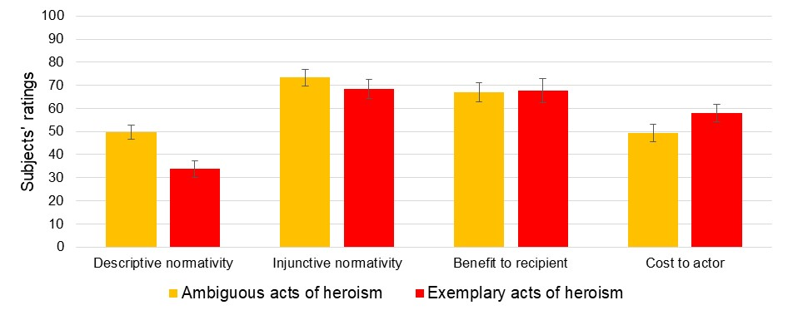
SI Figure 1. Exemplary acts of heroism are seen as rarer and more costly to actors (though not more beneficial to recipients) than ambiguous acts of heroism. Shown are means (with 95% CIs) of subjects’ ratings on four measures (0-100 slider scales; see SI Fig. 2 for distributions) aggregated over the 5 exemplary and 5 ambiguous acts of heroism.
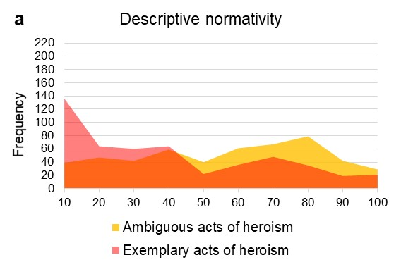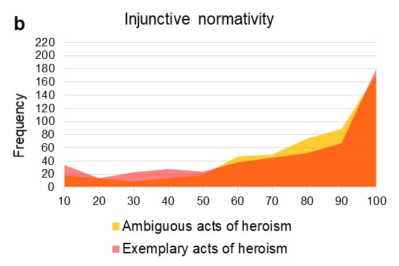
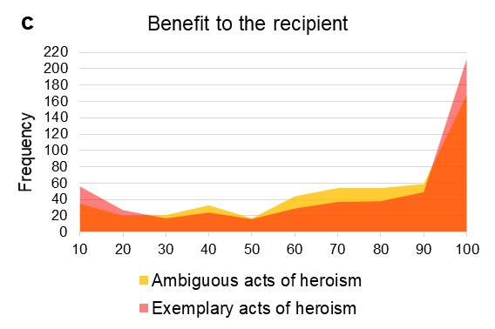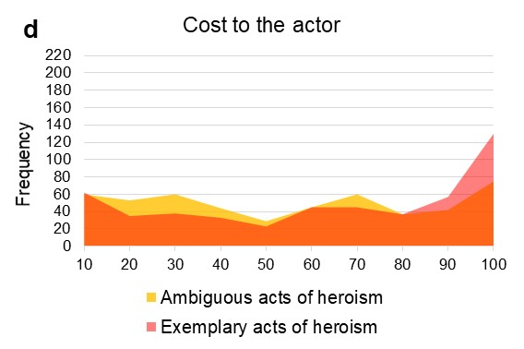
SI Figure 2. Subjects’ perceptions of exemplary v. ambiguous acts of heroism. Shown are distributions of subjects’ ratings on four measures (0-100 slider scales): (a) descriptive normativity (“In your opinion, how many people in your community do this behavior?”); (b) injunctive normativity (“In your opinion, how much do people in your community think doing this behavior is what you are supposed to do?”); (c) benefit to the recipient (“In your opinion, how much benefit (in terms of money, time, effort, etc.) does the recipient of this behavior receive?”); and (d) cost to the actor (“In your opinion, how much cost (in terms of money, time, effort, etc.) does the person who does this behavior incur?”).
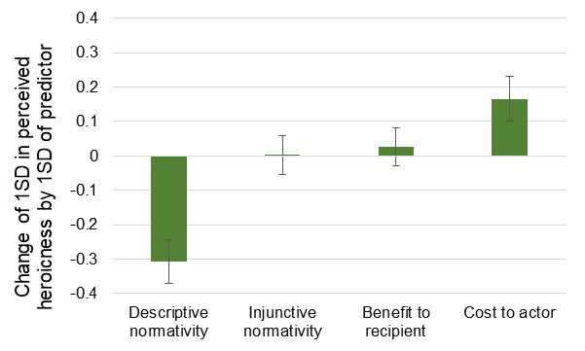
SI Figure 3. More heroic acts are seen as rarer and more costly to actors (though not more beneficial to recipients nor less obligatory) than ambiguous acts of heroism. Shown are standardized coefficients (with 95% CIs) of subjects’ ratings on four measures (0-100 slider scales) predicting the heroicness of the acts as measured on a continuous scale (from Study 2).

SI Table 2. Robustness check of Study 3 regression results. Results from Study 3 are robust to conducting regression analyses as OLS regression with proportion of Study 2 participants indicating the behavior was heroic (standardized) as the independent variable or a logistic regression with a classification of behavior as exemplary v. ambiguous acts of heroism as a binary independent variable.
