Supplementary Material

Salmonella Harborage Sites in Infected Poultry that May Contribute to Contamination of Ground Meat

Claire-Sophie Rimet ¹, John J. Maurer^{1,2}, Larissa Pickler³, Lisa Stabler¹, Kasey K. Johnson¹, Roy D. Berghaus⁴, Ana M. Villegas¹, Margie Lee^{1,2,5}, and Monique França^{1*}

¹ Poultry Diagnostic and Research Center, Department of Population Health, University of Georgia, Athens, GA, USA
² Center for Food Safety, College of Agriculture, University of Georgia, Athens, GA, USA
³ Department of Veterinary Medicine, Universidade Federal do Parana, Curitiba, PR, Brazil.
⁴Department of Population Health, University of Georgia, Athens, GA, USA,
⁵ Department of Biomedical Sciences and Pathobiology, Virginia-Maryland College of Veterinary Medicine, Virginia Tech, Blacksburg, VA

* Correspondence:
Dr. Monique França
mfranca@uga.edu

Supplementary Table 1. Location of Salmonella in skin, skeletal muscle and bone of infected chickens throughout the experimental period as detected by immunohistochemistry.

Days | Skin |  |  | Muscle |  |  |  |  | Bone
 | SH ª | ST ^{b} | Location | SH ª | ST ^{b} | Location | SH ª | ST ^{b} | Location
3 | 5/5 | 2/4 | Stratum corneum ^{a,b}, dermis ª | 3/5 | 4/5 | Connective tissue ^{a,b}, lymphatic ^{b} | 0/5 | 0/5 | N/A
5 | 5/5 | 5/5 | Stratum corneum ^{a,b}, dermis ^{a,b}, feather follicle ª, lymphatic ª | 5/5 | 5/5 | Connective tissue ^{a,b}, lymphatic ^{a,b} | 1/5 | 2/5 | Bone marrow ^{a,b}, physeal vessel ^{b}
7 | 4/5 | 2/5 | Stratum corneum ^{a,b}, dermis ª, feather follicle ª | 5/5 | 5/5 | Connective tissue ^{a,b}, lymphatic ª | 1/5 | 1/5 | Bone marrow ^{a,b}
14 | 2/5 | 4/5 | Stratum corneum ^{a,b}, dermis ^{b} | 4/5 | 3/5 | Connective tissue ^{a,b} | 0/5 | 0/5 | N/A
21 | 3/5 | 1/5 | Stratum corneum ^{a,b}, feather follicle ^{b} | 0/5 | 0/5 | N/A | 0/5 | 0/5 | N/A
28 | 4/5 | 4/5 | Stratum corneum ^{a,b} | 1/5 | 1/5 | Connective tissue ^{a,b} | 0/5 | 0/5 | N/A
35 | 4/5 | 1/5 | Stratum corneum ^{a,b}, feather follicle ª | 1/5 | 0/5 | Lymphatic ª | 0/5 | 0/5 | N/A
42 | 3/5 | 3/5 | Stratum corneum ^{a,b} | 2/5 | 1/5 | Connective tissue ª, lymphatic ^{a,b} | 0/4 | 0/5 | N/A
ª S. Heidelberg SH380-lux (SH), and ^{b} S. Typhimurium SL1344-lux (ST)

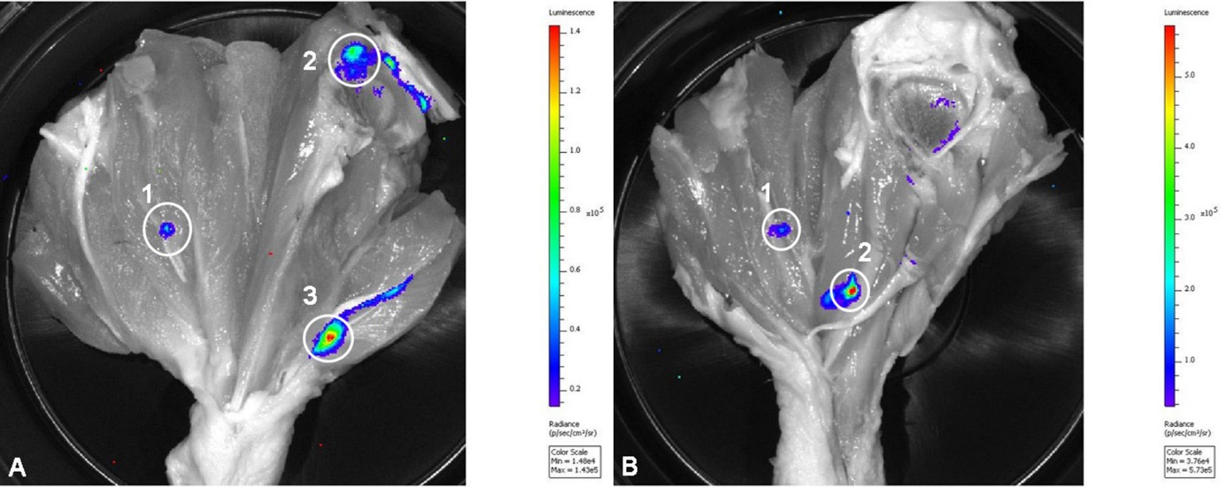

Supplementary Figure 1. Chicken drumstick injected with S. Heidelberg-lux and S. Typhimurium-lux. 0.1 ml of 8x10⁶ CFU S. Heidelberg-lux (A) or S. Typhimurium-lux (B) was injected into chicken legs and imaged using IVIS bioluminescence imaging system. Injection sites are demarcated with white circles and numbered. Total luminescence for injection sites with S. Heidelberg-lux (A) were 9.3 x 10², 5.7 x 10³ and 5.9 x 10³ p/s/cm²/sr for sites 1, 2, and 3, respectively. Total luminescence for injection sites with S. Typhimurium-lux (B) were 2.4 x 10³ and 1.1 x 10⁴ p/s/cm²/sr for sites 1 and 2, respectively.

