Supplementary Figures S1-S6

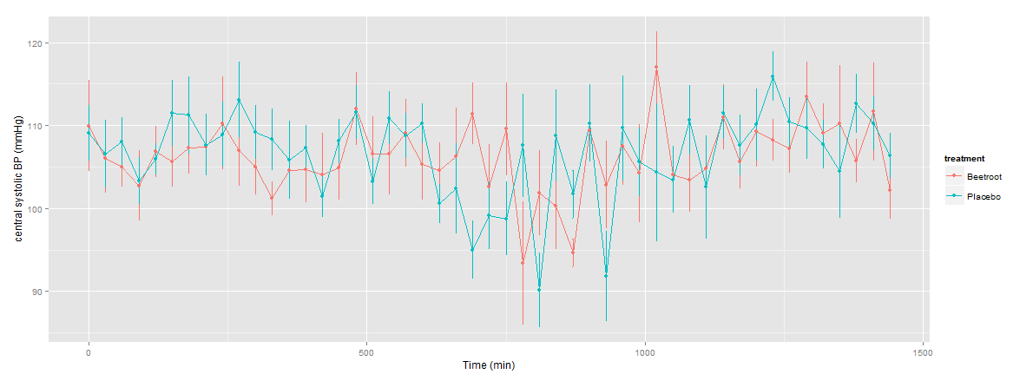
120
110
100
90
0
500
1000
1500
Time, mins
Aortic systolic blood pressure, mmHg
Figure S1. 24-hour ambulatory measures of aortic systolic blood pressure. Active beetroot (+nitrate) is shown in red, beetroot placebo in green. Data are means ± 95% confidence intervals.

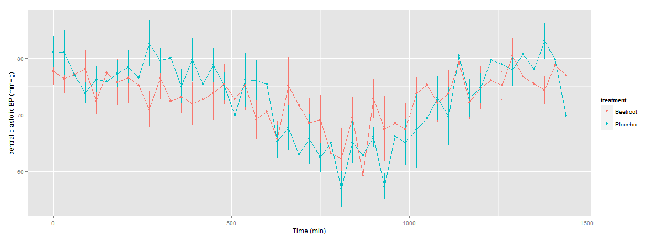
0
500
1000
1500
Time, mins
80
70
60
Diastolic blood pressure, mmHg
Figure S2. 24-hour ambulatory measures of diastolic blood pressure. Active beetroot (+nitrate) is shown in red, beetroot placebo in green. Data are means ± 95% confidence intervals.

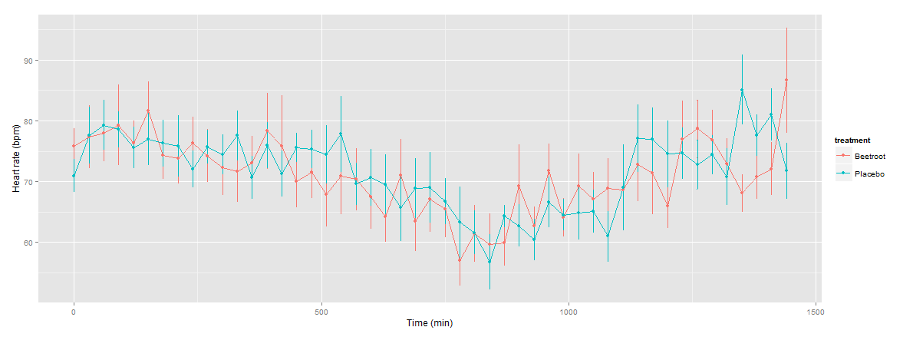
90
80
70
60
0
500
1000
1500
Time, mins
Heart rate, bpm
Figure S3. 24-hour ambulatory measures of heart rate. Active beetroot (+nitrate) is shown in red, beetroot placebo in green. Data are means ± 95% confidence intervals.

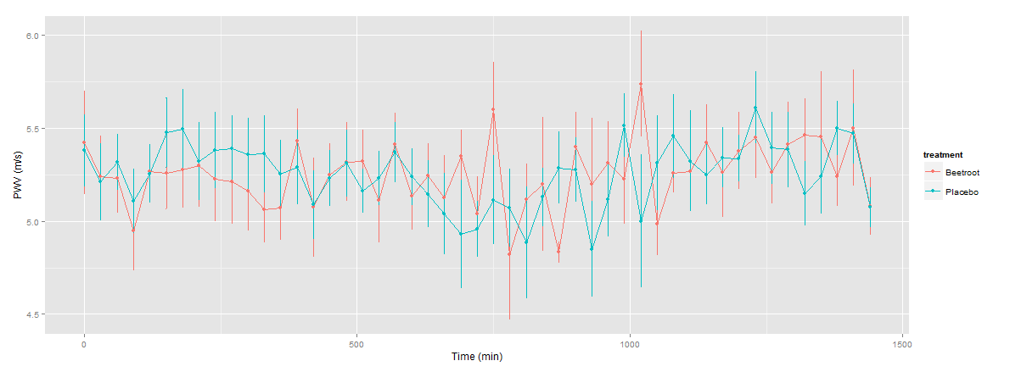
0
500
1000
1500
Time, mins
6.0
5.0
4.5
Pulse wave velocity, m/s
5.5
Figure S4. 24-hour ambulatory measures of pulse wave velocity (based on blood pressure cuff measurements). Active beetroot (+nitrate) is shown in red, beetroot placebo in green. Data are means ± 95% confidence intervals.

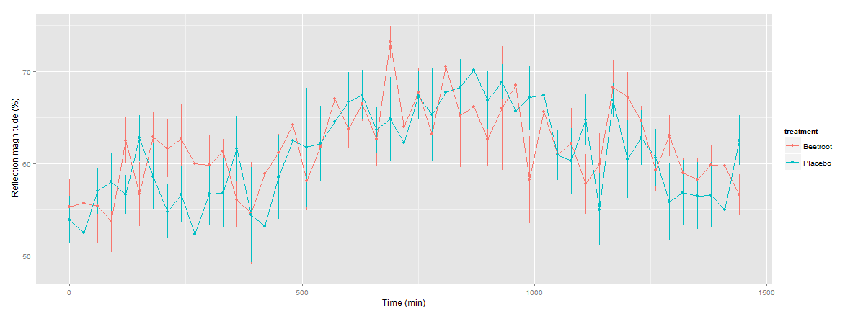
70
60
50
0
500
1000
1500
Time, mins
Reflection magnitude, %
Figure S5. 24-hour ambulatory measurement of reflection magnitude. Active beetroot (+nitrate) is shown in red, beetroot placebo in green. Data are means ± 95% confidence intervals.

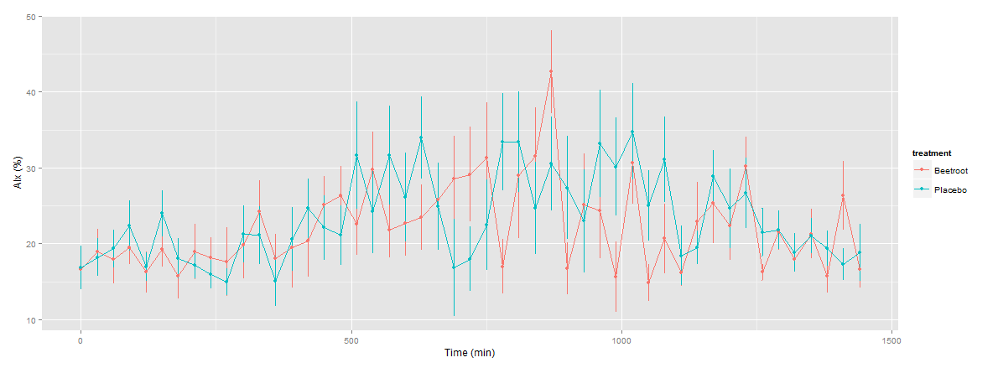
0
500
1000
1500
Time, mins
50
40
30
Augmentation index, %
20
10
Figure S6. 24-hour ambulatory measurement of augmentation index. Active beetroot (+nitrate) is shown in red, beetroot placebo in green. Data are means ± 95% confidence intervals.

