Supplementary Material
Willingness-to-pay-associated right prefrontal activation during a single, real use of cosmetics as revealed by functional near-infrared spectroscopy
Keith Kawabata Duncan^{1*}, Tatsuya Tokuda², Chiho Sato¹, Keiko Tagai¹, Ippeita Dan²
¹Shiseido Global Innovation Center, 2-1-1, Hayabuchi, Tsuzuki-ku, Yokohama, Kanagawa, 224-8558, Japan
²Chuo University, Applied Cognitive Neuroscience Laboratory, 1-13-27 Kasuga, Bunkyo, Tokyo, 112-8551, Japan
*Correspondence:
Dr. Keith Kawabata Duncan
keith.kawabata.duncan@to.shiseido.co.jp

Supplementary Information

Final questionnaire
Q1. Please enter how you made the decision regarding about how much you were willing to pay for the foundations.

Please complete the following.
Q2．What foundation do you typically use?
Brand:
Product:
Color code:
Type:
- Powdery
- Liquid
- Cream
- Cushion
- BB cream
< If you responded “Powdery” in Q2, please go to Q4. >
Q3. Have you ever used powdery foundation?
- I have used it on a daily basis.
- I have tried it
- I have never used it
Q4. What is the price of the foundation entered in Q2?
- JPY1000 or less
- JPY1001 to JPY2000
- JPY2001 to JPY3000
- JPY3001 to JPY4000
- JPY4001 to JPY5000
- JPY5001 or more
Q5. How frequently do you use foundation?
- 1 day or less per week
- 2 to 3 days per week
- 4 to 5 days per week
- 6 to 7 days per week
Q6. Please enter your age

Final questionnaire results
Q1. Answers to this question can be grouped into the following five reasons.
- Covering redness, blemishes, and pores or not
- Sheer coverage or full coverage
- Blending into skin or not
- Smoothness of spreading
- Color, light or dark shade
Q2. A variety of domestic and international brands were listed
Q3. Three participants reported they had never tried powdery foundation (1 in the LF group and 2 in the HF group). However, for an unknown reason, 15 participants did not answer this question.
Q4. The results of Q4 can be seen in the following pie chart.
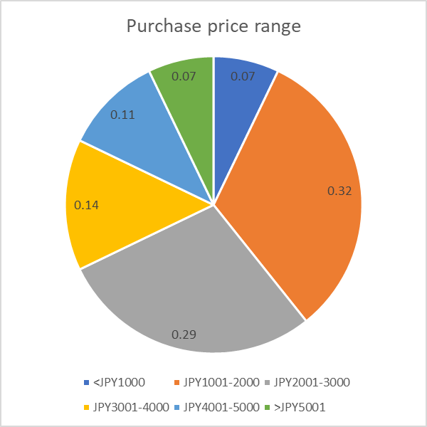
Two participants failed to give an answer to this question.
Q5. This question was used to group the participants in to HF and LF groups.
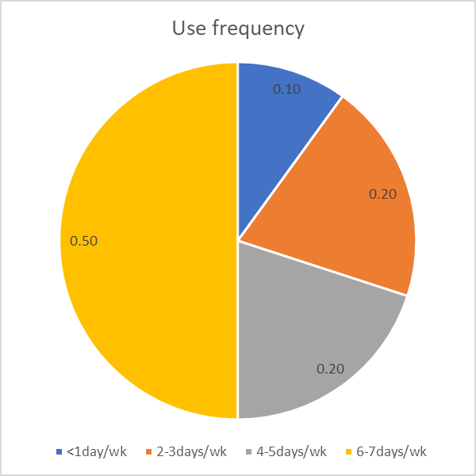
Q6. As reported in the methods, the average age was 21.2, SD: 0.86, range 20-22. There was no difference between the ages of the HF group (mean = 21.33, SD = 0.900) and the LF group (mean = 21.133, SD = 0.834; t(28) = 0.631, p = 0.533, d = 0.231).

Table S1: Results of one sample t tests for HF and LF groups, and the results of the two samples t test of the comparison of the correlations of HF and LF groups.
 | HF group |  |  |  |  | LF group |  |  |  |  | HF vs LF
channel | Mean z | t | df | p | Mean r | Mean z | t | df | p | Mean r | t | df | p
1 | -0.04 | -0.28 | 14 | 0.79 | -0.04 | -0.11 | -0.82 | 14 | 0.43 | -0.11 | 0.34 | 28 | 0.74
2 | -0.13 | -1.21 | 14 | 0.25 | -0.13 | -0.01 | -0.04 | 13 | 0.97 | -0.01 | -0.62 | 27 | 0.54
3 | 0.16 | 0.88 | 13 | 0.39 | 0.16 | -0.18 | -1.31 | 13 | 0.21 | -0.17 | 1.49 | 26 | 0.15
4 | -0.05 | -0.50 | 14 | 0.63 | -0.05 | -0.19 | -2.13 | 14 | 0.05 | -0.19 | 1.04 | 28 | 0.31
5 | -0.18 | -1.11 | 14 | 0.29 | -0.17 | -0.09 | -0.44 | 14 | 0.67 | -0.09 | -0.34 | 28 | 0.74
6 | -0.07 | -0.35 | 13 | 0.73 | -0.07 | -0.09 | -0.85 | 14 | 0.41 | -0.09 | 0.13 | 27 | 0.90
7 | 0.30 | 2.26 | 14 | 0.04 | 0.29 | -0.18 | -2.18 | 14 | 0.05 | -0.17 | 3.06 | 28 | 0.01
8 | 0.10 | 0.56 | 13 | 0.59 | 0.10 | -0.01 | -0.07 | 14 | 0.94 | -0.01 | 0.44 | 27 | 0.67
9 | 0.04 | 0.32 | 13 | 0.75 | 0.04 | -0.03 | -0.21 | 12 | 0.84 | -0.03 | 0.37 | 25 | 0.71
10 | 0.02 | 0.18 | 13 | 0.86 | 0.02 | -0.04 | -0.24 | 13 | 0.82 | -0.04 | 0.29 | 26 | 0.77
11 | -0.09 | -0.64 | 13 | 0.53 | -0.09 | -0.18 | -1.37 | 14 | 0.19 | -0.18 | 0.47 | 27 | 0.65
12 | -0.12 | -0.66 | 14 | 0.52 | -0.12 | -0.04 | -0.25 | 13 | 0.81 | -0.04 | -0.33 | 27 | 0.74
13 | -0.05 | -0.38 | 14 | 0.71 | -0.05 | -0.07 | -0.53 | 13 | 0.61 | -0.07 | 0.10 | 27 | 0.92
14 | -0.07 | -0.33 | 13 | 0.74 | -0.07 | -0.05 | -0.41 | 13 | 0.69 | -0.05 | -0.11 | 26 | 0.92
15 | -0.30 | -1.55 | 14 | 0.14 | -0.29 | -0.22 | -2.29 | 14 | 0.04 | -0.22 | -0.39 | 20.271 | 0.70
16 | -0.12 | -0.67 | 14 | 0.51 | -0.12 | 0.02 | 0.22 | 14 | 0.83 | 0.02 | -0.70 | 28 | 0.49
17 | -0.11 | -0.78 | 14 | 0.45 | -0.11 | -0.01 | -0.10 | 14 | 0.92 | -0.01 | -0.67 | 19.28 | 0.51
18 | 0.10 | 0.51 | 14 | 0.62 | 0.10 | -0.18 | -1.80 | 14 | 0.09 | -0.18 | 1.27 | 28 | 0.21
19 | 0.02 | 0.12 | 13 | 0.91 | 0.02 | -0.02 | -0.15 | 14 | 0.88 | -0.02 | 0.19 | 27 | 0.85
20 | 0.23 | 1.44 | 14 | 0.17 | 0.23 | 0.08 | 0.66 | 13 | 0.52 | 0.08 | 0.74 | 27 | 0.47
21 | 0.38 | 2.02 | 14 | 0.06 | 0.36 | -0.07 | -0.52 | 13 | 0.61 | -0.07 | 1.93 | 27 | 0.06
22 | 0.05 | 0.30 | 13 | 0.77 | 0.05 | 0.00 | 0.01 | 14 | 0.99 | 0.00 | 0.19 | 27 | 0.85
23 | -0.04 | -0.22 | 14 | 0.83 | -0.04 | 0.08 | 0.36 | 14 | 0.73 | 0.08 | -0.41 | 28 | 0.68
24 | 0.14 | 0.63 | 13 | 0.54 | 0.14 | -0.04 | -0.26 | 13 | 0.80 | -0.04 | 0.67 | 26 | 0.51
25 | -0.08 | -0.39 | 14 | 0.70 | -0.08 | -0.09 | -0.75 | 13 | 0.47 | -0.09 | 0.07 | 27 | 0.95
26 | -0.13 | -0.81 | 14 | 0.43 | -0.12 | -0.04 | -0.33 | 14 | 0.74 | -0.04 | -0.49 | 28 | 0.63
27 | 0.17 | 0.97 | 14 | 0.35 | 0.17 | -0.06 | -0.65 | 14 | 0.52 | -0.06 | 1.16 | 21.565 | 0.26
28 | 0.03 | 0.18 | 14 | 0.86 | 0.03 | -0.12 | -1.01 | 14 | 0.33 | -0.12 | 0.74 | 28 | 0.47
29 | 0.07 | 0.61 | 14 | 0.55 | 0.07 | 0.09 | 0.98 | 14 | 0.34 | 0.09 | -0.15 | 28 | 0.88
30 | 0.26 | 1.89 | 14 | 0.08 | 0.25 | -0.10 | -0.71 | 14 | 0.49 | -0.10 | 1.83 | 28 | 0.08
31 | 0.09 | 0.87 | 14 | 0.40 | 0.09 | -0.18 | -1.28 | 14 | 0.22 | -0.17 | 1.55 | 28 | 0.13
32 | -0.03 | -0.17 | 13 | 0.87 | -0.03 | 0.07 | 0.56 | 13 | 0.59 | 0.07 | -0.45 | 26 | 0.66
33 | -0.28 | -1.80 | 14 | 0.09 | -0.27 | 0.21 | 1.11 | 14 | 0.29 | 0.21 | -1.99 | 28 | 0.06
34 | 0.40 | 1.88 | 14 | 0.08 | 0.38 | -0.01 | -0.10 | 13 | 0.92 | -0.01 | 1.62 | 27 | 0.12
35 | 0.03 | 0.16 | 13 | 0.87 | 0.03 | 0.07 | 0.42 | 13 | 0.68 | 0.07 | -0.16 | 26 | 0.88
36 | 0.12 | 1.01 | 14 | 0.33 | 0.12 | -0.08 | -0.69 | 14 | 0.50 | -0.08 | 1.20 | 28 | 0.24
37 | 0.31 | 1.33 | 14 | 0.20 | 0.30 | -0.09 | -0.84 | 14 | 0.42 | -0.09 | 1.56 | 19.483 | 0.14
38 | 0.29 | 1.60 | 14 | 0.13 | 0.28 | -0.25 | -2.23 | 14 | 0.04 | -0.24 | 2.53 | 23.37 | 0.02
39 | 0.38 | 2.50 | 14 | 0.03 | 0.37 | 0.03 | 0.22 | 14 | 0.83 | 0.03 | 1.78 | 28 | 0.09
40 | 0.08 | 0.52 | 13 | 0.62 | 0.08 | -0.13 | -1.53 | 14 | 0.15 | -0.13 | 1.24 | 27 | 0.23
41 | 0.06 | 0.54 | 14 | 0.60 | 0.06 | -0.13 | -1.10 | 14 | 0.29 | -0.13 | 1.17 | 28 | 0.25
42 | 0.09 | 0.54 | 14 | 0.60 | 0.09 | 0.01 | 0.08 | 14 | 0.94 | 0.01 | 0.39 | 28 | 0.70
43 | -0.34 | -2.63 | 14 | 0.02 | -0.33 | -0.04 | -0.60 | 13 | 0.56 | -0.04 | -2.03 | 21.451 | 0.06
44 | -0.06 | -0.50 | 14 | 0.62 | -0.06 | -0.19 | -1.90 | 14 | 0.08 | -0.19 | 0.86 | 28 | 0.40
45 | 0.13 | 0.72 | 14 | 0.48 | 0.13 | -0.13 | -0.79 | 13 | 0.44 | -0.13 | 1.06 | 27 | 0.30
46 | 0.00 | 0.02 | 14 | 0.98 | 0.00 | -0.28 | -2.24 | 14 | 0.04 | -0.27 | 1.15 | 28 | 0.26
47 | 0.06 | 0.28 | 13 | 0.79 | 0.06 | -0.03 | -0.25 | 14 | 0.81 | -0.03 | 0.37 | 27 | 0.71
48 | 0.30 | 2.27 | 14 | 0.04 | 0.29 | -0.14 | -0.61 | 14 | 0.55 | -0.14 | 1.68 | 28 | 0.10
49 | -0.07 | -0.41 | 14 | 0.69 | -0.07 | -0.15 | -1.20 | 14 | 0.25 | -0.15 | 0.38 | 28 | 0.71
50 | 0.10 | 0.59 | 14 | 0.56 | 0.10 | -0.31 | -2.87 | 13 | 0.01 | -0.30 | 1.99 | 27 | 0.06
51 | -0.05 | -0.38 | 14 | 0.71 | -0.05 | -0.41 | -3.01 | 12 | 0.01 | -0.39 | 1.81 | 26 | 0.08
52 | -0.18 | -1.67 | 14 | 0.12 | -0.18 | -0.06 | -0.69 | 14 | 0.50 | -0.06 | -0.85 | 28 | 0.40

fNIRS results: Other brain areas
We had no a priori hypotheses about the relationship between WTP and other channels. However, for completeness the mean z values and results of one- and two-sample t tests (uncorrected) are shown in Supplementary Information Table 1 and the channels with a mean z value significantly greater than 0 are detailed below. All significant positive correlations were for the HF group whereas all significant correlations for the LF were negative.

Channel 7 (right fronto-polar area)
For channel 7, the mean z value for the HF group was positive (mean = 0.301, sem = 0.133) and differed significantly from 0 (t(14) = 2.26, p = 0.004, d = 0.0.584) whereas the mean z value for the LF group was negative (mean = -0.175, sem = 0.08) and differed significantly from 0 (t(14) = 2.184, p = 0.046, d = 0.546), and the two groups differed significantly from each other (t(22.954) = 3.064, p = 0.005, d = 1.119). In other words, as WTP increases, the activity in channel 7 increases for the HF group but decreases for the LF group. According to the result of the registration, channel 7 corresponds to the frontopolar area and orbitofrontal area (Table 3).

Channel 43 (left supramarginal gyrus)
For channel 43, the mean z value for the HF group was negative (mean = -3.444, sem = 0.131) and differed significantly from 0 (t(14) = 2.633, p = 0.020, d = 0.680). In contrast, the LF group mean z value (mean = -0.396, sem = 0.066) did not differ from 0 (t(14) = 0.599, p = 0.559, d = 0.160). The two groups differed significantly from each other (t(20.715) = 2.080, p = 0.050, d = 0.739, corrected for non-homogeneity). According to the result of the registration, channel 43 corresponds to the LH supramarginal gyrus area and primary somatosensory cortex (Table 3).

Channel 48 (right superior frontal gyrus)
For channel 48, the mean z value for the HF group was positive (mean = 0.302, sem = 0.133) and differed significantly from 0 (t(14) = 2.270, p = 0.040, d = 0.586). In contrast, the LF group mean z value (mean = -0.136, sem = 0.224) did not differ from 0 (t(14) = 0.607, p = 0.553, d = 0.157). However, the two groups did not differ significantly from each other (t(28) = 1.682, p = 0.104, d = 0.614). According to the result of the registration, channel 48 corresponds to the RH frontal eye fields (superior frontal gyrus) and RH-DLPFC (Table 3).

Table S2: The MNI coordinates of other channels with a significant correlation for the HF group, and the probability of the recorded data originating from the listed anatomical locations.
Channel | x | y | z | SD | Anatomy | Probability
7 | 41.66 | 62.33 | -6.33 | 8.253 | 10 – RH Frontopolar area | 0.756
 |  |  |  |  | 11 – RH Orbitofrontal area | 0.244
43 | -64.33 | -40.33 | 43.66 | 11.861 | 40 – LH Supramarginal gyrus | 0.958
 |  |  |  |  | 2 – LH Primary somatosensory cortex | 0.042
48 | 9.33 | 46.66 | 53.33 | 12.331 | 8 – RH frontal eye fields | 0.944
 |  |  |  |  | 9 – RH Dorsolateral prefrontal cortex | 0.056

