Supplementary figures:
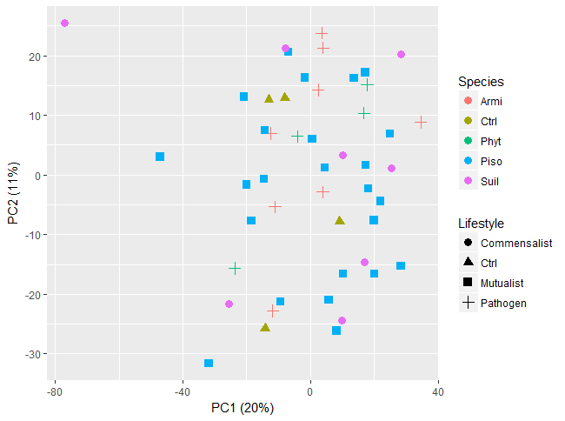
Supplementary figure 1. PCA score plot showing the variation among metabolite profiles (LC-MS ESI⁻ mode) of E. grandis root tips after 24 h pre-symbiosis with different microbes. The color and shape of symbols represent the species and the lifestyles of the interacting microbes. armi = Armillaria luteobubalina ; piso = Pisolithus microcarpus; suil = Suillus granulatus; phyt = Phytophthora cinnamomi; ctrl = uninfected control
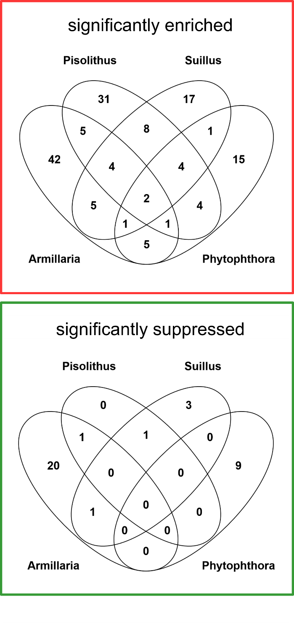
Supplementary figure 2. Venn diagrams showing the significantly enriched and suppressed molecular features amongst different microbe-treated roots in comparison to the untreated control. Student t-test was performed for each pair of comparison between the control and the microbes-treated root tips. Significantly regulated molecular features profiled with ESI⁻ mode that exhibit more than five-fold of intensity change and with p < 0.05 are shown in the Venn diagram.
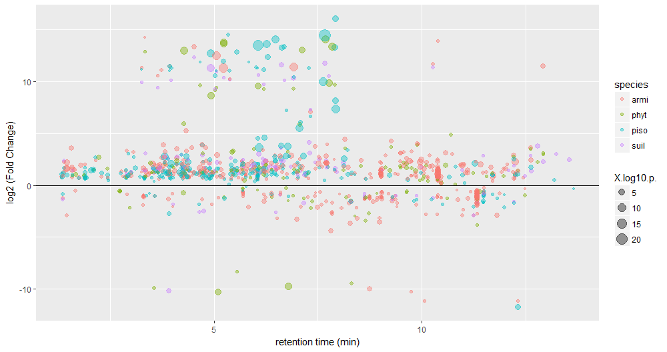
Supplementary figure 3. The scatter plot showing distribution of the significantly regulated metabolites (p < 0.05) across the span of retention time of metabolite profiling in root tips after pre-symbiotic interaction with microbes of different species that are captured in LC-MS (ESI⁻). armi = Armillaria luteobubalina ; piso = Pisolithus microcarpus; suil = Suillus granulatus; phyt = Phytophthora cinnamomi
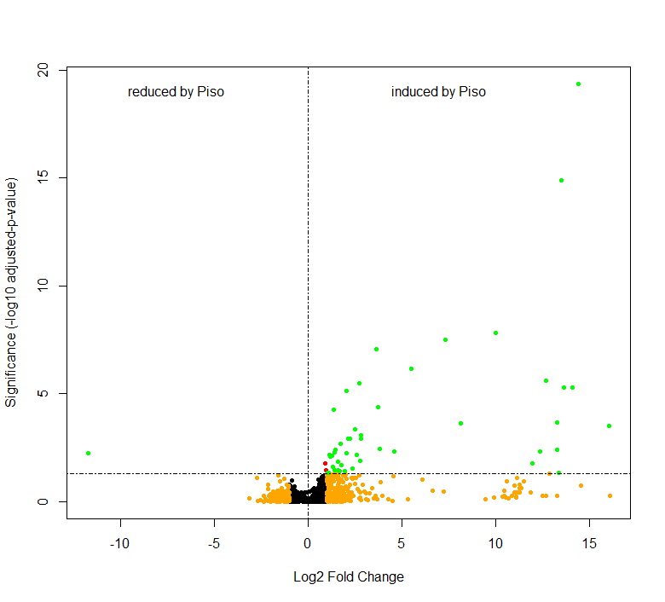Supplementary figure 4. Volcano plot showing the varied molecular features in E. grandis root tips after pre-symbiosis with P. microcarpus (n = 24) for 24 h in comparison to control root tips (n = 4). The metabolite profiles are derived from LC-MS (ESI⁻ mode). The y-axis and x-axis correspond to the mean fold change of Pisolithus-interacting root tips in comparison to control, and the significance value in terms of p-value (adjusted by Bonferroni-method). Red = p < 0.05; Orange = Fold Change > 2; Green = p < 0.05 and Intensity fold change >2.
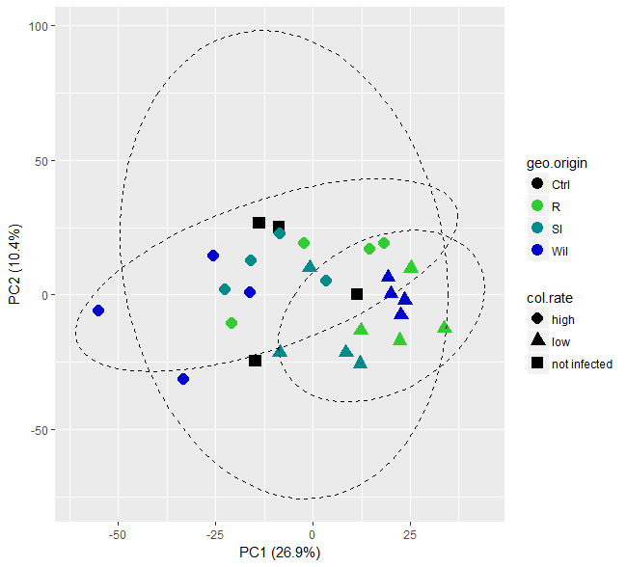
Supplementary figure 5. PCA score plot showing the multivariate-variation among Pisolithus-interacting root tips samples in terms of metabolite profiles derived from the ESI⁻ mode, LC-MS. The color of the symbols represents the geographical origin (geo. origin) of the Pisolithus strains, while the shape of the symbols represents the colonization rates (col. rate). Ctrl = un-infected control roots; R = Royal National Park; SI = Sussex Inlet; Wil = Wilberforce.
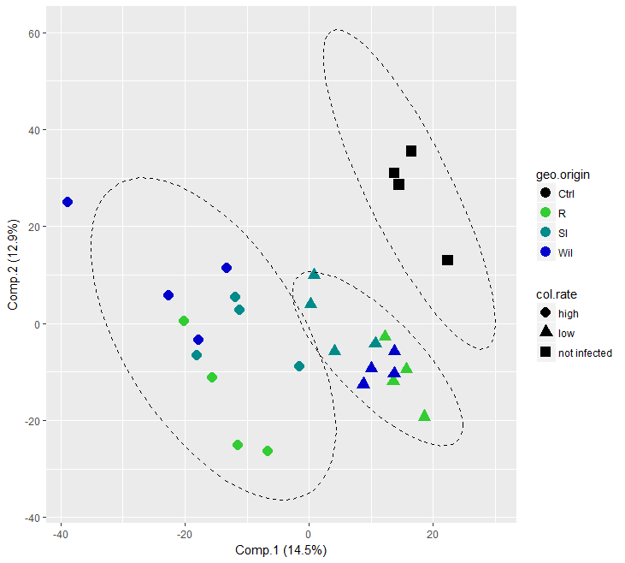
Supplementary figure 6. PLS-DA score plot showing the first two components of the supervised classification model that separates metabolite profiles of Pisolithus-interacting root tips samples (LC-MS ESI⁻ mode) in terms of colonization rate. The color of the symbols represents the geographical origin (geo. origin) of the Pisolithus isolates, while the shape of the symbols represents the colonization rates (col. rate). Ctrl = un-infected control roots; R = Royal National Park; SI = Sussex Inlet; Wil = Wilberforce.
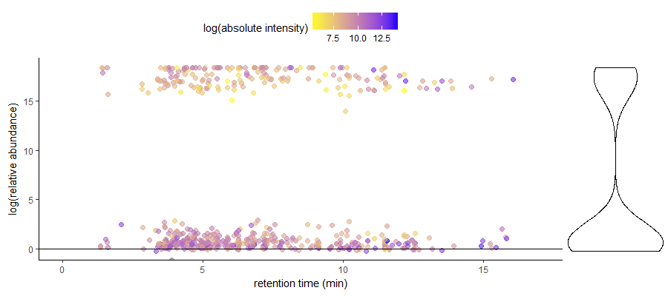
Supplementary figure 7. (Left) Scatter plot showing the abundance of ¹³C-labeled compounds in Pisolithus-treated root tips in labeled setup in relation to unlabeled setup, across the retention time span of LC-MS ESI⁻ mode metabolite profiling. The color of the points showing the absolute intensity of the compound peak detected by the LC-MS. An unlabeled or mis-detected labelled metabolite would have a log (relative abundance) ≤ 0. (right) The violin plot demonstrates the distribution of ¹³C-labeled compounds with different relative abundance.

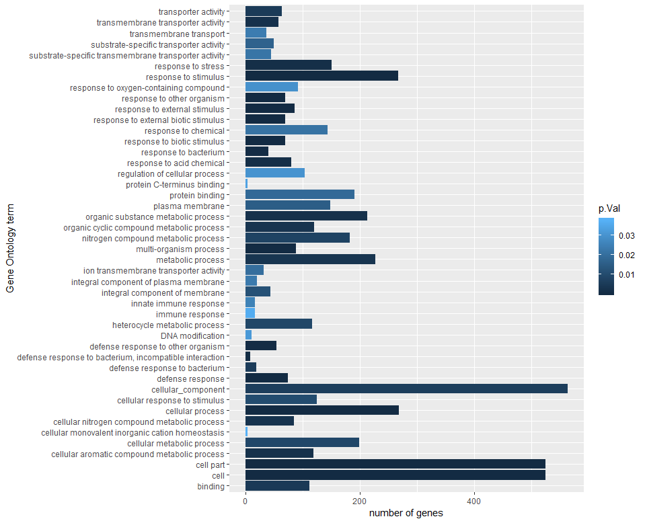
Supplementary figure 8. Gene ontology enrichment results for highly-induced genes (log₂(fold change) >5) in E. grandis roots in the pre-symbiotic interaction. Bar plot represent the number of genes involved in a gene-set of the enriched gene ontology term. The darkness of the color of the bar represent the significance (in terms of p-values) of the enriched gene-sets.

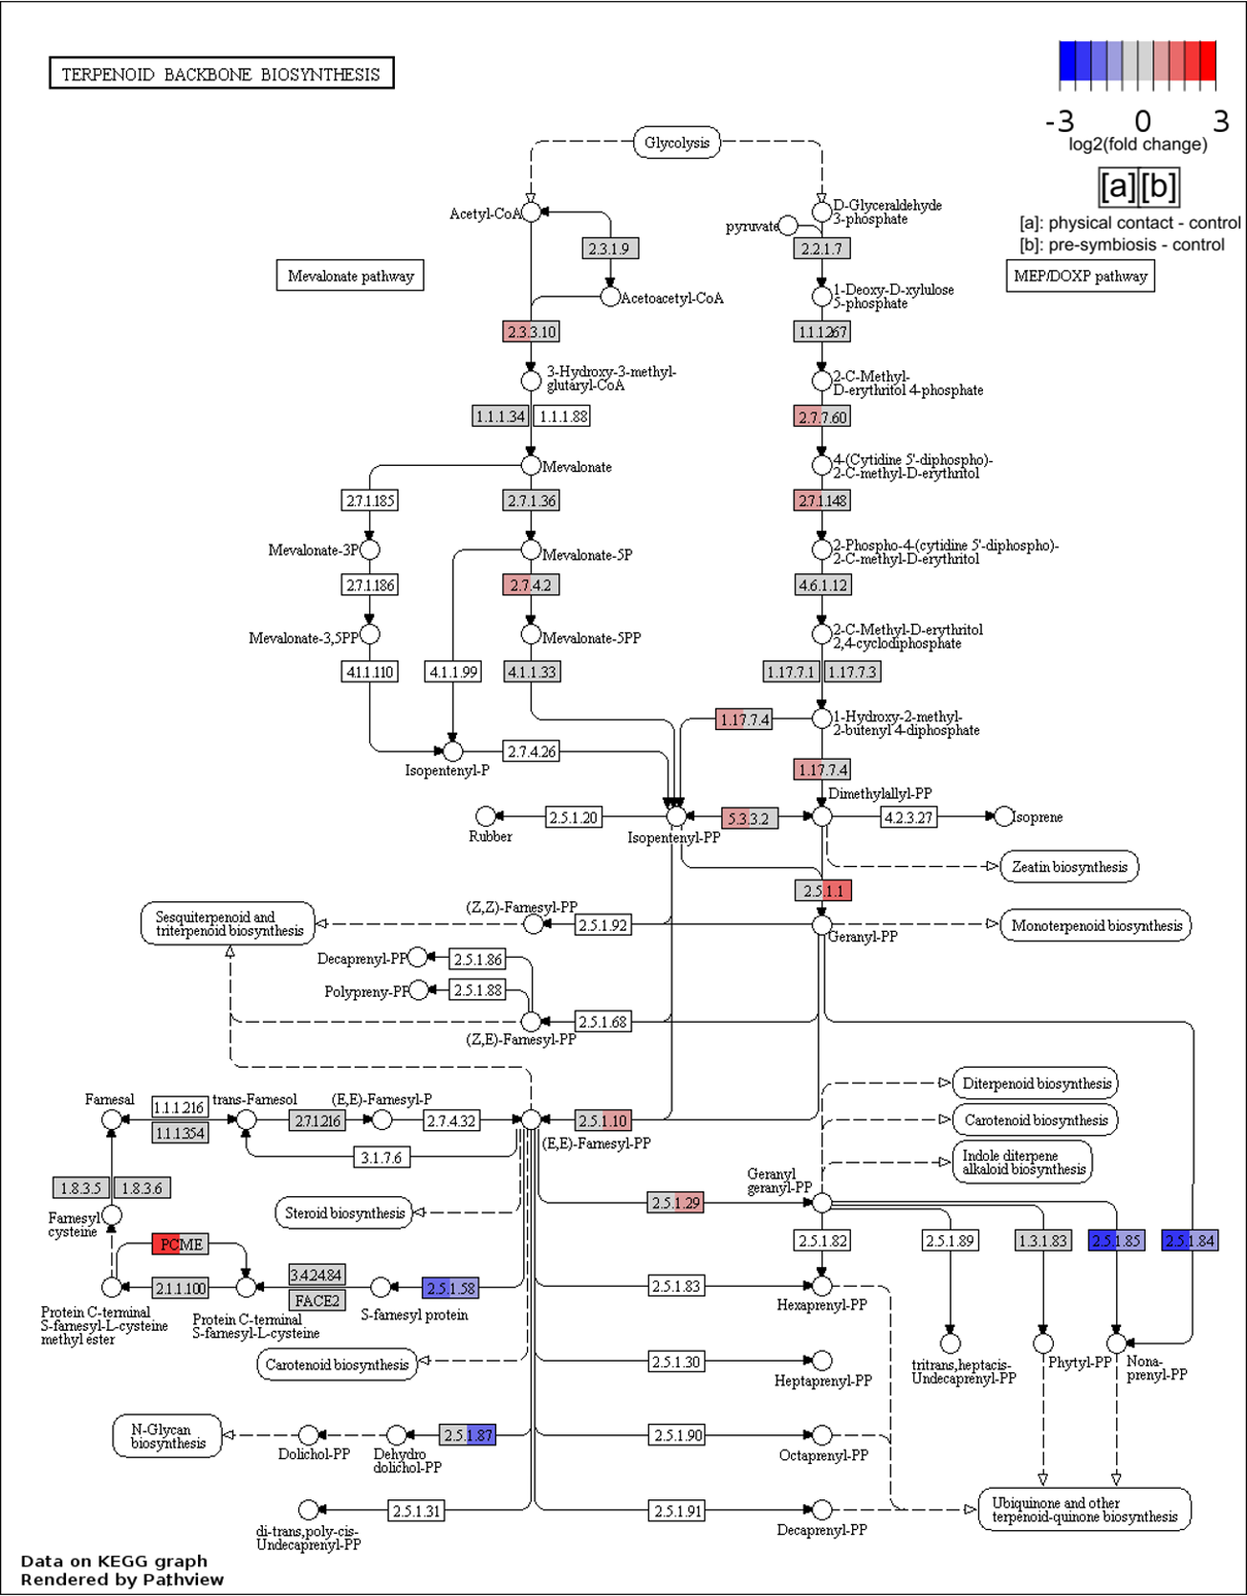
Supplementary figure 9. Pathway graph to visualize the genes associated with the terpenoid backbone biosynthesis pathway and their expressions in E. grandis roots during direct physical interaction (coloration on left-hand side of each enzyme box) and pre-symbiotic interaction (coloration on the right-hand side of each enzyme box) with Pisolithus microcarpus in comparison to uninfected control roots. The Arabidopsis thaliana homologs of the E. grandis genes and their expression were mapped onto the pathway. The color of the boxes represents the log₂(fold change) value of the gene.

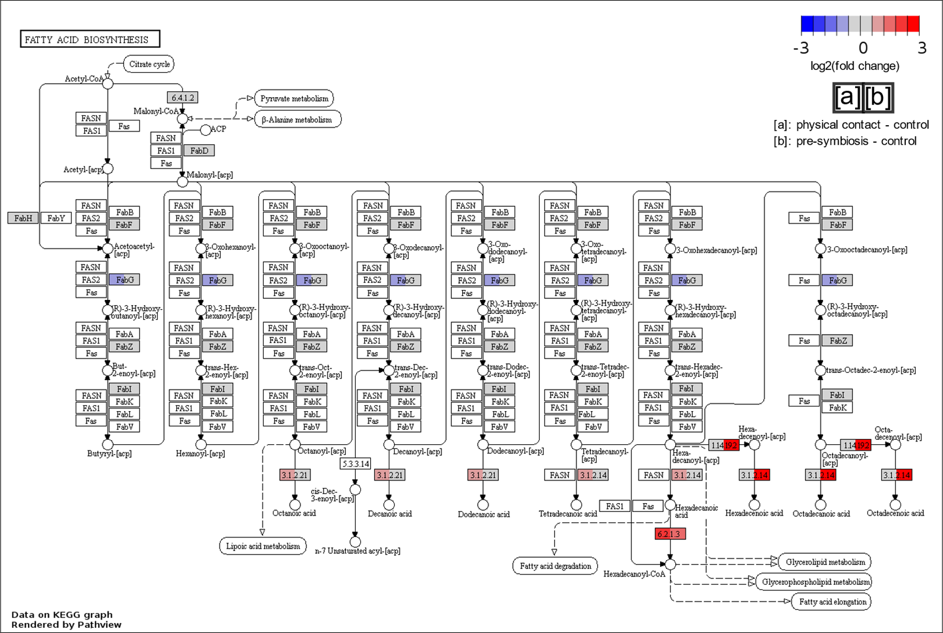
Supplementary figure 10. Pathway graph to visualize the genes associated with the fatty acid biosynthesis pathway and their expressions in E. grandis roots during direct physical interaction (coloration on left-hand side of each enzyme box) and pre-symbiotic interaction (coloration on the right-hand side of each enzyme box) with Pisolithus microcarpus in comparison to uninfected control roots. The Arabidopsis thaliana homologs of the E. grandis genes and their expression were mapped onto the pathway. The color of the boxes represents the log₂(fold change) value of the gene.
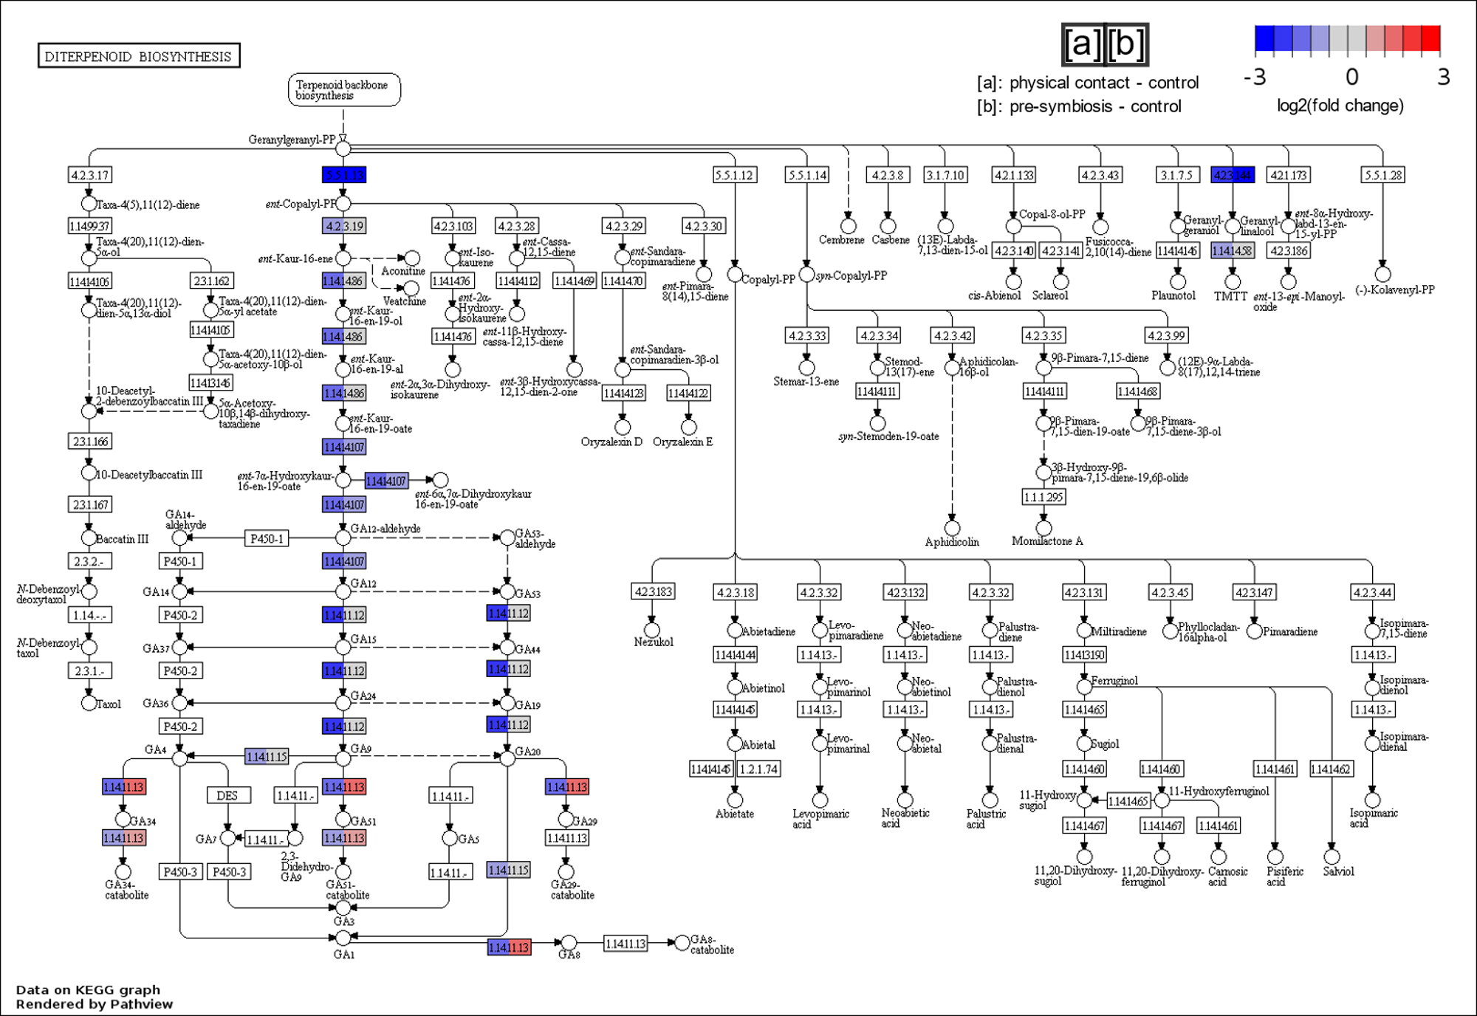
Supplementary figure 11. Pathway graph to visualize the genes associated with the diterpenoid biosynthesis pathway and their expressions in E. grandis roots during direct physical interaction (coloration on left-hand side of each enzyme box) and pre-symbiotic interaction (coloration on the right-hand side of each enzyme box) with Pisolithus microcarpus in comparison to uninfected control roots. The Arabidopsis thaliana homologs of the E. grandis genes and their expression were mapped onto the pathway. The color of the boxes represents the log₂(fold change) value of the gene.
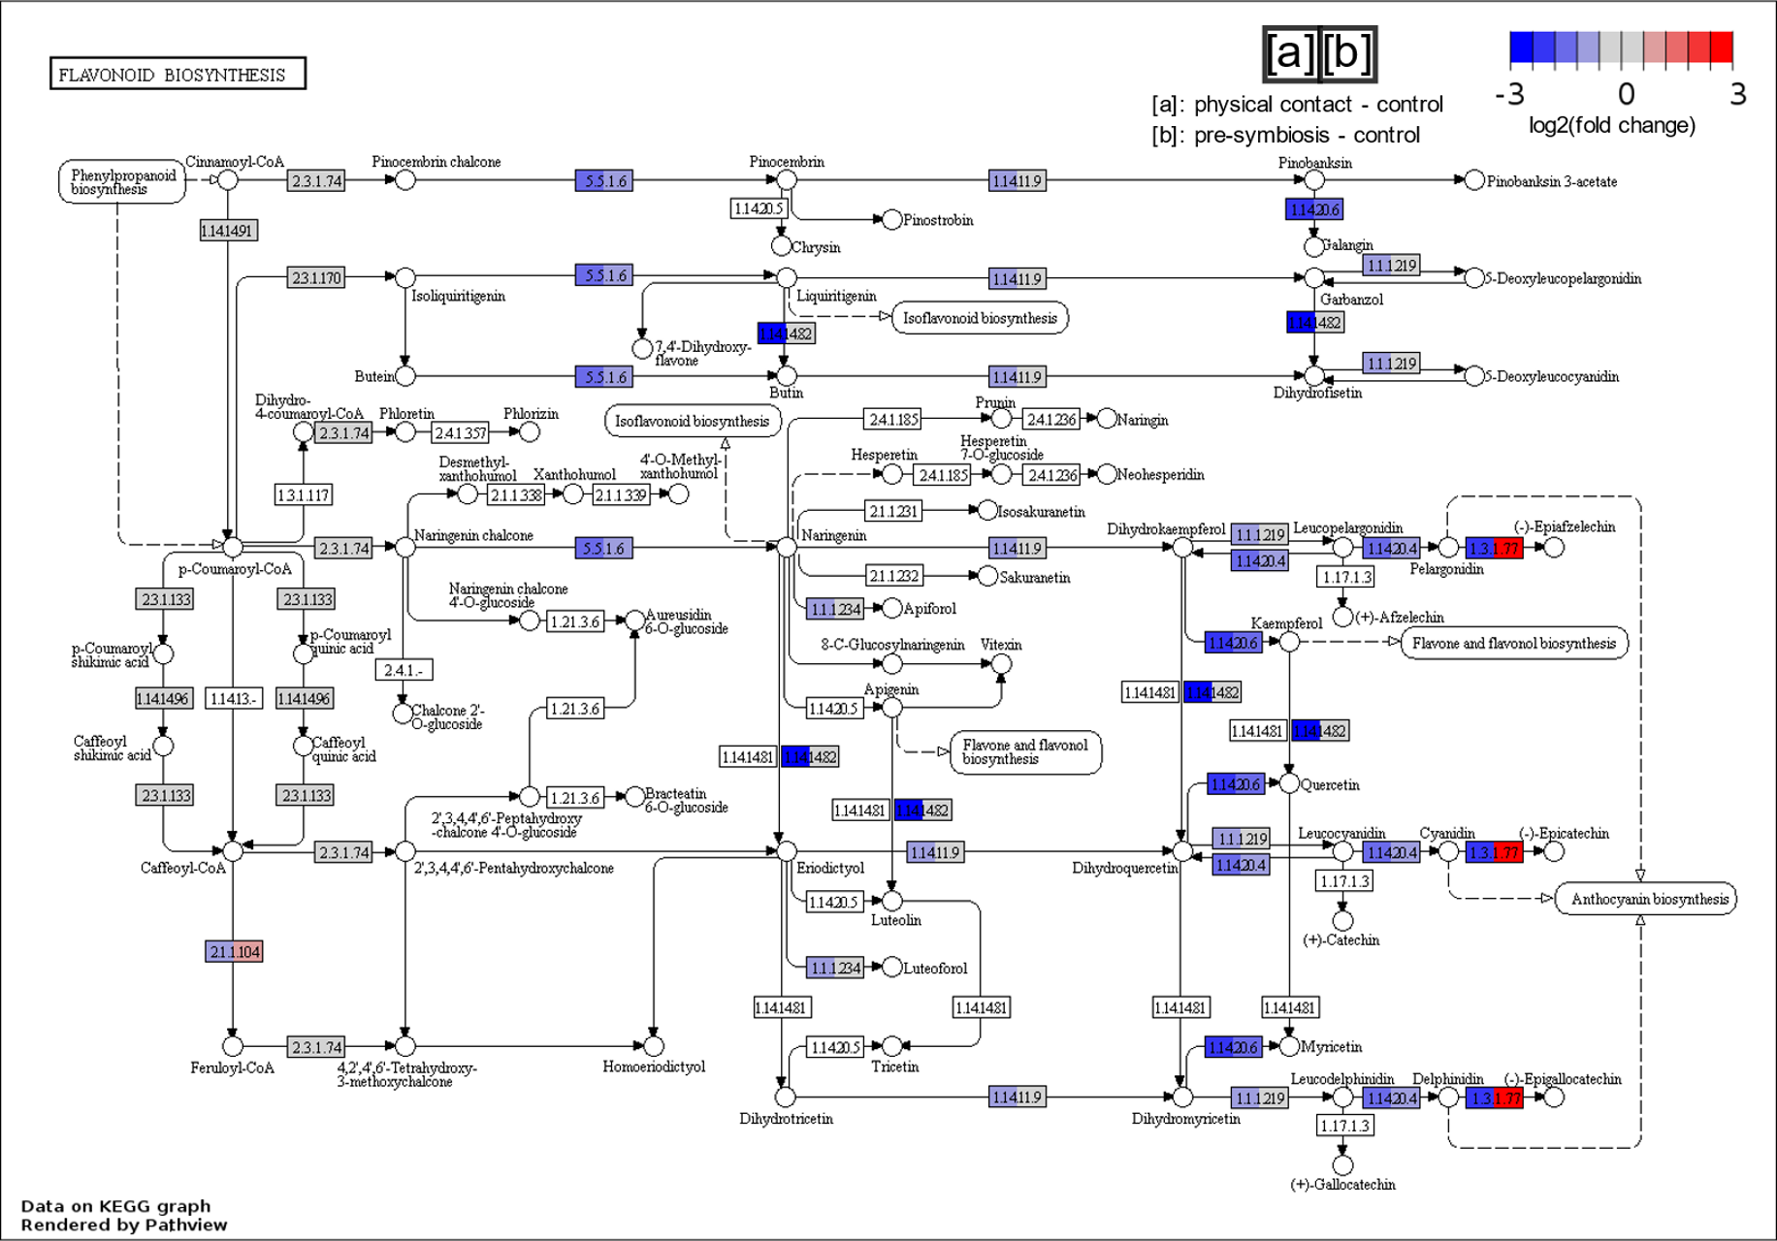
Supplementary figure 12. Pathway graph to visualize the genes associated with the flavonoid biosynthesis pathway and their expressions in E. grandis roots during direct physical interaction (coloration on left-hand side of each enzyme box) and pre-symbiotic interaction (coloration on the right-hand side of each enzyme box) with Pisolithus microcarpus in comparison to uninfected control roots. The Arabidopsis thaliana homologs of the E. grandis genes and their expression were mapped onto the pathway. The color of the boxes represents the log₂(fold change) value of the gene.

