Supplementary Material

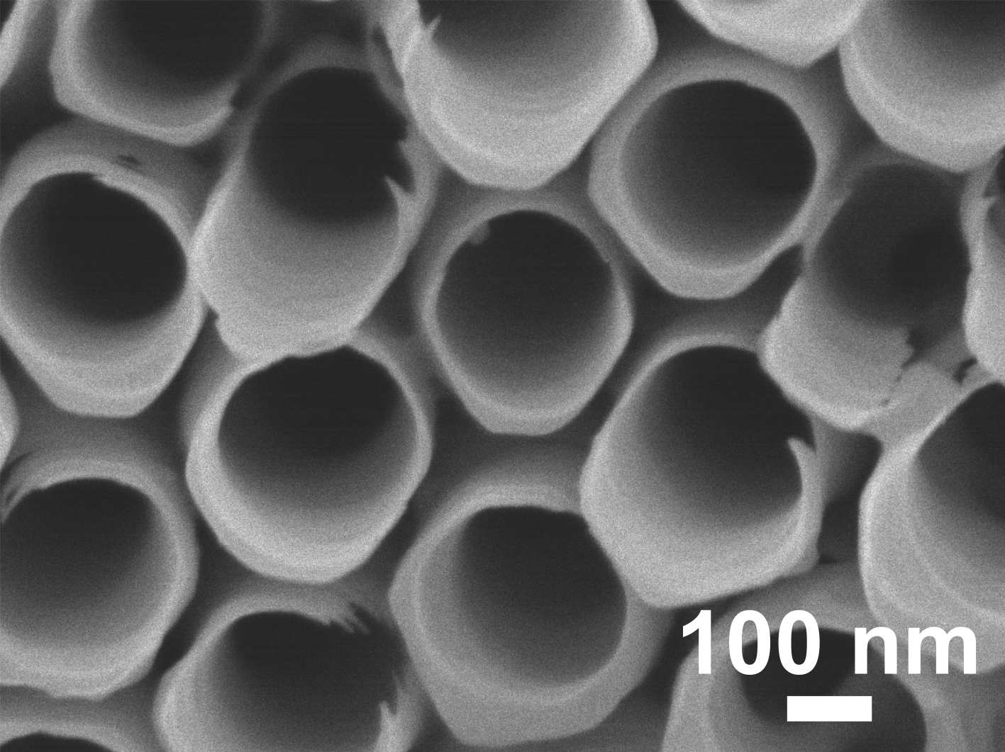
Supplementary Figure 1. SEM images of blank TiO₂ nanotube layers soaked in phosphate buffer solution (PBS) for 28 days.

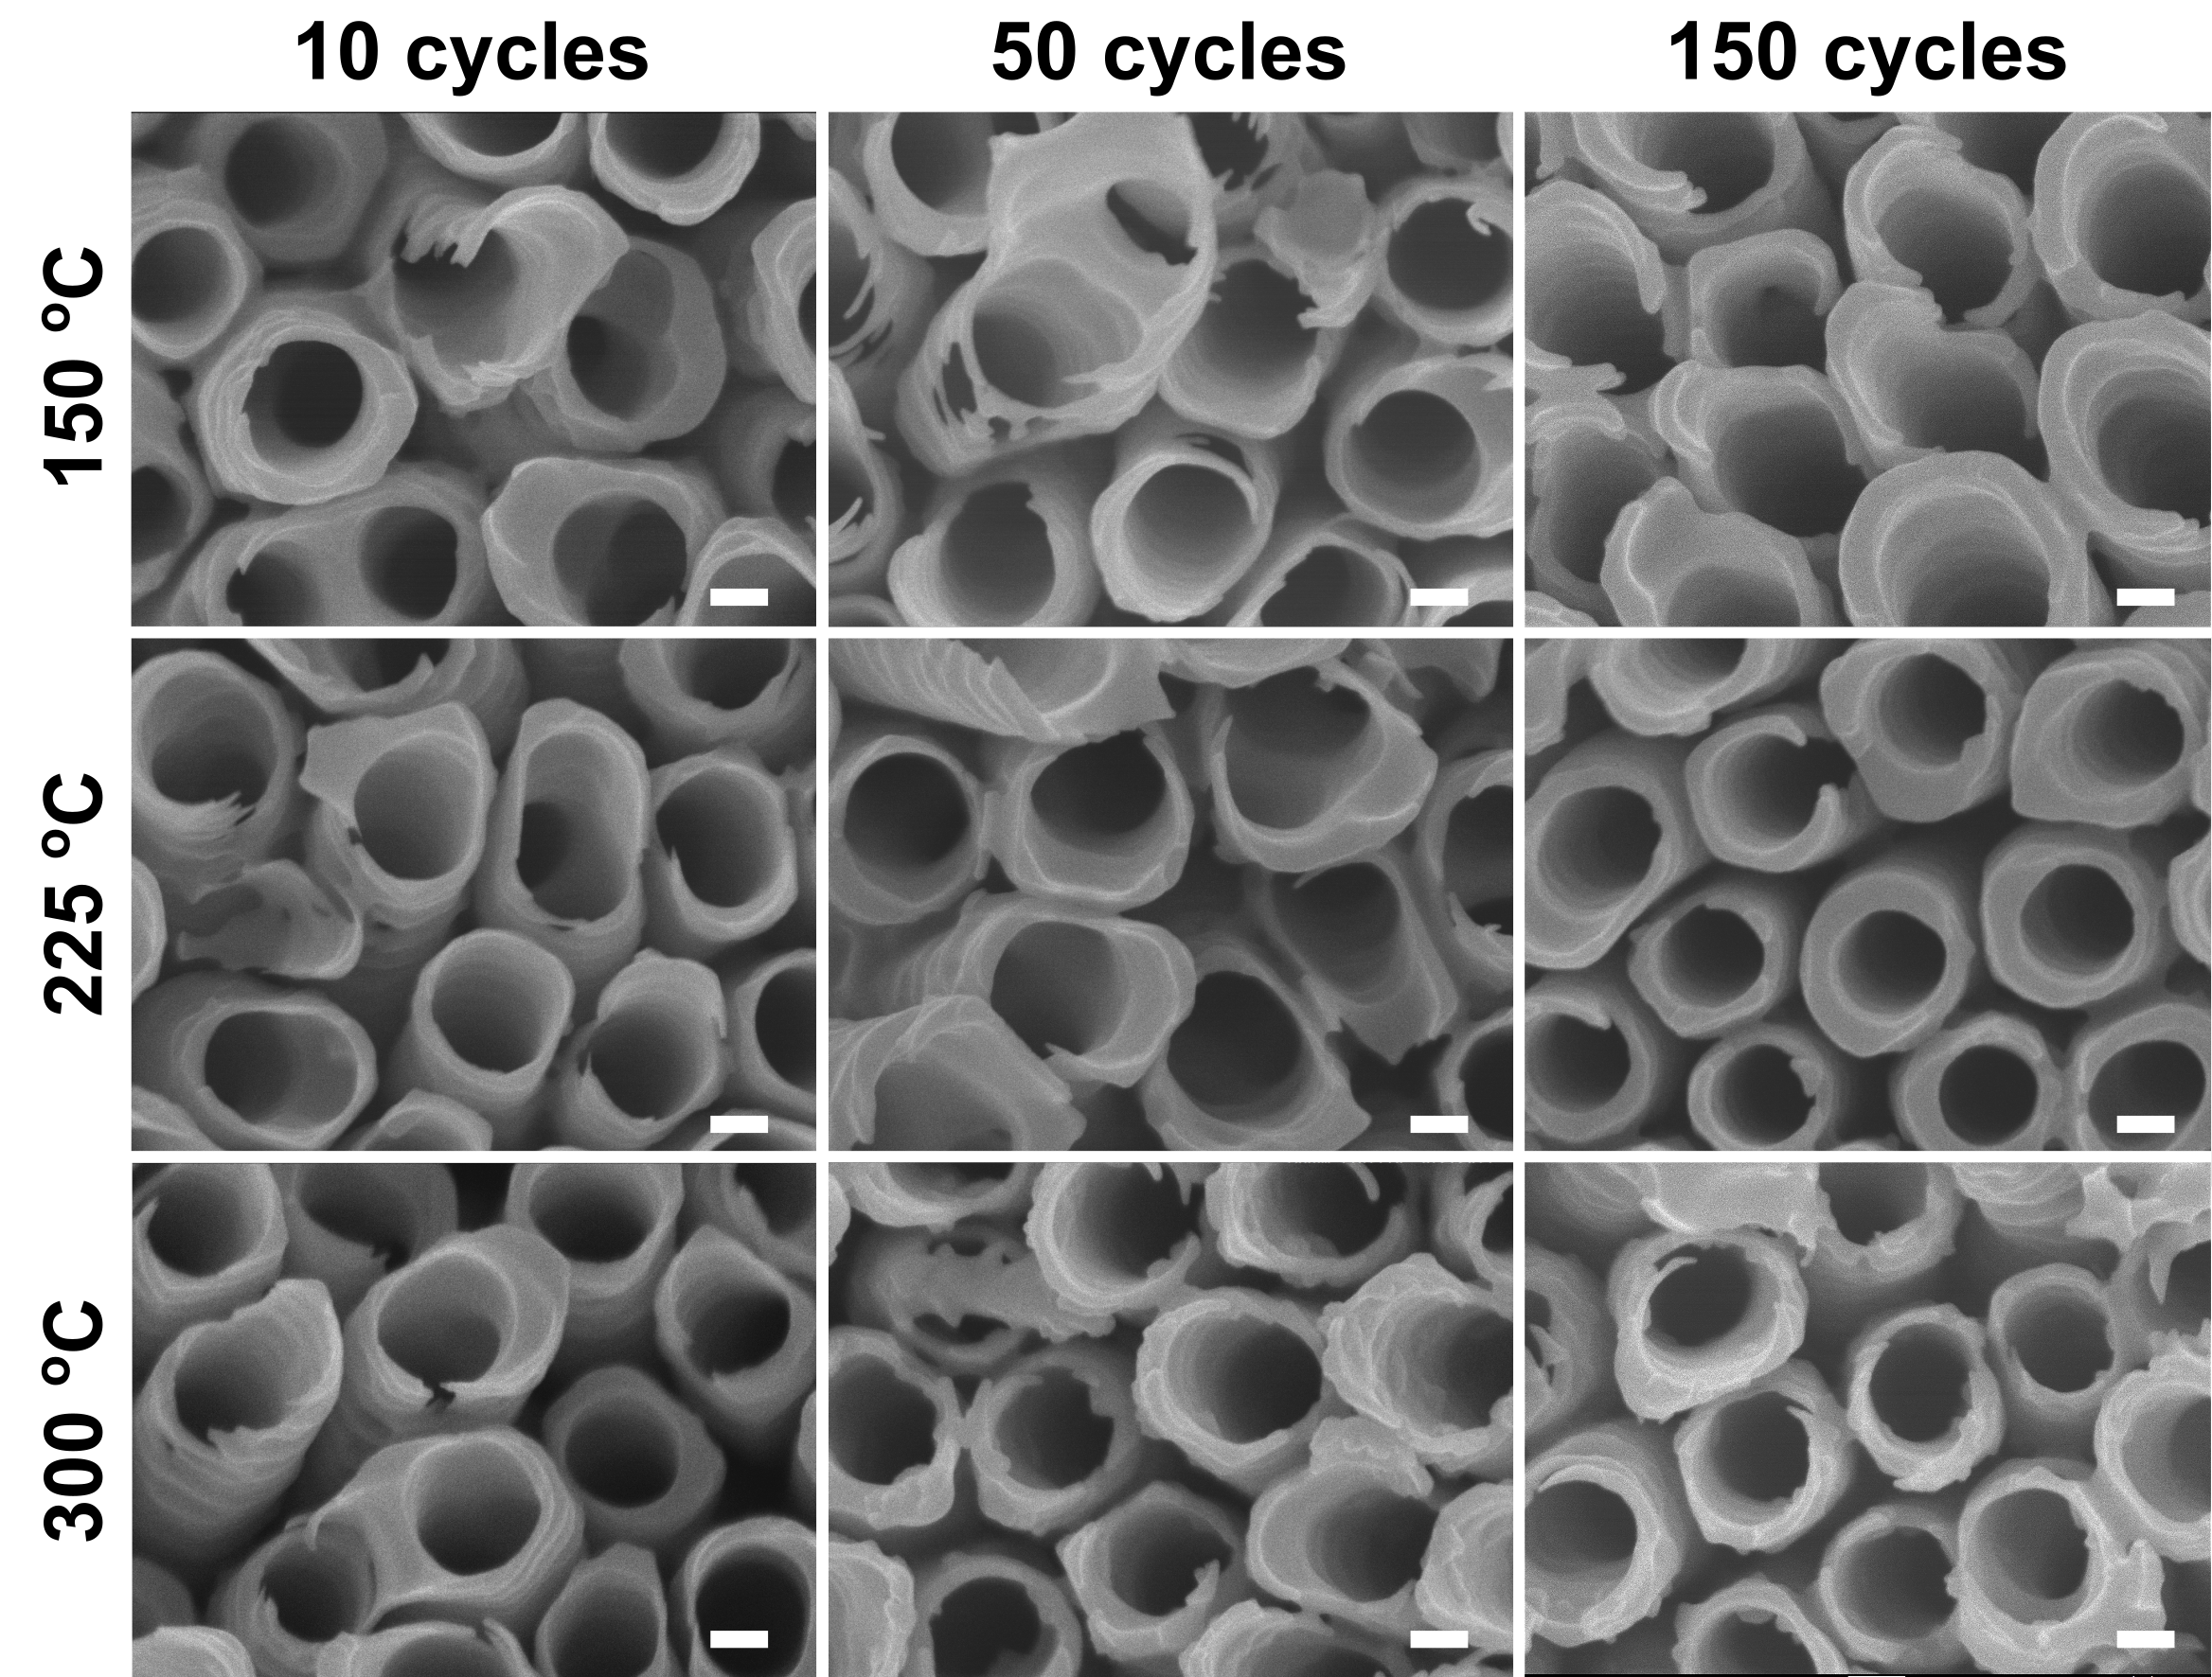

Supplementary Figure 2. SEM images of ALD TiO₂ coated TiO₂ nanotube layers soaked in PBS for 28 days. All scale bars are 100 nm.

