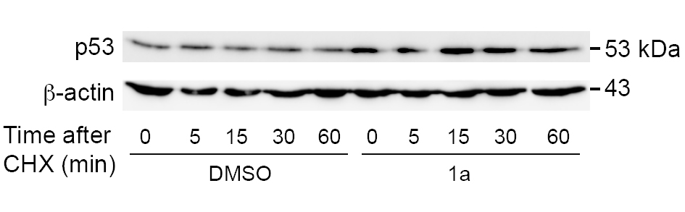

Figure R1. Spiropyrazoline oxindole 1a increases p53 stability. Mouse neural stem cells (MNSCs) were plated in 60-mm dishes at 4.2x10⁴ cells/cm². Twenty-four hours after plating, cells were treated with vehicle or 12.5 μM of 1a in differentiation medium for additional 24h. Cells were chased with cycloheximide (Sigma-Aldrich) at a final concentration of 100 μM/mL. At the indicated time points after the treatment with cycloheximide, cells were harvested, and whole-cell lysates were processed for immunoblot analysis with the anti-p53 antibody (sc-99). β-actin was used as protein loading control.

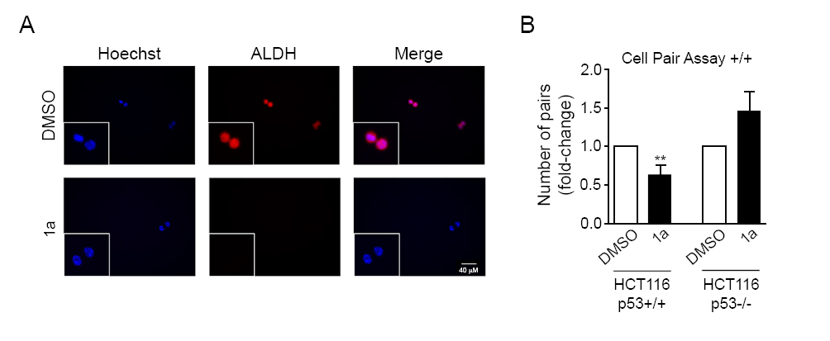
Figure R2. Spiropyrazoline oxindole 1a disrupts self-renewal in HCT116 p53+/+ cells. HCT116 p53+/+ and p53-/- cells were incubated with 2.5 μM 1a for 24 h. DMSO was used as vehicle control. (A) Representative microscopy images of HCT116 p53+/+ cell pairs labeled with Hoechst 33258 and anti-ALDH1/2 antibody (sc-50385) after 1a treatment. Scale bar, 40 µm. (B) Representative quantification data of paired cells ALDH-positive, in low EGF/bFGF containing medium after 1a treatment. Results are expressed as mean ± SEM fold-change to vehicle control of at least 3 different experiments. **p < 0.01 from DMSO.

