Supplementary Material
Whole genome sequencing and comparative genomics analyses of Pandoraea sp. XY-2, a new species capable of biodegrade tetracycline

Xueling Wu^{1,2}, Xiaoyan Wu¹, Li Shen^{1,2}, Jiaokun Li^{1,2}, Runlan Yu^{1,2}, Yuandong Liu^{1,2}, Guanzhou Qiu^{1,2} and Weimin Zeng^{1,2*}

* Correspondence: Weimin Zeng: zengweimin1024@126.com

Supplementary Data
As shown in Supplementary Figure 1, in blank group, the removal of tetracycline was processed by hydrolysis, the removal percentage of tetracycline increased slowly, reached about 5% in 108 h, and then keep it stable. However, the removal percentage of tetracycline normal group reached74.87% in 144h. So, the hydrolysis of tetracycline could be ignored, only biodegradation was considered in this study.

Supplementary Figure legends
Supplementary Figure 1. Changes of tetracycline removal percentage over time under various treatment conditions. The initial concentration of tetracycline was 50 mg L⁻¹. TC: tetracycline. In normal group, Pandoraea sp. XY-2 were cultured in 150 mL LB medium; In blank group, only 150 mL medium was used (without Pandoraea sp. XY-2).
Supplementary Figure 2. Scanning electron microscope image of the Pandoraea sp. XY-2.
Supplementary Figure 3. Six classification statistics of CAZy database.
Supplementary Figure 4. COG distribution of the Pandoraea sp. XY-2 genome annotation.
Supplementary Figure 5. GO classification statistics of the Pandoraea sp. XY-2 genome annotation.
Supplementary Figure 6. KEGG classification statistics of the Pandoraea sp. XY-2 genome annotation.
Supplementary Figure 7. Neighbor joining phylogenetic tree of 9 GSTs-encoding genes derived from Pandoraea sp. XY-2 and other close-related strains. Bootstrap values are indicated at each node based on a total of 1,000 bootstrap replicates. Pandoraea sp. XY-2 were marked in orange. The green dot and red dot indicated that each strain of Pandoraea spp. was isolated from environment and clinical, respectively.
Supplementary Figure 8. Neighbor-joining (NJ) phylogenetic tree of Pandoraea sp. XY-2 based on 16S rRNA gene sequence. The other reference sequences were retrieved from the EzTaxon server. Bootstrap values are indicated at each node based on a total of 1,000 bootstrap replicates.
Supplementary Figure 9. KEGG classification statistics of the specific genes of Pandoraea sp. XY-2.
Supplementary Figure 10. Phylogenetic analysis of Pandoraea sp. XY-2 based on all of the single-copy core genes among 19 whole genome sequences. The phylogeny tree was generated using the NJ method in Mega 7.0 with 1000 bootstrap replicates. The whole genome sequences of 18 other Pandoraea strains, which genome sequences level were complete, were retrieved from GenBank.

Supplementary Figures
Supplementary Figure 1.

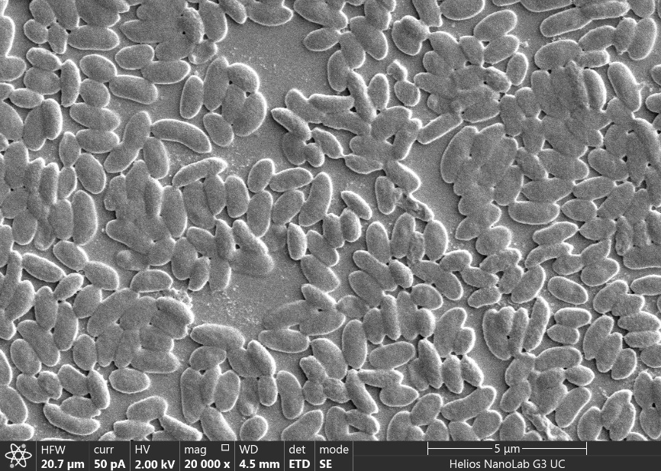
Supplementary Figure 2.

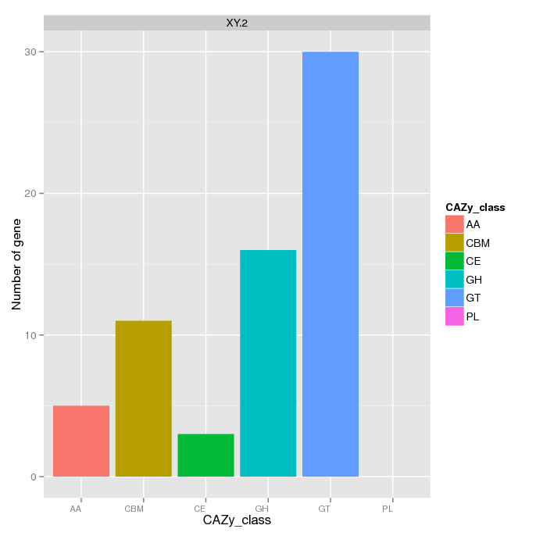
Supplementary Figure 3.

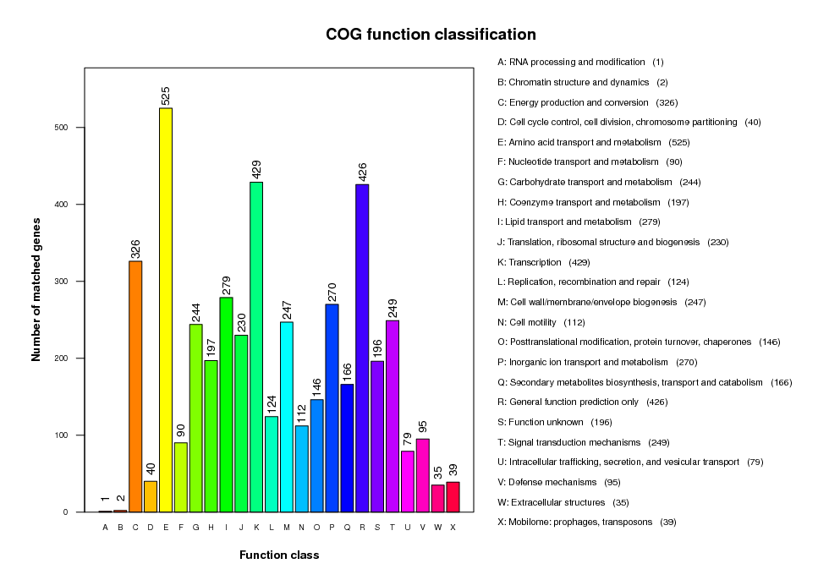
Supplementary Figure 4.

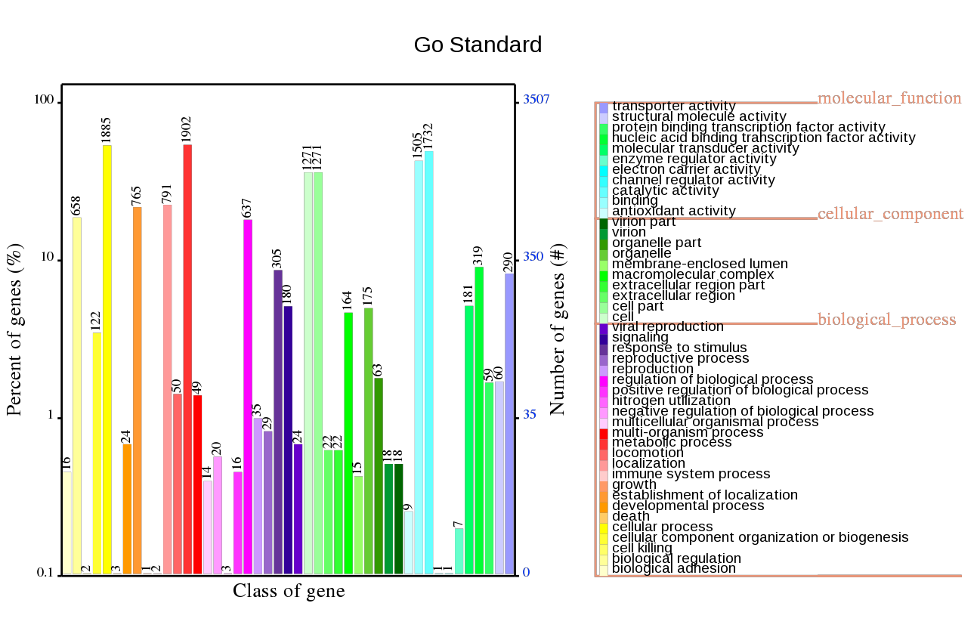
Supplementary Figure 5.

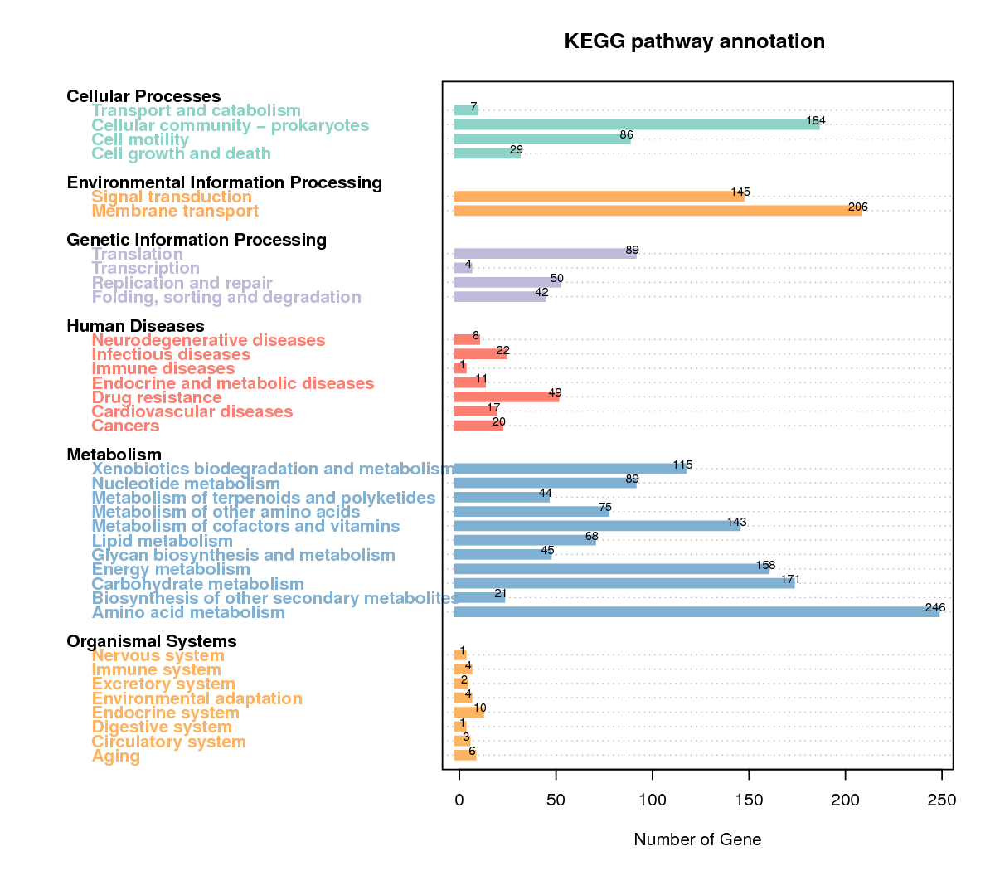
Supplementary Figure 6.

Supplementary Figure 7

Supplementary Figure 8

Supplementary Figure 9.

Supplementary Figure 10.

Supplementary Tables
Supplementary Table S1 The details source and the GSTs-encoding gene content of all testing strains.
Organism | Source | Number of GSTs-encoding gene
P. pnomenusa DSM 16536^{T} | CF patient (Lim et al., 2016) | 13
P. pnomenusa RB-44 | exlandfill dumping ground (Ee et al., 2014) | 12
P. pnomenusa 3kgm | former landfill site (Chan et al., 2013) | 13
P. pnomenusa RB38 | municipal solid waste landfill site (Lim et al., 2015) | 13
P. pnomenusa MCB032 | functionally stable bioreactor (Baptista et al., 2010) | 13
P. pnomenusa 6399 | CF patient^{b} | 14
P. pnomenusa 7641 | CF patient^{b} | 14
P. pnomenusa NCTC13160 | unkown | 13
P. pnomenusa RB44 | soil^{b} | 12
P. norimbergensis DSM11628^{T} | food (Moore, 2001) | 13
P. faecigallinarum DSM23572^{T} | oxalate-enriched culture (Nurettin et al., 2000) | 10
P. thiooxydans ATSB16^{T} | rhizosphere soils of sesame (Rangasamy et al., 2010) | 15
P. thiooxydans DSM25325 ^{T} | rhizosphere soils of sesame (Yong et al., 2016) | 15
P. oxalativorans DSM23570^{T} | soil (Chan et al., 2016) | 9
P. apista TF81F4 | sputum^{b} | 14
P. apista TF80G25 | sputum^{b} | 14
P. apista AU2161 | sputum^{b} | 14
P.apista FDAARGOS_126 | sputum^{b} | 14
P. apista LMG16407^{T} | CF patient (Ackiss et al., 2011) | 14
P. apista Pa14367 | sputum^{b} | 14
P. apista Pa16226 | sputum^{b} | 14
P. apista DSM16535 ^{T} | CF patient (Ackiss et al., 2011) | 14
P. vervacti NS15^{T} | uncultivated field soil (Ee et al., 2015) | 12
P. pulmonicola DSM 16583^{T} | CF patient (Coenye et al., 2000) | 14
P. pulmonicola NCTC13159 | CF patient (Coenye et al., 2000) | 14
P. sputorum DSM21091 ^{T} | CF patient (Coenye et al., 2000) | 12
P. sputorum NCTC13161 ^{T} | CF patient (Coenye et al., 2000) | 12
Pandoraea sp. 64-18 | unkown | 13
Pandoraea sp. B-6 | bamboo slips (Shi et al., 2013) | 8
Pandoraea sp. CB10b_02 | unkown | unkown
Pandoraea sp. E26 | former landfill site (Chan et al., 2015) | 12
Pandoraea sp. ISTKB | rhizospheric zone of trees (Kumar et al., 2016) | 14
Pandoraea sp. PE-S2R-1 | forest^{b} | 15
Pandoraea sp. PE-S2T-3 | forest^{b} | 15
Pandoraea sp. SD6-2 | lindane-contaminated soil (Hafizah et al., 2013) | 12
Pandoraea sp. XY-2ª | tetracycline-contaminated sludge | 9
ª This study. ^{b} represents informations obtained from the EzBioCloud Database (https://www.ezbiocloud.net/).

Supplementary Table S3 16SrRNA gene sequence similarity of Pandoraea sp. XY-2 and the type strains of Pandoraea spp. using EzTaxon server.
Organism | 16SrRNA accession | Similarity (100%)
P. pnomenusa DSM 16536^{T} | CP009553 | 99.72
P. norimbergensis DSM 11628^{T} | CP013480 | 99.17
P. faecigallinarum DSM23572^{T} | CP011807 | 98.97
P. thiooxydans DSM25325^{T} | CP011568 | 96.9
P. oxalativorans DSM23570^{T} | CP011253 | 99.24
P. apista LMG16407^{T} | CEWL01000012 | 99.59
P. vervacti NS15^{T} | CP010897 | 99.24
P. pulmonicola DSM 16583^{T} | CP010310 | 99.24
P. sputorum DSM21091^{T} | CP010431 | 99.04
P. terrae SE-S21 | KJ831094 | 98.69
NGUR_s PE-S2R-1 | NGUR01000188 | 99.24

Supplementary Table S4 Digital DNA-DNA hybridization (dDDH) between Pandoraea genomes.
 |  |  |  |  | Formula 1 |  |  |  |  |  | Formula 2 |  |  |  |  |  |  | Formula 3
Query genome |  | Reference genome | DDH | Model C.I. |  | Distance | Prob. DDH >= 70% |  | DDH | Model C.I. |  | Distance |  | Prob. DDH >= 70% |  | DDH | Model C.I. |  | Distance |  | Prob. DDH >= 70%
XY-2 |  | CP009553 | 44.5 | [41.1 - 47.9%] |  | 0.351 | 4.53 |  | 27.5 | [25.1 - 30%] |  | 0.1569 |  | 0.03 |  | 39.2 | [36.2 - 42.2%] |  | 0.4529 |  | 0.1
XY-2 |  | CP006938 | 44.5 | [41.1 - 48%] |  | 0.3507 | 4.57 |  | 27.5 | [25.2 - 30%] |  | 0.1567 |  | 0.03 |  | 39.2 | [36.3 - 42.3%] |  | 0.4524 |  | 0.1
XY-2 |  | CP006900 | 44.1 | [40.7 - 47.5%] |  | 0.3543 | 4.19 |  | 27.5 | [25.1 - 30%] |  | 0.1569 |  | 0.03 |  | 38.9 | [36 - 42%] |  | 0.4557 |  | 0.09
XY-2 |  | CP007506 | 44.8 | [41.4 - 48.2%] |  | 0.3481 | 4.85 |  | 27.5 | [25.2 - 30%] |  | 0.1568 |  | 0.03 |  | 39.4 | [36.5 - 42.5%] |  | 0.4503 |  | 0.11
XY-2 |  | CP015371 | 43.4 | [40.1 - 46.9%] |  | 0.3602 | 3.66 |  | 27.5 | [25.2 - 30%] |  | 0.1567 |  | 0.03 |  | 38.5 | [35.5 - 41.5%] |  | 0.4604 |  | 0.08
XY-2 |  | CP013480 | 33.2 | [29.8 - 36.8%] |  | 0.4687 | 0.26 |  | 26.2 | [23.9 - 28.7%] |  | 0.1654 |  | 0.02 |  | 30.5 | [27.6 - 33.6%] |  | 0.5566 |  | 0
XY-2 |  | CP011807 | 40 | [36.6 - 43.5%] |  | 0.3924 | 1.69 |  | 27.2 | [24.8 - 29.6%] |  | 0.1591 |  | 0.03 |  | 35.8 | [32.9 - 38.9%] |  | 0.489 |  | 0.03
XY-2 |  | CP014839 | 14.9 | [12 - 18.3%] |  | 0.8834 | 0 |  | 20.7 | [18.5 - 23.1%] |  | 0.2122 |  | 0 |  | 15 | [12.6 - 17.9%] |  | 0.9081 |  | 0
XY-2 |  | CP011568 | 14.9 | [12 - 18.3%] |  | 0.8834 | 0 |  | 20.7 | [18.5 - 23.1%] |  | 0.2124 |  | 0 |  | 15 | [12.6 - 17.9%] |  | 0.9082 |  | 0
XY-2 |  | CP011253 | 39.8 | [36.4 - 43.2%] |  | 0.3949 | 1.59 |  | 27.3 | [24.9 - 29.7%] |  | 0.1585 |  | 0.03 |  | 35.7 | [32.7 - 38.8%] |  | 0.4908 |  | 0.03
XY-2 |  | CP010518 | 50 | [46.6 - 53.5%] |  | 0.3067 | 12.35 |  | 28.8 | [26.4 - 31.3%] |  | 0.149 |  | 0.06 |  | 43.7 | [40.7 - 46.7%] |  | 0.41 |  | 0.46
XY-2 |  | CP011279 | 50 | [46.6 - 53.5%] |  | 0.3065 | 12.39 |  | 28.8 | [26.4 - 31.3%] |  | 0.149 |  | 0.06 |  | 43.7 | [40.7 - 46.7%] |  | 0.4098 |  | 0.46
XY-2 |  | CP011501 | 49.8 | [46.4 - 53.3%] |  | 0.308 | 12 |  | 28.8 | [26.4 - 31.3%] |  | 0.1489 |  | 0.06 |  | 43.6 | [40.6 - 46.6%] |  | 0.411 |  | 0.44
XY-2 |  | CP013481 | 49.4 | [45.9 - 52.8%] |  | 0.3117 | 11.08 |  | 28.9 | [26.5 - 31.4%] |  | 0.1483 |  | 0.07 |  | 43.3 | [40.3 - 46.3%] |  | 0.4138 |  | 0.4
XY-2 |  | CP014018 | 52.2 | [48.8 - 55.7%] |  | 0.2906 | 17.28 |  | 28.7 | [26.4 - 31.2%] |  | 0.1492 |  | 0.06 |  | 45.2 | [42.2 - 48.2%] |  | 0.3965 |  | 0.73
XY-2 |  | CP010897 | 36.8 | [33.4 - 40.3%] |  | 0.4259 | 0.75 |  | 27.2 | [24.9 - 29.7%] |  | 0.1586 |  | 0.03 |  | 33.5 | [30.6 - 36.6%] |  | 0.517 |  | 0.01
XY-2 |  | CP010310 | 38.3 | [34.9 - 41.7%] |  | 0.4102 | 1.1 |  | 27.8 | [25.4 - 30.2%] |  | 0.1553 |  | 0.04 |  | 34.8 | [31.8 - 37.8%] |  | 0.5018 |  | 0.02
XY-2 |  | CP010431 | 40 | [36.6 - 43.5%] |  | 0.3924 | 1.69 |  | 27.1 | [24.7 - 29.6%] |  | 0.1595 |  | 0.03 |  | 35.8 | [32.9 - 38.9%] |  | 0.4894 |  | 0.03
XY-2 |  | LT906435 | 40 | [36.6 - 43.5%] |  | 0.3925 | 1.69 |  | 27.1 | [24.7 - 29.6%] |  | 0.1595 |  | 0.03 |  | 35.8 | [32.9 - 38.9%] |  | 0.4894 |  | 0.03
Figures in gray denote the dDDH (%) values of Pandoraea sp. XY-2 against all reference strains.

Supplementary Table S5 Statistic information of the single nucleotide polymorphism (SNPs) of Pandoraea sp. XY-2 compare with P. apista DSM16535^{T}.
Type | Number | Percentage (%)
Total SNPs | 372,574 | 100
Synonymous | 264,974 | 71.12
Nonsynonymous | 67,476 | 18.11
Nonsense mutation | 395 | 0.11
SNPs in CDS | 333,149 | 89.42
SNPs in intergenic | 39,425 | 10.58

Supplementary Table S6 Statistic information of the insertion/deletion variations (InDels) of Pandoraea sp. XY-2 compare with P. apista DSM16535 ^{T}.
Type | Number | Percentage (%)
Total InDels | 581 | 100
Insertion | 228 | 39.24
Deletion | 353 | 60.76
InDels in CDS | 193 | 33.22
InDels in intergenic | 388 | 66.78

Supplementary Table S8 Statistics information of tetracycline resistance genes identified in Pandoraea sp. XY-2.
Gene type | Gene ID | Gene locus
TetA(48) | XY.2_GM000586 | locus=Chr1:592121:593143:-
TetA(48) | XY.2_GM000605 | locus=Chr1:608628:609431:-
TetA(48) | XY.2_GM001703 | locus=Chr1:1727464:1728267:+
TetA(48) | XY.2_GM003133 | locus=Chr1:3180686:3181561:-
TetA(48) | XY.2_GM003479 | locus=Chr1:3564880:3565809:+
TetA(48) | XY.2_GM004567 | locus=Chr1:462922:4630178:-
TetB(P) | XY.2_GM002024 | locus=Chr1:2046568:2048664:-
TetG | XY.2_GM004469 | locus=Chr1:4540924:4542099:+
TetT | XY.2_GM004640 | locus=Chr1:4692983:4695085:-

REFERENCES
Ackiss, E., Guzman-Cottrill, J., Wall, M., and Lipuma, J. (2011). An Investigation of Genotypically Clonal Pandoraea apista Isolates at a Cystic Fibrosis Center. Ajic American Journal of Infection Control 39, E122-E123. doi: 10.1016/j.ajic.2011.04.214
Baptista, I.I.R., Zhou, N.Y., Emanuelsson, E.A.C., Peeva, L.G., Mantalaris, A., and Livingston, A.G. (2010). Evidence of species succession during chlorobenzene biodegradation. Biotechnology & Bioengineering 99, 68-74. doi: 10.1002/bit.21576
Chan, K.G., Yin, W.F., Tee, K.K., Chang, C.Y., and Priya, K. (2015). Pandoraea sp. Strain E26: Discovery of Its Quorum-Sensing Properties via Whole-Genome Sequence Analysis. Genome Announc 3. doi: 10.1128/genomeA.00565-15
Chan, K.G., Yin, W.F., and Goh, S.Y. (2013). Complete Genome Sequence of Pandoraea pnomenusa 3kgm, a Quorum-Sensing Strain Isolated from a Former Landfill Site. Genome Announcements 2. doi: 10.1128/genomeA.00427-14
Chan, K.G., Yong, D., Ee, R., Lim, Y.L., Yu, C.Y., Tee, K.K., et al. (2016). Complete genome sequence of Pandoraea oxalativorans DSM 23570 T, an oxalate metabolizing soil bacterium. J. Biotechnol. 219, 124-125. doi: 10.1016/j.jbiotec.2015.12.037
Coenye, T., Falsen, E., Hoste, B., Ohlen, M., Goris, J., Govan, J.R.W., et al. (2000). Description of Pandoraea gen. nov. with Pandoraea apista sp. nov., Pandoraea pulmonicola sp. nov., Pandoraea pnomenusa sp. nov., Pandoraea sputorum sp. nov. and Pandoraea norimbergensis comb. nov. International Journal of Systematic & Evolutionary Microbiology 50 Pt 2, 887. doi: 10.1099/00207713-50-2-887
Ee, R., Lim, Y.L., Yin, W.F., and Chan, K.G. (2014). De Novo Assembly of the Quorum-Sensing Pandoraea sp. Strain RB-44 Complete Genome Sequence Using PacBio Single-Molecule Real-Time Sequencing Technology. Genome Announc 2. doi: 10.1128/genomeA.00245-14
Ee, R., Yong, D., Yan, L.L., Yin, W.F., and Chan, K.G. (2015). Complete genome sequence of oxalate-degrading bacterium Pandoraea vervacti DSM 23571 T. J. Biotechnol. 204, 5-6. doi: 10.1016/j.jbiotec.2015.03.020
Hafizah, P., Pearce, S.L., Oakeshott, J.G., Russell, R.J., and Gunjan, P. (2013). Draft Genome Sequence of Pandoraea sp. Strain SD6-2, Isolated from Lindane-Contaminated Australian Soil. Genome Announcements 1, 340-344. doi: 10.1128/genomea.00415-13
Kumar, M., Singhal, A., and Thakur, I.S. (2016). Comparison of submerged and solid state pretreatment of sugarcane bagasse by Pandoraea sp. ISTKB: Enzymatic and structural analysis. Bioresource Technol. 203, 18-25. doi: 10.1016/j.biortech.2015.12.034
Lim, Y.L., Ee, R., Yong, D., Tee, K.K., Yin, W.F., and Chan, K.G. (2015). Complete genome of Pandoraea pnomenusa RB-38, an oxalotrophic bacterium isolated from municipal solid waste landfill site. J. Biotechnol. 214, 83-84. doi: 10.1016/j.jbiotec.2015.09.018
Lim, Y.L., Ee, R., Yong, D., Yu, C.Y., Ang, G.Y., Tee, K.K., et al. (2016). Complete Genome Sequence Analysis of Pandoraea pnomenusa Type Strain DSM 16536T Isolated from a Cystic Fibrosis Patient. Front. Microbiol. 7, 109. doi: 10.3389/fmicb.2016.00109
Moore, J.E. (2001). First report of Pandoraea norimbergensis isolated from food--potential clinical significance. Food Microbiol. 18, 113-114. doi: 10.1006/fmic.2000.0375
Nurettin, S., Akio, T., Recep, K., Ivo, S., Kazuhide, K., and Abdurrahman, U.T. (2000). Pandoraea oxalativorans sp. nov., Pandoraea faecigallinarum sp. nov. and Pandoraea vervacti sp. nov., isolated from oxalate-enriched culture. International Journal of Systematic and Evolutionary Microbiology, 50, 887–899. doi: 10.1099/ijs.0.026138-0
Rangasamy, A., Pandiyan, I., Soon Wo, K., Min, S.T., Ok, J.C., Ki, K.Y., et al. (2010). Pandoraea thiooxydans sp. nov., a facultatively chemolithotrophic, thiosulfate-oxidizing bacterium isolated from rhizosphere soils of sesame (Sesamum indicum L.). International Journal of Systematic & Evolutionary Microbiology 60, 21. doi: 10.1099/ijs.0.012823-0
Shi, Y., Chai, L., Tang, C., Yang, Z., Zheng, Y., Chen, Y., et al. (2013). Biochemical investigation of kraft lignin degradation by Pandoraea sp. B-6 isolated from bamboo slips. Bioprocess & Biosystems Engineering 36, 1957-1965. doi: 10.1007/s00449-013-0972-9
Yong, D., Ee, R., Lim, Y.L., Yu, C.Y., Ang, G.Y., How, K.Y., et al. (2016). Complete genome sequence of Pandoraea thiooxydans DSM 25325 T, a thiosulfate-oxidizing bacterium. J. Biotechnol. 217, 51-52. doi: 10.1016/j.jbiotec.2015.12.037

