Supplementary Material

Elaboration of PCBM coated P3HT nanoparticles: understanding the shell formation

Abigail Palacio Valera,1 Christophe Schatz,2 Emmanuel Ibarboure,2 Takaya Kubo,3 Hiroshi Segawa,3 Sylvain Chambon1*

1 Univ. Bordeaux, IMS, CNRS, UMR 5218, Bordeaux INP, ENSCBP, F-33405 Talence, France

2 Univ. Bordeaux, LCPO, CNRS, UMR 5629, Bordeaux INP, ENSCBP, F-33405 Talence, France

3 University of Tokyo, RCAST, 4-6-1, Komaba, Meguro-ku, Tokyo, Japan

**\* Correspondence:** Sylvain Chambon: sylvain.chambon@u-bordeaux.fr

# Supplementary Figures and Tables

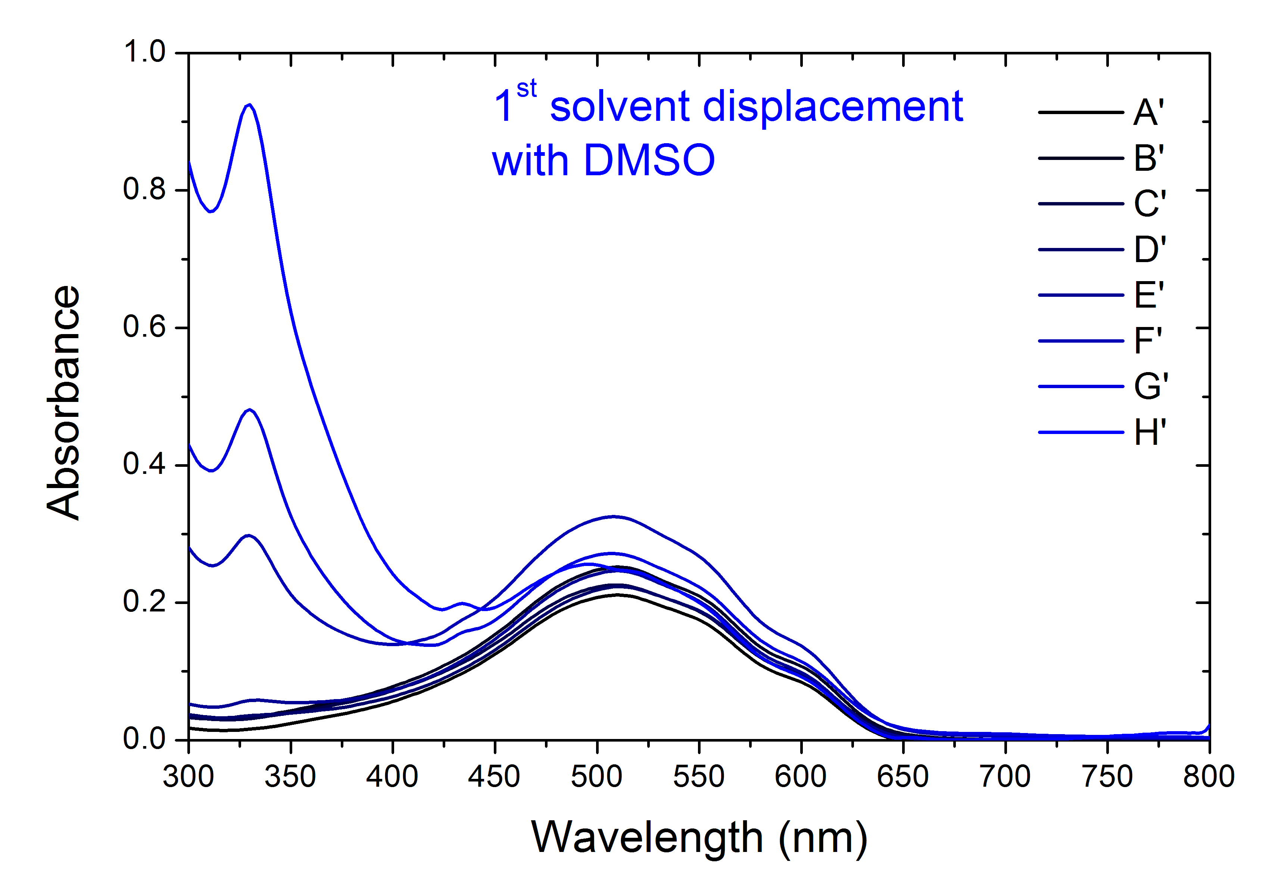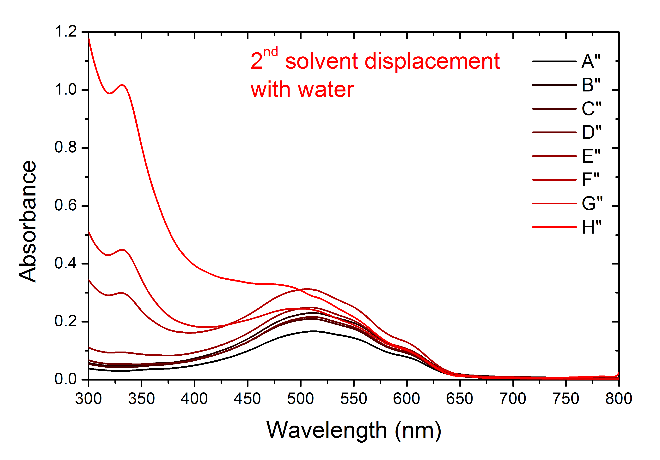

# Supplementary Figure 1. UV-visible spectra of the NP dispersions after the first solvent displacement with DMSO (top, blue curves) and after the second solvent displacement with water (bottom, red curve).

# 

# Supplementary Figure 2. UV-visible spectra of P3HT thin film (black curve) and P3HT nanoparticles generated by nanoprecipitation (red curve).

# 

# Supplementary Figure 3. Experimental decay and fit of the 1100 nm signal for P3HT NP colloidal dispersion.

# 

# 

# Supplementary Figure 4. Experimental decay and fit of the (red) 1100 nm and (blue) 960 nm signals for P3HT:PCBM composite NP colloidal dispersion.





# Supplementary Figure 5. Experimental decay and fit of the (red) 1100 nm and (blue) 960 nm signals for P3HT@PCBM 1:1 core-shell NP colloidal dispersion.





# Supplementary Figure 6. Experimental decay and fit of the (red) 1100 nm and (blue) 960 nm signals for P3HT@PCBM 10:1 core-shell NP colloidal dispersion.