Supplementary Material

CO2 Absorption by DBU-Based Protic Ionic Liquids: Basicity of Anion Dictates the Absorption Capacity and Mechanism

Feixiang Gao,1,+ Zhen Wang,3,+ Pengju Ji1,* and Jin-Pei Cheng1,2,*

1Center of Basic Molecular Science (CBMS), Department of Chemistry, Tsinghua University, Beijing, 100084, China

2State Key Laboratory of Elemento-Organic Chemistry, Collaborative Innovation Centre of Chemical Science and Engineering, Nankai University, Tianjin, 300071, China

3School of Chemical and Environmental Engineering, Anyang Institute of Technology, Anyang, 455000, China

+These authors contribute equally to this work;  
[jipengju@mail.tsinghua.edu.cn;](mailto:jipengju@mail.tsinghua.edu.cn(Ji.P.))  [jinpei_cheng@mail.tsinghua.edu.cn;](mailto:jinpei_cheng@mail.tsinghua.edu.cn(Cheng)

# Synthesis of DBU-based PILs [DBUH][X].



Figure S1. The synthesis of DBU-based PILs (**1**-**8**) through method A

Method A: These PILs (**1**-**8**, Figures 1 and S1) were synthesized by a direct equimolar acid and base neutralization reaction under neat condition. [Wang et al., 2010] In specific, 0.1 mol DBU (1,5-diazabicyclo[5.4.0]-5-undecene) and 0.1 mol acid HX were added slowly to a 250 ml round-bottom flask in a glove-box, then the reaction mixture was stirred at 60 oC for 24 hours under argon protection. The crude PILs were dried in vacuo at a constant temperature of 60 oC for overnight, then flushed with argon and stored in a glove-box before used as the media for CO2 absorption.



Figure S2. The synthesis of DBU-based PILs (**9**-**11**) through method B

Method B: These PILs (**9**-**11**, Figures 1 and S2) were synthesized by direct equimolar acid and base neutralization reactions in MeOH,[Losetty et al., 2017] instead of under neat condition as described in Method A. After reaction, the methanol was removed under vacuum. The crude PILs were dried in vacuo at a constant temperature of 40 oC for overnight, then flushed with argon and stored in a glove-box before used as the media for CO2 absorption.

# NMR and IR spectra

* [DBUH][Im] **(1)**

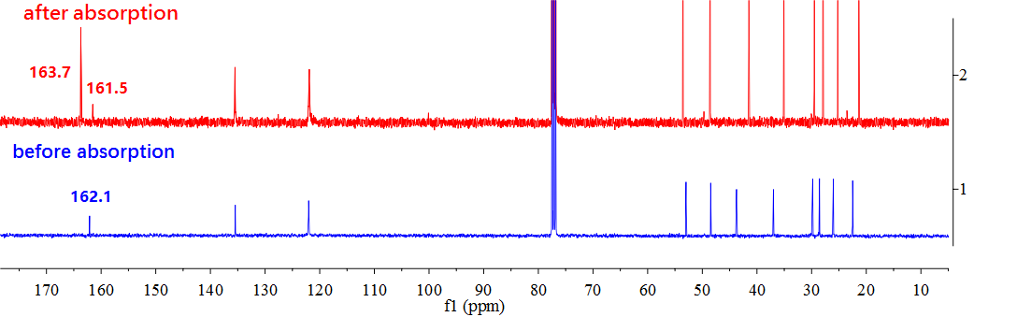

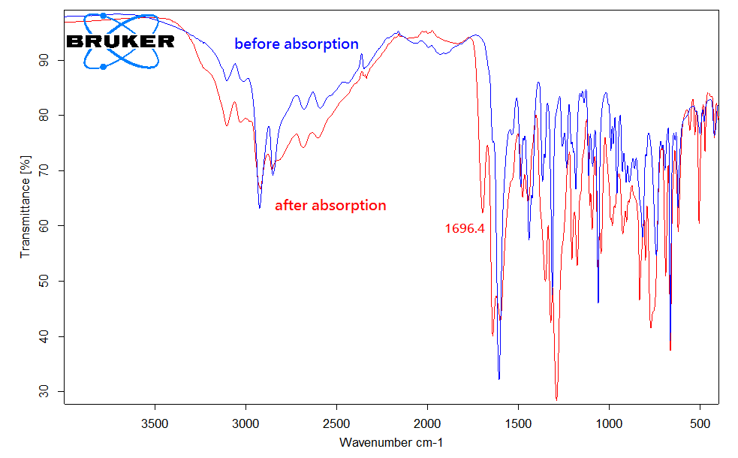

Figure S3. 13C NMR and IR spectra for [DBUH][Im] (**1**) before and after CO2 absorption

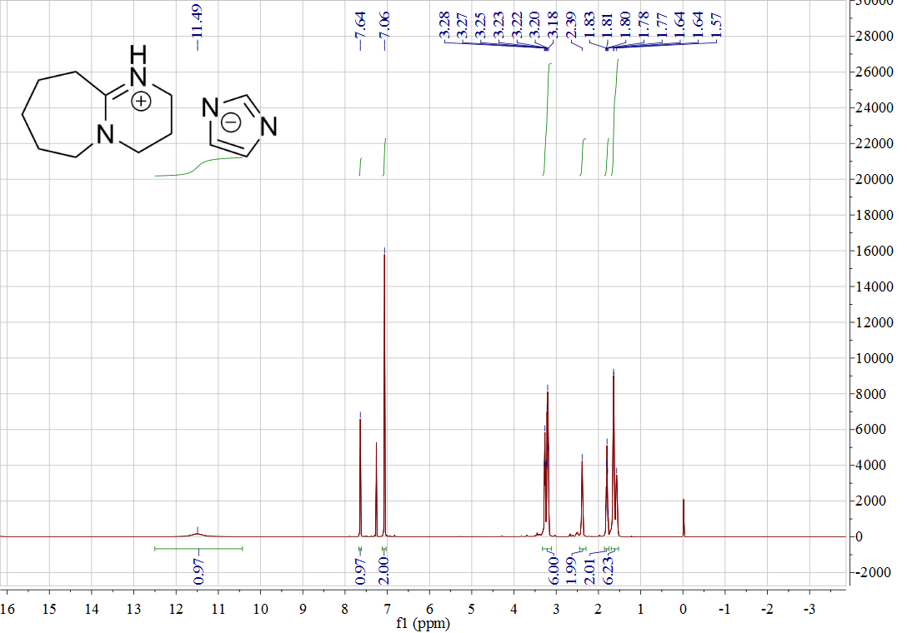

Figure S4. 1H NMR of [DBUH][Im] (**1**)

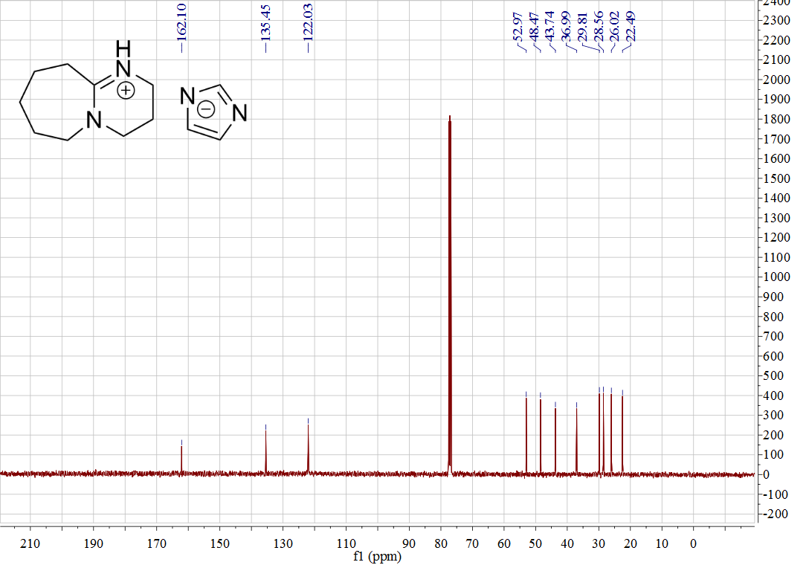

Figure S5: 13C NMR of [DBUH][Im] (**1**)

* [DBUH][Pyra] (**2**)

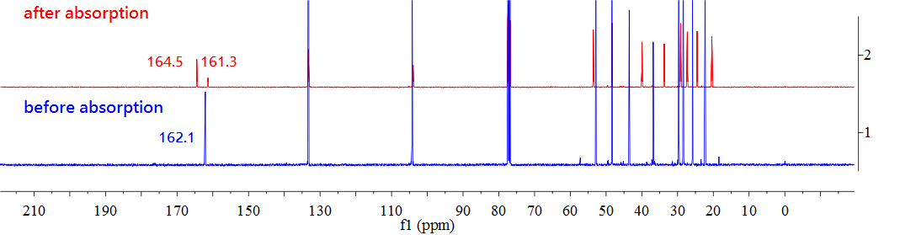

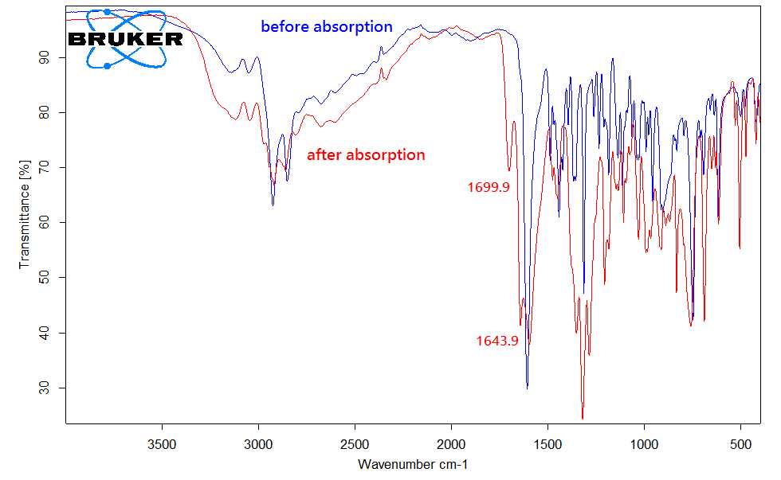

Figure S6. 13C NMR and IR spectra for [DBUH][Pyra] (**2**) before and after CO2 absorption

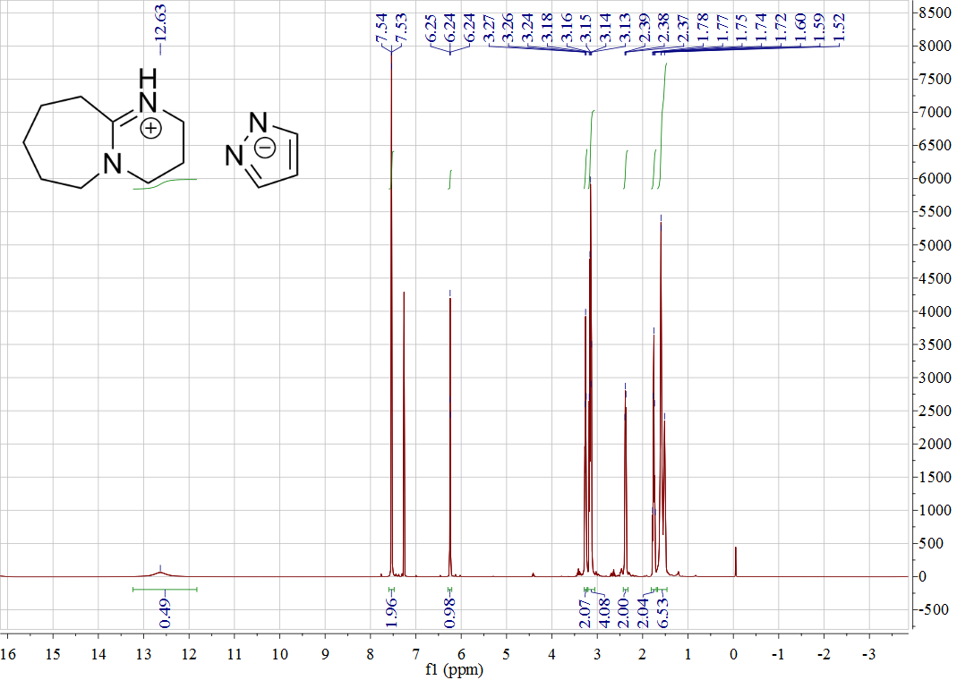

Figure S7. 1H NMR of [DBUH][Pyra] (**2**)

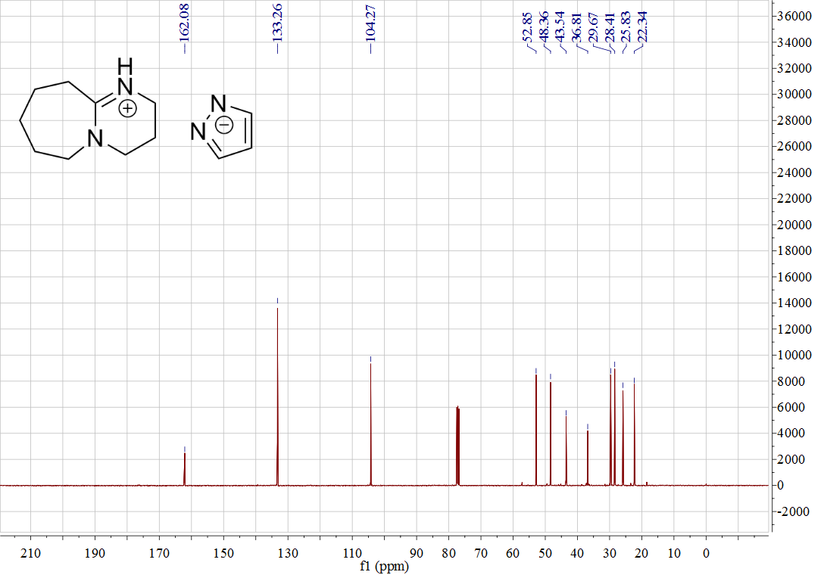

Figure S8. 13C NMR of [DBUH][Pyra] (**2**)

* [DBUH][4-MP] (**3**)

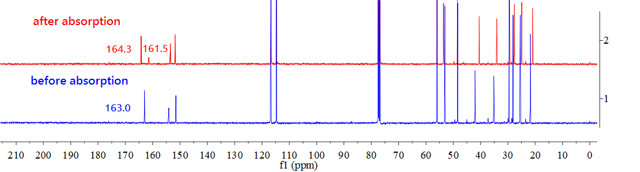

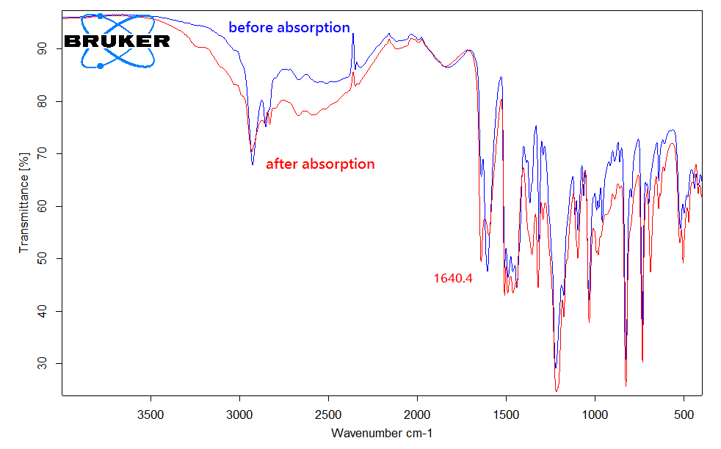

Figure S9. 13C NMR and IR spectra for [DBUH][4-MP] (**3**) before and after CO2 absorption

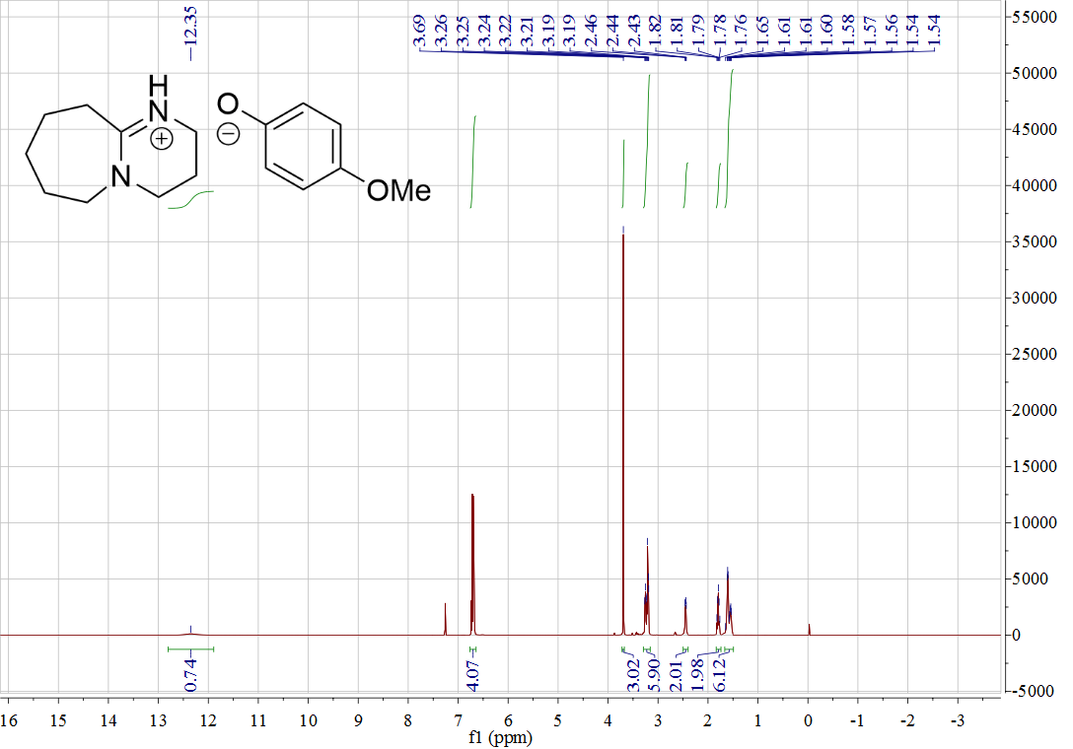

Figure S10. 1H NMR of [DBUH][4-MP] (**3**)

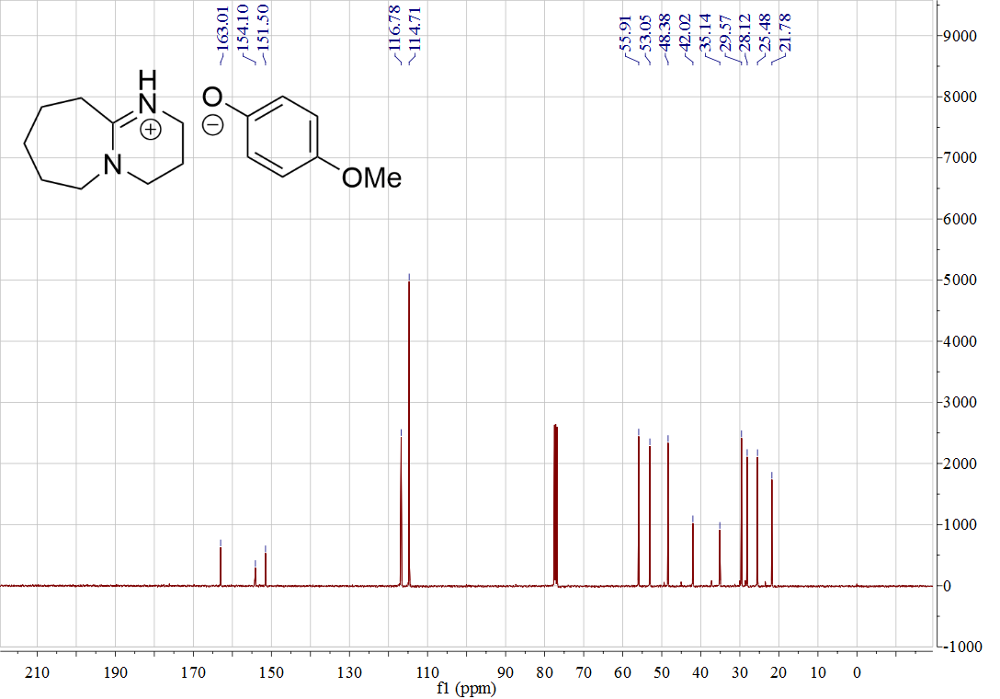

Figure S11. 13C NMR of [DBUH][4-MP] (**3**)

* [DBUH][PhO] (**4**)

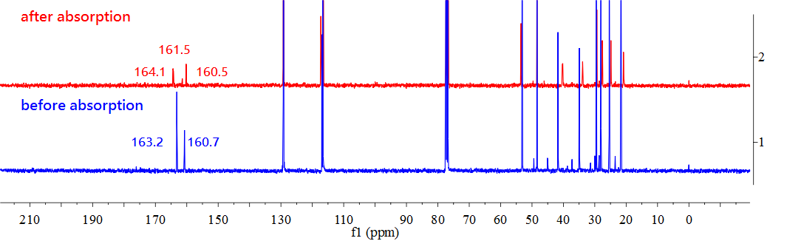

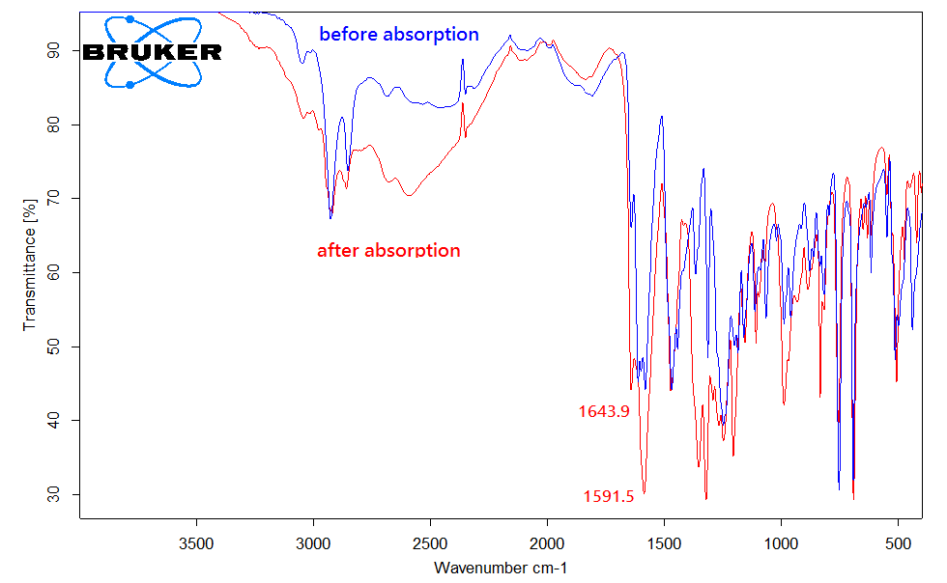

Figure S12. 13C NMR and IR spectra for [DBUH][PhO] (**4**) before and after CO2 absorption

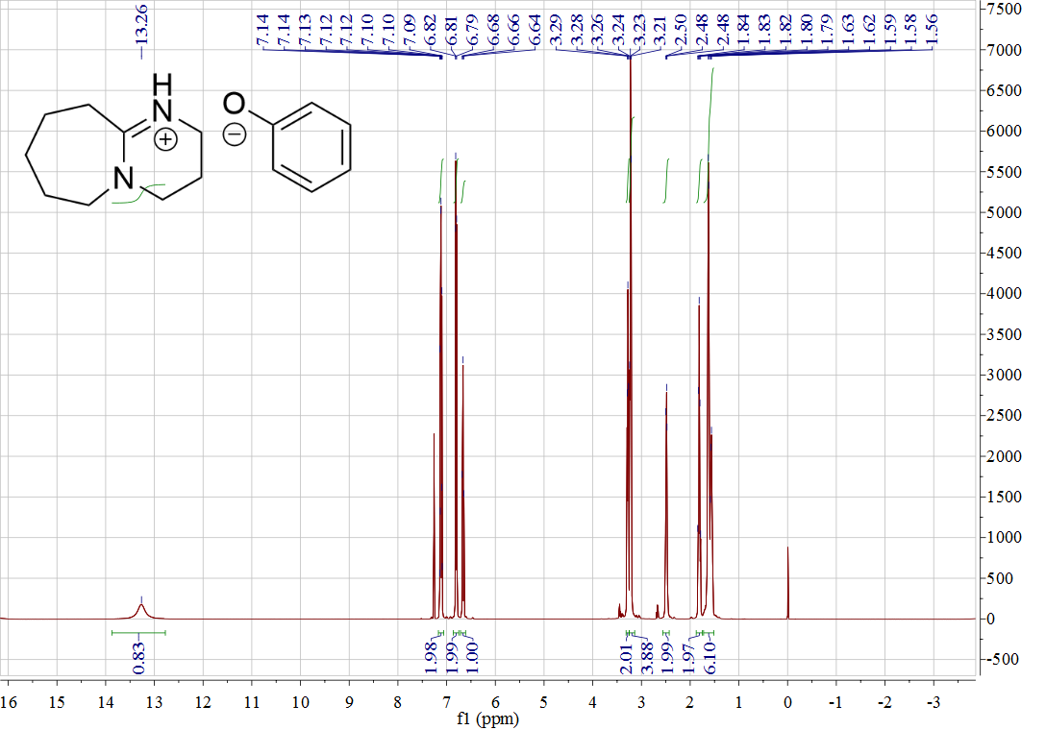

Figure S13. 1H NMR of [DBUH][PhO] (**4**)

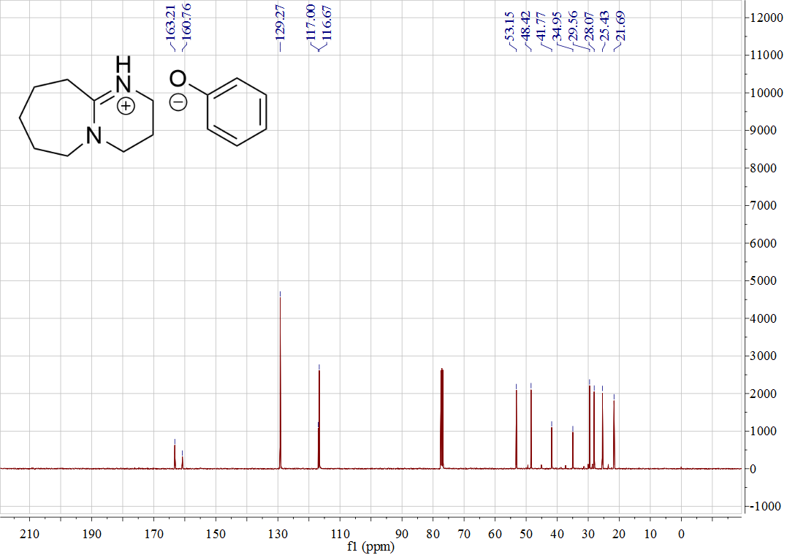

Figure S14. 13C NMR of [DBUH][PhO] (**4**)

* [DBUH][4-BP] (**5**)

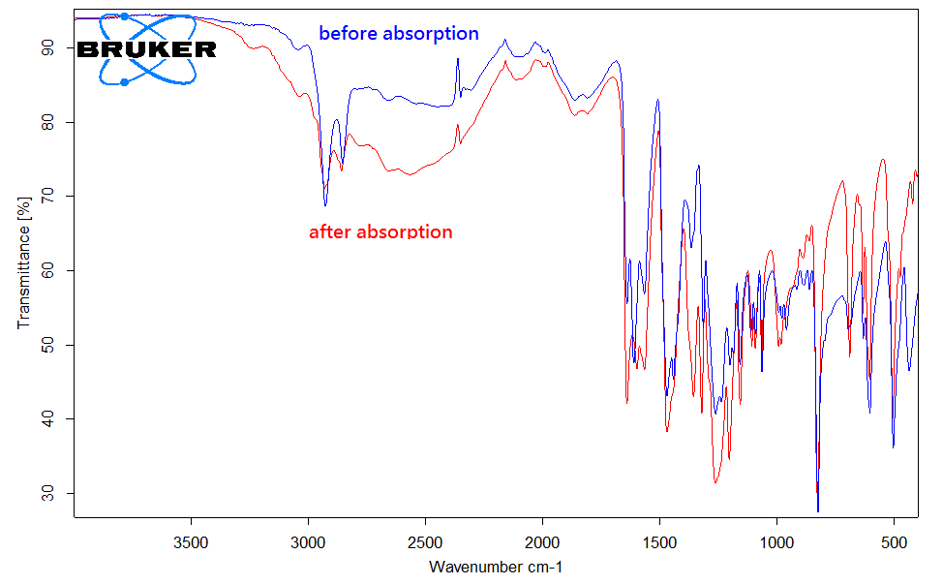

Figure S15. IR spectrum for [DBUH][BP] (**5**) before and after CO2 absorption

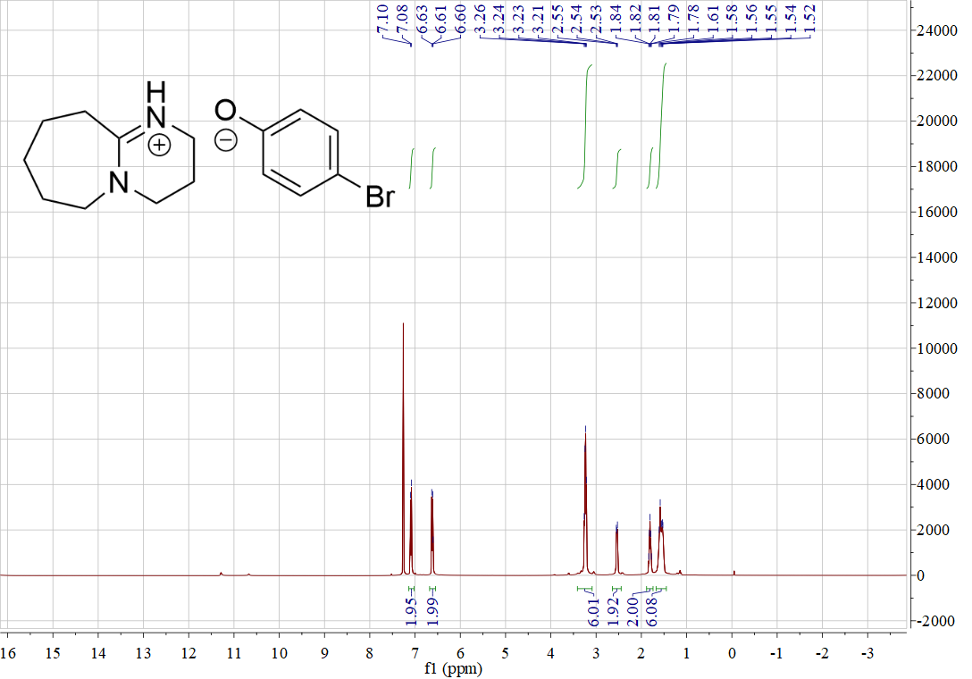

Figure S16. 1H NMR of [DBUH][4-BP] (**5**)

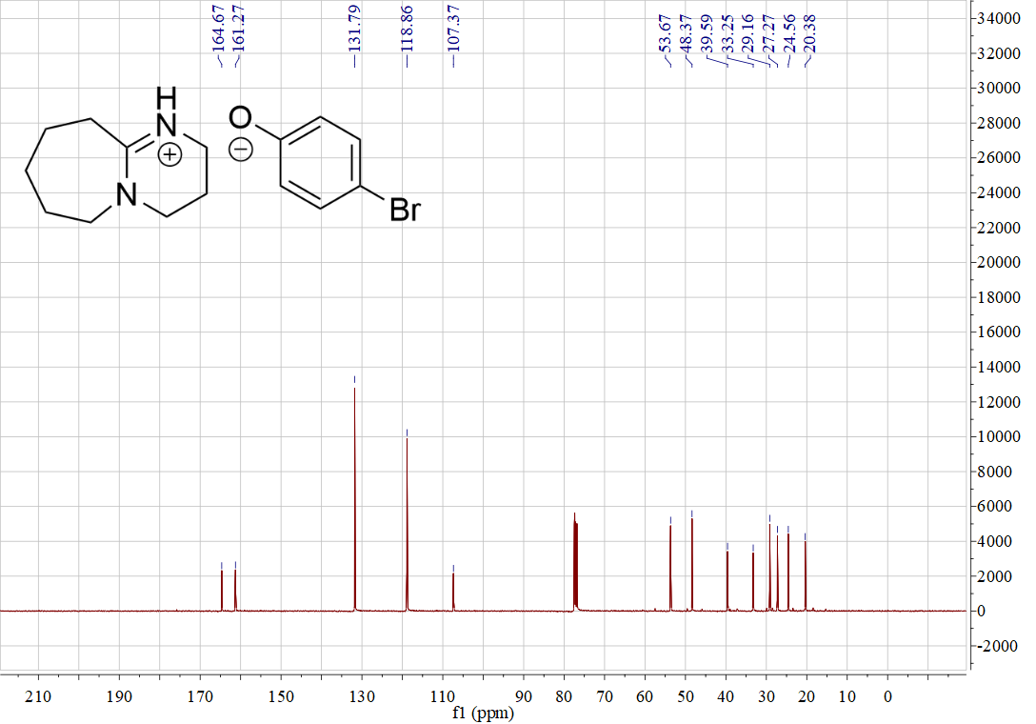

Figure S17. 13C NMR of [DBUH][4-BP] (**5**)

* [DBUH][4-TFMP] (**6**)

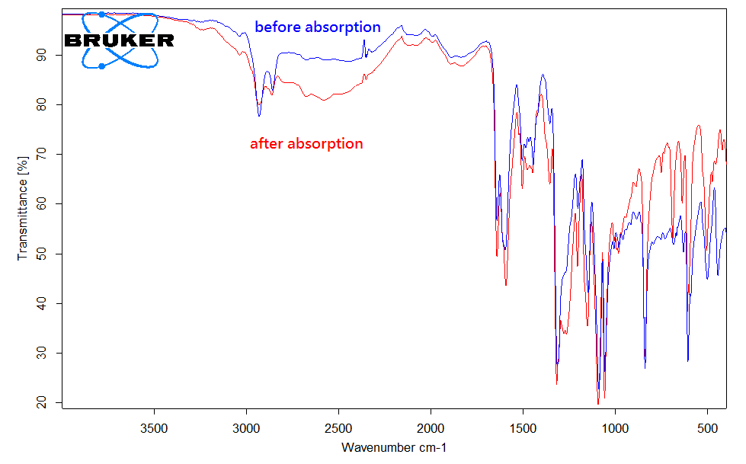

Figure S18. IR spectrum for [DBUH][TFMP] (**6**) before and after CO2 absorption

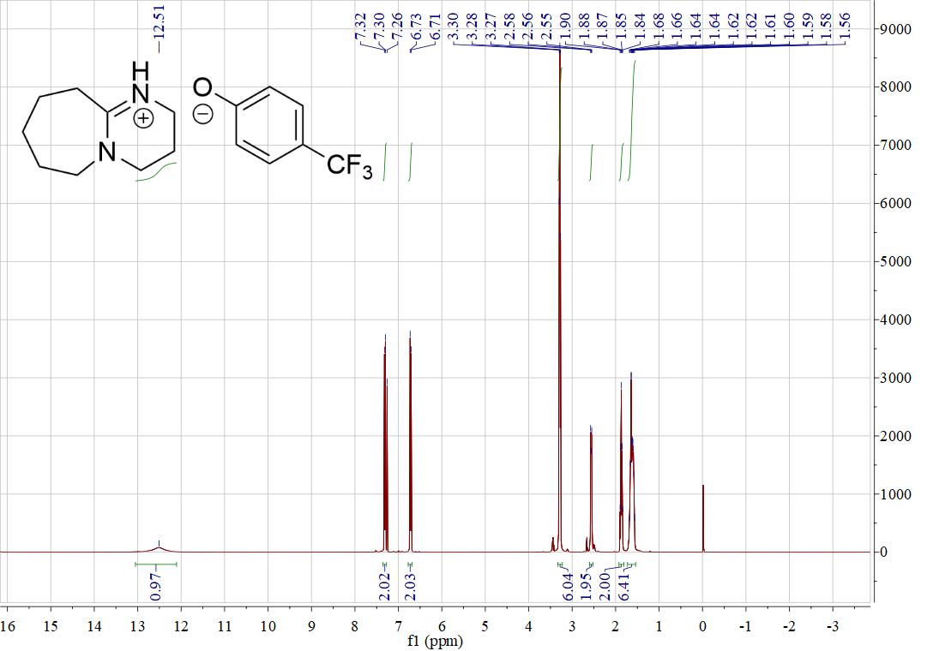

Figure S19. 1H NMR of [DBUH][4-TFMP] (**6**)

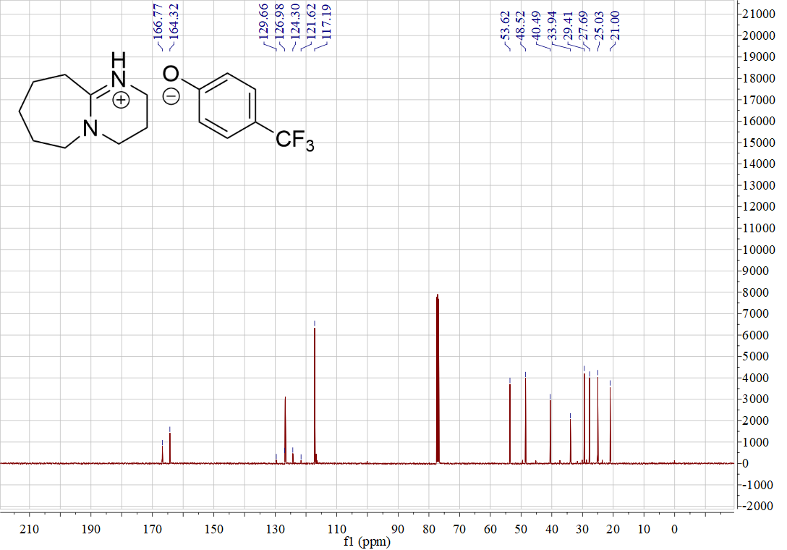

Figure S20. 13C NMR of [DBUH][4-TFMP] (**6**)

* [DBUH][1,2,4-Triz] (**7**)

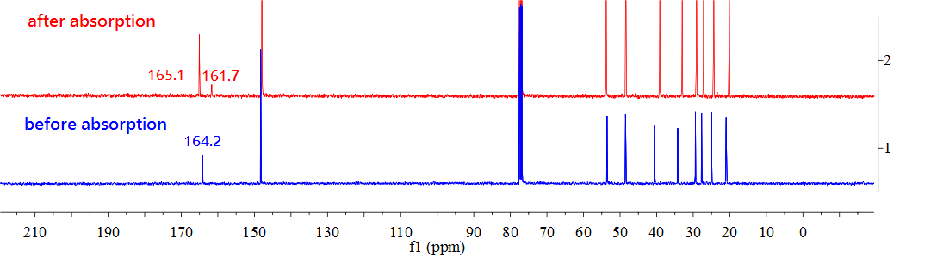

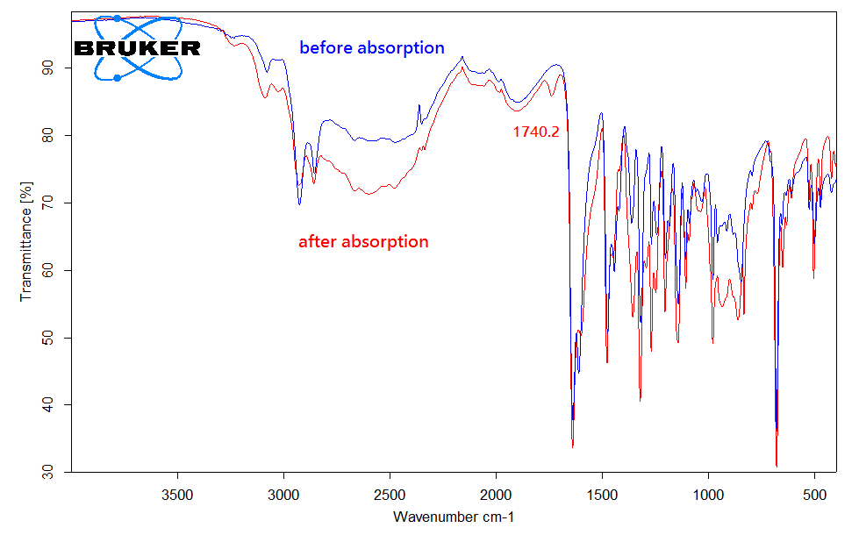

Figure S21. 13C NMR and IR spectra for [DBUH][1,2,4-Triz] (**4**) before and after CO2 absorption

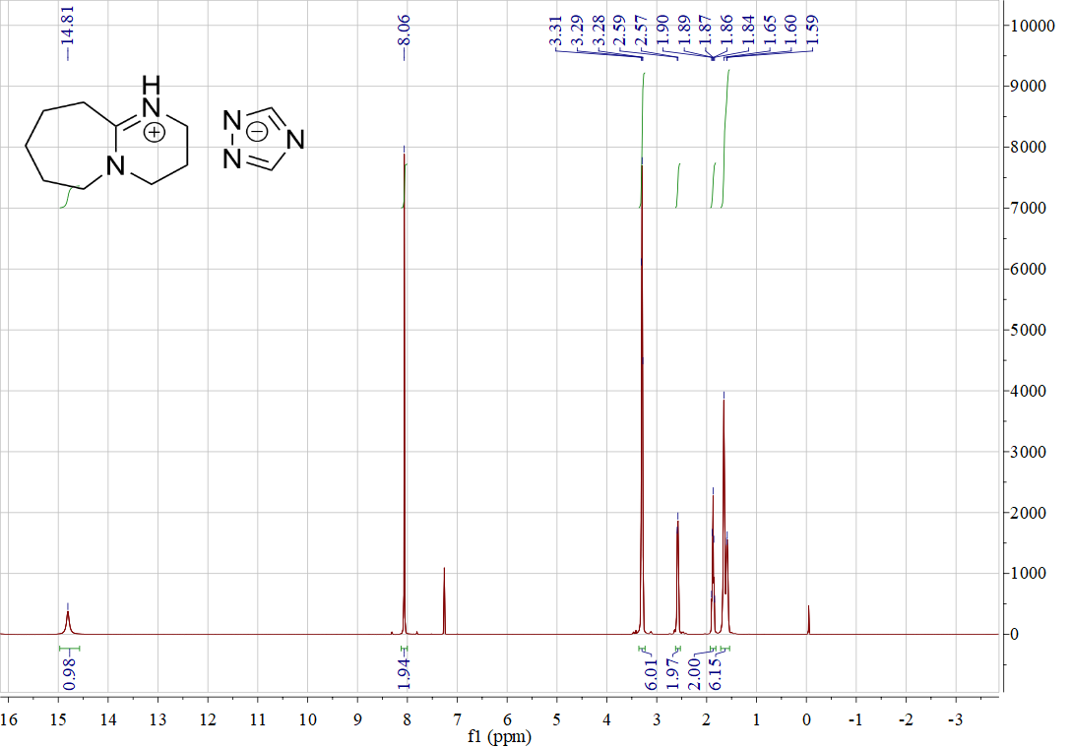

Figure S22. 1H NMR of [DBUH][1,2,4-Triz] (**7**)

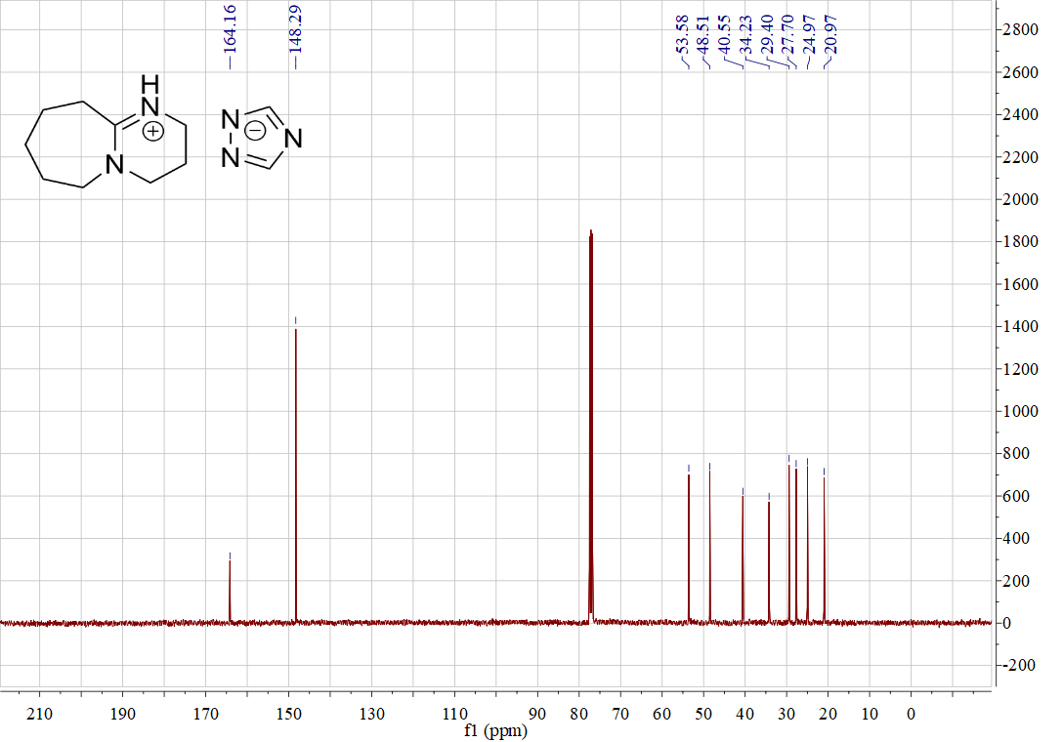

Figure S23. 13C NMR of [DBUH][1,2,4-Triz] (**7**)

* [DBUH][1,2,3-Triz] (**8**)

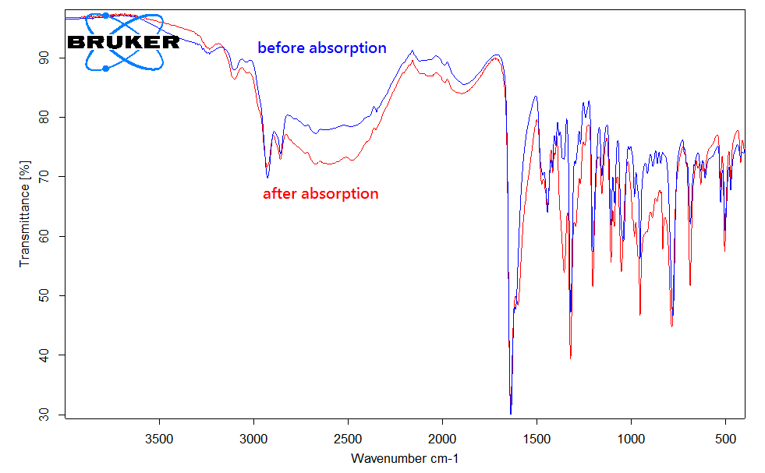

Figure S24. IR spectra for [DBUH][1,2,3-Triz] (**8**) before and after CO2 absorption

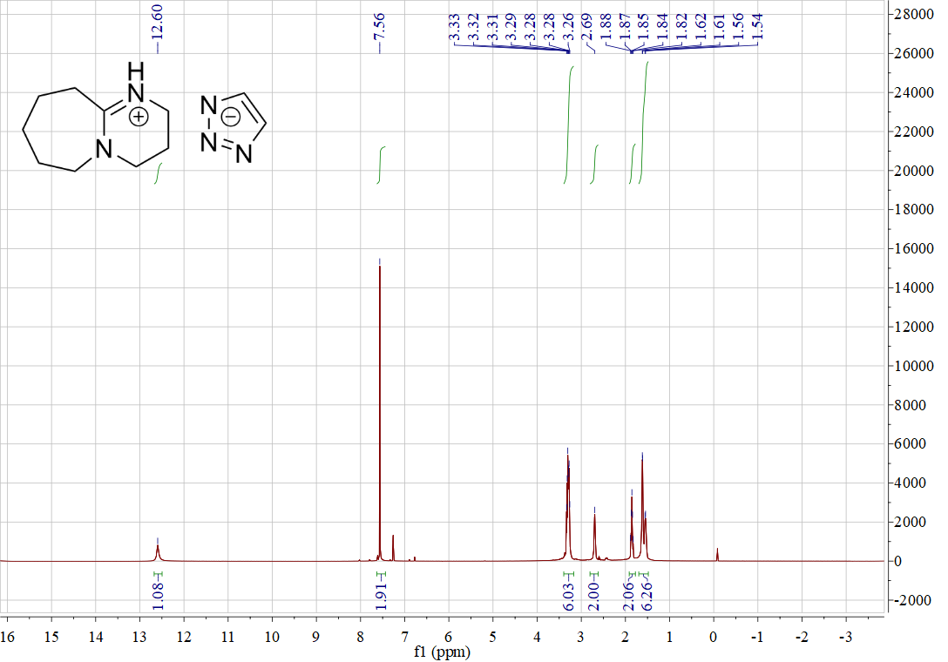

Figure S25. 1H NMR of [DBUH][1,2,3-Triz] (**8**)

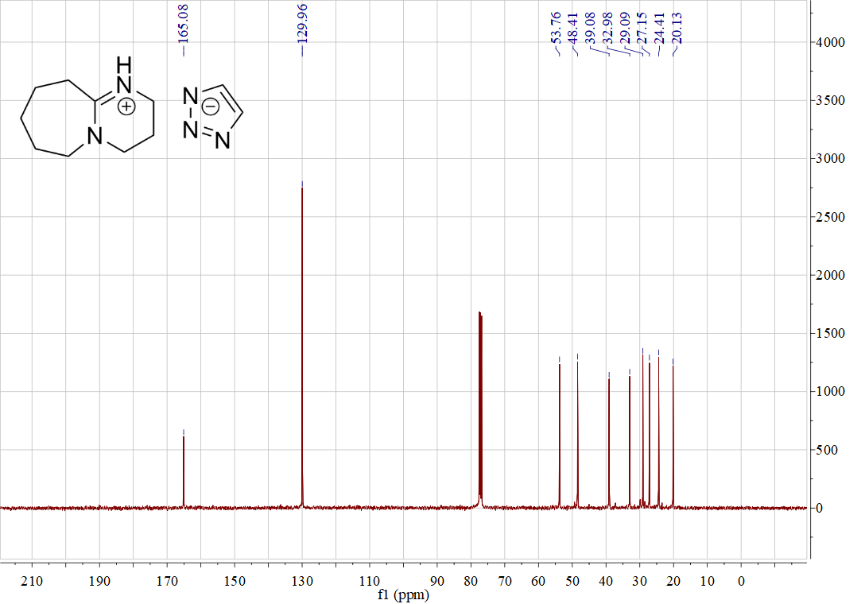

Figure S26. 13C NMR of [DBUH][1,2,3-Triz] (**8**)

* [DBUH][OAc] (**9**)

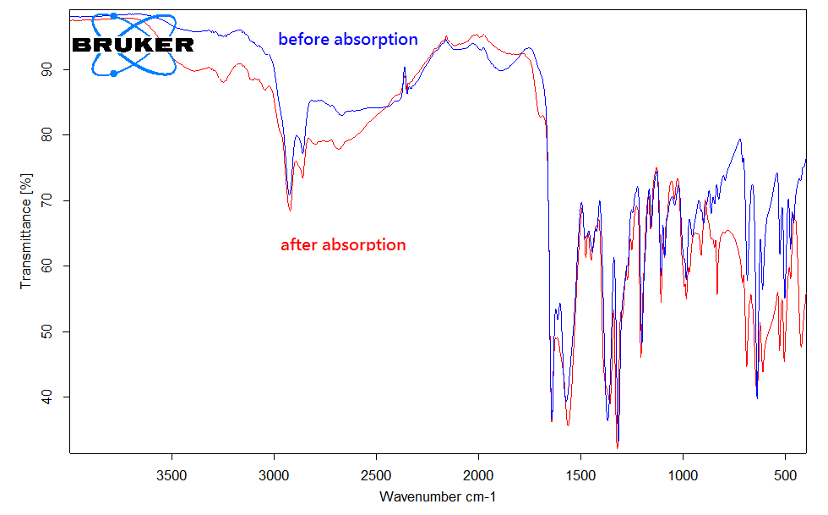

Figure S27. IR spectra for [DBUH][OAc] (**9**) before and after CO2 absorption

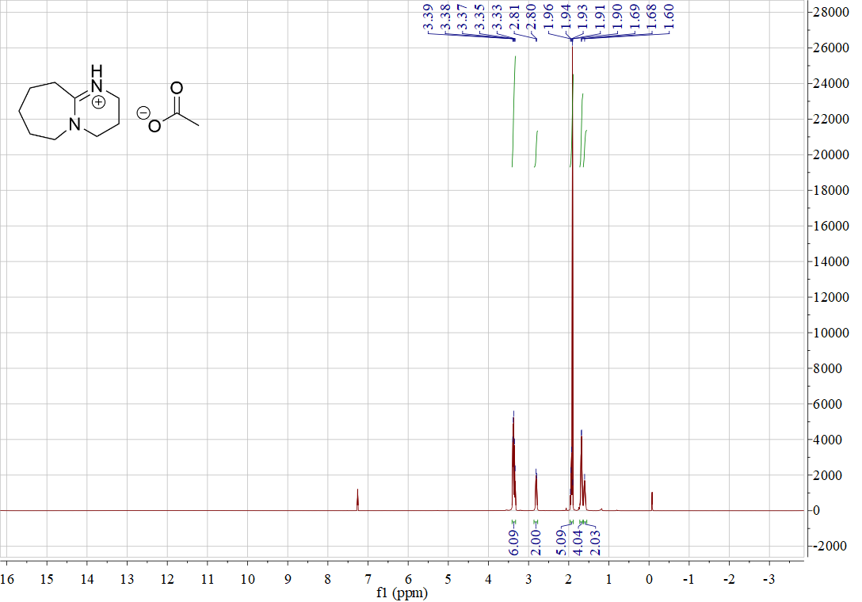

Figure S28. 1H NMR of [DBUH][OAc] (**9**)

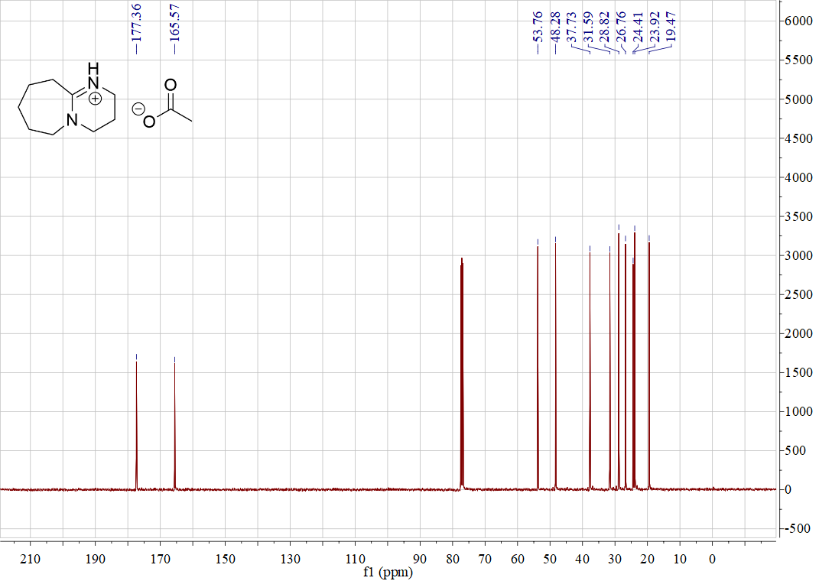

Figure S29. 13C NMR of [DBUH][OAc] (**9**)

* [DBUH][Cl2CHCOO] (**10**)

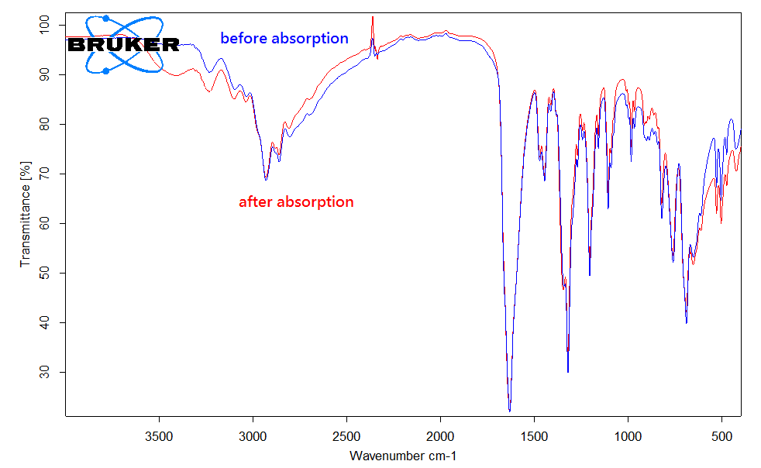

Figure S30. IR spectra for [DBUH][Cl2CHCOO] (**10**) before and after CO2 absorption

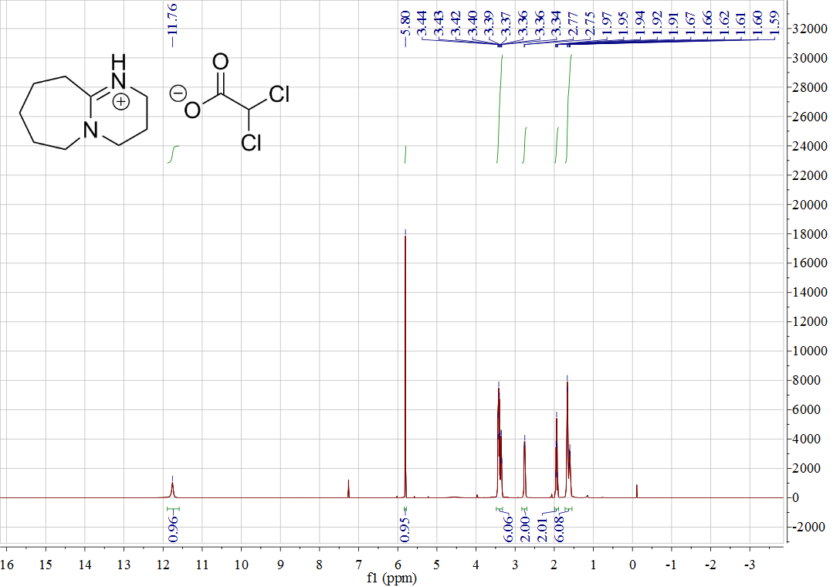

Figure S31. 1H NMR of [DBUH][Cl2CHCOO] (**10**)

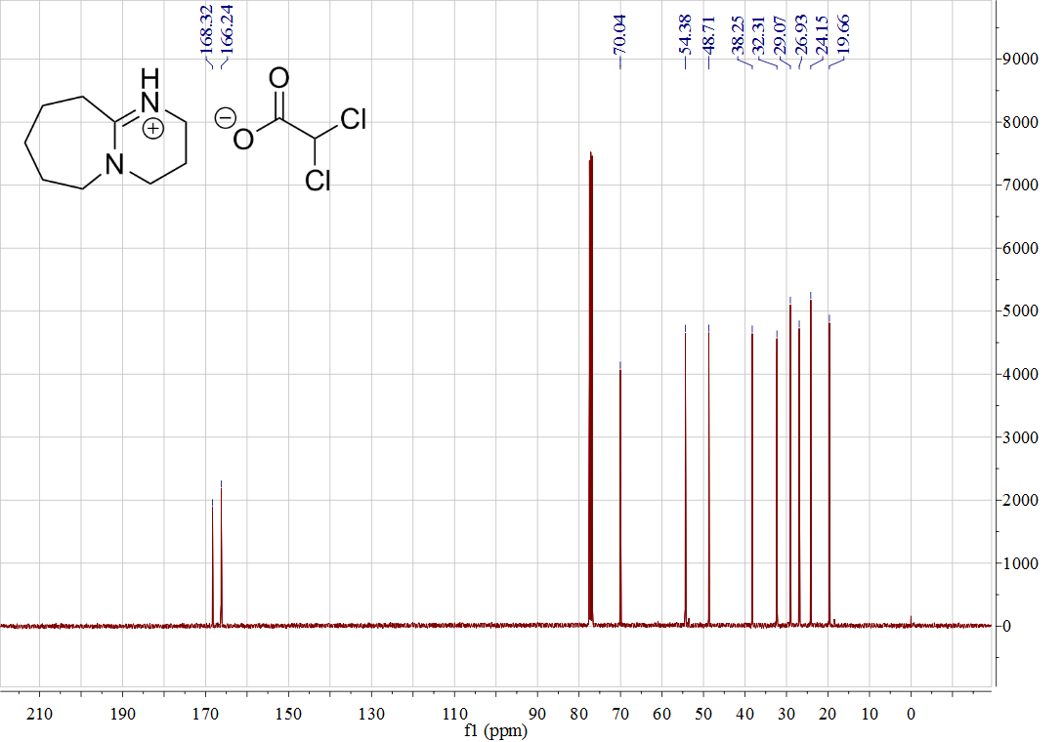

Figure S32. 13C NMR of [DBUH][Cl2CHCOO] (**10**)

* [DBUH][TFA](**11**)

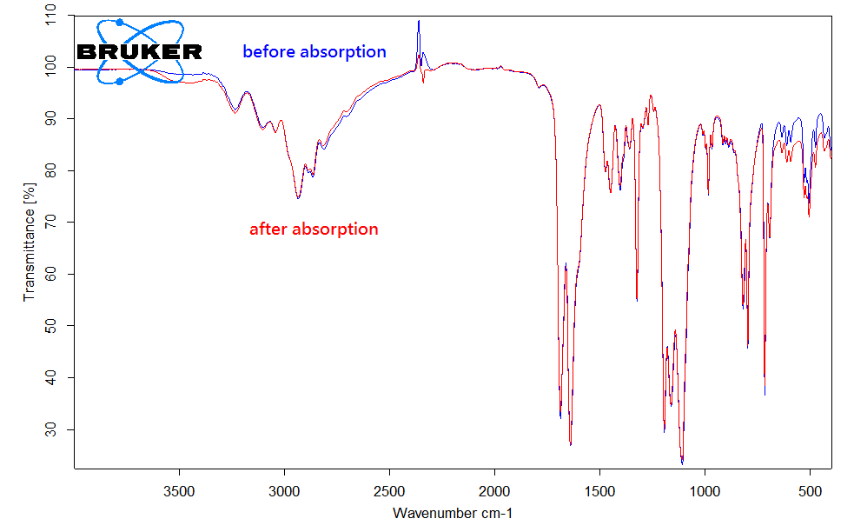

Figure S33. IR spectra for [DBUH][TFA] (**11**) before and after CO2 absorption

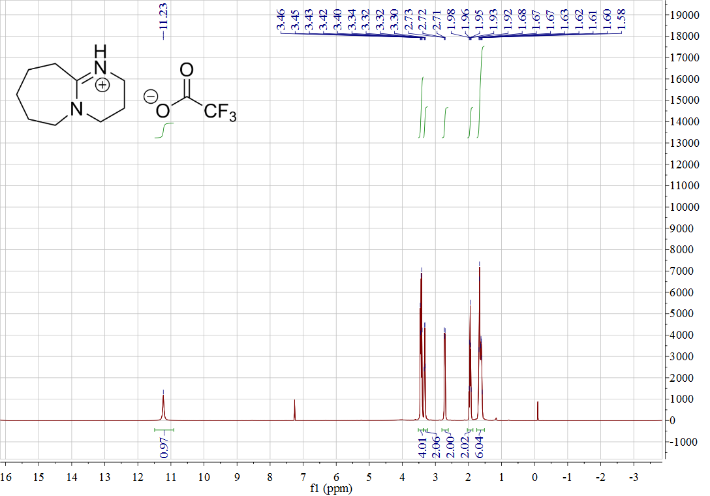

Figure S34. 1H NMR of [DBUH][TFA] (**11**)

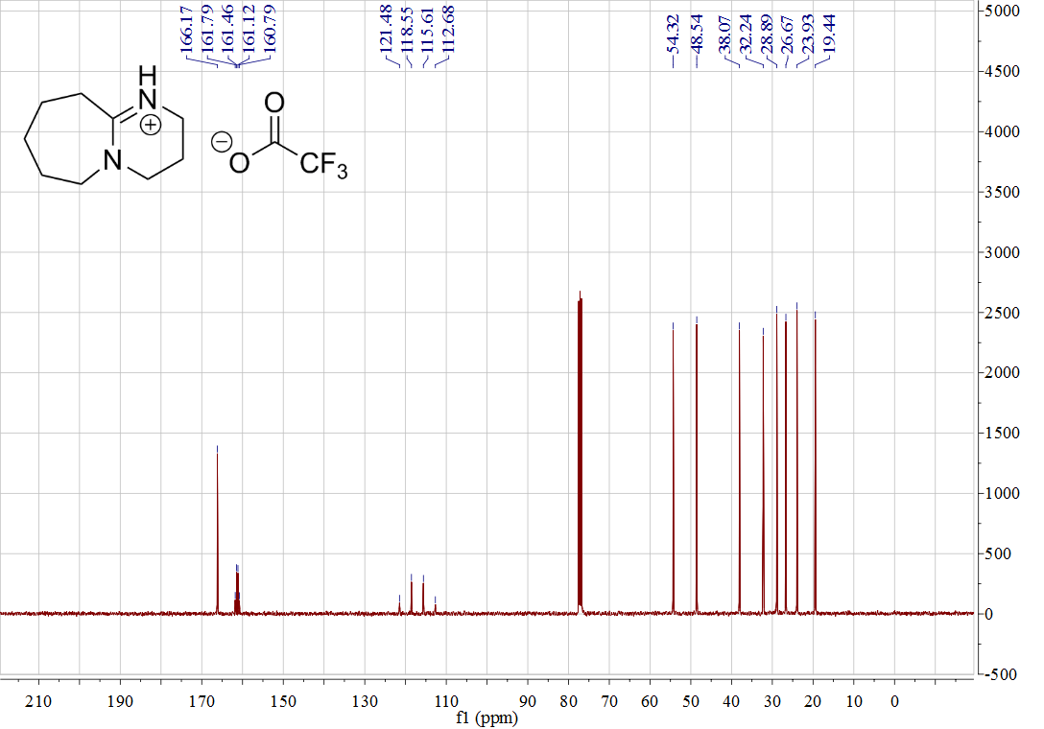

Figure S35. 13C NMR of [DBUH][TFA] (**11**)

# Linear correlations between anion basicity and absorption capacity.

Figure S36. Correlation between the anion basicity in water[3] and absorption capacity in [DBUH][X] (**1**-**9**)

Figure S37. Correlation between the anion basicity in DMSO[3] and absorption capacity in [DBUH][X] (**1**-**9**)

# References.

[1] Wang, C. M., Luo, H. M., Jiang, D. E., Li, H. R., Dai, S. (2010). Carbon dioxide capture by superbase-derived protic ionic liquids. *Angew. Chem. Int. Ed.* 49, 5978-5981. doi: 10.1002/anie.201002641

[2] Losetty, V., Matheswaran, P., Wilfred, C. D. (2017). Synthesis, thermophysical properties and COSMO-RS study of DBU based protic ionic liquids. *J. Chem. Thermodyn.* 105, 151-158. doi:10.1016/j.jct.2016.10.021

[3] p*K*a data in molecular solvents is available at *i*Bond 2.0 Database: ibond.chem.tsinghua.edu.cn; ibond.nankai.edu.cn.