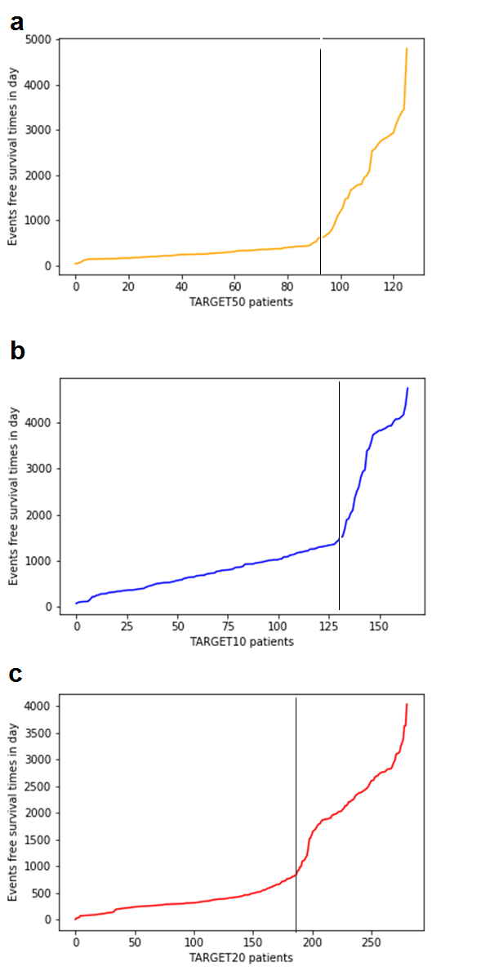

Supplementary figure S1. Distribution of event-free time for the patients of TARGET-50 (a), TARGET-10 (b) and TARGET-20 (c) datasets (Goldman et al., 2015). Patients to the left from vertical line were considered as non-responders, and to the right from this line – as responders to the treatment.

References

Goldman, M., Craft, B., Swatloski, T., Cline, M., Morozova, O., Diekhans, M., et al. (2015). The UCSC Cancer Genomics Browser: update 2015. Nucleic Acids Res. 43, D812–D817. doi:10.1093/nar/gku1073.

