Supplementary Material

Title: Soil bacterial community are associated with high potato production and minimal water use

Authors: Thiago Gumiere, Silvio J. Gumiere, Jean-Pascal Matteau, Philippe Constant, Alain N. Rousseau

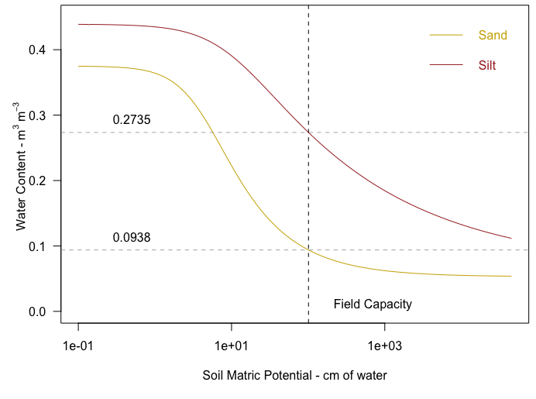
Figure S1 – Water retention curve relating the water content (m³ of water / m³ of soil), and soil water potential (cm of water). Considering |1 kPa | = 10.1972 cm of water

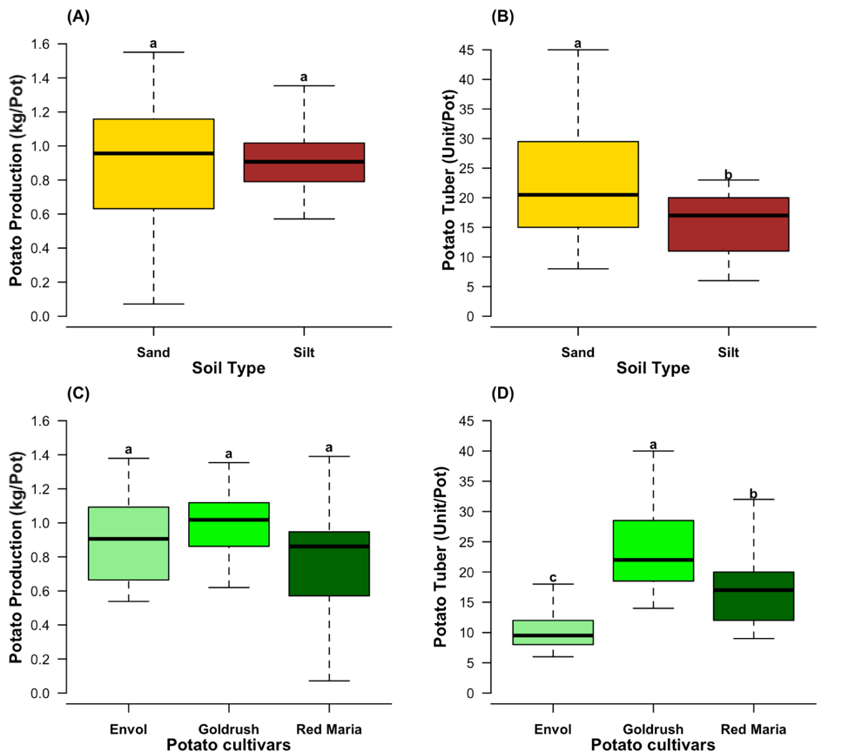
Figure S 2 – The boxplot of soil types and potato production (kg/pot) (A) and potato tuber number (unit/pot) (B). The boxplot of potato cultivar and potato production (kg/pot) (C) and potato tuber number (unit/pot) (D). The rank letters were obtained by ANOVA test (p-value<0.05) and Tukey test.

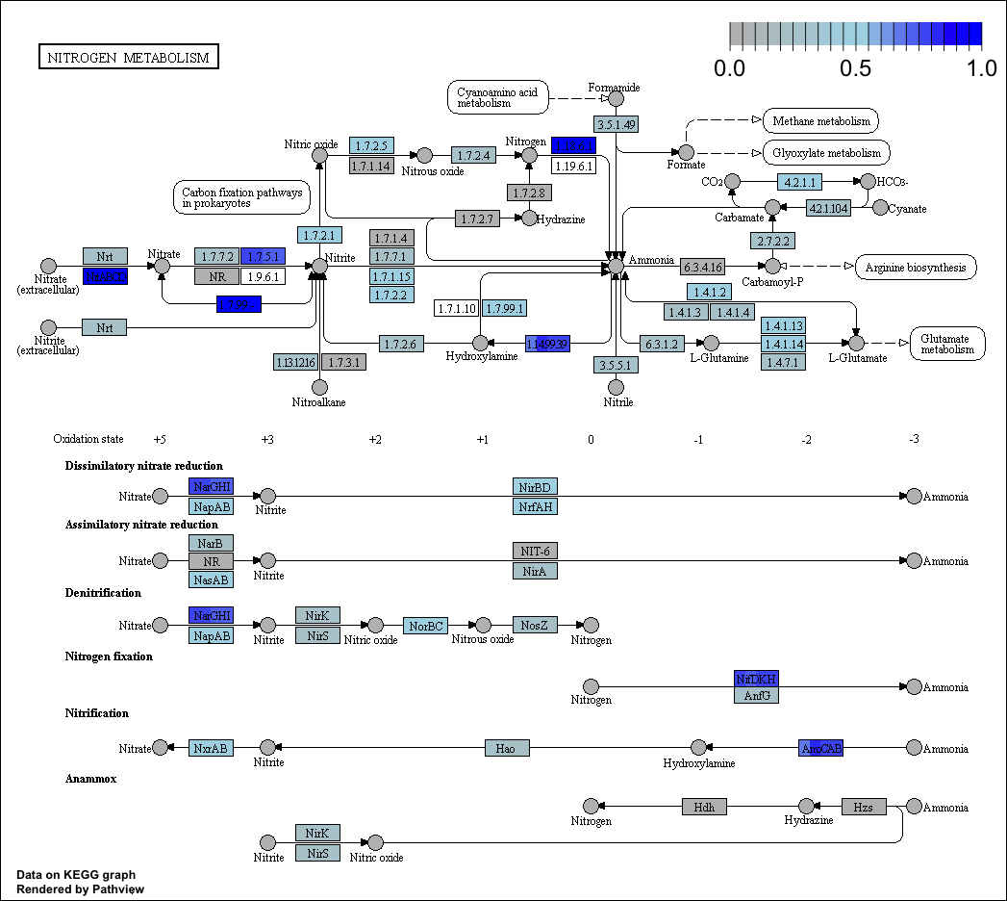
Figure S3 - Genes predicted in nitrogen metabolism (KEGG map 00910) based on taxonomic composition of soils cultivated with potato plants. Each square gene is divided in four parties related with different water irrigation treatments (-15 kPa, -25 kPa, -30 kPa, -45 kPa).
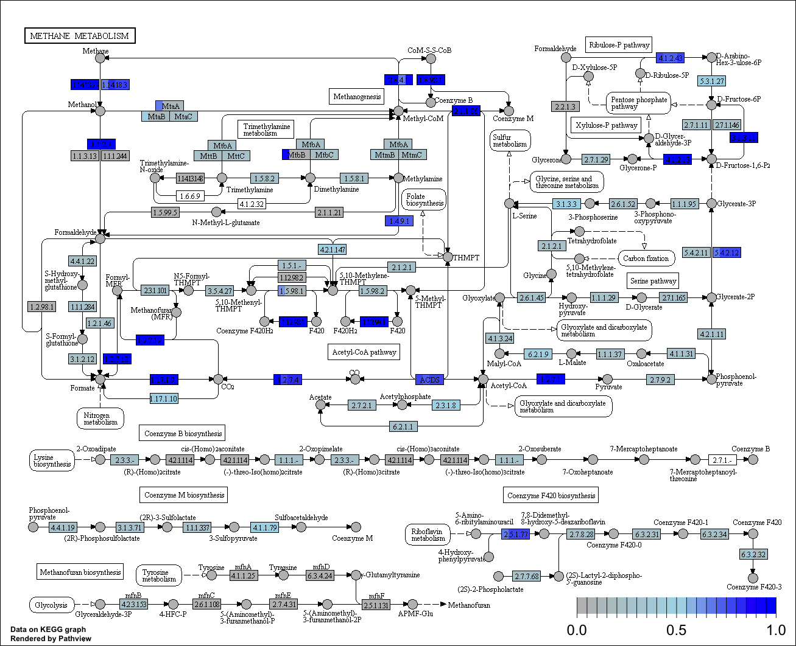
Figure S4 - Genes predicted in methane metabolism (KEGG map 00680) based on taxonomic composition of soils cultivated with potato plants. Each square gene is divided in four parties related with different water irrigation treatments (-15 kPa, -25 kPa, -30 kPa, -45 kPa).

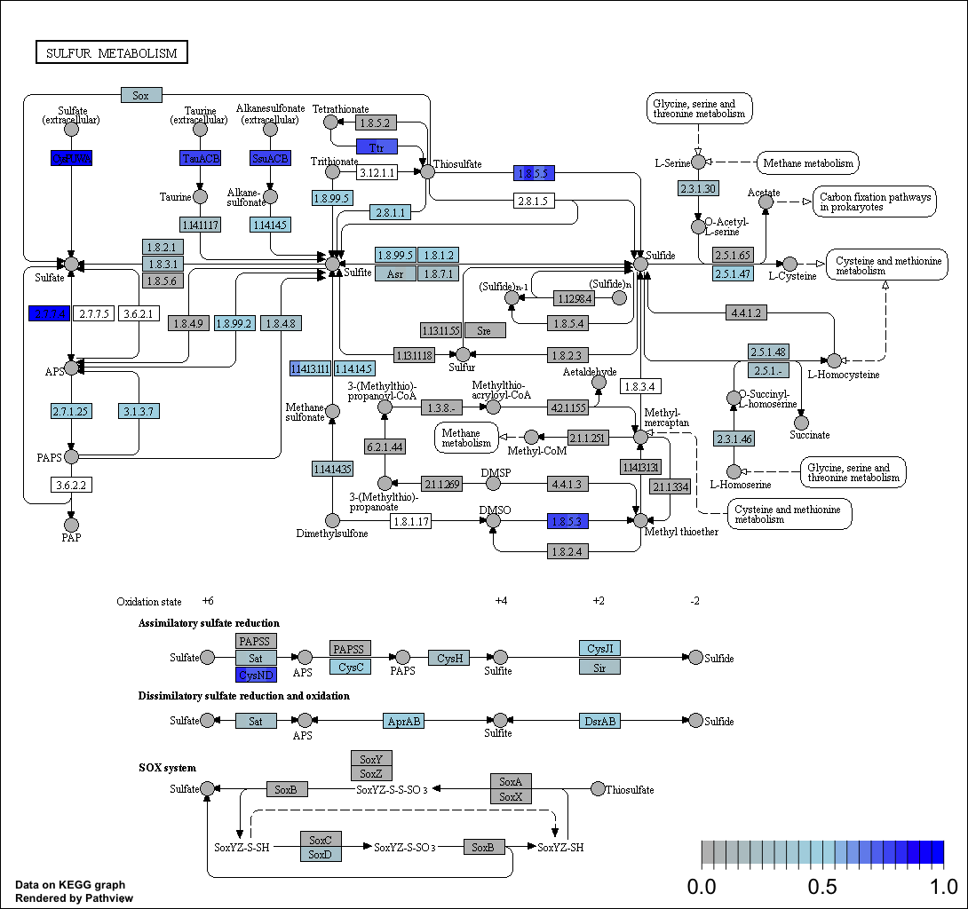
Figure S5 - Genes predicted in sulfur metabolism (KEGG map 00920) based on taxonomic composition of soils cultivated with potato plants. Each square gene is divided in four parties related with different water irrigation treatments (-15 kPa, -25 kPa, -30 kPa, -45 kPa)

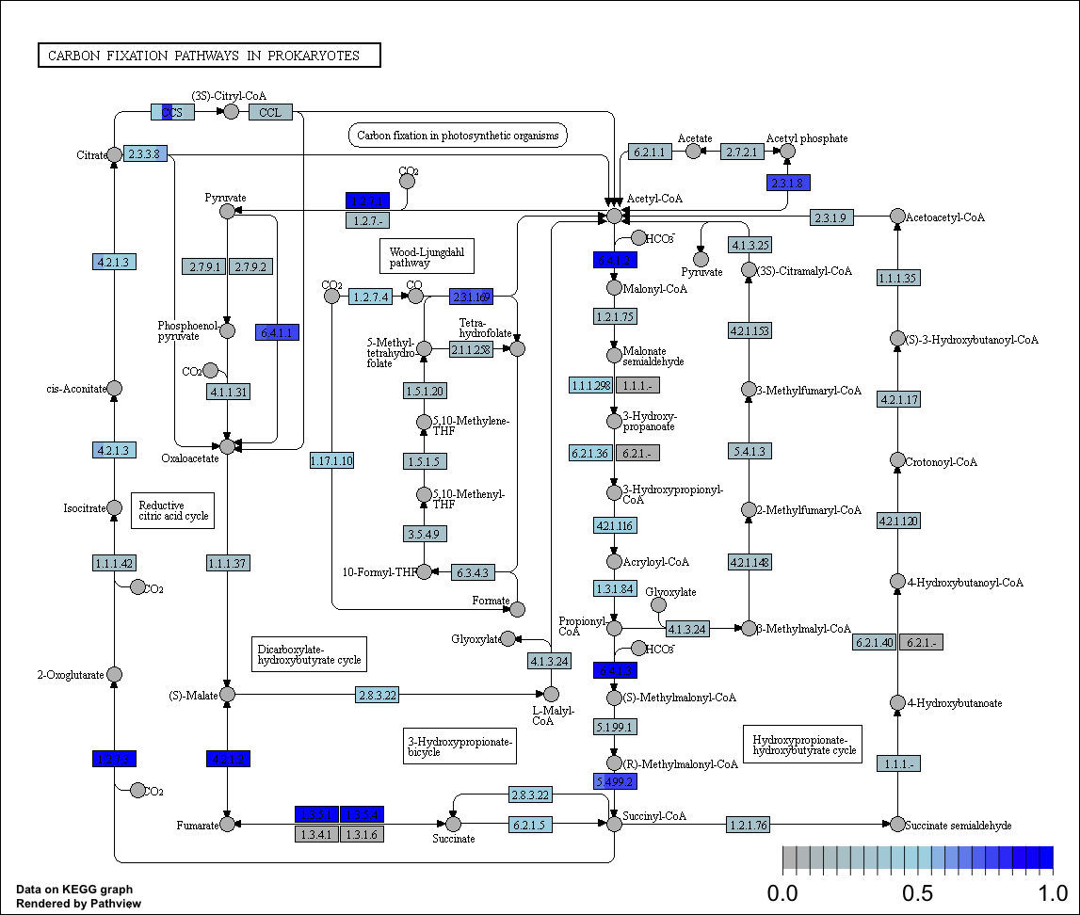
Figure S6 - Genes predicted in carbon fixation pathways in prokaryotes (KEGG map 00720) based on taxonomic composition of soils cultivated with potato plants. Each square gene is divided in four parties related with different water irrigation treatments (-15 kPa, -25 kPa, -30 kPa, -45 kPa).

Table S1 - Relative abundance of genera composition in soil samples for each irrigation level (not considering the unclassified sequences).
 | Irrigation Levels
Genera | -15 kPa | -25 kPa | -30 kPa | -45 kPa
Bacillus | 3.54% | 5.00% | 5.16% | 5.87%
Arthrobacter | 5.67% | 4.91% | 3.76% | 3.80%
Streptomyces | 4.39% | 4.36% | 4.23% | 4.33%
Bradyrhizobium | 2.96% | 3.25% | 3.87% | 3.10%
Variibacter | 2.79% | 3.14% | 3.71% | 3.23%
Sphingomonas | 2.70% | 3.47% | 2.47% | 2.73%
Clostridiumsensustricto13 | 2.01% | 2.81% | 2.89% | 3.58%
Jatrophihabitans | 2.79% | 2.56% | 2.44% | 2.14%
Nocardioides | 2.54% | 2.82% | 1.77% | 1.85%
Uncultured actinobacterium | 1.95% | 2.12% | 2.50% | 2.31%
Rhodanobacter | 3.86% | 1.80% | 0.84% | 0.84%
Uncultured Verrucomicrobiabacterium | 1.53% | 1.85% | 2.08% | 2.00%
Pseudolabrys | 1.62% | 1.80% | 2.09% | 1.86%
Pseudonocardia | 1.29% | 1.80% | 1.95% | 1.89%
Blastococcus | 1.41% | 1.89% | 1.60% | 1.62%
Gemmatimonas | 1.48% | 1.71% | 1.51% | 1.39%
Bryobacter | 1.21% | 1.50% | 1.72% | 1.53%
Mycobacterium | 1.30% | 1.29% | 1.77% | 1.33%
Patulibacter | 1.18% | 1.40% | 1.47% | 1.49%
CandidatusSolibacter | 1.00% | 1.25% | 1.69% | 1.45%
Acidibacter | 1.22% | 1.23% | 1.41% | 1.22%
Blastocatella | 0.98% | 1.28% | 1.28% | 1.38%
Mizugakiibacter | 2.02% | 0.77% | 0.69% | 1.27%
Burkholderia | 1.19% | 1.02% | 1.15% | 1.06%
Roseiflexus | 0.83% | 0.97% | 1.25% | 1.28%
Gemmata | 0.82% | 0.92% | 1.16% | 1.07%
Massilia | 0.64% | 1.67% | 0.59% | 0.98%
Uncultured Actinomycetalesbacterium | 0.71% | 0.84% | 1.29% | 0.87%
Paenibacillus | 0.71% | 0.92% | 0.91% | 1.12%
Solirubrobacter | 0.81% | 0.89% | 0.87% | 0.91%
Pir4lineage | 0.75% | 0.78% | 0.83% | 0.82%
Sporosarcina | 0.55% | 0.77% | 0.81% | 0.92%
Planctomyces | 0.63% | 0.66% | 0.91% | 0.84%
Conexibacter | 0.78% | 0.69% | 0.59% | 0.65%
Marmoricola | 0.60% | 0.64% | 0.75% | 0.74%
Haliangium | 0.42% | 0.71% | 0.80% | 0.81%
Oryzihumus | 0.67% | 0.73% | 0.67% | 0.63%
Uncultured Conexibactersp. | 0.55% | 0.74% | 0.76% | 0.65%
Devosia | 0.87% | 0.60% | 0.62% | 0.57%
Bauldia | 0.59% | 0.63% | 0.72% | 0.70%
Terrabacter | 0.69% | 0.77% | 0.58% | 0.57%
Uncultured Gaiellasp. | 0.45% | 0.60% | 0.69% | 0.63%
Isosphaera | 0.54% | 0.59% | 0.68% | 0.51%
Nakamurella | 0.55% | 0.55% | 0.62% | 0.56%
Phenylobacterium | 0.48% | 0.55% | 0.61% | 0.64%
Rhizomicrobium | 0.55% | 0.53% | 0.63% | 0.54%
Uncultured Prosthecobactersp. | 0.47% | 0.54% | 0.63% | 0.59%
Singulisphaera | 0.41% | 0.56% | 0.61% | 0.54%
Uncultured Rubrobacteraceaebacterium | 0.45% | 0.44% | 0.52% | 0.67%
Methylobacterium | 0.33% | 0.54% | 0.50% | 0.66%
Rhodoplanes | 0.42% | 0.46% | 0.61% | 0.50%
Reyranella | 0.40% | 0.44% | 0.52% | 0.53%
Chthonomonas | 0.32% | 0.42% | 0.56% | 0.58%
Phycicoccus | 0.47% | 0.59% | 0.41% | 0.39%
Pirellula | 0.37% | 0.40% | 0.48% | 0.52%
Angustibacter | 0.43% | 0.47% | 0.42% | 0.42%
Gaiella | 0.35% | 0.38% | 0.48% | 0.47%
Nitrospira | 1.07% | 0.13% | 0.16% | 0.16%
Dokdonella | 0.44% | 0.38% | 0.40% | 0.35%
Rhizobium | 0.34% | 0.35% | 0.42% | 0.47%
Ramlibacter | 0.33% | 0.30% | 0.45% | 0.48%
Opitutus | 0.33% | 0.50% | 0.35% | 0.37%
Mesorhizobium | 0.52% | 0.32% | 0.32% | 0.32%
Uncultured proteobacterium | 0.32% | 0.39% | 0.40% | 0.36%
Uncultured soilbacterium | 1.34% | >0.01% | >0.01% | >0.01%
bacteriumEllin6517 | 0.27% | 0.35% | 0.42% | 0.40%
Sphingobacterium | 0.30% | 0.34% | 0.46% | 0.34%
Lysinibacillus | 0.25% | 0.35% | 0.37% | 0.38%
Chthoniobacter | 0.37% | 0.26% | 0.33% | 0.34%
Lapillicoccus | 0.32% | 0.36% | 0.28% | 0.29%
Pullulanibacillus | 0.32% | 0.58% | 0.14% | 0.17%
CL500-29marinegroup | 0.24% | 0.25% | 0.34% | 0.36%
Rhodopseudomonas | 0.30% | 0.30% | 0.33% | 0.26%
Tumebacillus | 0.25% | 0.30% | 0.26% | 0.36%
Crossiella | 0.24% | 0.32% | 0.31% | 0.28%
Acidothermus | 0.25% | 0.29% | 0.35% | 0.27%
Naasia | 0.49% | 0.24% | 0.19% | 0.21%
Lysinimonas | 0.66% | 0.15% | 0.13% | 0.13%
Uncultured Mycobacteriumsp. | 0.21% | 0.25% | 0.34% | 0.26%
Martelella | 0.37% | 0.33% | 0.13% | 0.20%
Xanthomonas | 0.26% | 0.44% | 0.12% | 0.18%
Desulfosporosinus | 0.18% | 0.25% | 0.26% | 0.32%
Sorangium | 0.21% | 0.27% | 0.26% | 0.26%
Flexivirga | 0.83% | 0.04% | 0.03% | 0.03%
Modestobacter | 0.19% | 0.23% | 0.25% | 0.26%
Uncultured alphaproteobacterium | 0.18% | 0.20% | 0.29% | 0.25%
Hyphomicrobium | 0.22% | 0.23% | 0.23% | 0.21%
Pseudoclavibacter | 0.51% | 0.14% | 0.09% | 0.12%
Uncultured forestsoilbacterium | 0.18% | 0.21% | 0.25% | 0.22%
Pedomicrobium | 0.17% | 0.20% | 0.23% | 0.24%
Acidovorax | 0.24% | 0.19% | 0.18% | 0.22%
Arenimonas | 0.20% | 0.20% | 0.21% | 0.20%
Noviherbaspirillum | 0.15% | 0.22% | 0.22% | 0.23%
Kitasatospora | 0.19% | 0.20% | 0.20% | 0.19%
Alsobacter | 0.14% | 0.21% | 0.21% | 0.22%
Methylorosula | 0.16% | 0.21% | 0.18% | 0.22%
Leifsonia | 0.41% | 0.13% | 0.11% | 0.09%
CandidatusXiphinematobacter | 0.16% | 0.19% | 0.20% | 0.20%
Uncultured Sphingomonadaceaebacterium | 0.15% | 0.20% | 0.22% | 0.19%
Sporichthya | 0.17% | 0.19% | 0.19% | 0.20%
Labrys | 0.15% | 0.19% | 0.20% | 0.22%
Pedobacter | 0.49% | 0.08% | 0.03% | 0.10%
Uncultured Hyphomicrobiaceaebacterium | 0.16% | 0.19% | 0.18% | 0.19%
Solibacillus | 0.13% | 0.18% | 0.19% | 0.22%
Sporolactobacillus | 0.13% | 0.19% | 0.19% | 0.20%
Streptosporangium | 0.13% | 0.27% | 0.11% | 0.18%
Anaeromyxobacter | 0.60% | >0.01% | 0.01% | 0.01%
Afipia | 0.14% | 0.18% | 0.18% | 0.18%
Brevundimonas | 0.17% | 0.15% | 0.18% | 0.15%
Frigoribacterium | 0.42% | 0.06% | 0.07% | 0.08%
Micromonospora | 0.11% | 0.16% | 0.19% | 0.20%
Actinoplanes | 0.32% | 0.13% | 0.06% | 0.11%
Lysobacter | 0.14% | 0.16% | 0.18% | 0.17%
Microvirga | 0.12% | 0.16% | 0.16% | 0.19%
Uncultured Pseudonocardiaceaebacterium | 0.12% | 0.21% | 0.15% | 0.15%
Telmatobacter | 0.11% | 0.15% | 0.21% | 0.12%
Actinoallomurus | 0.10% | 0.15% | 0.17% | 0.16%
Actinomycetospora | 0.12% | 0.15% | 0.15% | 0.15%
Planococcus | 0.13% | 0.14% | 0.14% | 0.12%
Catenulispora | 0.09% | 0.13% | 0.15% | 0.17%
Aeromicrobium | 0.20% | 0.12% | 0.09% | 0.10%
Variovorax | 0.11% | 0.11% | 0.15% | 0.14%
Iamia | 0.11% | 0.13% | 0.15% | 0.11%
Actinospica | 0.11% | 0.13% | 0.12% | 0.15%
Nonomuraea | 0.10% | 0.12% | 0.16% | 0.13%
Uncultured Cystobacterineaebacterium | 0.14% | 0.13% | 0.11% | 0.12%
Azospira | 0.11% | 0.12% | 0.14% | 0.13%
Flavisolibacter | 0.11% | 0.16% | 0.10% | 0.12%
Pseudomonas | 0.10% | 0.11% | 0.06% | 0.22%
Geodermatophilus | 0.39% | 0.02% | 0.02% | 0.03%
Microbacterium | 0.13% | 0.11% | 0.11% | 0.13%
Cohnella | 0.09% | 0.11% | 0.12% | 0.14%
Microlunatus | 0.10% | 0.11% | 0.11% | 0.11%
Uncultured betaproteobacterium | 0.08% | 0.10% | 0.13% | 0.11%
Kribbella | 0.12% | 0.13% | 0.10% | 0.06%
Aquicella | 0.11% | 0.10% | 0.10% | 0.10%
Virgibacillus | 0.08% | 0.11% | 0.09% | 0.14%
Uncultured Acidobacteriabacterium | 0.09% | 0.09% | 0.11% | 0.13%
ConexibacterwoeseiIso977N | 0.09% | 0.10% | 0.12% | 0.10%
Ensifer | 0.27% | 0.03% | >0.01% | 0.08%
Chryseobacterium | 0.24% | 0.05% | 0.03% | 0.06%
Uncultured Conexibacteraceaebacterium | 0.07% | 0.09% | 0.13% | 0.11%
Terrimonas | 0.08% | 0.08% | 0.10% | 0.12%
Uncultured Mycobacteriaceaebacterium | 0.09% | 0.09% | 0.09% | 0.11%
Amycolatopsis | 0.09% | 0.11% | 0.11% | 0.07%
Uncultured Bradyrhizobiaceaebacterium | 0.07% | 0.08% | 0.12% | 0.10%
Uncultured Rubrobacteralesbacterium | 0.10% | 0.10% | 0.09% | 0.08%
Granulicella | 0.08% | 0.09% | 0.12% | 0.09%
Catellatospora | 0.07% | 0.10% | 0.11% | 0.09%
Woodsholea | 0.08% | 0.07% | 0.10% | 0.10%
Uncultured Rubrobacteridaebacterium | 0.06% | 0.09% | 0.10% | 0.10%
Nordella | 0.08% | 0.09% | 0.09% | 0.10%
Ferruginibacter | 0.08% | 0.08% | 0.09% | 0.10%
CandidatusKoribacter | 0.07% | 0.08% | 0.11% | 0.08%
Rhodococcus | 0.07% | 0.08% | 0.07% | 0.12%
Luedemannella | 0.07% | 0.06% | 0.09% | 0.10%
Flavobacterium | 0.02% | 0.07% | 0.01% | 0.23%
Actinosynnema | 0.22% | 0.02% | 0.02% | 0.03%
Bosea | 0.10% | 0.08% | 0.10% | 0.04%
Skermanella | 0.07% | 0.07% | 0.08% | 0.08%
Paucimonas | 0.07% | 0.08% | 0.07% | 0.08%
Spirilliplanes | 0.05% | 0.06% | 0.09% | 0.10%
Acidiphilium | 0.06% | 0.09% | 0.08% | 0.08%
Actinomadura | 0.07% | 0.07% | 0.08% | 0.07%
Uncultured Planctomycetaceaebacterium | 0.12% | 0.04% | 0.04% | 0.07%
Roseateles | 0.05% | 0.08% | 0.09% | 0.07%
Frankia | 0.06% | 0.06% | 0.09% | 0.06%
Couchioplanes | 0.05% | 0.08% | 0.07% | 0.07%
Dactylosporangium | 0.06% | 0.07% | 0.06% | 0.08%
Clostridiumsensustricto9 | 0.04% | 0.06% | 0.07% | 0.08%
Altererythrobacter | 0.07% | 0.07% | 0.06% | 0.06%
Mucilaginibacter | 0.07% | 0.06% | 0.06% | 0.06%
Nitratireductor | 0.08% | 0.05% | 0.05% | 0.05%
Uncultured eubacteriumWD248 | 0.10% | 0.04% | 0.05% | 0.04%
Cellulomonas | 0.05% | 0.06% | 0.08% | 0.05%
Rhizobacter | 0.06% | 0.05% | 0.05% | 0.06%
Uncultured Methylocystaceaebacterium | 0.05% | 0.06% | 0.05% | 0.06%
Nitrolancea | 0.05% | 0.05% | 0.06% | 0.06%
Novosphingobium | 0.05% | 0.04% | 0.05% | 0.06%
Oceanobacillus | 0.04% | 0.05% | 0.05% | 0.07%
Umezawaea | 0.04% | 0.04% | 0.07% | 0.05%
Janthinobacterium | 0.04% | 0.05% | 0.09% | 0.02%
Lentzea | 0.02% | 0.08% | 0.01% | 0.09%
Polaromonas | 0.07% | 0.03% | 0.04% | 0.05%
Achromobacter | 0.05% | 0.04% | 0.05% | 0.05%
Segetibacter | 0.02% | 0.06% | 0.04% | 0.06%
Sphaerisporangiumviridialbum | 0.03% | 0.04% | 0.05% | 0.05%
Uncultured Acidimicrobidaebacterium | 0.08% | 0.03% | 0.03% | 0.04%
Motilibacter | 0.14% | 0.01% | >0.01% | 0.02%
Methylovirgula | 0.16% | 0.01% | >0.01% | >0.01%
Friedmanniella | 0.03% | 0.04% | 0.05% | 0.06%
Comamonas | 0.03% | 0.04% | 0.05% | 0.05%
Serratia | 0.03% | 0.05% | 0.04% | 0.06%
Phaselicystis | 0.04% | 0.04% | 0.04% | 0.05%
Acidobacterium | 0.05% | 0.04% | 0.04% | 0.04%
Uncultured Ktedonobactersp. | 0.03% | 0.04% | 0.04% | 0.05%
Pelosinus | 0.03% | 0.04% | 0.04% | 0.05%
Nitrosospira | 0.03% | 0.03% | 0.05% | 0.05%
Paucisalibacillus | 0.04% | 0.03% | 0.04% | 0.05%
freshwatersedimentmetagenome | 0.03% | 0.04% | 0.04% | 0.05%
Uncultured deltaproteobacterium | 0.03% | 0.04% | 0.04% | 0.04%
Uncultured Chloroflexibacterium | 0.03% | 0.04% | 0.04% | 0.04%
Caulobacter | 0.05% | 0.03% | 0.02% | 0.05%
Kineosporia | 0.03% | 0.03% | 0.04% | 0.05%
Uncultured organism | 0.03% | 0.04% | 0.04% | 0.04%
Ktedonobacter | 0.03% | 0.04% | 0.03% | 0.05%
Blastochloris | 0.03% | 0.04% | 0.04% | 0.04%
Legionella | 0.04% | 0.04% | 0.04% | 0.03%
Microcoleus | 0.01% | 0.04% | 0.05% | 0.05%
Alicyclobacillus | 0.03% | 0.04% | 0.03% | 0.04%
Byssovorax | 0.09% | 0.02% | 0.01% | 0.01%
Uncultured Spartobacteriabacterium | 0.03% | 0.03% | 0.03% | 0.04%
Rudaibacter | 0.03% | 0.03% | 0.04% | 0.03%
Bdellovibrio | 0.12% | >0.01% | >0.01% | >0.01%
Defluviicoccus | 0.03% | 0.03% | 0.03% | 0.04%
Parafilimonas | 0.03% | 0.03% | 0.04% | 0.04%
Herbiconiux | 0.08% | 0.02% | 0.02% | 0.02%
Stenotrophomonas | 0.04% | 0.03% | 0.03% | 0.04%
Cupriavidus | 0.07% | 0.01% | 0.01% | 0.03%
Dongia | 0.04% | 0.03% | 0.04% | 0.03%
Uncultured Rhizobialesbacterium | 0.03% | 0.02% | 0.04% | 0.04%
Methylocystis | 0.03% | 0.02% | 0.04% | 0.04%
CandidatusMicrothrix | 0.02% | 0.03% | 0.04% | 0.04%
Hirschia | 0.04% | 0.03% | 0.03% | 0.03%
Chitinimonas | >0.01% | 0.04% | >0.01% | 0.08%
Niastella | 0.03% | 0.04% | 0.03% | 0.03%
Lachnoclostridium | 0.03% | 0.03% | 0.03% | 0.03%
Pandoraea | 0.04% | 0.03% | 0.02% | 0.02%
Luteimonas | 0.03% | 0.04% | 0.02% | 0.03%
Nocardia | 0.03% | 0.03% | 0.04% | 0.03%
Microbispora | 0.08% | 0.01% | >0.01% | 0.02%
Planosporangium | 0.02% | 0.03% | 0.04% | 0.03%
Taibaiella | 0.02% | 0.03% | 0.04% | 0.03%
Vasilyevaea | 0.04% | 0.03% | 0.02% | 0.03%
Psychrobacillus | 0.03% | 0.03% | 0.03% | 0.03%
CandidatusAlysiosphaera | 0.02% | 0.03% | 0.03% | 0.04%
Acidicaldus | 0.03% | 0.03% | 0.03% | 0.02%
Nostoc | 0.02% | 0.02% | 0.04% | 0.03%
Schlesneria | 0.02% | 0.02% | 0.03% | 0.03%
Clostridiumsensustricto1 | 0.02% | 0.03% | 0.03% | 0.03%
Domibacillus | 0.02% | 0.03% | 0.03% | 0.03%
Uncultured Thermosporotrichaceaebacterium | 0.02% | 0.03% | 0.03% | 0.03%
Sphingopyxis | 0.06% | 0.01% | 0.01% | 0.01%
Uncultured Polyangiaceaebacterium | 0.02% | 0.03% | 0.02% | 0.03%
Uncultured Cystobacteraceaebacterium | 0.02% | 0.02% | 0.03% | 0.03%
Deinococcus | 0.02% | 0.03% | 0.03% | 0.03%
Pedosphaera | 0.02% | 0.02% | 0.03% | 0.03%
Uncultured Microbacteriaceaebacterium | 0.02% | 0.02% | 0.03% | 0.02%
Frateuria | 0.02% | 0.02% | 0.01% | 0.04%
GAL15 | 0.02% | 0.03% | 0.02% | 0.03%
Uncultured Acetobacteraceaebacterium | 0.02% | 0.02% | 0.03% | 0.02%
Tahibacter | 0.02% | 0.02% | 0.03% | 0.03%
Vulgatibacter | 0.02% | 0.02% | 0.02% | 0.02%
Inquilinus | 0.02% | 0.02% | 0.02% | 0.02%
Sphingobium | 0.02% | 0.03% | 0.02% | 0.02%
Georgenia | 0.03% | 0.02% | 0.02% | 0.02%
Aquabacterium | 0.02% | 0.02% | 0.02% | 0.03%
Methylotenera | 0.02% | 0.02% | 0.03% | 0.01%
Phyllobacterium | 0.03% | 0.01% | 0.02% | 0.01%
Polycyclovorans | 0.02% | 0.02% | 0.02% | 0.02%
Uncultured Aciditerrimonassp. | 0.01% | 0.02% | 0.03% | 0.02%
Luteolibacter | 0.02% | 0.02% | 0.02% | 0.02%
Flavitalea | 0.01% | 0.01% | 0.02% | 0.03%
CandidatusNostocoida | 0.02% | 0.02% | 0.02% | 0.02%
Lachnoclostridium5 | 0.01% | 0.02% | 0.02% | 0.02%
Kutzneria | 0.02% | 0.02% | 0.02% | 0.01%
Rhodopila | 0.01% | 0.02% | 0.02% | 0.02%
Tuberibacillus | 0.02% | 0.03% | 0.02% | 0.01%
Herminiimonas | 0.02% | 0.02% | 0.02% | 0.02%
Elstera | 0.01% | 0.02% | 0.02% | 0.02%
Chryseolinea | 0.03% | 0.01% | 0.02% | 0.01%
Holophaga | 0.02% | 0.01% | 0.02% | 0.02%
Corallococcus | 0.01% | 0.01% | 0.02% | 0.02%
Dyella | 0.02% | 0.03% | 0.01% | 0.02%
Turicibacter | 0.01% | 0.02% | 0.02% | 0.02%
CandidatusSaccharimonas | 0.03% | 0.03% | >0.01% | >0.01%
Uncultured Bacteroidetesbacterium | 0.03% | 0.01% | 0.01% | 0.02%
Pelomonas | 0.01% | 0.02% | 0.02% | 0.02%
Edaphobacter | 0.02% | 0.02% | 0.01% | 0.01%
Shinella | 0.04% | 0.01% | 0.01% | 0.01%
Steroidobacter | 0.02% | 0.01% | 0.02% | 0.01%
SM1A02 | 0.02% | 0.01% | 0.02% | 0.02%
Longispora | 0.02% | 0.01% | 0.02% | 0.01%
Anaerosinus | 0.01% | 0.01% | 0.01% | 0.02%
AKYG587 | 0.01% | 0.01% | 0.02% | 0.02%
Smaragdicoccus | 0.01% | 0.02% | 0.02% | 0.01%
Uncultured typeIImethanotroph | 0.01% | 0.01% | 0.02% | 0.02%
Clostridiumsensustricto12 | 0.04% | 0.01% | >0.01% | 0.01%
Peredibacter | 0.01% | 0.01% | 0.01% | 0.02%
Aureimonas | 0.01% | 0.02% | 0.01% | 0.02%
Nostocsp.PCC7107 | 0.02% | 0.01% | 0.01% | 0.02%
Rhodovastum | 0.02% | 0.01% | 0.01% | 0.01%
Ornithinibacillus | 0.01% | 0.01% | 0.01% | 0.02%
Duganella | 0.01% | 0.01% | 0.02% | 0.01%
Leptospirillum | 0.01% | 0.01% | 0.02% | 0.02%
Leptolyngbya | 0.01% | 0.01% | 0.04% | 0.01%
possiblegenus04 | 0.05% | >0.01% | >0.01% | >0.01%
Porphyrobacter | 0.01% | 0.01% | 0.01% | 0.02%
Enterobacter | 0.02% | 0.02% | 0.01% | 0.01%
Sandaracinus | 0.01% | 0.01% | 0.01% | 0.01%
Chlorochromatium | 0.01% | 0.01% | 0.01% | 0.02%
Hymenobacter | 0.01% | 0.02% | 0.01% | 0.02%
Demetria | 0.04% | >0.01% | >0.01% | >0.01%
Delftia | 0.02% | 0.01% | 0.01% | 0.01%
Rhodomicrobium | 0.01% | 0.01% | 0.01% | 0.01%
Haloactinobacterium | 0.03% | 0.01% | >0.01% | 0.01%
Intestinibacter | 0.04% | >0.01% | >0.01% | >0.01%
Chitinophaga | 0.01% | 0.01% | 0.02% | 0.01%
Parapusillimonas | 0.01% | 0.01% | 0.01% | 0.01%
Ruminiclostridium1 | 0.04% | >0.01% | >0.01% | >0.01%
Amaricoccus | 0.01% | 0.01% | 0.01% | 0.01%
Acinetobacter | 0.01% | 0.01% | 0.01% | 0.01%
OM27clade | 0.01% | 0.01% | 0.01% | 0.01%
Actinotalea | 0.01% | 0.01% | 0.01% | 0.01%
Rhodoglobus | 0.03% | >0.01% | >0.01% | >0.01%
Uncultured Ktedobacteriabacterium | 0.01% | 0.01% | 0.01% | 0.01%
bacteriumenrichmentculturecloneauto73_4W | 0.01% | 0.01% | 0.01% | 0.01%
Limnobacter | 0.01% | 0.01% | 0.01% | 0.01%
Undibacterium | 0.01% | 0.01% | 0.01% | 0.01%
Mobilitalea | 0.01% | 0.01% | 0.01% | 0.01%
Actinocorallia | >0.01% | 0.01% | 0.01% | 0.01%
Nevskia | 0.01% | 0.01% | 0.01% | 0.01%
Lentibacillus | 0.01% | 0.01% | 0.01% | 0.01%
Geobacter | 0.01% | 0.01% | 0.01% | 0.01%
Shimazuella | 0.01% | 0.01% | 0.01% | 0.01%
Uncultured Rhodospirillaceaebacterium | 0.03% | >0.01% | >0.01% | >0.01%
Agromyces | 0.01% | 0.01% | 0.01% | 0.01%
Propionicicella | >0.01% | 0.01% | 0.01% | 0.01%
Castellaniella | 0.01% | >0.01% | 0.01% | 0.01%
Adhaeribacter | 0.03% | >0.01% | >0.01% | >0.01%
Elizabethkingia | 0.01% | 0.01% | >0.01% | 0.01%
Sporomusa | 0.01% | 0.01% | 0.01% | 0.01%
Herbidospora | >0.01% | 0.01% | 0.01% | 0.01%
OM43clade | 0.01% | 0.01% | 0.01% | 0.01%
Falsibacillus | 0.02% | >0.01% | >0.01% | 0.01%
Clavibacter | 0.01% | 0.01% | 0.01% | 0.01%
CandidatusMethylacidiphilum | 0.01% | 0.01% | 0.01% | 0.01%
Thermobacillus | >0.01% | 0.01% | 0.01% | 0.01%
Cellvibrio | 0.01% | 0.01% | 0.01% | 0.01%
Virgisporangium | 0.01% | 0.01% | 0.01% | 0.01%
Planomicrobium | >0.01% | 0.01% | 0.01% | 0.01%
Roseomonas | 0.01% | 0.01% | 0.01% | 0.01%
Aminobacter | 0.02% | >0.01% | >0.01% | >0.01%
Methylocella | 0.01% | 0.01% | 0.01% | 0.01%
Cryobacterium | 0.01% | 0.01% | 0.01% | 0.01%
Pasteuria | 0.02% | >0.01% | >0.01% | >0.01%
Pusillimonas | 0.02% | >0.01% | >0.01% | >0.01%
Paralcaligenes | >0.01% | >0.01% | 0.01% | 0.01%
Chungangia | 0.01% | >0.01% | 0.01% | 0.01%
Phreatobacter | >0.01% | >0.01% | 0.01% | 0.01%
Fodinicola | 0.01% | 0.01% | >0.01% | 0.01%
Herbaspirillum | >0.01% | 0.01% | 0.01% | 0.01%
Sphaerotilus | 0.01% | >0.01% | >0.01% | 0.01%
Asticcacaulis | 0.01% | 0.01% | >0.01% | >0.01%
Azospirillum | 0.01% | >0.01% | 0.01% | 0.01%
Uncultured Oscillatorialescyanobacterium | 0.01% | >0.01% | 0.01% | >0.01%
CandidatusProtochlamydia | >0.01% | 0.01% | 0.01% | 0.01%
Haloferula | 0.01% | >0.01% | >0.01% | 0.01%
Leptothrix | 0.01% | >0.01% | 0.01% | >0.01%
Fontibacillus | >0.01% | 0.01% | >0.01% | 0.01%
Bacteriovorax | >0.01% | 0.01% | >0.01% | 0.01%
CandidatusCaptivus | >0.01% | >0.01% | 0.01% | 0.01%
Clostridiumsensustricto3 | 0.01% | 0.01% | >0.01% | >0.01%
Uncultured Firmicutesbacterium | 0.01% | >0.01% | >0.01% | >0.01%
Luteibacter | >0.01% | >0.01% | 0.01% | 0.01%
Prosthecobacter | >0.01% | >0.01% | >0.01% | 0.01%
Geobacillus | >0.01% | >0.01% | 0.01% | >0.01%
Belnapia | >0.01% | >0.01% | >0.01% | 0.01%
Filomicrobium | >0.01% | >0.01% | 0.01% | >0.01%
Sphaerisporangium | >0.01% | >0.01% | >0.01% | 0.01%
Uncultured Holophagasp. | >0.01% | >0.01% | >0.01% | >0.01%
Ochrobactrum | 0.01% | >0.01% | >0.01% | >0.01%
Promicromonospora | 0.01% | >0.01% | >0.01% | 0.01%
Anaerobacillus | >0.01% | 0.01% | >0.01% | >0.01%
Rhodobacter | 0.01% | >0.01% | >0.01% | >0.01%
Bordetella | >0.01% | >0.01% | >0.01% | >0.01%
Thermomonas | 0.01% | 0.01% | >0.01% | >0.01%
Limnohabitans | >0.01% | >0.01% | >0.01% | 0.01%
Escherichia-Shigella | >0.01% | >0.01% | >0.01% | 0.01%
Illumatobacter | 0.01% | >0.01% | >0.01% | >0.01%
Ureibacillus | >0.01% | >0.01% | >0.01% | >0.01%
Ruminiclostridium | >0.01% | >0.01% | >0.01% | >0.01%
Thermoactinomyces | >0.01% | >0.01% | >0.01% | >0.01%
Gordonia | 0.01% | >0.01% | >0.01% | >0.01%
bacteriumWX65 | >0.01% | >0.01% | >0.01% | 0.01%
Simplicispira | 0.01% | >0.01% | >0.01% | >0.01%
Parvibaculum | >0.01% | >0.01% | >0.01% | >0.01%
bacteriumenrichmentculturecloneheteroB56_4W | >0.01% | >0.01% | >0.01% | >0.01%
Chelatococcussp.P-117 | >0.01% | >0.01% | 0.01% | >0.01%
Planifilum | >0.01% | >0.01% | >0.01% | >0.01%
Oligoflexus | >0.01% | >0.01% | >0.01% | >0.01%
Thermoflavimicrobium | >0.01% | >0.01% | >0.01% | >0.01%
CandidatusOdyssella | >0.01% | >0.01% | >0.01% | >0.01%
Dyadobacter | 0.01% | >0.01% | >0.01% | >0.01%
Phycicola | >0.01% | >0.01% | >0.01% | >0.01%
Panacagrimonas | >0.01% | >0.01% | >0.01% | >0.01%
Flavihumibacter | >0.01% | >0.01% | >0.01% | >0.01%
Kocuria | >0.01% | >0.01% | >0.01% | >0.01%
Cryptosporangium | >0.01% | 0.01% | >0.01% | >0.01%
Uncultured Rhodospirillalesbacterium | >0.01% | >0.01% | >0.01% | >0.01%
Kibdelosporangium | >0.01% | >0.01% | >0.01% | 0.01%
Terrisporobacter | >0.01% | >0.01% | >0.01% | >0.01%
Kaistia | >0.01% | >0.01% | >0.01% | >0.01%
Symbiobacterium | >0.01% | >0.01% | >0.01% | >0.01%
Uncultured Beijerinckiasp. | >0.01% | >0.01% | >0.01% | >0.01%
Hydrotalea | >0.01% | >0.01% | >0.01% | >0.01%
Clostridiumsensustricto8 | >0.01% | >0.01% | >0.01% | >0.01%
Uncultured Iamiasp. | >0.01% | >0.01% | >0.01% | 0.01%
Acetivibrio | >0.01% | >0.01% | >0.01% | >0.01%
Saccharopolyspora | >0.01% | >0.01% | >0.01% | >0.01%
Uncultured gammaproteobacterium | >0.01% | >0.01% | >0.01% | >0.01%
Gracilibacter | >0.01% | >0.01% | >0.01% | >0.01%
Nostocsp.KK-01 | >0.01% | >0.01% | >0.01% | >0.01%
Fluviicola | >0.01% | >0.01% | >0.01% | >0.01%
Sediminibacterium | >0.01% | >0.01% | >0.01% | >0.01%
Allocatelliglobosispora | >0.01% | >0.01% | >0.01% | >0.01%
Denitratisoma | >0.01% | >0.01% | >0.01% | >0.01%
Methylosinus | >0.01% | >0.01% | >0.01% | >0.01%
Nannocystis | >0.01% | >0.01% | >0.01% | >0.01%
Uncultured Acidobacteriaceaebacterium | >0.01% | >0.01% | >0.01% | >0.01%
Clostridiumsensustricto11 | >0.01% | >0.01% | >0.01% | >0.01%
Lutispora | >0.01% | >0.01% | >0.01% | >0.01%
CandidatusEntotheonella | >0.01% | >0.01% | >0.01% | >0.01%
Brevibacillus | >0.01% | >0.01% | >0.01% | >0.01%
Acidisoma | >0.01% | >0.01% | >0.01% | >0.01%
Uncultured Phyllobacteriaceaebacterium | 0.01% | >0.01% | >0.01% | >0.01%
Capsicumannuum | >0.01% | >0.01% | >0.01% | >0.01%
Williamsia | >0.01% | >0.01% | >0.01% | >0.01%
Nitrosococcus | >0.01% | >0.01% | >0.01% | >0.01%
Alkanibacter | >0.01% | >0.01% | >0.01% | >0.01%
CandidatusSoleaferrea | >0.01% | >0.01% | >0.01% | >0.01%
Clostridiumsensustricto5 | >0.01% | >0.01% | >0.01% | >0.01%
Ruminococcus1 | >0.01% | >0.01% | >0.01% | >0.01%
Uncultured Caulobacteraceaebacterium | >0.01% | >0.01% | >0.01% | >0.01%
Fonticella | >0.01% | >0.01% | >0.01% | >0.01%
Curtobacterium | >0.01% | >0.01% | >0.01% | >0.01%
Glycomyces | >0.01% | >0.01% | >0.01% | >0.01%
Geothrix | >0.01% | >0.01% | >0.01% | >0.01%
Zavarzinella | >0.01% | >0.01% | >0.01% | >0.01%
Desulfitobacterium | >0.01% | >0.01% | >0.01% | >0.01%
Uncultured prokaryote | >0.01% | >0.01% | >0.01% | >0.01%
Ewingella | >0.01% | >0.01% | >0.01% | >0.01%
bacteriumenrichmentculturecloneheteroC45_4W | >0.01% | >0.01% | >0.01% | >0.01%
Actinopolymorpha | >0.01% | >0.01% | >0.01% | >0.01%
Aeribacillus | >0.01% | >0.01% | >0.01% | >0.01%
Rickettsiellasp.5-186-2 | >0.01% | >0.01% | >0.01% | >0.01%
Neorhizobium | >0.01% | >0.01% | >0.01% | >0.01%
Spirochaeta2 | >0.01% | >0.01% | >0.01% | >0.01%
Clostridiisalibacter | >0.01% | >0.01% | >0.01% | >0.01%
Solitalea | >0.01% | >0.01% | >0.01% | >0.01%
Rubrobacter | >0.01% | >0.01% | >0.01% | >0.01%
Alkaliphilus | >0.01% | >0.01% | >0.01% | >0.01%
Actinokineospora | >0.01% | >0.01% | >0.01% | >0.01%
Uncultured Nitrospiralesbacterium | 0.01% | >0.01% | >0.01% | >0.01%
Asteroleplasma | >0.01% | >0.01% | >0.01% | >0.01%
Ralstonia | >0.01% | >0.01% | >0.01% | >0.01%
Lysinimicrobium | >0.01% | >0.01% | >0.01% | >0.01%
Aquincola | >0.01% | >0.01% | >0.01% | >0.01%
Aneurinibacillus | >0.01% | >0.01% | >0.01% | >0.01%
Anaerospora | >0.01% | >0.01% | >0.01% | >0.01%
I-8 | >0.01% | >0.01% | >0.01% | >0.01%
Aquibacter | >0.01% | >0.01% | >0.01% | >0.01%
Calidifontibacter | >0.01% | >0.01% | >0.01% | >0.01%
LachnospiraceaeUCG-008 | >0.01% | >0.01% | >0.01% | >0.01%
Peptoclostridium | >0.01% | >0.01% | >0.01% | >0.01%
Demequina | >0.01% | >0.01% | >0.01% | >0.01%
Cronobacter | >0.01% | >0.01% | >0.01% | >0.01%
Paenisporosarcina | >0.01% | >0.01% | >0.01% | >0.01%
Herpetosiphon | >0.01% | >0.01% | >0.01% | >0.01%
Caldicoprobacter | >0.01% | >0.01% | >0.01% | >0.01%
Ideonella | >0.01% | >0.01% | >0.01% | >0.01%
Pelotomaculum | >0.01% | >0.01% | >0.01% | >0.01%
Coxiella | >0.01% | >0.01% | >0.01% | >0.01%
Beijerinckiasp.Lor46 | >0.01% | >0.01% | >0.01% | >0.01%
Sporocytophaga | >0.01% | >0.01% | >0.01% | >0.01%
Syntrophomonas | >0.01% | >0.01% | >0.01% | >0.01%
Uncultured Desulfuromonadalesbacterium | >0.01% | >0.01% | >0.01% | >0.01%
Uncultured bacteriumAk20-3 | >0.01% | >0.01% | >0.01% | >0.01%
Salinibacteriumsp.BA-73-09 | >0.01% | >0.01% | >0.01% | >0.01%
Barrientosiimonas | >0.01% | >0.01% | >0.01% | >0.01%
Sedimentibacter | >0.01% | >0.01% | >0.01% | >0.01%
Actinocatenispora | >0.01% | >0.01% | >0.01% | >0.01%
Terriglobus | >0.01% | >0.01% | >0.01% | >0.01%
Nitrobacter | >0.01% | >0.01% | >0.01% | >0.01%
PythiumiwayamaiDAOMBR242034 | >0.01% | >0.01% | >0.01% | >0.01%
Asanoa | >0.01% | >0.01% | >0.01% | >0.01%
Uncultured Solirubrobactersp. | >0.01% | >0.01% | >0.01% | >0.01%
unidentified | >0.01% | >0.01% | >0.01% | >0.01%
Amnibacterium | >0.01% | >0.01% | >0.01% | >0.01%
Gemmobacter | >0.01% | >0.01% | >0.01% | >0.01%
Tyzzerella3 | >0.01% | >0.01% | >0.01% | >0.01%
Diaminobutyricimonas | >0.01% | >0.01% | >0.01% | >0.01%
Thermobispora | >0.01% | >0.01% | >0.01% | >0.01%
Uncultured Acidimicrobialesbacterium | >0.01% | >0.01% | >0.01% | >0.01%
Methylocapsa | >0.01% | >0.01% | >0.01% | >0.01%
Endobacter | >0.01% | >0.01% | >0.01% | >0.01%
Pseudospirillum | >0.01% | >0.01% | >0.01% | >0.01%
Kurthia | >0.01% | >0.01% | >0.01% | >0.01%
Proteiniborus | >0.01% | >0.01% | >0.01% | >0.01%
Tissierella | >0.01% | >0.01% | >0.01% | >0.01%
Ruminiclostridium5 | >0.01% | >0.01% | >0.01% | >0.01%
Alterococcus | >0.01% | >0.01% | >0.01% | >0.01%
Arcticibacter | >0.01% | >0.01% | >0.01% | >0.01%
Actinophytocola | >0.01% | >0.01% | >0.01% | >0.01%
Uncultured Verrucomicrobialesbacterium | >0.01% | >0.01% | >0.01% | >0.01%
Acidocella | >0.01% | >0.01% | >0.01% | >0.01%
Uncultured Acidobacterialesbacterium | >0.01% | >0.01% | >0.01% | >0.01%
Thermopolyspora | >0.01% | >0.01% | >0.01% | >0.01%
Cryocola | >0.01% | >0.01% | >0.01% | >0.01%
Lautropia | >0.01% | >0.01% | >0.01% | >0.01%
Aestuariimicrobium | >0.01% | >0.01% | >0.01% | >0.01%
Turneriella | >0.01% | >0.01% | >0.01% | >0.01%
Mastigocladopsis | >0.01% | >0.01% | >0.01% | >0.01%
Criblamydia | >0.01% | >0.01% | >0.01% | >0.01%
Anaerosporobacter | >0.01% | >0.01% | >0.01% | >0.01%
Rhizocola | >0.01% | >0.01% | >0.01% | >0.01%
Rivibacter | >0.01% | >0.01% | >0.01% | >0.01%
LD28freshwatergroup | >0.01% | >0.01% | >0.01% | >0.01%
Pseudorhodoferax | >0.01% | >0.01% | >0.01% | >0.01%
Rhodoferax | >0.01% | >0.01% | >0.01% | >0.01%
Okibacterium | >0.01% | >0.01% | >0.01% | >0.01%
Intrasporangium | >0.01% | >0.01% | >0.01% | >0.01%
Alkalibacter | >0.01% | >0.01% | >0.01% | >0.01%
Pseudanabaenasp.CAWBG530 | >0.01% | >0.01% | >0.01% | >0.01%
Pseudoxanthomonas | >0.01% | >0.01% | >0.01% | >0.01%
Uliginosibacterium | >0.01% | >0.01% | >0.01% | >0.01%
Beutenbergia | >0.01% | >0.01% | >0.01% | >0.01%
Filimonas | >0.01% | >0.01% | >0.01% | >0.01%
Cytophaga | >0.01% | >0.01% | >0.01% | >0.01%
Marisediminicola | >0.01% | >0.01% | >0.01% | >0.01%
Uncultured Frankiaceaebacterium | >0.01% | >0.01% | >0.01% | >0.01%
Cellulosilyticum | >0.01% | >0.01% | >0.01% | >0.01%
RhizobialesbacteriumUme16 | >0.01% | >0.01% | >0.01% | >0.01%
Albidiferax | >0.01% | >0.01% | >0.01% | >0.01%
Desulfotomaculum | >0.01% | >0.01% | >0.01% | >0.01%
Desulfitibacter | >0.01% | >0.01% | >0.01% | >0.01%
Rickettsia | >0.01% | >0.01% | >0.01% | >0.01%
Magnetospirillum | >0.01% | >0.01% | >0.01% | >0.01%
Uncultured Chlorobibacterium | >0.01% | >0.01% | >0.01% | >0.01%
RuminococcaceaeUCG-012 | >0.01% | >0.01% | >0.01% | >0.01%
CL500-3 | >0.01% | >0.01% | >0.01% | >0.01%
Viridibacillus | >0.01% | >0.01% | >0.01% | >0.01%
Perlucidibaca | >0.01% | >0.01% | >0.01% | >0.01%
Geminicoccus | >0.01% | >0.01% | >0.01% | >0.01%
ChlamydialesbacteriumNS11 | >0.01% | >0.01% | >0.01% | >0.01%
Parasegetibacter | >0.01% | >0.01% | >0.01% | >0.01%
Uncultured Geobacteraceaebacterium | >0.01% | >0.01% | >0.01% | >0.01%
Leucobacter | >0.01% | >0.01% | >0.01% | >0.01%
Uncultured Acidobacteriumsp. | >0.01% | >0.01% | >0.01% | >0.01%
Chryseoglobus | >0.01% | >0.01% | >0.01% | >0.01%
Blastopirellula | >0.01% | >0.01% | >0.01% | >0.01%
Telmatospirillum | >0.01% | >0.01% | >0.01% | >0.01%
Laceyella | >0.01% | >0.01% | >0.01% | >0.01%
Brachymonas | >0.01% | >0.01% | >0.01% | >0.01%
Uncultured Acidimicrobiaceaebacterium | >0.01% | >0.01% | >0.01% | >0.01%
Zymomonas | >0.01% | >0.01% | >0.01% | >0.01%
Clostridiumsensustricto10 | >0.01% | >0.01% | >0.01% | >0.01%
Rickettsiella | >0.01% | >0.01% | >0.01% | >0.01%
Plantactinospora | >0.01% | >0.01% | >0.01% | >0.01%
Micropruina | >0.01% | >0.01% | >0.01% | >0.01%
Propionibacterium | >0.01% | >0.01% | >0.01% | >0.01%
ChlamydialesbacteriumCRIB32 | >0.01% | >0.01% | >0.01% | >0.01%
Anaerobacterium | >0.01% | >0.01% | >0.01% | >0.01%
Oerskovia | >0.01% | >0.01% | >0.01% | >0.01%
Uncultured thermalsoilbacterium | >0.01% | >0.01% | >0.01% | >0.01%
Thiobacillus | >0.01% | >0.01% | >0.01% | >0.01%
Aeromonas | >0.01% | >0.01% | >0.01% | >0.01%
Saccharomonospora | >0.01% | >0.01% | >0.01% | >0.01%
Halocella | >0.01% | >0.01% | >0.01% | >0.01%
Methylibium | >0.01% | >0.01% | >0.01% | >0.01%
Rubrivivax | >0.01% | >0.01% | >0.01% | >0.01%
ChristensenellaceaeR-7group | >0.01% | >0.01% | >0.01% | >0.01%
Sinomonas | >0.01% | >0.01% | >0.01% | >0.01%
bacteriumenrichmentculturecloneauto222_4W | >0.01% | >0.01% | >0.01% | >0.01%
Clostridiumsensustricto7 | >0.01% | >0.01% | >0.01% | >0.01%
Ammoniibacillus | >0.01% | >0.01% | >0.01% | >0.01%
Uncultured sludgebacteriumA12b | >0.01% | >0.01% | >0.01% | >0.01%
Acidiferrobacter | >0.01% | >0.01% | >0.01% | >0.01%
LachnospiraceaeUCG-007 | >0.01% | >0.01% | >0.01% | >0.01%
Clostridiumsensustricto2 | >0.01% | >0.01% | >0.01% | >0.01%
Aquamicrobium | >0.01% | >0.01% | >0.01% | >0.01%
Plantibacter | >0.01% | >0.01% | >0.01% | >0.01%
Verrucomicrobium | >0.01% | >0.01% | >0.01% | >0.01%
CandidatusGlomeribacter | >0.01% | >0.01% | >0.01% | >0.01%
Dehalobacter | >0.01% | >0.01% | >0.01% | >0.01%
Acidicapsa | >0.01% | >0.01% | >0.01% | >0.01%
Tetraphispellucida | >0.01% | >0.01% | >0.01% | >0.01%
Quadrisphaera | >0.01% | >0.01% | >0.01% | >0.01%
Arsenicicoccus | >0.01% | >0.01% | >0.01% | >0.01%
Tyzzerella | >0.01% | >0.01% | >0.01% | >0.01%
Papillibacter | >0.01% | >0.01% | >0.01% | >0.01%
FamilyXIIIUCG-002 | >0.01% | >0.01% | >0.01% | >0.01%
Caldibacillus | >0.01% | >0.01% | >0.01% | >0.01%
Anaerostipes | >0.01% | >0.01% | >0.01% | >0.01%
Dermacoccus | >0.01% | >0.01% | >0.01% | >0.01%
Advenella | >0.01% | >0.01% | >0.01% | >0.01%
Gemella | >0.01% | >0.01% | >0.01% | >0.01%
Bryocella | >0.01% | >0.01% | >0.01% | >0.01%
Polyangium | >0.01% | >0.01% | >0.01% | >0.01%
PseudanabaenaminimaCHAB705 | >0.01% | >0.01% | >0.01% | >0.01%
Alkanindiges | >0.01% | >0.01% | >0.01% | >0.01%
Thioclava | >0.01% | >0.01% | >0.01% | >0.01%
Sphingosinicellasp.YJ22 | >0.01% | >0.01% | >0.01% | >0.01%
Agaricicola | >0.01% | >0.01% | >0.01% | >0.01%
Aliihoeflea | >0.01% | >0.01% | >0.01% | >0.01%
Cyanobacterium | >0.01% | >0.01% | >0.01% | >0.01%
Micrococcus | >0.01% | >0.01% | >0.01% | >0.01%
OM60(NOR5)clade | >0.01% | >0.01% | >0.01% | >0.01%
Romboutsia | >0.01% | >0.01% | >0.01% | >0.01%
Roseococcus | >0.01% | >0.01% | >0.01% | >0.01%
Citrobacter | >0.01% | >0.01% | >0.01% | >0.01%
Branchiibius | >0.01% | >0.01% | >0.01% | >0.01%
Spirosoma | >0.01% | >0.01% | >0.01% | >0.01%
AcidobacteriabacteriumLX3 | >0.01% | >0.01% | >0.01% | >0.01%
Kytococcus | >0.01% | >0.01% | >0.01% | >0.01%
Phormidium | >0.01% | >0.01% | >0.01% | >0.01%
Rubellimicrobium | >0.01% | >0.01% | >0.01% | >0.01%
IncertaeSedis | >0.01% | >0.01% | >0.01% | >0.01%
Prosthecomicrobium | >0.01% | >0.01% | >0.01% | >0.01%
Sarcina | >0.01% | >0.01% | >0.01% | >0.01%
Uncultured Sporomusasp. | >0.01% | >0.01% | >0.01% | >0.01%
Dendrosporobacter | >0.01% | >0.01% | >0.01% | >0.01%
Alkalibaculum | >0.01% | >0.01% | >0.01% | >0.01%
Brachybacterium | >0.01% | >0.01% | >0.01% | >0.01%
Halolactibacillus | >0.01% | >0.01% | >0.01% | >0.01%
Uncultured marinebacterium | >0.01% | >0.01% | >0.01% | >0.01%
Collimonas | >0.01% | >0.01% | >0.01% | >0.01%
Caldalkalibacillus | >0.01% | >0.01% | >0.01% | >0.01%
Uncultured Stigmatellasp. | >0.01% | >0.01% | >0.01% | >0.01%
actinobacteriumYJF2-33 | >0.01% | >0.01% | >0.01% | >0.01%
Cellulosibacter | >0.01% | >0.01% | >0.01% | >0.01%
LachnospiraceaeUCG-005 | >0.01% | >0.01% | >0.01% | >0.01%
Pantoea | >0.01% | >0.01% | >0.01% | >0.01%
CandidatusAccumulibacter | >0.01% | >0.01% | >0.01% | >0.01%
Marinicella | >0.01% | >0.01% | >0.01% | >0.01%
Prauserella | >0.01% | >0.01% | >0.01% | >0.01%
Acrocarpaspora | >0.01% | >0.01% | >0.01% | >0.01%
Rhodovulum | >0.01% | >0.01% | >0.01% | >0.01%
Sporacetigenium | >0.01% | >0.01% | >0.01% | >0.01%
Uncultured Nitrosomonadalesbacterium | >0.01% | >0.01% | >0.01% | >0.01%
Salimesophilobacter | >0.01% | >0.01% | >0.01% | >0.01%
Oxalophagus | >0.01% | >0.01% | >0.01% | >0.01%
Rugosimonospora | >0.01% | >0.01% | >0.01% | >0.01%
CandidatusCaedibacteracanthamoebae | >0.01% | >0.01% | >0.01% | >0.01%
Neochlamydia | >0.01% | >0.01% | >0.01% | >0.01%
Litorilinea | >0.01% | >0.01% | >0.01% | >0.01%
Ornithinicoccus | >0.01% | >0.01% | >0.01% | >0.01%
RuminococcaceaeNK4A214group | >0.01% | >0.01% | >0.01% | >0.01%
Lachnoclostridium12 | >0.01% | >0.01% | >0.01% | >0.01%
Acetanaerobacterium | >0.01% | >0.01% | >0.01% | >0.01%
Meganema | >0.01% | >0.01% | >0.01% | >0.01%
Sideroxydans | >0.01% | >0.01% | >0.01% | >0.01%
Sporanaerobacter | >0.01% | >0.01% | >0.01% | >0.01%
LachnospiraceaeUCG-009 | >0.01% | >0.01% | >0.01% | >0.01%
Leptospira | >0.01% | >0.01% | >0.01% | >0.01%
Pseudobacteroides | >0.01% | >0.01% | >0.01% | >0.01%
Uncultured Ammoniphilussp. | >0.01% | >0.01% | >0.01% | >0.01%
Cerasibacillus | >0.01% | >0.01% | >0.01% | >0.01%
Catelliglobosispora | >0.01% | >0.01% | >0.01% | >0.01%
Fulvimarina | >0.01% | >0.01% | >0.01% | >0.01%
Pseudenhygromyxa | >0.01% | >0.01% | >0.01% | >0.01%
Bartonella | >0.01% | >0.01% | >0.01% | >0.01%
Cellulosimicrobium | >0.01% | >0.01% | >0.01% | >0.01%
Anaerosalibacter | >0.01% | >0.01% | >0.01% | >0.01%
Ferritrophicum | >0.01% | >0.01% | >0.01% | >0.01%
Staphylococcus | >0.01% | >0.01% | >0.01% | >0.01%
Thermaerobacter | >0.01% | >0.01% | >0.01% | >0.01%
Vogesella | >0.01% | >0.01% | >0.01% | >0.01%
CandidatusRhabdochlamydia | >0.01% | >0.01% | >0.01% | >0.01%
Listeria | >0.01% | >0.01% | >0.01% | >0.01%
Paracocccus | >0.01% | >0.01% | >0.01% | >0.01%
Piscinibacter | >0.01% | >0.01% | >0.01% | >0.01%
RuminococcaceaeUCG-010 | >0.01% | >0.01% | >0.01% | >0.01%
bacteriumEllin6089 | >0.01% | >0.01% | >0.01% | >0.01%
Corynebacterium1 | >0.01% | >0.01% | >0.01% | >0.01%
Haloplasma | >0.01% | >0.01% | >0.01% | >0.01%
Sporotomaculum | >0.01% | >0.01% | >0.01% | >0.01%
Triticumaestivum(breadwheat) | >0.01% | >0.01% | >0.01% | >0.01%
Truepera | >0.01% | >0.01% | >0.01% | >0.01%
Uncultured eubacteriumWD260 | >0.01% | >0.01% | >0.01% | >0.01%
Epilithonimonas | >0.01% | >0.01% | >0.01% | >0.01%
Mycetocola | >0.01% | >0.01% | >0.01% | >0.01%
Ottowia | >0.01% | >0.01% | >0.01% | >0.01%
Cryptanaerobacter | >0.01% | >0.01% | >0.01% | >0.01%
Larkinella | >0.01% | >0.01% | >0.01% | >0.01%
RuminococcaceaeUCG-014 | >0.01% | >0.01% | >0.01% | >0.01%
Xylophilus | >0.01% | >0.01% | >0.01% | >0.01%
Azonexus | >0.01% | >0.01% | >0.01% | >0.01%
Armatimonas | >0.01% | >0.01% | >0.01% | >0.01%
Defluviitalea | >0.01% | >0.01% | >0.01% | >0.01%
Halomonas | >0.01% | >0.01% | >0.01% | >0.01%
Hydrogenophaga | >0.01% | >0.01% | >0.01% | >0.01%
Methylophilus | >0.01% | >0.01% | >0.01% | >0.01%
Sanguibacter | >0.01% | >0.01% | >0.01% | >0.01%
Tepidimicrobium | >0.01% | >0.01% | >0.01% | >0.01%
Tetrasphaera | >0.01% | >0.01% | >0.01% | >0.01%
Chitinivorax | >0.01% | >0.01% | >0.01% | >0.01%
Lachnoclostridium10 | >0.01% | >0.01% | >0.01% | >0.01%
Propionivibrio | >0.01% | >0.01% | >0.01% | >0.01%
Syntrophaceticus | >0.01% | >0.01% | >0.01% | >0.01%
Chelatococcus | >0.01% | >0.01% | >0.01% | >0.01%
Kroppenstedtia | >0.01% | >0.01% | >0.01% | >0.01%
Pontibacter | >0.01% | >0.01% | >0.01% | >0.01%
Uncultured cyanobacterium | >0.01% | >0.01% | >0.01% | >0.01%

