Supplementary material

SIRT6 suppresses NFATc4 expression and activation in cardiomyocyte hypertrophy
Running title: SIRT6 suppresses NFATc4 in cardiomyocyte hypertrophy

Zhenzhen Li ^{a, #}, Xiaoying Zhang ^{b, #}, Zhen Guo ª, Yao Zhong ^{a, c}, Panxia Wang ª, Jingyan Li ª, Zhuoming Li ^{a,} *, Peiqing Liu ^{a,} *

ª Department of Pharmacology and Toxicology, School of Pharmaceutical Sciences; National and Local United Engineering Lab of Druggability and New Drugs Evaluation; Guangdong Provincial Key Laboratory of New Drug Design and Evaluation, Sun Yat-Sen University, Guangzhou, PR China
^{b} Department of Pharmacology, School of Medicine, Xizang Minzu University, Shaanxi, PR China
^{c} Department of Cardiology, Third people's Hospital of Dongguan, Dongguan, PR China
#Zhenzhen Li and Xiaoying Zhang contributed equally to this work.
*Corresponding authors: Prof. Peiqing Liu & Dr. Zhuoming Li
Address: Department of Pharmacology and Toxicology, School of Pharmaceutical Sciences, Sun Yat-sen University (Higher Education Mega Center), 132# East Wai-huan Road, Guangzhou 510006, Guangdong, PR China.
Fax: +86 20 39943026
E-mail address: liupq@mail.sysu.edu.cn (P. Liu); lizhm5@mail.sysu.edu.cn (Z. Li)
Table S1 Primer sequences for qRT-PCR
Gene | Sequences | Species
SIRT6 | Forward:5'-GCCGTCTGGTCATTGTCA-3'  Reverse:5'-AGCCTTGGGTGCTACTGG-3' | Rattus norvegicus
BNP | Forward:5'-GGAAGTCAACCCGTCTCA-3'  Reverse:5'-AGCCCTCAGTTTGCTTTT-3' | Rattus norvegicus
NFATc4 | Forward:5'-TCTTAACCTGGGTGCTGGCT-3'  Reverse:5'-CACACCCTCAGTCCCTTTCAA-3' | Rattus norvegicus
β-actin | Forward:5'-TCGTGCGTGACATTAAAGAG-3'  Reverse:5'-ATTGCCGATAGTGATGACCT-3' | Rattus norvegicus
Abbreviations: SIRT6, Sirtuin 6; BNP, brain natriuretic polypeptide; NFATc4, nuclear factor of activated T cells c4
Table S2 Small interference RNAs
Name | Primer Sequences
SIRT6 | Forward:5'-GCCGUCUGGUCAUUGUCAATT-3'  Reverse:5'-UUGACAAUGACCAGACGGCTT-3'
NFATc4 | Forward:5'-GGAGUCUGAACUUAAUGAATT-3'  Reverse:5'-UUCAUUAAGUUCAGACUCCTT-3'

Table S3 Echocardiographic parameters from all groups of rats
Parameters | Sham  (n = 6) | AAC  (n = 6)
LVAW_{d} (mm) | 1.48 ± 0.05 | 2.52 ± 0.29**
LVAW_{s} (mm) | 2.12 ± 0.10 | 3.84 ± 0.13***
LVID_{d} (mm) | 7.47 ± 0.22 | 5.73 ± 0.56*
LVID_{s} (mm) | 5.02 ± 0.19 | 2.80 ± 0.19***
LVPW_{d} (mm) | 1.73 ± 0.05 | 2.57 ± 0.20*
LVPW_{s} (mm) | 2.52 ± 0.09 | 3.49 ± 0.22**
EF (%) | 59.56 ± 1.75 | 80.46 ± 2.28***
FS (%) | 32.84 ± 1.24 | 50.12 ± 2.63***
CO (mL) | 59.13 ± 4.11 | 48.46 ± 8.22
SV (mL) | 176.8 ± 10.72 | 142.1 ± 30.34
HR (bpm) | 335.8 ± 17.42 | 379.2 ± 44.8
Abbreviations: AAC, abdominal aortic constriction; LVAW, left ventricular anterior wall thickness; LVID, left ventricular internal diameter; LVPW, left ventricular posterior wall thickness; -d, diastolic; -s, systolic; EF, ejection fraction; FS, fractional shortening; CO, cardiac output; SV, stroke volume; HR, heart rate. All values are presented as means ± SEM. *P < 0.05, **P < 0.01, ***P < 0.001 vs. normal saline (NS) group.
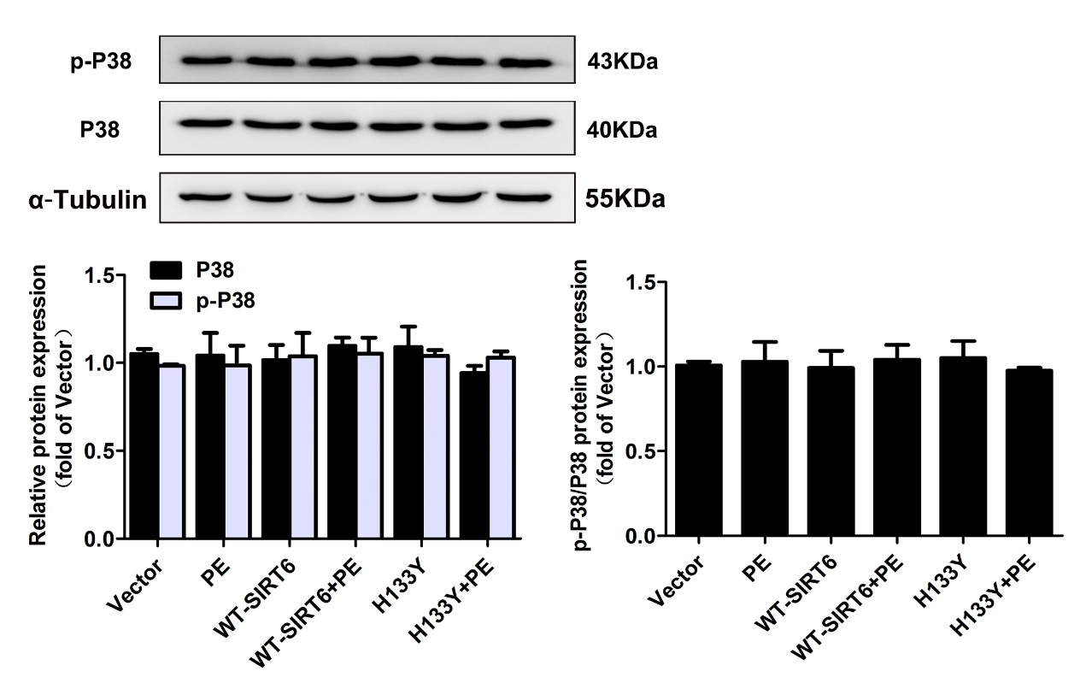
Fig. S1. Change of p38 expression in SIRT6 overexpression. NRCMs were transiently transfected with plasmid encoding the wildtype SIRT6 (WT-SIRT6) and mutant of SIRT6 (H133Y) for 48h. Western blot analysis was conducted to determine the protein expression of p38. Data were normalized by α-tubulin for protein expression and presented as mean ± SEM, n = 4.

Fig. S2. Changes of miR-29a and miR-133a expression in SIRT6 overexpression. NRCMs were transiently transfected with plasmid encoding the wildtype SIRT6 (WT-SIRT6) for 48h and the expression of miR-29a and miR-133a were determined by qRT-PCR. The data were presented as mean ± SEM. **P < 0.01 vs. Vector. n = 4.

A
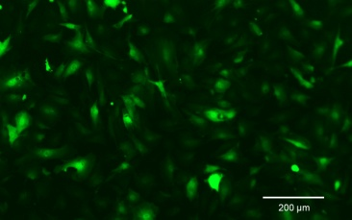
B
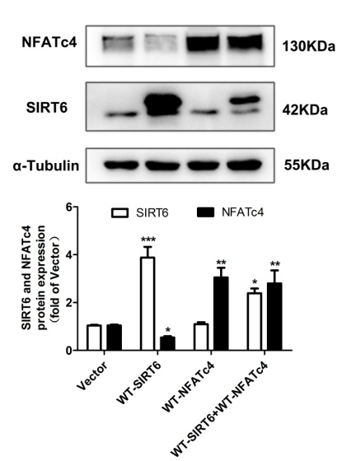
Fig. S3. The transfection efficiency of cardiomyocytes. (A) Cells were transfected with GFP-SIRT1 plasmid for 48 h using Lipofectamine 2000. The image was captured by fluorescence microscope. (B) Cells were transfected with WT-SIRT6 and WT-NFATc4 plasmids for 48 h using Lipofectamine 2000. The protein expression of NFATc4 and SIRT6 were measured by Western blotting. The data were presented as mean ± SEM. *P < 0.05, **P < 0.01, ***P < 0.001 vs. Vector. n = 4.

