Discovery and verification of candidate biomarkers in cerebrospinal fluid of preclinical Alzheimer’s disease
Xiaofang Zhong^{1†}, Jingxin Wang^{2†}, Cynthia Carlsson³, Ozioma Okonkwo³, Henrik Zetterberg^{4,5,6,7}, Lingjun Li^{1,8*}
¹School of Pharmacy, University of Wisconsin-Madison, Madison, Wisconsin, USA.
²Neuroscience Training Program, University of Wisconsin-Madison, Madison, Wisconsin, USA.
³School of Medicine and Public Health, University of Wisconsin, Madison, Wisconsin, USA.
⁴Institute of Neuroscience and Physiology, Sahlgrenska Academy, University of Gothenburg, Gothenburg, Sweden.
⁵Clinical Neurochemistry Laboratory, Sahlgrenska University Hospital, Mölndal, Sweden.
⁶Department of Neurodegenerative Disease, UCL Institute of Neurology, London, UK.
⁷UK Dementia Research Institute at UCL, London, UK
⁸Department of Chemistry, University of Wisconsin, Madison, Wisconsin, USA.
†These authors contributed equally to this work.
*Correspondence should be addressed to L.L. (lingjun.li@wisc.edu)

Supplementary Materials
Supplementary Figure S1. Structure of isotopic N,N-dimethyl leucine (iDiLeu) tags.
Supplementary Figure S2. Boxplots of log2 fold change of 5-plex iDiLeu labeled peptide standards at ratio of 1:1:1:1:1. The median ratio from precursor quantification was 0.89:1.08:0.87:0.85:1.00. The lower and upper inner fence of the box represent the first and third quartile. The whiskers expand to the most extreme data point with a coefficient value of 1.5x interquartile range.
Supplementary Table S1. Significantly regulated proteins in female (A) and male (B) preclinical AD patients compared to corresponding healthy controls.
Supplementary Table S2. Primary and isotopic peak fractions for iDiLeu-labeled target peptides.
Supplementary Figures and Tables
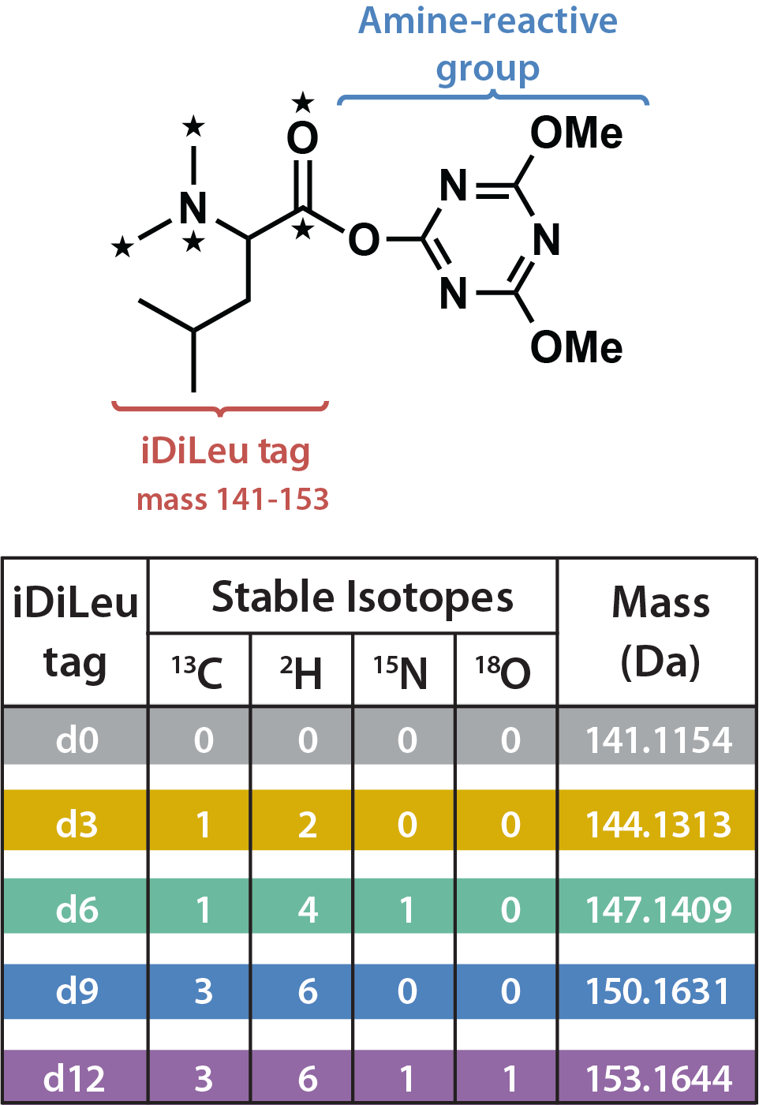
Figure S1.
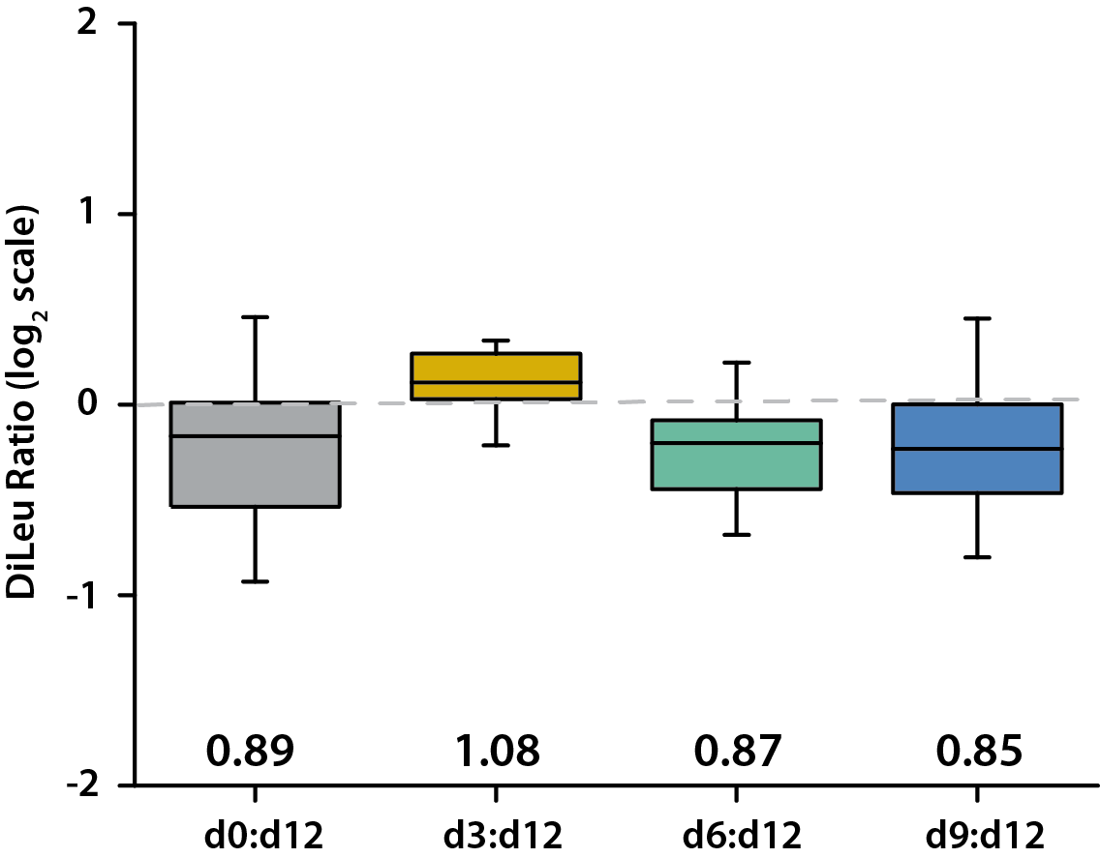
Figure S2.
Table S2. Primary and isotopic peak fractions for iDiLeu-labeled target peptides.
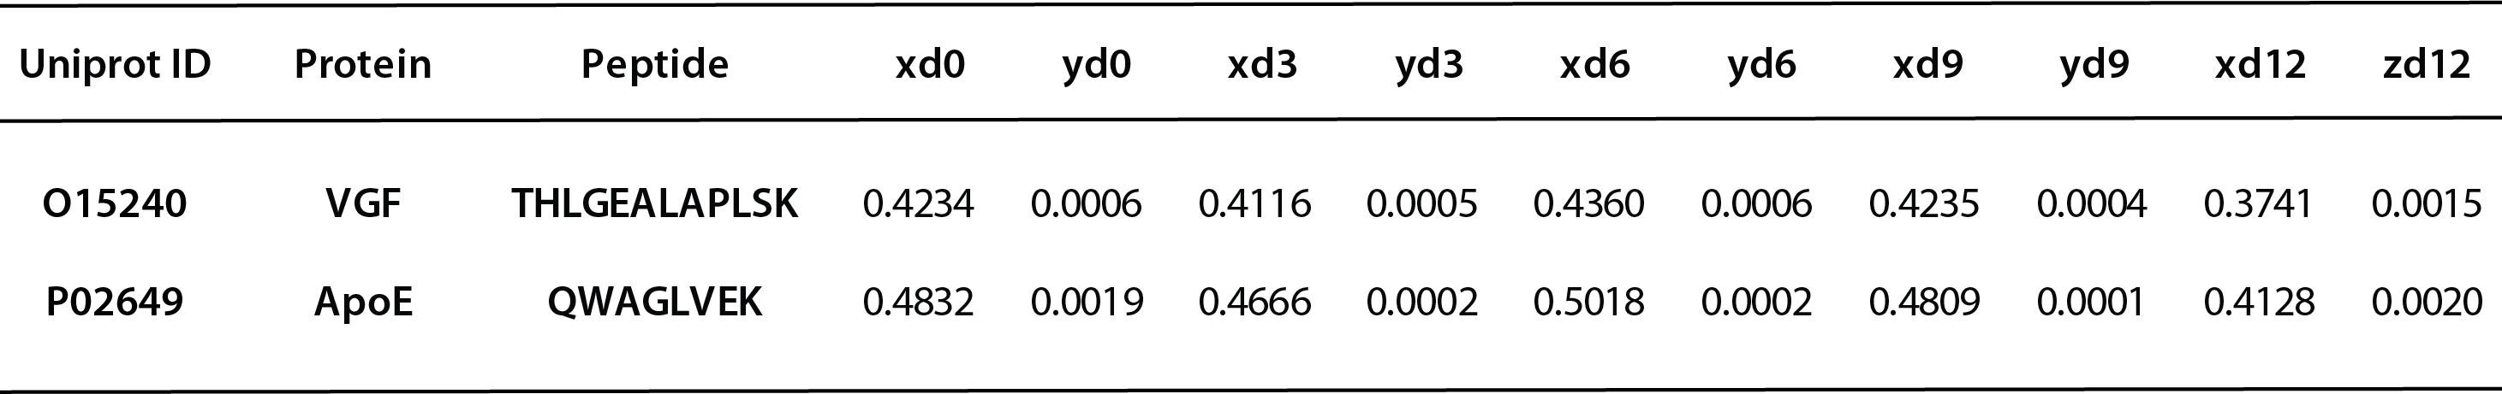
x, y, and z represent the percentages of monoisotopic peak, interference peak to the heavier mass-labeled peptide, and interference peak to the lighter mass-labeled peptide, respectively.

