Supplemental Methods

- ¹⁵N₂ LABELING EXPERIMENT
1a. Gravimetric biomass quantitation. After growth in baffled flasks containing BG-11 modified media, DG1 biomass was concentrated by gravitational settling for 30 min. Cleared supernatant was removed to adjust volume and achieve cell suspensions with approximate dry biomass densities of 2.5 mg L⁻¹. A 1.5-mL subsample of each suspension was used for gravimetric biomass quantitation with a microbalance after centrifuging the subsamples (6000 g) for 2 min, washing in sterile, distilled water three times to remove salts, and drying at 60°C. Suspensions (10 mL) were pipetted into 5-cm petri dishes, which were wrapped carefully with parafilm to retain moisture during incubation in the controlled-atmosphere chamber with added ¹⁵N₂.

1b. Chamber construction and incubation. A glass desiccator (21-L volume) was used for the controlled-atmosphere chamber (Fig. S1). Chamber connections included a gas gauge custom-calibrated to read between -0.1 - 0.6 bar (Swagelok, Pittsburgh, PA), a gas tight septum, and a vacuum pump through vacuum fittings (Swagelok Ultra-Torr, Pittsburgh, PA). A LED light ring, constructed from “natural light” strips (HitLites, Baton Rouge, LA), was fitted around the exterior of the desiccator to produce a uniform light intensity (210 Lux) following a 14/10 h light - dark cycle. The chamber was confirmed to be gas-tight before each experiment by observing a constant reading (at -0.1 bar) on the gas gauge for a period of two h after evacuating the desiccator. Headspace gas samples were collected through the septum using 140-mL syringes and 25-gauge needles with Luer-Lock fittings. These also were used to inject ¹⁵N₂ and O₂ into the growth chamber. Chamber was located in a darkened room with ambient temperature of 22-23°C.

1c. ¹⁵N isotopic calculations
After 7 d incubation, suspensions were dried and ground for isotopic analysis, the ¹⁵N atom % excess of biomass was calculated for each ¹⁵N labeled sample as follows:

First, given that:
$$δ^{15}N \left(‰\right)= \left[\frac{{(^{15}N/^{14}N)}_{sample}}{{(^{15}N/^{14}N)}_{atmosphere}} -1\right]×1000‰$$where the ${(^{15}N/^{14}N)}_{atmosphere}$ is 0.003676 (Junk and Svec, 1958). The atom percentage of ¹⁵N can be calculated as:
$$Atom\%^{15}N= \left[\frac{\left({10}^{-3}×δ^{15}N+1\right)×{(^{15}N/^{14}N)}_{atmosphere}}{1+\left({10}^{-3}×δ^{15}N+1\right)×{(^{15}N/^{14}N)}_{atmosphere}}\right]×100\%$$and ¹⁵N atom % excess as:
$$^{15}N atom \% excess=(Atom\%^{15}{N)}_{T }- \overline{(Atom\%^{15}{N)}_{C}}$$where $(Atom\%^{15}{N)}_{T }$is the ¹⁵N atom % of samples that have been labeled with ¹⁵N, and $\overline{(Atom\%^{15}{N)}_{C}}$ is the mean ¹⁵N atom % of the corresponding non-exposure control samples with the same medium N concentrations.
Second, the ¹⁵N weight percentage of the total N was calculated as:
$$Wt\%^{15}N = \frac{Atom\%^{15}N×15}{Atom\%^{15}N×15+(100\%-Atom\%^{15}N)×14} ×100\%$$Therefore, the weight of ¹⁵N fixed per unit dry DG1 biomass was:
$$Wt^{15}N \left(mg N {∙mg}^{-1} dry biomass\right)=1×Wt\%N×\left[({Wt\%^{15}N)}_{T}-\overline{({Wt\%^{15}N)}_{C}} \right]$$where $({Wt\%^{15}N)}_{T}$ is the ¹⁵N weight percentage of samples that have been labeled with ¹⁵N, and $\overline{({Wt\%^{15}N)}_{C}}$ is the mean ¹⁵N weight percentage of the corresponding non-exposure control samples in liquid medium with the same N concentration. Given that the atom percentage of ¹⁵N in the headspace [$(Atom\%^{15}N)_{Headspace}$] of the test chamber was 1.77%, the weight of ¹⁴N fixed per unit dry DG1 biomass was:
$$Wt^{14}N \left(mg N{∙mg}^{-1} dry biomass\right)= \frac{Wt^{15}N×\left[1-(Atom\%^{15}N)_{Headspace}\right]×14}{15×(Atom\%^{15}N)_{Headspace} }$$
Then the biomass based N₂ fixation rate was estimated as:
$$N_{2}{fixation rate}/{biomass} \left(μg N∙g^{-1}dry biomass∙day^{-1}\right)= {10}^{6}×\frac{\left(Wt^{15}N+Wt^{14}N\right)}{t}$$where t is the incubation time (seven days). Finally, total N₂ fixed in one petri dish was estimated as:
$$N_{2} fixed amount \left(μg N∙petri dish^{-1}\right)= {10}^{3}×\left(Wt^{15}N+Wt^{14}N\right)×V×BD$$where V is the loading volume (10 ml) and BD is the biomass density (mg dry biomass ml⁻¹) of the concentrated DG1 cell suspension.
- SOIL N RETENTION EXPERIMENT
2a. Description of photobioreactor and DG1 cultivation conditions
A photobioreactor (PBR) system was used to grow DG1 for soil N retention trials. The system allowed for simultaneous growth of DG1 in five PBR bottles placed on a multiple-spot magnetic stir plate (Fig. S2). Inocula (90 ml) of concentrated cell suspensions (biomass density ~ 2 mg dry biomass ml⁻¹) were added to PBRs containing 1.2 L of medium with the appropriate NO₃-N concentration. Condensed biomass was introduced through the sampling tube (Fig. S3). For temperature and gas regulation, PBRs had been constructed based on Mazowski's patent (Mazowski, 1971) with a 1.5-L volume BELL-FLO Flask (Bellco Glass, Inc., Vineland, NJ) with a thermometer and a gas inlet on one side and a sampling tube and gas outlet on the opposite side (Fig. S3A and S3B). Each PBR bottle was surrounded by an environmental jacket consisting of a custom glass cylinder lined on the inside with 'natural light' LED light strips (HitLites, Baton Rouge, LA) (Figure S4). A water circulation jacket made from polyethylene plastic was wrapped around the glass cylinder. The LED light strips were connected to a dimmer on the light-control panel to adjust light intensity. Circulating water in water jackets was set at about 20℃ to cool the PBRs, and the input water flow was controlled by an open-jaw screw compressor clamp to guarantee that the average temperature in all cultivation reactors was maintained at 22.5℃.

Gas flow (air with 2% CO₂ gas) was set to 400 cm³ min⁻¹ using a gas-control panel built with one gas flow meter and multiple purge meters. Growth of flocculating biomass was improved after addition of an impeller constructed from 1-mm thick PVC plastic sheeting. The impeller was attached to a magnetic rod placed on the bottom of the reactor. The impeller could rotate freely at 80 revolutions per minute (RPM), driven by the magnetic stir plates. Prior to use, assembled PBR bottles were sterilized by autoclaving. The thermometer probe was treated with the 100× diluted Minncare® Cold Sterilant (Mar Cor Purification, Skippack, PA) for 15 min and rinsed with sterile dH₂O for four times before placing in the PBR bottle. Densities of DG1 cultures grown in PBRs for 15 d reflected respective responses to different NO₃-N concentrations (Fig. S5).

2b. Preparation of soil microcosms
Retention of NO₃-N by DG1 was assessed using soil microcosms prepared in small petri dishes (5 cm diam) containing 15 cm³ (bulk density = 1.04 g cm⁻²) autoclaved soil. Petri dish bottoms were pre-perforated (to permit water flow-through during rainfall simulation) and sealed with tape. Soil was classified as Hagerstown silt loam (Typic Hapludalfs) (Soil Survey Staff, 2010) and collected at the Pennsylvania State University Agronomy Farm from a mixture of Ap/B1 horizon soils (30-cm depth) in a location with no recent N fertilization. The soil had been well-mixed, air-dried and passed through a 2-mm sieve prior to autoclaving. Soil chemical analyses are reported in Table S1.

2c. Inoculation of soil microcosms
Surfaces of soil microcosms were inoculated with DG1 as follows: Reactor-grown DG1 was harvested after 15 days and subjected to gravitational settling and volume adjustment to obtain cell suspensions with an average dry biomass density of 1.7 mg ml⁻¹. Volumes of 1, 2 and 4 mL of these suspensions were each reduced to a standard volume of 0.5 mL and then added to 6 mL fresh medium of appropriate NO₃-N concentration (0, 62 or 124 mg L⁻¹). The 6.5-mL suspensions were evenly pipetted onto soil surfaces to achieve initial inoculum densities of 0.88, 1.75 and 3.51 g dry biomass m⁻² in microcosms. The edges of the petri dishes were sealed with parafilm and incubated at 22-23 °C under continuous fluorescent illumination ('natural light') with an average light intensity of 250 Lux.

2d. Experimental design testing growth (before rainfall treatment)
A randomized complete block design (RCBD) was applied in growth experiments testing the effects of growth medium N concentration and inoculum amount. Each of three replicated blocks consisted of all combinations of the following two factors with three levels per factor. Factor one was the biomass amount added to soil surfaces (1, 2 or 4 mL of condensed DG1), while factor two was the culture medium N concentration in microcosms (0, 62 or 124 ppm). Combinations of the two factors were randomly applied to soil microcosms in each block.
A total of 27 soil microcosms were set up in every block using half of the concentrated DG1 suspensions, which contained three replicate microcosms for every factor level combination comprising three biomass amounts by three medium N concentrations. After inoculating DG1 onto soils on day 1, one replicate microcosm was randomly selected for sacrificial harvesting on day 2, day 4, and day 8 (collection of upper 3-mm soil for chlorophyll analysis). These harvesting dates corresponded to one, three, and seven days of soil contact time for biofilm establishment following DG1 inoculation.

2e. Chlorophyll analysis and growth evaluation
Chlorophylls in surface soil samples from each microcosm were extracted with a total 20 mL of 1:1 ratio DMSO: acetone solution based on Nayak's method (Nayak et al., 2004). Absorbances of cleared extracts were measured at 750, 663, 645, and 630 nm (A₇₅₀, A₆₆₃, A₆₄₅, and A₆₃₀). Replicates of negative control samples per block were included in chlorophyll extractions and measurements to adjust for soil background absorbances. These samples were collected from the upper 3-mm soils of microcosms that had not been inoculated with DG1, but incubated in the same way as inoculated microcosms.
Chlorophyll a concentration in each extract (Chl a) was calculated as (UNESCO, 1966):
$$Chl a (μg {ml}^{-1})=11.64×(A_{663}-A_{750})-2.16×(A_{645}-A_{750})+0.1×(A_{630}-A_{750})$$
The growth of DG1 during incubation from day 2 to day 8 was determined from the percentage increase in chlorophyll a content (% Chl a increase) and adjusted by subtracting absorbances of negative controls. The % Chl a increase was calculated as:
$$\% Chl a increase=\frac{(Chl a)_{day 8}-(Chl a)_{day 2}}{(Chl a)_{day 8}- (Chl a)_{NC}}×100\%$$
where (Chl a)_{day 8} and (Chl a)_{day 2} were chlorophyll a concentrations of the samples at day 8 and day 2, and (Chl a)_{NC} was the average chlorophyll a concentration of four negative control samples.
2f. Preparation of the sample collection device.
For rainfall trials, soil microcosms were fixed onto the tops of collection cylinders as shown in Fig. S6. To enable water infiltration and downward flow through the soils in the microcosms, the bottoms of the petri dishes were pre-perforated with five drainage holes (diameter = 5 mm) and covered with a piece of waterproof duct tape during incubation. Before each rainfall treatment, the tape was removed from the petri dish bottom, and the microcosm was securely attached to the top of the cylinder with duct tape. To help maintain atmospheric pressure in the cylinder during water collection (and allow water to flow through), a circular opening was made near the top of the cylinder. To prevent water from entering the opening, a duct tape 'canopy' was placed above the opening during rainfall application.
2g. Rainfall simulator and calibration
Prior to each treatment block, the rainfall rate was calibrated by adjusting the water pressure at the rain-producing nozzle (Kibet et al., 2014). Rainfall rate was checked before every rainfall treatment by confirming that a 10-sec total water flow from the nozzle using a collection pipe was consistent over three trials (nozzle size = 24 wsq full jet 3/8 HH, precipitation intensity = 3.3 cm hr⁻¹, 10 second flow = 1140 ml). Water-collecting cylinders (10-cm height with the same 5-cm diameter as petri dish microcosms) were arranged in a three by six matrix (about 16 cm between columns and rows) to support the microcosms within the uniform rainfall area. The uniformity of rainfall was pre-tested and validated by measuring water volumes across a complete set of cylinders after a 30-minute rainfall event (CV < 5%). An array of soil microcosms positioned underneath the rainfall simulator is shown in Fig. S7.
References
Junk, G., Svec, H.J., 1958. The absolute abundance of the nitrogen isotopes in the atmosphere and compressed gas from various sources. Geochimica et Cosmochimica Acta 14, 234-243.
Mazowski, E., 1971. Magnetic stirrer apparatus. US patent 3622129.
Soil Survey Staff (2010) Keys to soil taxonomy, 11th Edn. Washington, DC: USDA -Resources Conservation Service.
UNESCO, 1966. Determination of photosynthetic pigments in seawater, Monographs on oceanographic methodology. United Nations Educational, Scientific and Cultural Organization, Place de Fontenoy, pp. 15-16.

Fig. S1. Photograph of chamber made from a 21-L glass desiccator and used for ¹⁵N₂ fixation tests. Headspace contained 1.77% atom% ¹⁵N introduced as ¹⁵N₂ gas.

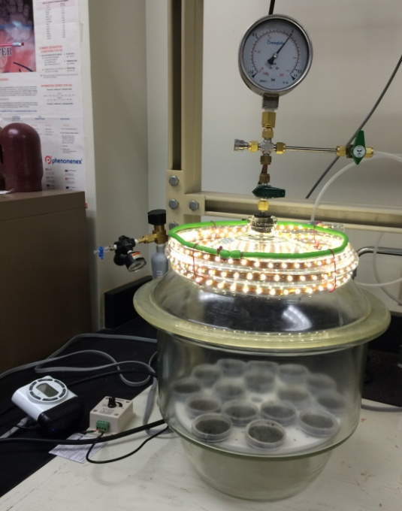

Figure S2. Overview of the PBR system. From left to right, the entire system includes a light-control panel, a water circulation pump, a multiple-spot magnetic stir plate, five cultivation reactors, five environmental jackets, and a gas-control panel.

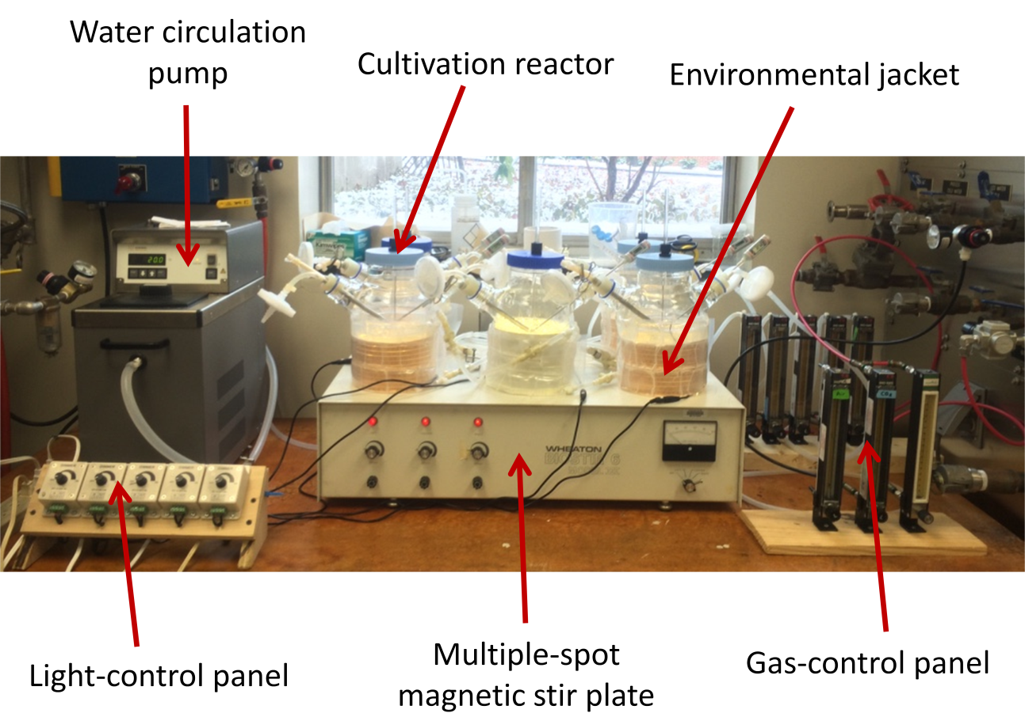

Fig. S3. An individual cultivation reactor in the PBR system. (A) Diagram of customized design. (B) Photograph of cultivation reactor. (C) Photograph of the impeller (diameter = 4.8 cm, leaf size = 1.9 cm × 1.6 cm).

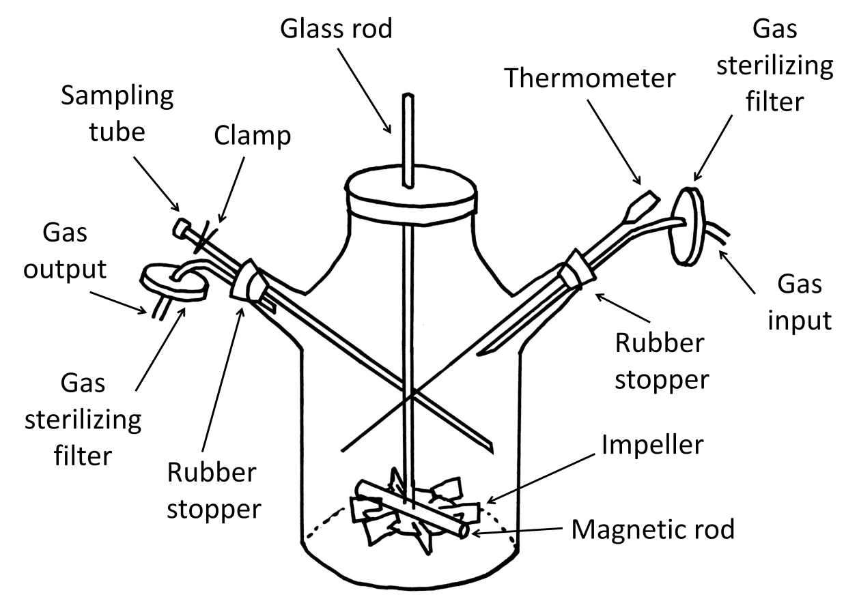
(A)

(B)
Fig. S4. Environmental jacket for a cultivation reactor. (A) Diagram of design. (B) Photograph of the constructed environmental jacket. (C) Photograph of the LED light cylinder. (D) Photograph of the water jacket (jacket size = 50 cm × 12 cm).
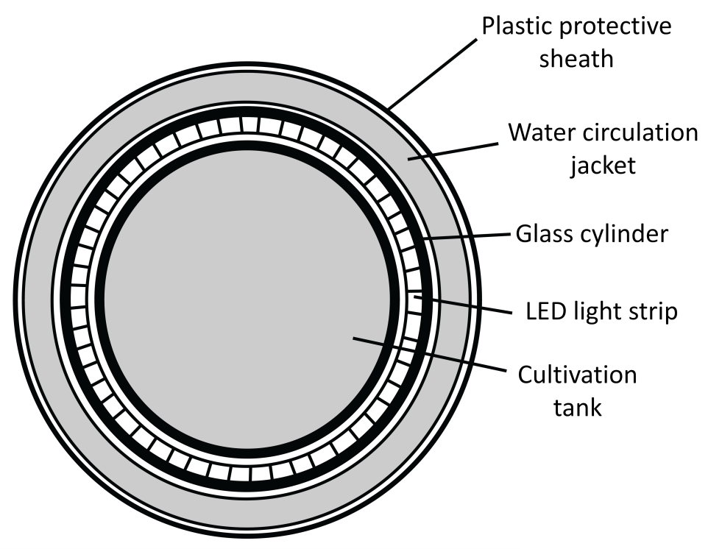
(A)

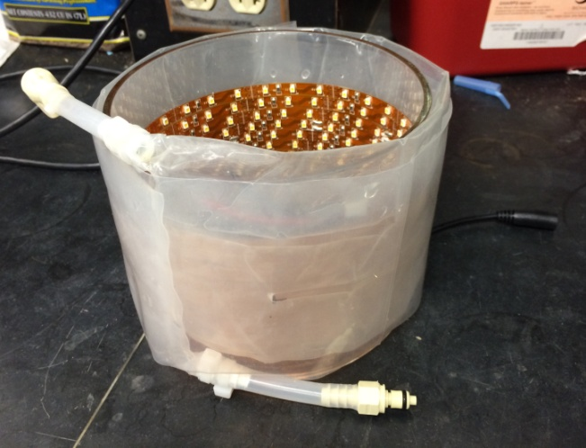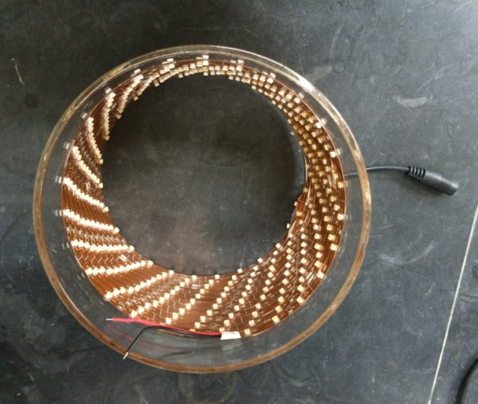
(B) (C)

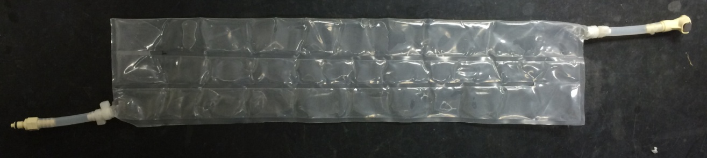
(D)
Figure S5. Photo of DG1 enrichment after being cultivated for two weeks in media with different nitrate-N. The medium NO₃-N concentrations in cultivation reactors from left to right were 0, 62, 124 and 247 mg L⁻¹.

Fig S6. Photographs of (A) DG1 growth on soil microcosm after incubation for 7 d and (B) water collection unit holding a non-inoculated soil microcosm. Black and white drawing indicates holes in the bottom of the microcosm dish that permit simulated rainfall to flow through the soil and into cylindrical collector for subsequent measurement.

A

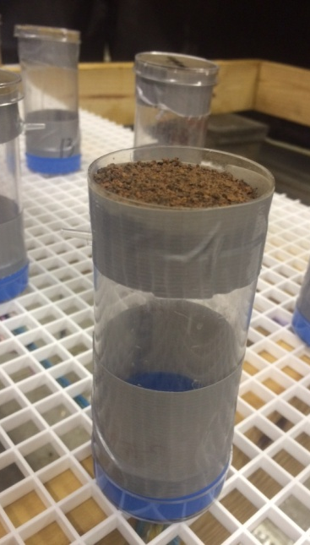
B

Fig. S7. Photograph of collection units holding inoculated soil microcosms under the rainfall simulator.

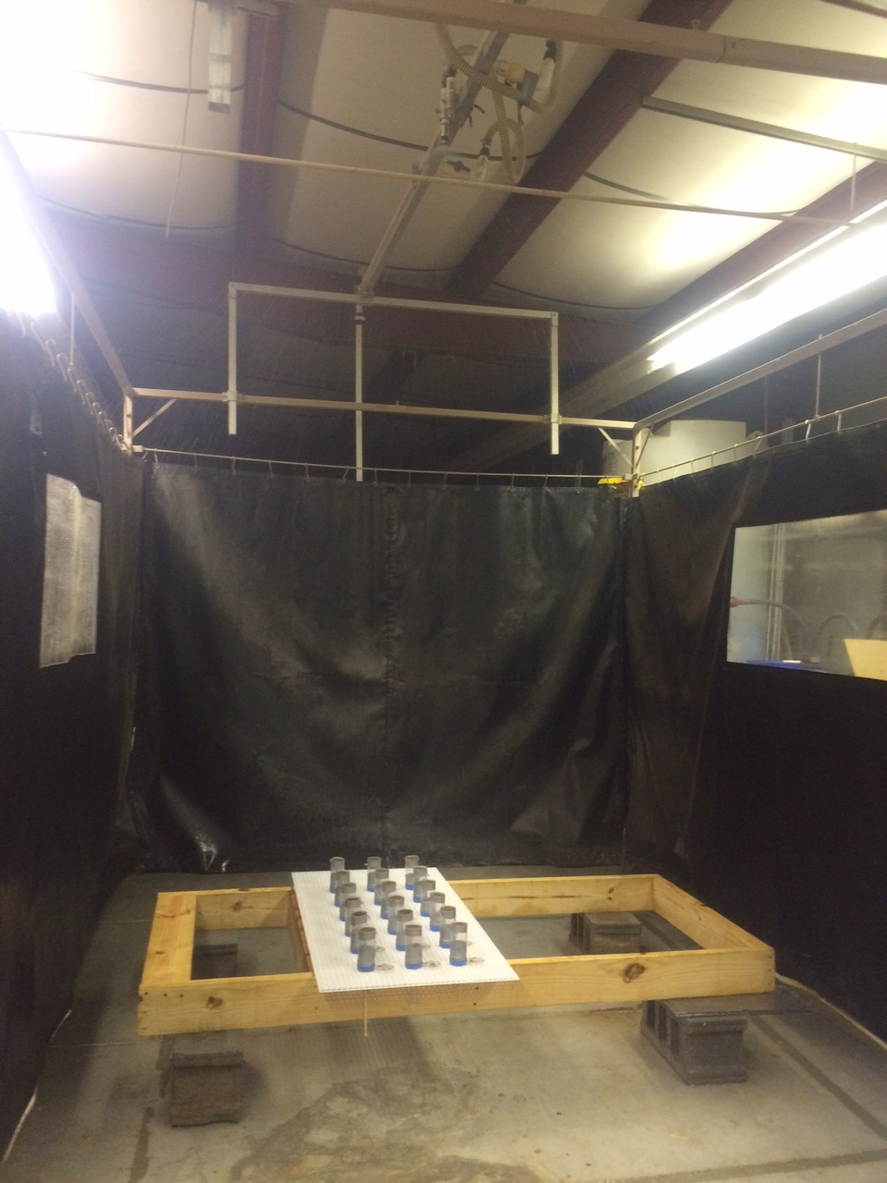

Table S1. Chemical analyses of Hagerstown soil used in microcosms. Values are shown as mean ± standard deviation.

Elements |  | Content
C% |  | 1.17 ± 0.02
N% |  | 0.17 ± 0.00
Ammonium N (ppm) | Before autoclaving | 0.77 ± 0.06
 | After autoclaving | 1.33 ± 0.42
Nitrate N (ppm) | Before autoclaving | 6.78 ± 0.96
 | After autoclaving | 6.89 ± 0.25
Phosphorus (ppm) |  | 372.5 ± 13.9
Metal elements (ppm)
Aluminum |  | 24139.7 ± 597.3
Iron |  | 27263.3 ± 999.8
Potassium |  | 3376.2 ± 209.9
Magnesium |  | 2044.1 ± 31.0
Calcium |  | 3424.9 ± 119.4
Chromium |  | 57.37 ± 8.71
Copper |  | 17.72 ± 0.39
Lead |  | 19.16 ± 0.78
Nickel |  | 25.21 ± 0.60
Zinc |  | 51.41 ± 0.54
Barium |  | 121.77 ± 2.26
Cobalt |  | 14.57 ± 0.28
Manganese |  | 839.89 ± 27.45
Sodium |  | 42.89 ± 3.49
Strontium |  | 16.19 ± 0.34

