Supplementary Material
Composition of rumen bacterial community in dairy cows with different levels of somatic cell counts

Yifan Zhong^{1#}, Mingyuan Xue^{1#}, Jianxin Liu^{1*}

¹ Institute of Diary Science, MoE Key Laboratory of Molecular Animal Nutrition, College of Animal Sciences, Zhejiang University, 310058Hangzhou, P. R. China

#These authors contributed equally to this work.

*Correspondence:
Corresponding author:
Dr. Jianxin Liu (Requests for materials should be addressed to: J. X. Liu)
liujx@zju.edu.cn

1. Supplementary Figures and Tables
1.1 Supplementary Figure
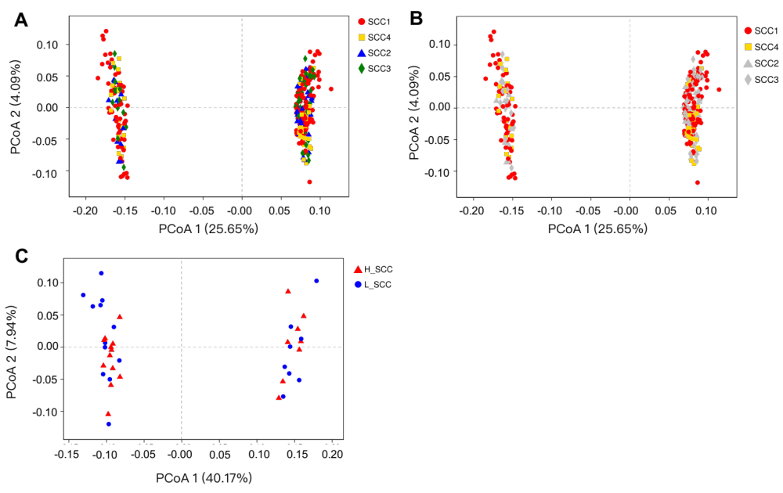
Supplementary Figure S1. Principal coordinates analysis (PCoA) based on unweighted Unifrac distances of OTUs. Samples are indicated by points and colored for different SCC groups. (A) PCoA of the four SCC groups. (B) PCoA of the four SCC groups with SCC1 and SCC4 highlighted. (C) PCoA of L_SCC and H_ SCC groups.
1.2 Supplementary Tables
Supplementary Table S1. Ingredients and nutrient compositions of the experimental diet.
Ingredient | % of DM
Ground corn grain | 24.4
Cottonseed meal | 4.33
Soybean meal | 11.0
Corn silage | 16.7
Alfalfa hay | 13.5
Oat hay | 9.63
Distiller | 8.49
Beet pulp | 8.22
Premix¹ | 3.79
Chemical Composition, %
Crude protein | 16.3
Ether extract | 3.31
Neutral detergent fiber | 29.2
Acid detergent fiber | 18.2
Non-fibrous carbohydrate (NFC)² | 43.0
Ca | 0.764
P | 0.521
Net energy for lactation (NE_{L}), Mcal/kg DM | 1.70
¹ Formulated to provide (per kilogram of DM) Fe 600 mg; Cu 650 mg; Mn 630 mg; Zn 3,000 mg; Se 17 mg; I 36 mg; Co 8 mg; Vitamin A 250,000 IU; Vitamin D 50,000 IU; Vitamin E 1,100 IU; 15~18% NaCl; water <10%.
² NFC=100 - % NDF - % CP - % ether extract - % ash.
Supplementary Table S2. Power analysis of the outcome variables when comparing L_SCC and H_SCC groups.
Variables | Total sample size | Power
Alpha diversity
Shannon | 40 | 0.684
Simpson | 40 | 0.081
Ace | 40 | 0.301
Chao1 | 40 | 0.295
Top 5 phylum
Proteobacteria | 40 | 0.78
Firmicutes | 40 | 0.158
Bacteroidetes | 40 | 0.455
Tenericutes | 40 | 0.748
Spirochaetes | 40 | 0.104
Top 10 genus
Prevotella | 40 | 0.231
norank_o__Clostridiales | 40 | 0.095
Ruminococcus | 40 | 0.303
norank_f__Succinivibrionaceae | 40 | 0.753
norank_f__Ruminococcaceae | 40 | 0.372
norank_o__Bacteroidales | 40 | 0.261
norank_f__Lachnospiraceae | 40 | 0.344
unclassified_o__Clostridiales | 40 | 0.799
Butyrivibrio | 40 | 0.191
unclassified_o__Bacteroidales | 40 | 0.623
VFAs concentrations
Acetate | 40 | 0.114
Propionate | 40 | 0.692
Isobutyrate | 40 | 0.076
Butyrate | 40 | 0.144
Isovalerate | 40 | 0.151
Valerate | 40 | 0.701
Total VFA | 40 | 0.255
A: P ratio | 40 | 0.803

Supplementary Table S3. Unique bacterial genera in 4 groups with different levels of somatic cell counts (SCC).
Genus¹ | Relative abundance (%)
SCC1
unclassified_c__TM7-1 | 0.000186
unclassified_o__SM2F09 | 0.000116
Flavobacterium | 0.000116
unclassified_o__Acidimicrobiales | 0.000093
Trichococcus | 0.000093
unclassified_f__OM27 | 0.000093
unclassified_f__Beijerinckiaceae | 0.000093
unclassified_c__TM7-3 | 0.000093
unclassified_f__Peptococcaceae | 0.000070
Gluconobacter | 0.000070
unclassified_f__Cryomorphaceae | 0.000047
Microvirgula | 0.000047
unclassified_o__Chromatiales | 0.000047
unclassified_f__[Chthoniobacteraceae] | 0.000047
unclassified_o__Sva0725 | 0.000023
unclassified_o__Solirubrobacterales | 0.000023
unclassified_f__Micromonosporaceae | 0.000023
unclassified_f__Dermatophilaceae | 0.000023
unclassified_f__Porphyromonadaceae | 0.000023
unclassified_o__Chloroflexales | 0.000023
Gracilibacter | 0.000023
Ammoniphilus | 0.000023
unclassified_f__[Chromatiaceae] | 0.000023
unclassified_f__Legionellaceae | 0.000023
Proteus | 0.000023
unclassified_f__Rhodocyclaceae | 0.000023
unclassified_f__Methylophilaceae | 0.000023
unclassified_o__Thiohalorhabdales | 0.000023
unclassified_c__TM7-3 | 0.000023
SCC2
Ralstonia | 0.000166
Sphingobium | 0.000083
Lactococcus | 0.000083
Rheinheimera | 0.000083
Bilophila | 0.000083
unclassified_f__Flavobacteriaceae | 0.000083
SCC3
Helcococcus | 0.000166
unclassified_c__SC3 | 0.000166
unclassified_c__ABY1 | 0.000166
Magnetospirillum | 0.000166
Prauseria | 0.000083
Desulfococcus | 0.000083
Anaerotruncus | 0.000083
[Prevotella] | 0.000083
unclassified_o__[Roseiflexales] | 0.000083
Mycoplasma | 0.000083
SCC4
unclassified_f__R4-45B | 0.000089
Paludibacter | 0.000089
Parvibaculum | 0.000089
unclassified_c__OPB41 | 0.000089
unclassified_o__MBA08 | 0.000089
unclassified_f__Cytophagaceae | 0.000089
Candidatus_Koribacter | 0.000089
Brevibacterium | 0.000089
¹ SCC1: somatic cell counts< 200,000/mL; SCC2: somatic cell counts range from 200,001 to 500,000/mL; SCC3: somatic cell counts range from 500,001 to 1,000,000/mL; SCC4: somatic cell counts >1,000,000/mL
Supplementary Table S4. Unique bacterial genera in cows with the highest (L_SCC) and lowest somatic cell counts (H_SCC).
Genus | Relative abundance (%)
L_SCC
unclassified_f__LD19 | 0.002038
norank_f__Oxalobacteraceae | 0.001631
Enterococcus | 0.001224
Rhodobacter | 0.001020
unclassified_o__Burkholderiales | 0.001019
unclassified_o__Actinomycetales | 0.000816
unclassified_f__Lactobacillaceae | 0.000612
Fusobacterium | 0.000612
Methylosinus | 0.000612
Porphyromonas | 0.000611
Candidatus_Aquiluna | 0.000408
Saccharopolyspora | 0.000408
unclassified_f__Cryomorphaceae | 0.000408
unclassified_o__Chlorophyta | 0.000408
Oribacterium | 0.000408
Veillonella | 0.000408
Methylobacterium | 0.000408
Rhodoferax | 0.000408
Polynucleobacter | 0.000408
Actinomyces | 0.000408
Granulicatella | 0.000408
Phascolarctobacterium | 0.000408
unclassified_o__Acidimicrobiales | 0.000204
Brachybacterium | 0.000204
Curtobacterium | 0.000204
Arthrobacter | 0.000204
unclassified_o__Gaiellales | 0.000204
unclassified_f__Chitinophagaceae | 0.000204
unclassified_f__Saprospiraceae | 0.000204
unclassified_f__[Barnesiellaceae] | 0.000204
Dysgonomonas | 0.000204
unclassified_f__Porphyromonadaceae | 0.000204
Flavobacterium | 0.000204
unclassified_f__Flavobacteriaceae | 0.000204
unclassified_o__Sphingobacteriales | 0.000204
unclassified_f__Chlamydomonadaceae | 0.000204
Exiguobacterium | 0.000204
unclassified_o__Bacillales | 0.000204
Planomicrobium | 0.000204
Carnobacterium | 0.000204
Trichococcus | 0.000204
Gracilibacter | 0.000204
unclassified_f__Peptococcaceae | 0.000204
Thalassospira | 0.000204
unclassified_f__Beijerinckiaceae | 0.000204
Rhodovulum | 0.000204
Gluconobacter | 0.000204
unclassified_f__Acetobacteraceae | 0.000204
Azospirillum | 0.000204
Schlegelella | 0.000204
unclassified_f__Methylophilaceae | 0.000204
Microvirgula | 0.000204
C39 | 0.000204
unclassified_f__OM27 | 0.000204
unclassified_f__[Chromatiaceae] | 0.000204
unclassified_o__Chromatiales | 0.000204
Serratia | 0.000204
Halomonas | 0.000204
unclassified_f__Pasteurellaceae | 0.000204
unclassified_f__Pseudomonadaceae | 0.000204
unclassified_c__Spirochaetes | 0.000204
unclassified_f__Synergistaceae | 0.000204
unclassified_c__TM7-1 | 0.000204
unclassified_c__TM7-3 | 0.000204
H_SCC
unclassified_f__Pirellulaceae | 0.001020
Planktothrix | 0.000612
Sphingomonas | 0.000612
Pediococcus | 0.000408
unclassified_o__Rhizobiales | 0.000408
unclassified_c__Verruco-5 | 0.000408
Collinsella | 0.000408
Thermus | 0.000204
unclassified_f__Koribacteraceae | 0.000204
Cellulomonas | 0.000204
unclassified_f__Microbacteriaceae | 0.000204
Mycobacterium | 0.000204
Sanguibacter | 0.000204
Streptomyces | 0.000204
Slackia | 0.000204
unclassified_c__SJA-176 | 0.000204
unclassified_p__Armatimonadetes | 0.000204
Paludibacter | 0.000204
unclassified_f__Porphyromonadaceae | 0.000204
Wautersiella | 0.000204
Sphingobacterium | 0.000204
unclassified_o__Bacillales | 0.000204
Facklamia | 0.000204
unclassified_f__Lactobacillaceae | 0.000204
unclassified_p__Firmicutes | 0.000204
unclassified_f__R4-45B | 0.000204
unclassified_o__Desulfuromonadales | 0.000204
HTCC | 0.000204
unclassified_f__Enterobacteriaceae | 0.000204
unclassified_c__Gammaproteobacteria | 0.000204
unclassified_f__R4-41B | 0.000204

