Supplementary Figures and Tables

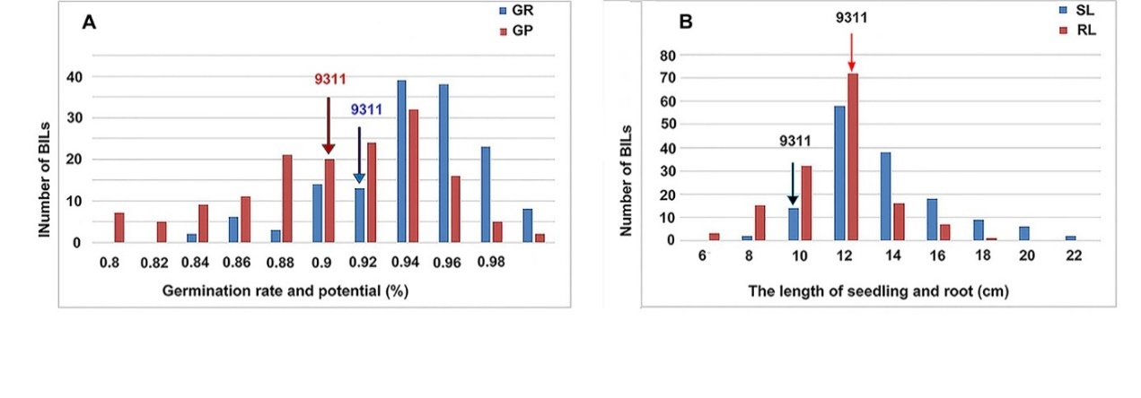
Supplementary Fig. 1 Distribution frequency of the seed vigor trait of BIL population under normal treatment. A indicates the germination potential and germination rate, and B shows the seedling length and root length.

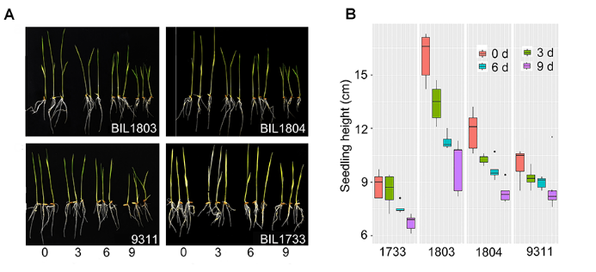
Supplementary Fig. 2 The plants stature of 9311 and three BIL lines under artificial aging treatment. A, the seedling plants; B, the statistical box plot of the seedling length, red: control; blue: treatment 3 days; green: treatment 6 days; purple: treatment 9 days.

Supplementary Fig. 3 QTLs for seed vigor for artificial aging treatments detected in BIL population shared by 9311. QTLs for seed vigor related traits (germination potential, germination rate, seedling length and root length) under artificial aging treatments. Red, artificial aging for 0 day; blue, artificial aging for 3 days; green, artificial aging for 6 days; dark black, artificial aging for 9 days. Positive triangle, germination rate (GR); inverted triangle, germination potential (GP); rectangle, seedling length (SL); diamond, root length (RL).

Supplementary Fig. 4 QTLs q9SL1.1 and q9GR8.1 from O. longistaminata contributed to seed-vigor related traits under artificial aging A. with the QTL q9SL1.1 BILs show significance high seedling length than the BILs which not shared with the QTL q9SL1.1 with four artificial aging treatments. B. when under 0 and 3 days aging condition, there is no significance difference between the BILs with or without the QTL q9GR8.1, but under 6 and 9 days aging condition, with q9GR8.1 BILs performance better than BILs without q9GR9.1. Significance levels: *, P < 0.05; **, P < 0.01 and ***, P < 0.0001.

Supplementary Table 1. Correlation analysis of the four seed vigor related traits.
trait | treatments | GP | GR | SL | RL
GP | 0
 | 3d aging
 | 6d aging
 | 9d aging
GR | 0 | 0.89**
 | 3d aging | 0.69**
 | 6d aging | 0.9**
 | 9d aging | 0.96**
SL | 0 | -0.09 | -0.05
 | 3d aging | 0.13 | 0.17*
 | 6d aging | 0.03 | 0.02
 | 9d aging | -0.03 | -0.01
RL | 0 | 0.02 | 0.03 | 0.22**
 | 3d aging | 0.04 | -0.04 | 0.09
 | 6d aging | -0.05 | -0.05 | 0.27**
 | 9d aging | 0.03 | 0.03 | 0.45**

Significance levels: * P < 0.05, and ** P < 0.01. Lower diagonal present the same treatment wise correlations. Person method was carried out to calculate the correlation in this study.

Supplementary Table 2. Putative QTLs for seed vigor in the BILs under aging stress derived from 9311.
QTLs | Chromosome | Position | Left Marker | Right Marker | LOD | PVE (%) | Add
qnGR4.1 | 4 | 20cM | BIN4-13 | BIN4-14 | 3.3813 | 10.9278 | -0.0147
q3GR4.1 | 4 | 37cM | BIN4-35 | BIN4-36 | 9.9432 | 27.2070 | -0.0364
q3GR11.1 | 11 | 58cM | BIN11-48 | BIN11-49 | 2.9990 | 7.7378 | -0.0148
q6GR11.1 | 11 | 304cM | BIN11-135 | BIN11-136 | 3.9316 | 10.4119 | -0.0584
q9GR11.1 | 11 | 302cM | BIN11-134 | BIN11-135 | 4.7531 | 13.2605 | -0.1162
qnGP3.1 | 3 | 156cM | BIN3-75 | BIN3-76 | 2.7947 | 15.7109 | -0.0622
qnGP4.1 | 4 | 19cM | BIN4-13 | BIN4-14 | 2.9899 | 9.3253 | -0.0204
q6GP1.2 | 1 | 94cM | BIN1-85 | BIN1-86 | 49.8463 | 171.4421 | -0.4177
q6GP11.1 | 11 | 303cM | BIN11-135 | BIN11-136 | 4.1736 | 6.6499 | -0.0759
q6GP12.1 | 12 | 176cM | BIN12-182 | BIN12-183 | 3.3086 | 5.9074 | -0.0290
q9GP5.1 | 5 | 159cM | BIN5-134 | BIN5-135 | 3.8301 | 8.9926 | -0.2058
q9GP5.2 | 5 | 309cM | BIN5-205 | BIN5-206 | 3.0648 | 7.0671 | -0.0375
qnSL4.1 | 4 | 56cM | BIN4-55 | BIN4-56 | 3.9157 | 7.6364 | -1.1777
q3SL4.1 | 4 | 42cM | BIN4-42 | BIN4-43 | 2.6127 | 4.7710 | -0.6947
q6SL11.1 | 11 | 145cM | BIN11-102 | BIN11-103 | 2.9635 | 6.9983 | -0.6992
q9SL3.1 | 3 | 332cM | BIN3-178 | BIN3-179 | 3.5878 | 10.94 | -1.1694
qnRL11.1 | 11 | 145cM | BIN11-102 | BIN11-103 | 3.5361 | 10.8258 | -0.9114
q3RL11.1 | 11 | 145cM | BIN11-102 | BIN11-103 | 3.2248 | 8.9712 | -0.7688
q6RL11.1 | 11 | 136cM | BIN11-100 | BIN11-101 | 3.9298 | 17.6261 | -1.0396
q9RL3.1 | 3 | 352cM | BIN3-213 | BIN3-214 | 3.1279 | 7.1639 | -0.8839
q9RL5.1 | 5 | 258cM | BIN5-184 | BIN5-185 | 4.0736 | 9.3032 | -0.8259
q9RL11.1 | 11 | 147cM | BIN11-102 | BIN11-103 | 5.6786 | 14.2183 | -0.8473
Notes: RL, represents root length; SL, represents seedling length; GP, represents germinating potential; GR, represents germinating rate.

