Supplementary material
Figure S1a. Spatiotemporal pattern of spruce budworm impacts (percentage of affected trees) and synchrony (Getis-Ord hotspot analysis) in eastern Canadian boreal forests for the period 1900–1914.
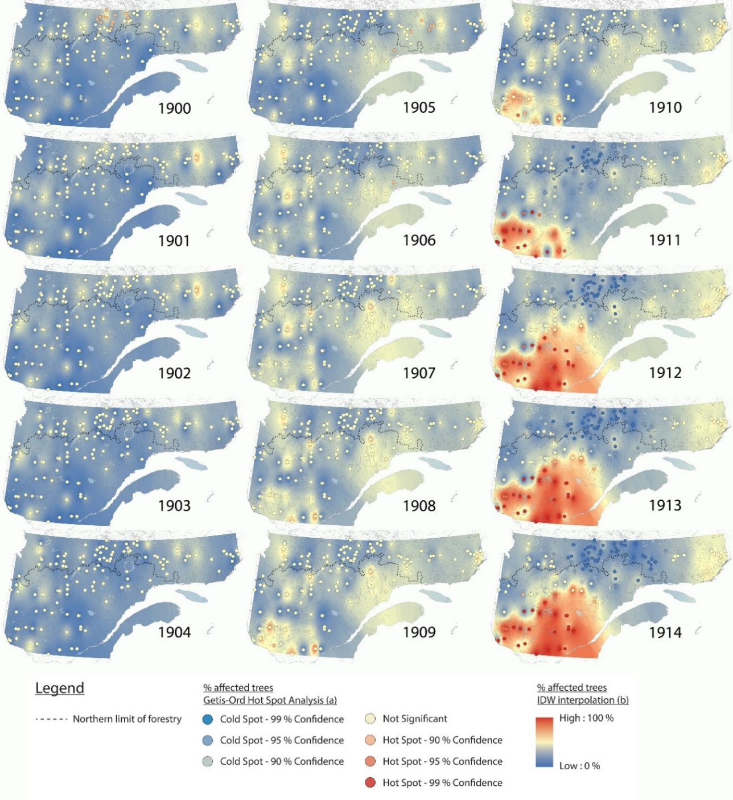
Figure S1b. Spatiotemporal pattern of spruce budworm impacts (percentage of affected trees) and synchrony (Getis-Ord hotspot analysis) in eastern Canadian boreal forests for the period 1915–1929.
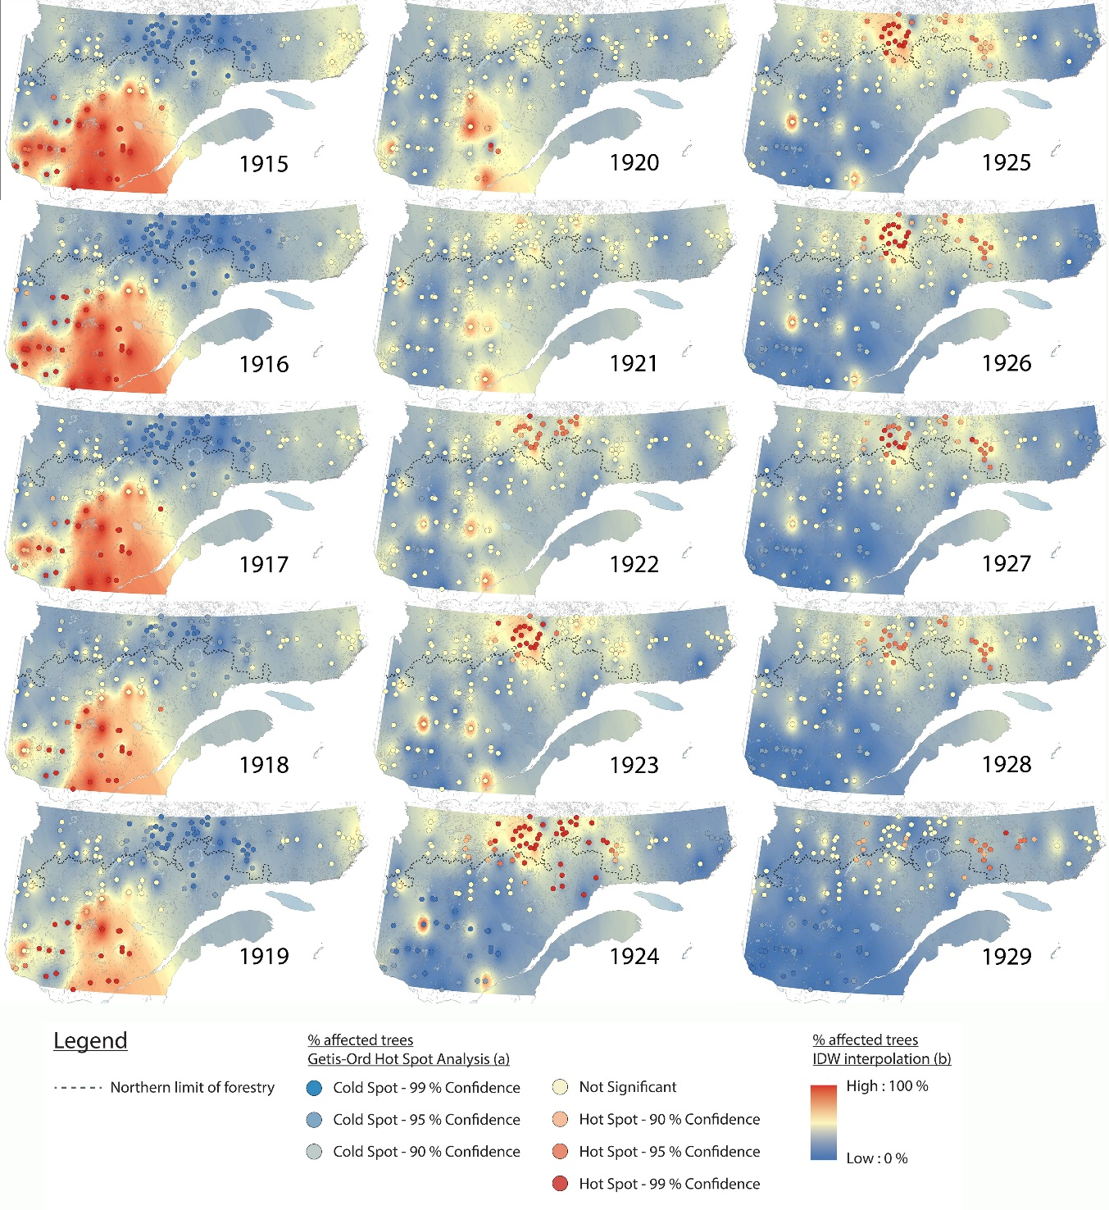
Figure S1c. Spatiotemporal pattern of spruce budworm impacts (percentage of affected trees) and synchrony (Getis-Ord hotspot analysis) in eastern Canadian boreal forests for the period 1930–1944.
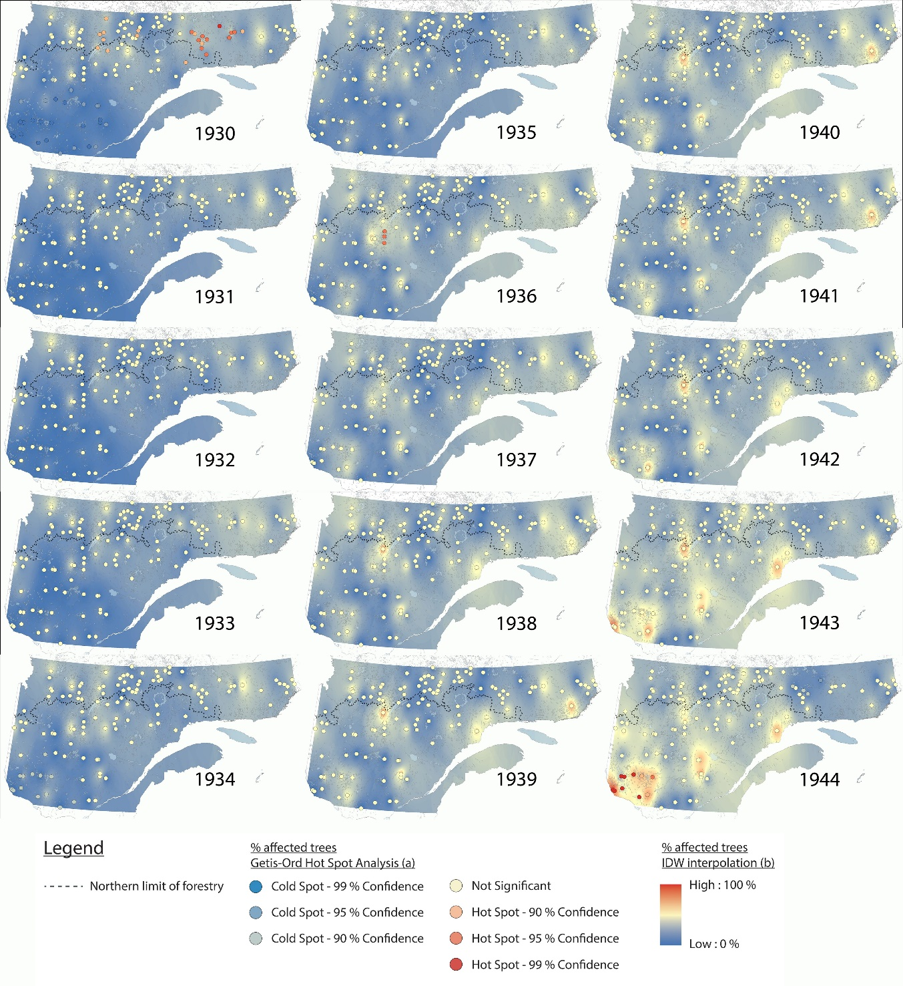
Figure S1d. Spatiotemporal pattern of spruce budworm impacts (percentage of affected trees) and synchrony (Getis-Ord hotspot analysis) in eastern Canadian boreal forests for the period 1944–1959.
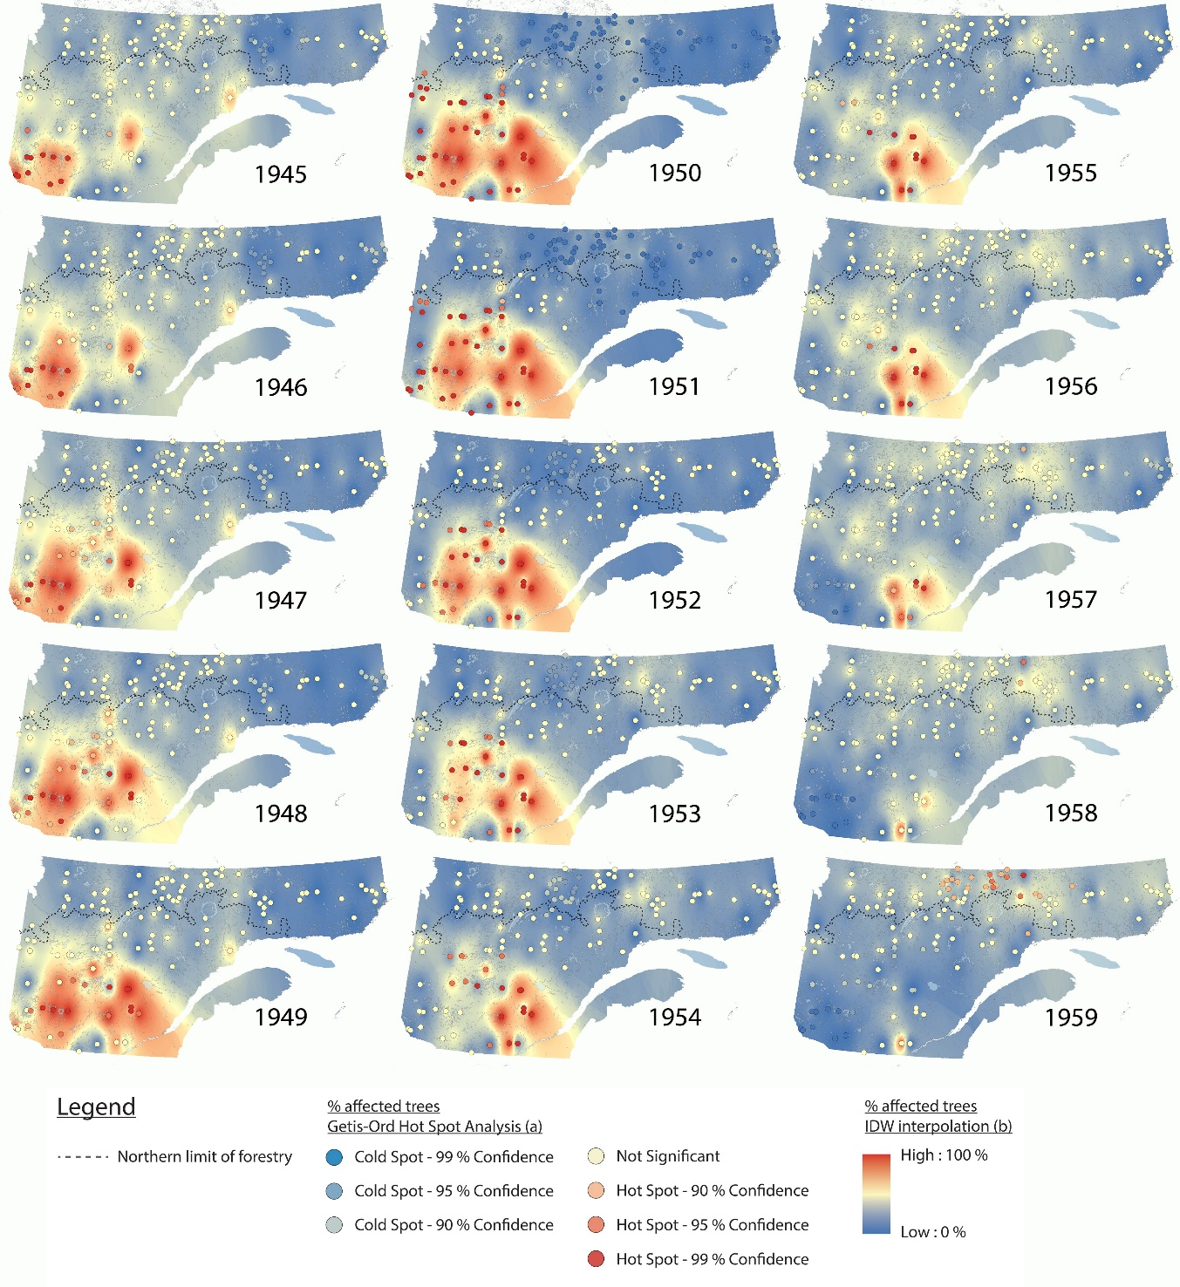
Figure S1e. Spatiotemporal pattern of spruce budworm impacts (percentage of affected trees) and synchrony (Getis-Ord hotspot analysis) in eastern Canadian boreal forests for the period 1960–1974.
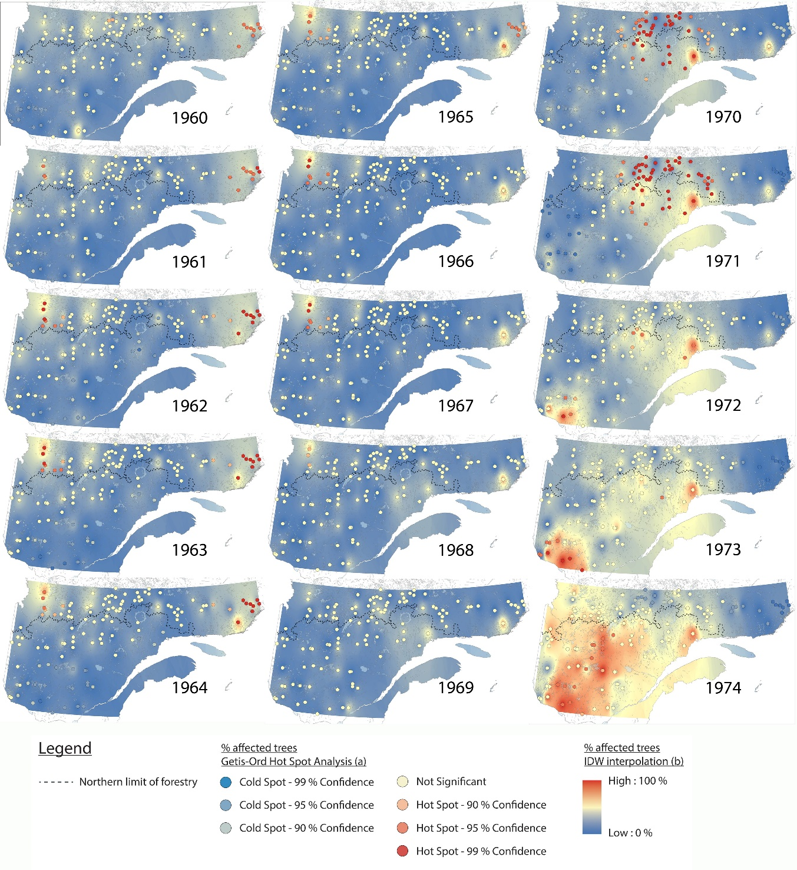
Figure S1f. Spatiotemporal pattern of spruce budworm impacts (percentage of affected trees) and synchrony (Getis-Ord hotspot analysis) in eastern Canadian boreal forests for the period 1975–1989.
