Supplementary Material

Genomic Selection for Ascochyta Blight Resistance in Pea
Margaret A. Carpenter*, David S. Goulden, Carmel J. Woods, Susan J. Thomson, Fernand Kenel, Tonya J. Frew, Rebecca D. Cooper, Gail M. Timmerman-Vaughan
* Correspondence: Margaret Carpenter: Margaret.carpenter@plantandfood.co.nz

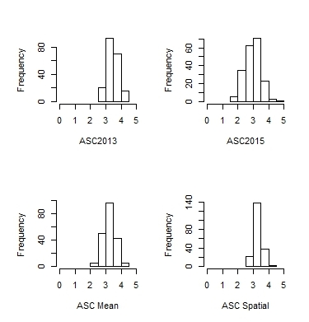

Supplementary File 5: Histograms of trait values
ASC = Ascochyta blight disease scores from trials in 2013 (ASC2013) and 2015 (ASC2015), mean values of the two trials (ASC Mean), and adjusted means from a spatial analysis (ASC Spatial).

