Supporting information for:

Physical-chemical properties of biogenic selenium nanostructures produced by Stenotrophomonas maltophilia SeITE02 and Ochrobactrum sp. MPV1

Elena Piacenza^{1,2,*}, Alessandro Presentato^{1,*,†}, Emmanuele Ambrosi³, Adolfo Speghini⁴, Raymond J. Turner², Giovanni Vallini^{1,†} and Silvia Lampis¹

¹Environmental Microbiology and Microbial Biotechnology Laboratory, Department of Biotechnology, University of Verona, Verona, Italy
²Department of Biological Sciences, University of Calgary, Calgary, AB, Canada
³Department of Molecular Sciences and Nanosystems, Ca’Foscari University, Venezia, Italy
⁴Nanomaterials Research Group, Department of Biotechnology, University of Verona and INSTM, RU Verona, Verona, Italy

*These authors contributed equally to the work.
†Corresponding author: giovanni.vallini@univr.it; alessandro.presentato@univr.it

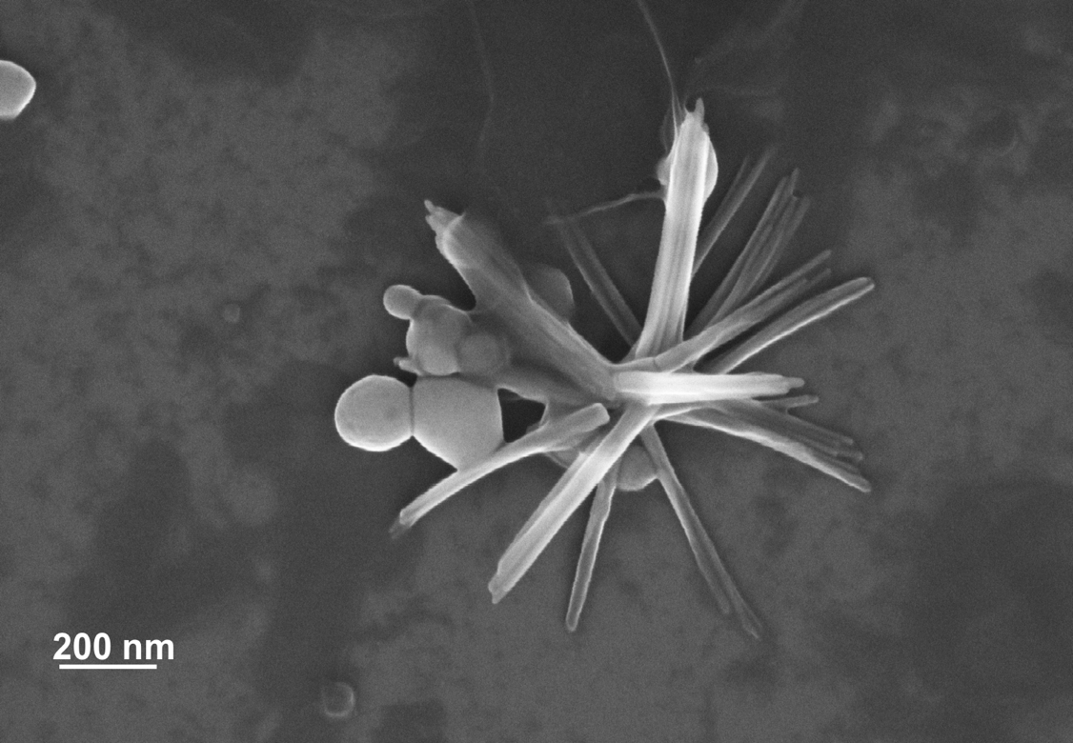
Figure S1: Scanning electron micrograph of SeNS_{MPV1-G_e} showing SeNPs and SeNRs.

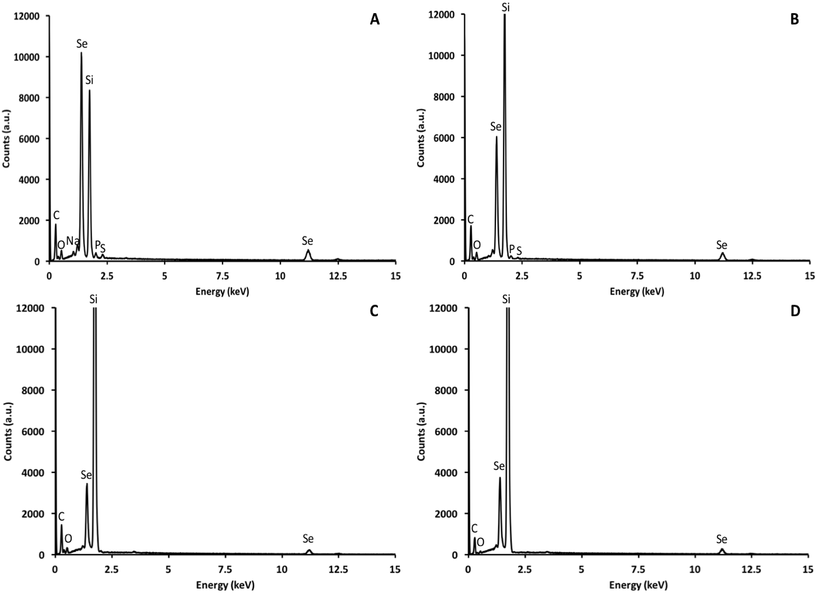
Figure S2: EDX spectra of SeNPs_{SeITE02-G_e} (a), SeNPs_{SeITE02-P_e} (b), SeNS_{MPV1-G_e} (c), and SeNS_{MPV1-P_e} (d).

Table S1: growth conditions adopted to culture the environmental bacterial isolates to generate SeNS extracts and their acronym.
Bacterial strain | Growth conditions of production | Acronym of SeNS extracts
Stenotrophomonas maltophilia SeITE02 | DM ª medium amended with glucose (0.5% v/v) and SeO₃²⁻ (0.5 mM) | SeNPs_{SeITE02-G_e}
 | DM ª medium amended with pyruvate (0.5% v/v) and SeO₃²⁻ (0.5 mM) | SeNPs_{SeITE02-P_e}
Ochrobactrum sp. MPV1 | DM ª medium amended with glucose (0.5% v/v) and SeO₃²⁻ (0.5 mM) | SeNS_{MPV1-G_e}
 | DM ª medium amended with pyruvate (0.5% v/v) and SeO₃²⁻ (0.5 mM) | SeNPs_{MPV1-P_e}
ª Defined Medium (Frassinetti et al., 1998)

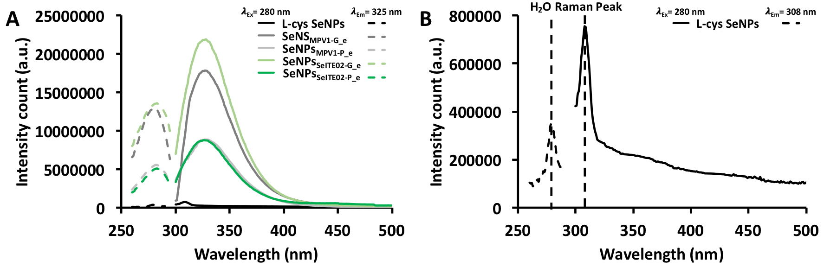
Figure S3: Fluorescence emission and excitation spectra of unlabeled biogenic SeNS extracts and chemically synthesized L-cys SeNPs (a), while, for clarity, in (b) is represented resolution of L-cys SeNPs spectra. The dashed black line indicates the water Raman peak.

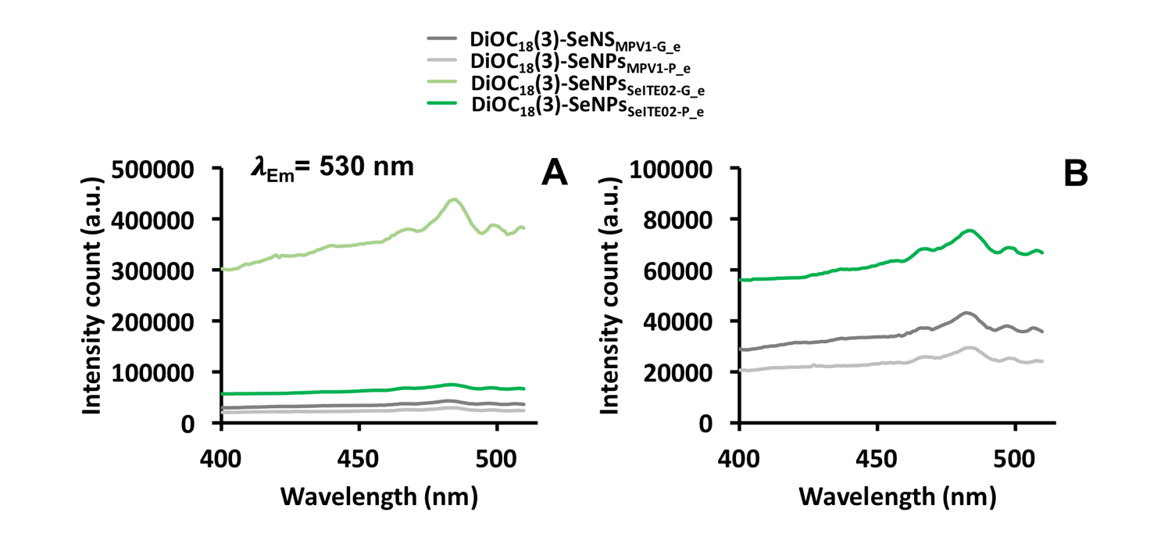
Figure S4: Fluorescence excitation spectra of the biogenic SeNS extracts labelled with the lipophilic tracer DiOC₁₈(3) (a), while, for clarity, in (b) is represented a better resolution of those samples with low fluorescent signal.

Table S2: SeNS photoluminescence’s dependency on the excitation wavelength.
Emission wavelength (nm)
λ_{exc} (nm) | L-cys SeNPs | SeNPs_{SeITE02-G_e} | SeNPs_{SeITE02-P_e} | SeNS_{MPV1-G_e} | SeNPs_{MPV1-P_e}
380 | 428 | 415 | 416 | 416 | 415
400 | 439 | 437 | 438 | 438 | 438
420 | 460 | 459 | 459 | 460 | 459
450 | 507 | 507 | 506 | 505 | 505
485 | 529 | 530 | 531 | 530 | 530
510 | 636 | 638 | 636 | 638 | 637
532 | 640 | 641 | 640 | 641 | 640
566 | 670 | 672 | 669 | 671 | 670
589 | 680 | 680 | 678 | 682 | 681
R² | 0.96 | 0.96 | 0.96 | 0.96 | 0.96

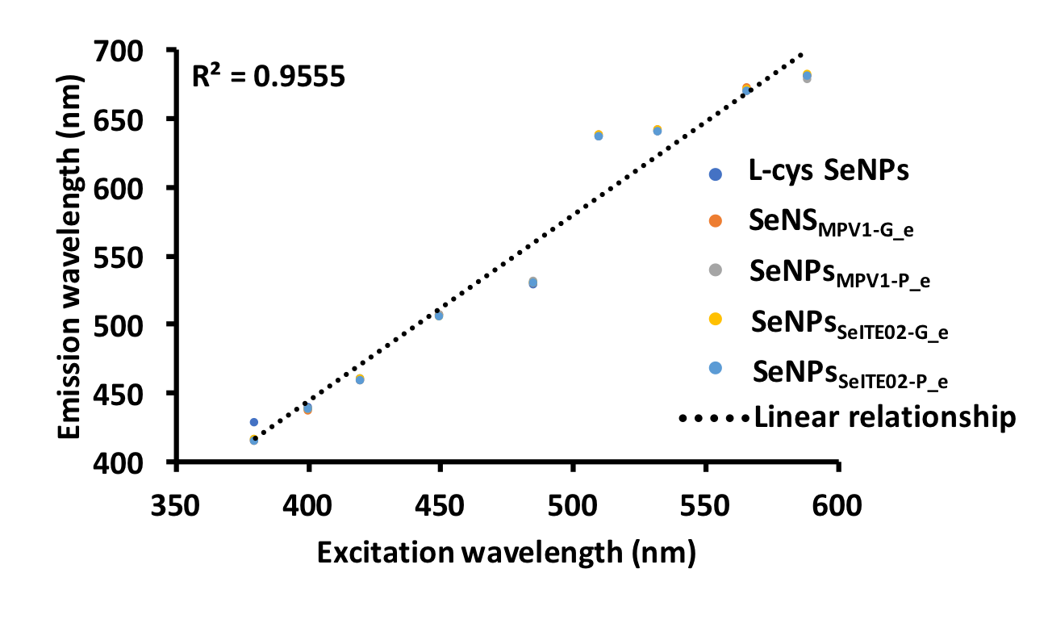
Figure S5: Linear relationship between the photoluminescence emission wavelength and the excitation wavelengths.

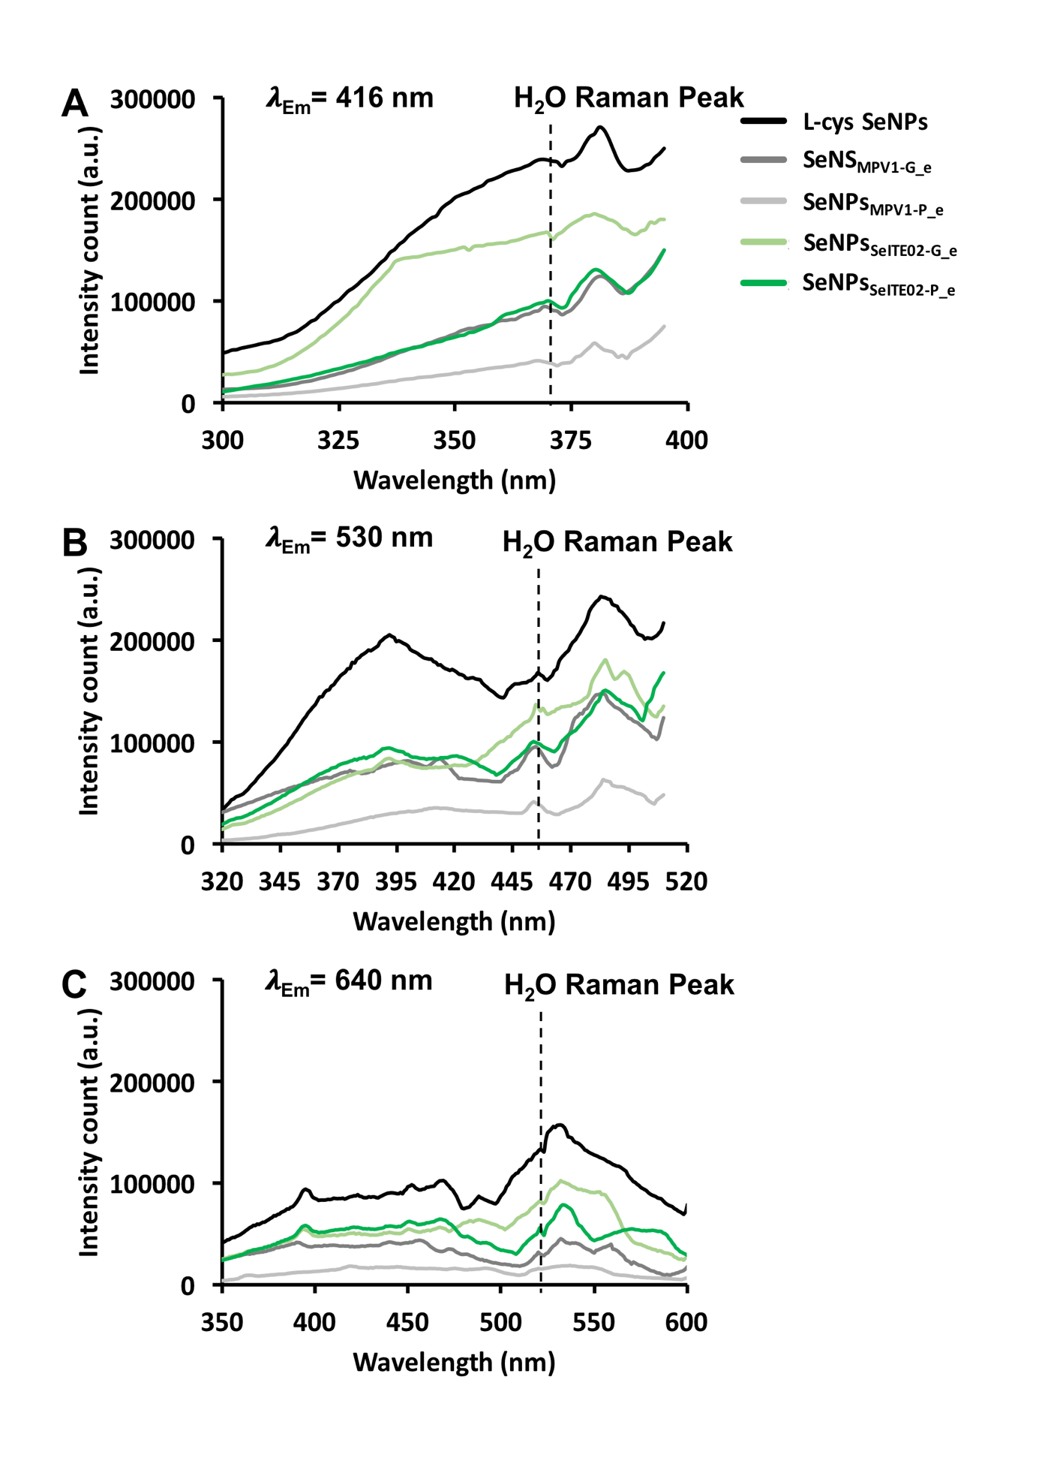
Figure S6: Photoluminescence excitation spectra of the unlabeled chemically and biogenically synthesized SeNS, setting the emission wavelength at 416 nm (a), 530 nm (b) and 640 nm (c). The dashed black line indicates the water Raman peak.

Table S3: SeNS photoluminescence excitation dependency on the emission wavelength.
Excitation wavelength (nm)
λ_{em} (nm) | L-cys SeNPs | SeNPs_{SeITE02-G_e} | SeNPs_{SeITE02-P_e} | SeNS_{MPV1-G_e} | SeNPs_{MPV1-P_e}
416 | 381 | 380 | 380 | 381 | 380
440 | 402 | 401 | 400 | 401 | 400
460 | 421 | 419 | 418 | 420 | 420
490 | 451 | 448 | 449 | 449 | 450
510 | 466 | 466 | 466 | 465 | 464
530 | 483 | 485 | 485 | 484 | 484
550 | 503 | 506 | 505 | 505 | 502
570 | 509 | 512 | 510 | 511 | 510
640 | 533 | 532 | 533 | 532 | 533
R² | 0.94 | 0.94 | 0.95 | 0.95 | 0.95

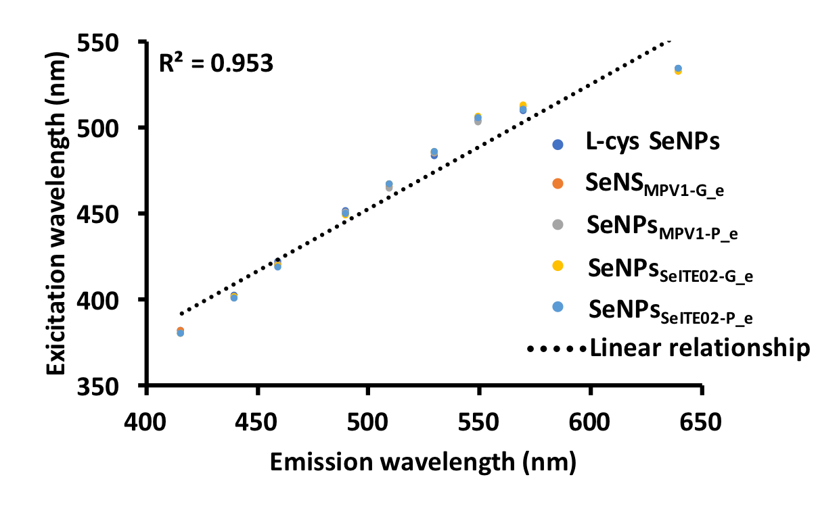
Figure S7: Linear relationship between the photoluminescence excitation wavelength and the emission wavelengths.

