Appendix 1: Abundance, AFDW biomass and BPc values in individual cores

A B
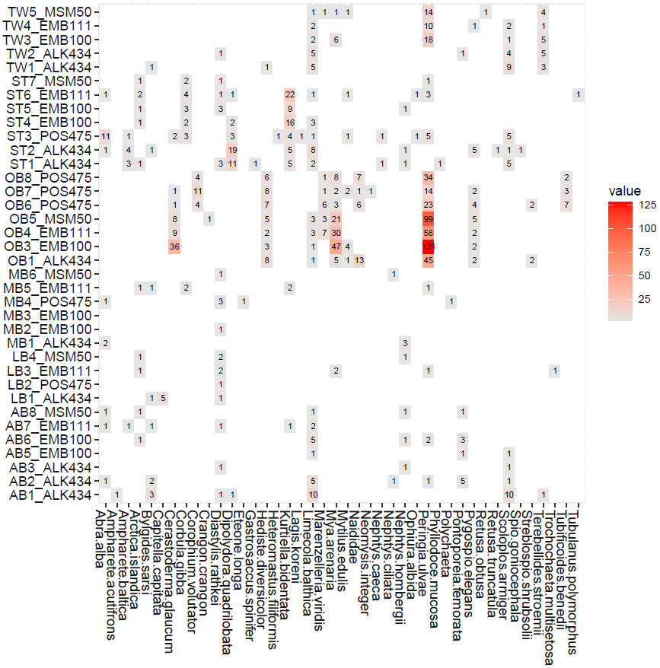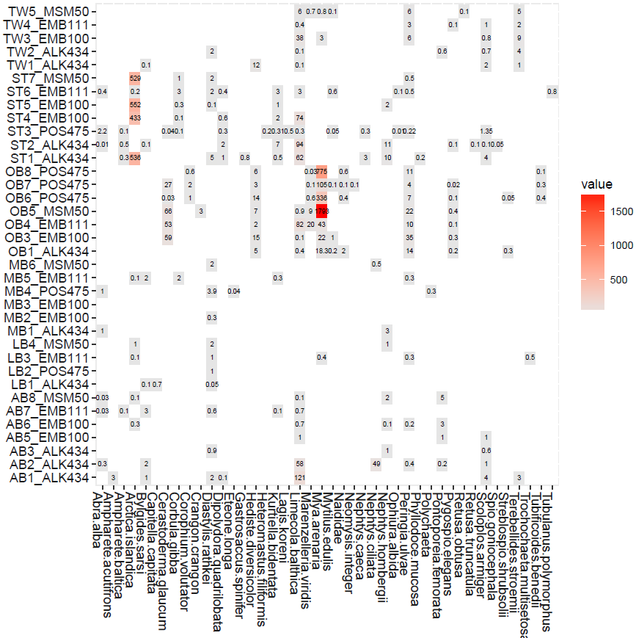

C
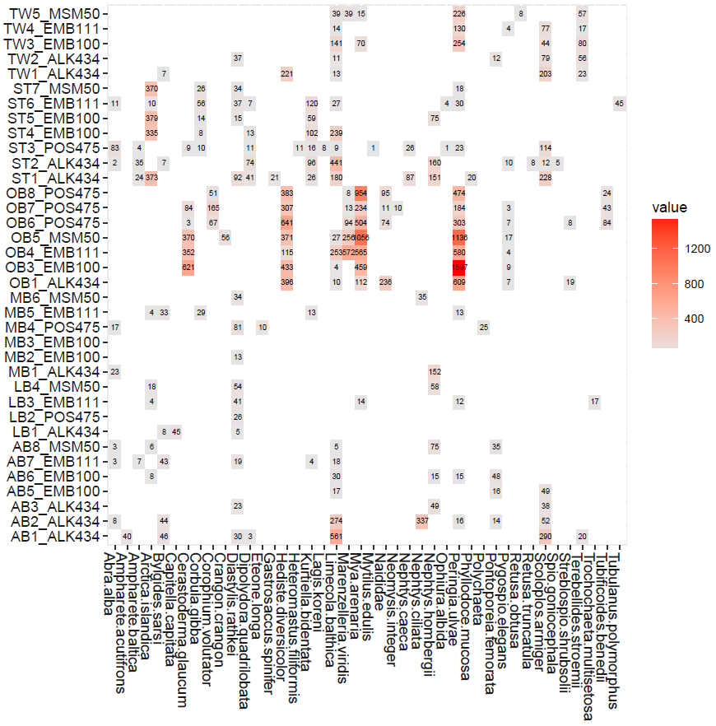
Figure A1.1 A) Abundance in porewater cores (Ind/0.00785 m²); B) AFDW biomass in porewater cores (mg/0.00785 m²); C) BPpi in porewater cores (BPpi is the bioturbation potential attributed to the populations of i-th taxon in the community inhabiting the particular core, i.e. BPpi summed across all species in a sample gives an estimate of community-level bioturbation potential, 𝐵𝑃𝑐).

A B
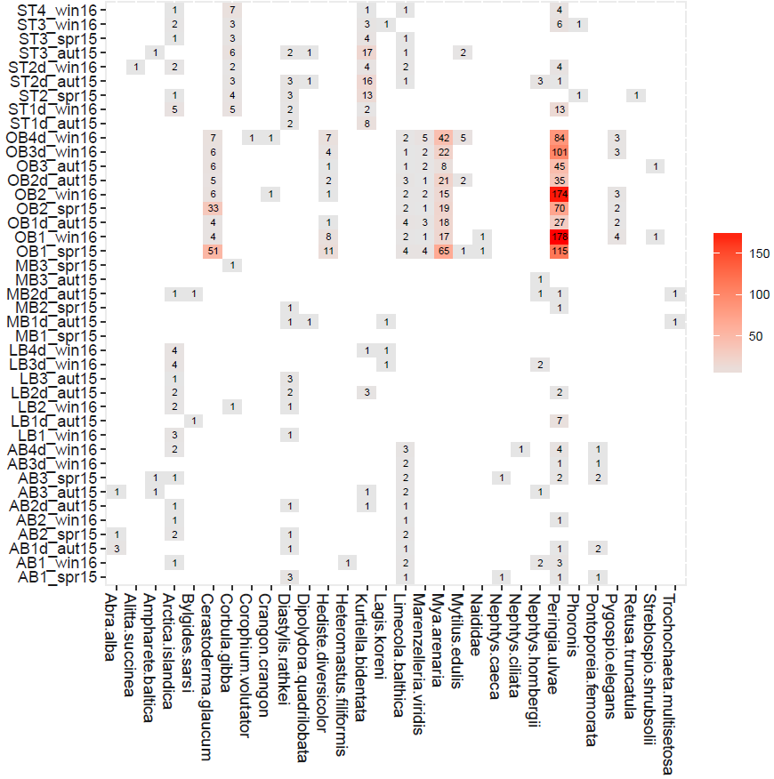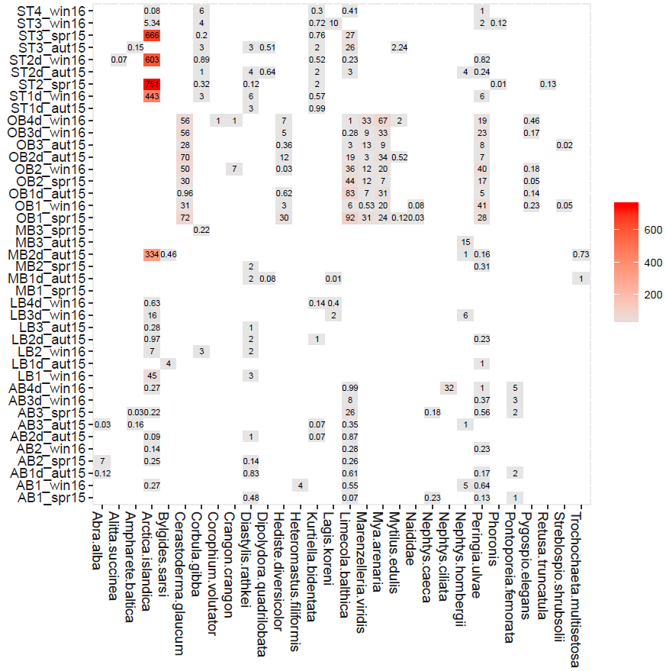

C
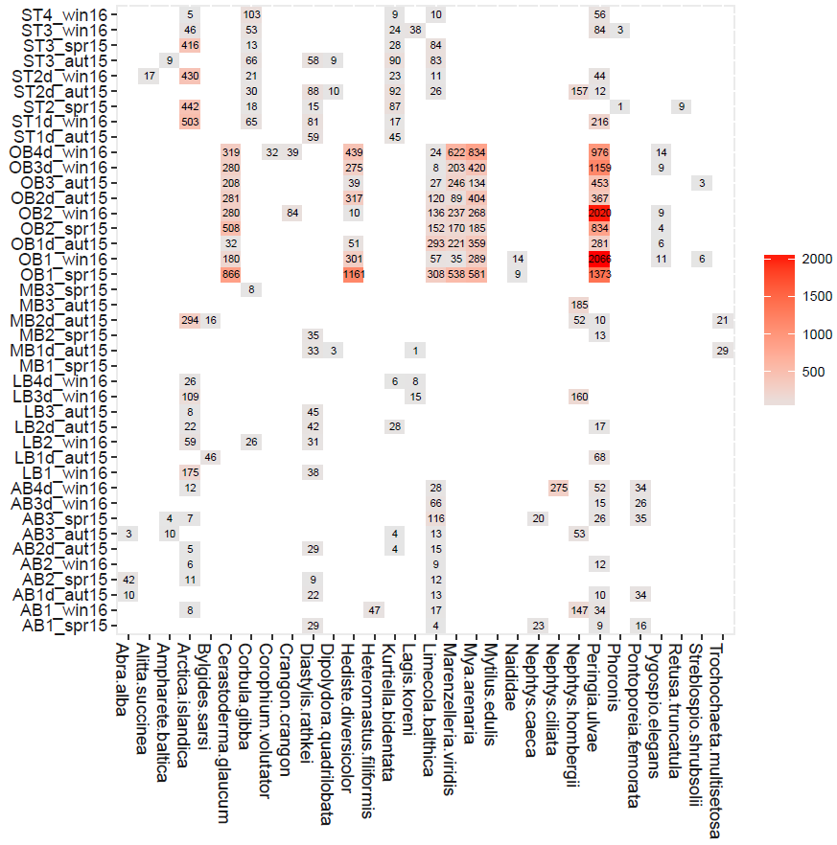
Figure A1.2 A) Abundance in incubation cores (Ind/0.00785 m²); B) AFDW biomass in incubation cores (mg/0.00785 m²); C) BPpi in incubation cores (BPpi is the bioturbation potential attributed to the populations of i-th taxon in the community inhabiting the particular core, i.e. BPpi summed across all species in a sample gives an estimate of community-level bioturbation potential, 𝐵𝑃𝑐).

Appendix 2: Functional traits structure

A B
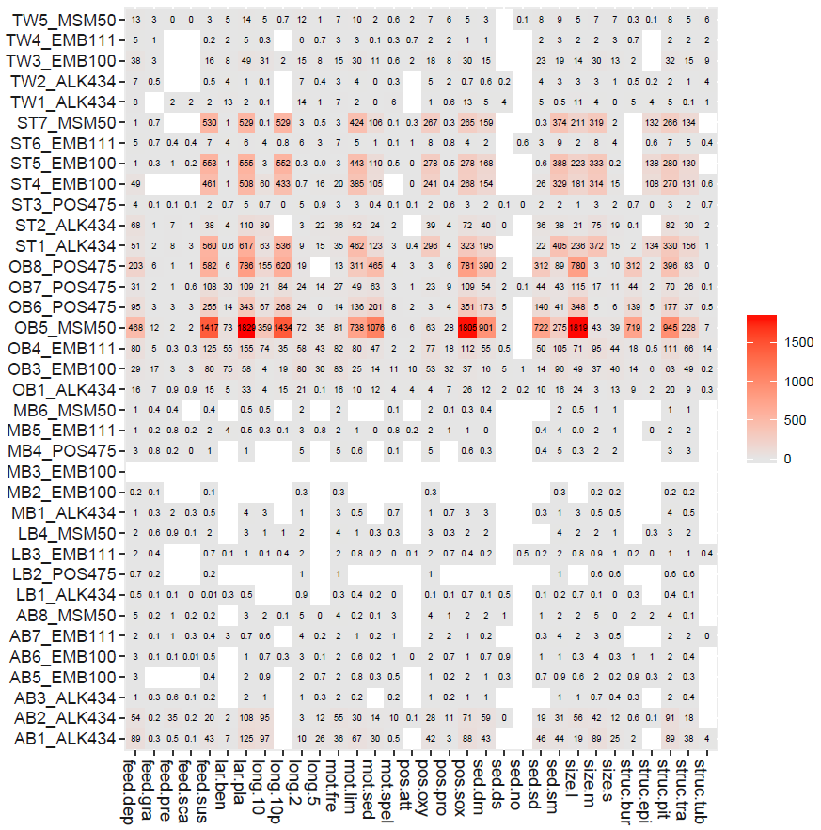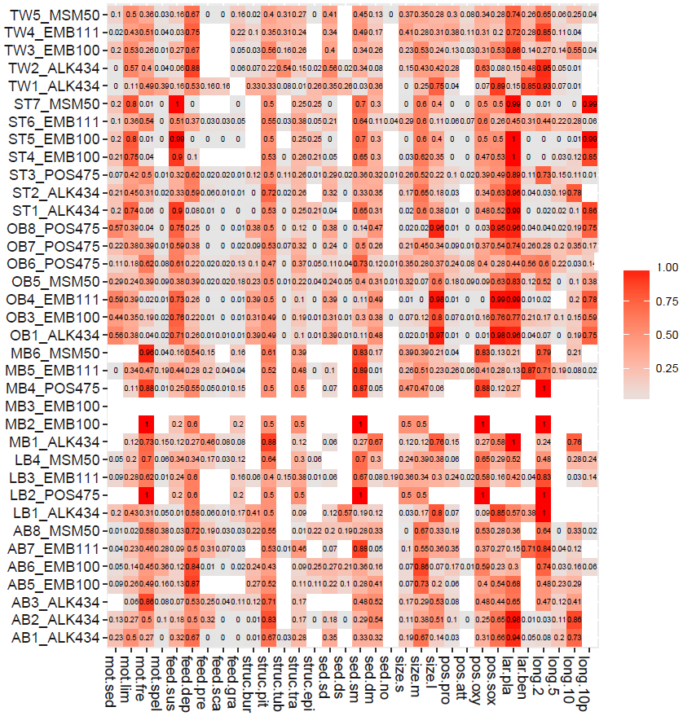
Figure A2.1 A) Functional traits structure in porewater cores weighted by AFDW biomass (mg/0.00785 m²); B) functional traits structure in porewater cores weighted by relative AFDW biomass.

A B
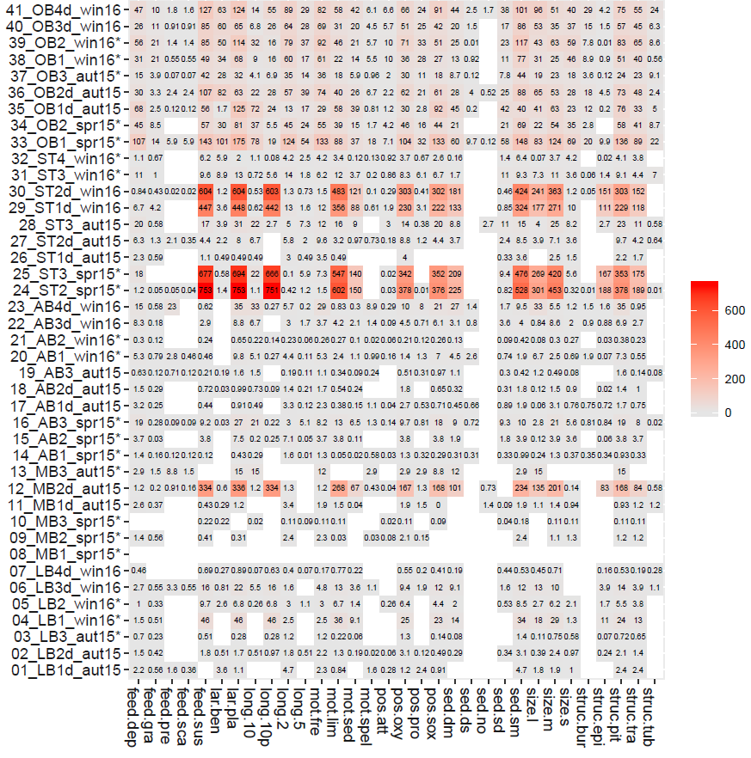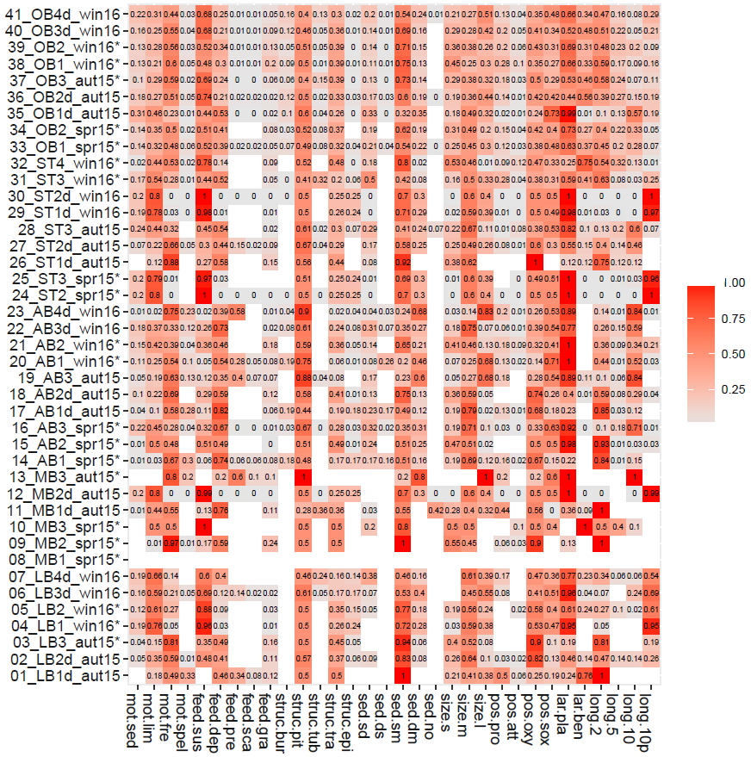
Figure A2.2 A) Functional traits structure in incubation cores weighted by AFDW biomass (mg/0.00785 m²); B) functional traits structure in incubation cores weighted by relative AFDW biomass. Cores marked with * are incubated under oxic conditions and included in the analysis.

Appendix 3: Benthic solute reservoirs vs selected functional traits (Spearman rank correlation)
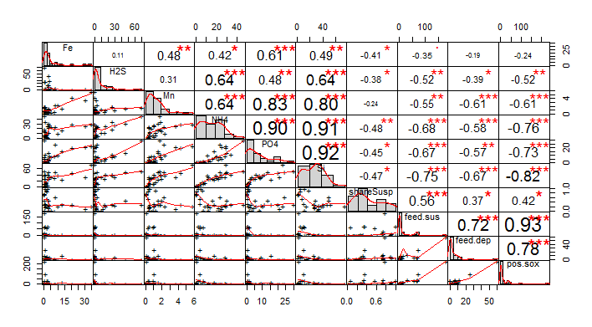
Figure A3. Chart correlation matrix showing Spearman rank correlation values between benthic solute reservoirs in top 10 cm of porewater core and selected functional traits

Appendix 4: DistLM results
SEQUENTIAL TESTS Forward Selection procedure (R²=0.6365, Adj. R²=0.5463)
Variable Adj R^2 SS(trace) Pseudo-F P Prop. Cumul. res.df
+Nsp 0.22907 10.815 5.457 0.004 0.28046 0.28046 14
+R4afdw 0.3986 7.6472 4.9465 0.005 0.19832 0.47879 13
+log1pBPc 0.54563 6.0814 5.2065 0.012 0.15771 0.6365 12

Redundancy analysis of multivariate variability in normalised benthic fluxes against major environmental and macrobenthic parameters (dbRDA) measured during incubation experiments (for 3 cruises and 5 stations. Outliers (OB1_spr15, OB2_win16, OB3_aut15, AB2_win16, AB3_spr15) were removed from the analysis. Predictor variables were checked for collinearly, and those highly correlated (r > 0.9) or those that had not significant effect in the marginal and sequential test were excluded, leaving in the final model the following:

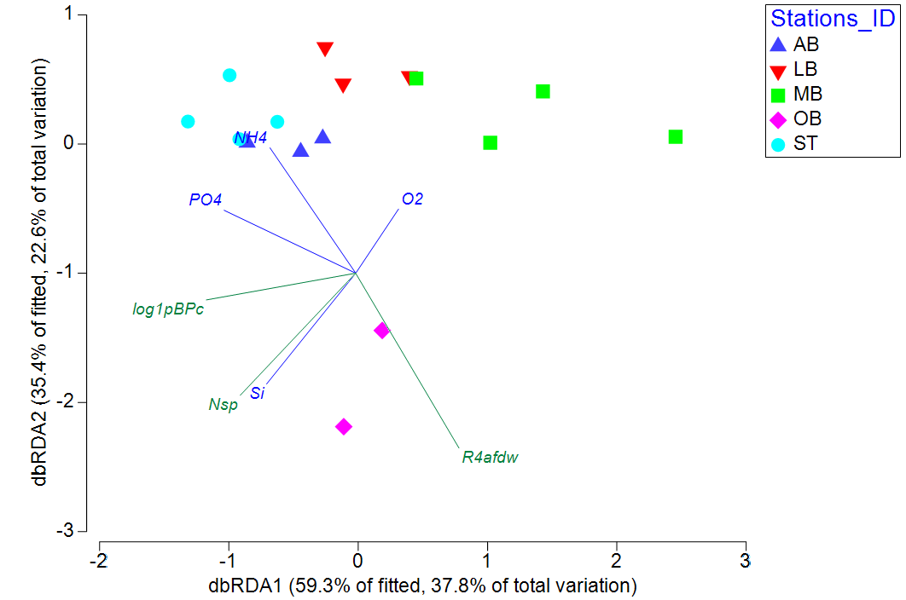
Percent variation explained by individual axes and relationships between dbRDA coordinates axes and orthonormal variables from redundancy analysis of multivariate variability in normalised benthic fluxes against major environmental and macrobenthic parameters:
Variation explained by individual axes (%) |  |  |  |  | Relationships between dbRDA coordinate axes and orthonormal variables (multiple partial correlations)
 | % explained variation out of fitted model |  | % explained variation out of total variation |  | Nsp | R4afdw | log1pBPc
Axis | Ind. | Cum. | Ind. | Cum.
1 | 59.33 | 59.33 | 37.77 | 37.77 | -0.536 | 0.48 | -0.694
2 | 35.45 | 94.78 | 22.56 | 60.33 | -0.568 | -0.814 | -0.124
3 | 5.22 | 100 | 3.32 | 63.65 | -0.624 | 0.327 | 0.709

Appendix 5: NH₄ flux at SWI (µmol*m²/day, right axis, positive values indicate sediment uptake, NH4_sed_uptake) in the cores incubated under oxic conditions plotted against log(x+1)-transformed AFDW biomass (g/m², left axis, struc.bur) of species creating burrows.

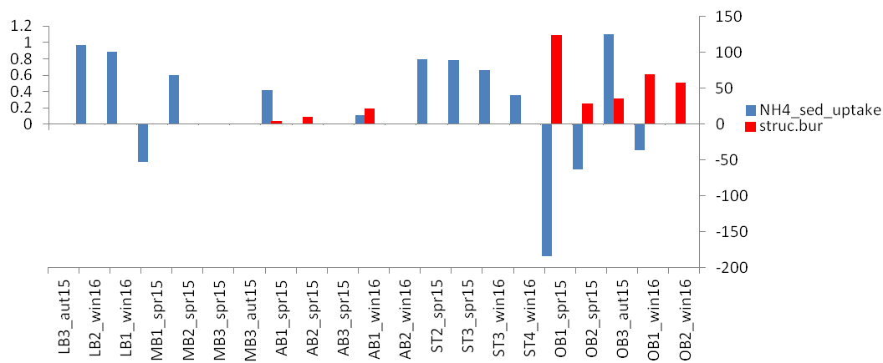
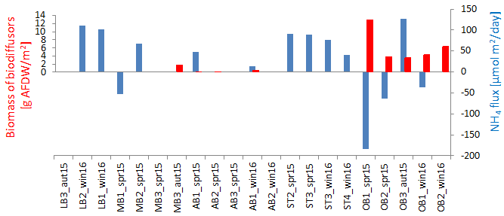

Appendix 6: Abundance of M. arenaria per PW core vs maximal non-sulfidic depth.

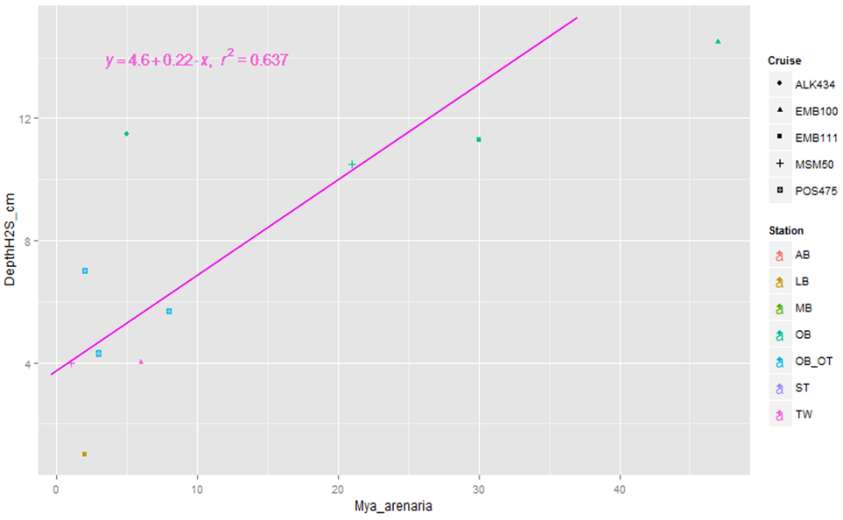

Appendix 7: Estimate of advective Si fluxes (upper pane) and diffusive Si flux (lower pane) at different sites and seasons (EMB100 – spring 2015, EMB111 – autumn 2015, MSM50 – winter 2016) plotted against log-transformed major macrofaunal parameters (BPc_VV, BPc_PW, BPc_INC – community bioturbation potential estimated per m² based on Van Veen Grab (0.1 m²) samples, PW cores set and INC cores set, respectively, Abu refers to respective abundance [ind/m²] and AFDW – to biomass [AFDW g/m²].

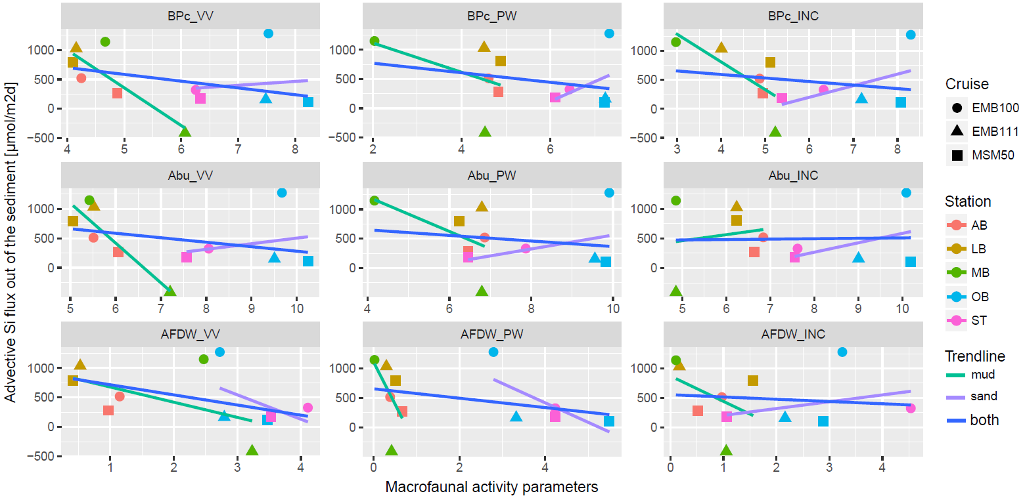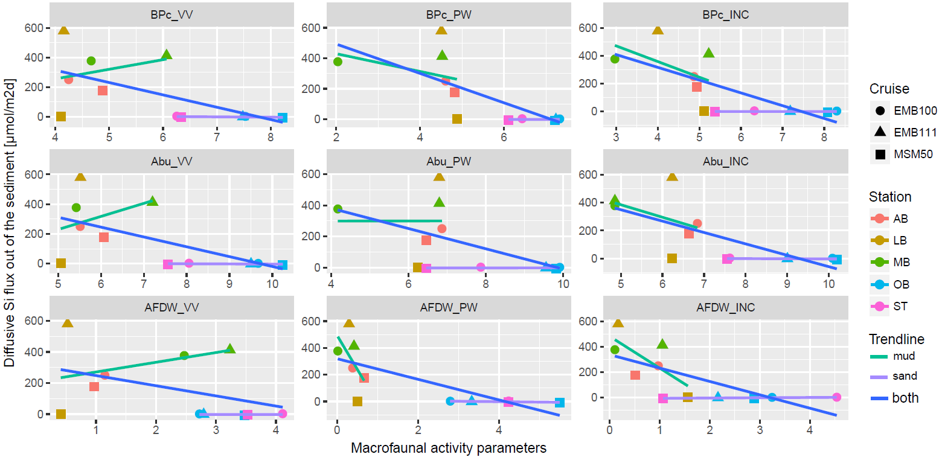

Appendix 8: Diffusive flux of phosphate from the sediment to the water column based on porewater analysis plotted against BPc of the macrofauna community inhabiting each core, for A) cores of all sediment types (cores with PO₄ sediment uptake or zero BPc where excluded to allow power trendline, N=32); and B) for cores from sandy stations considered separately and together.

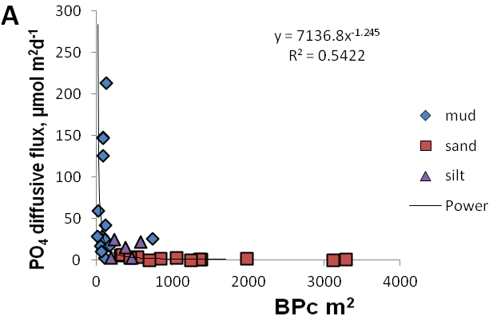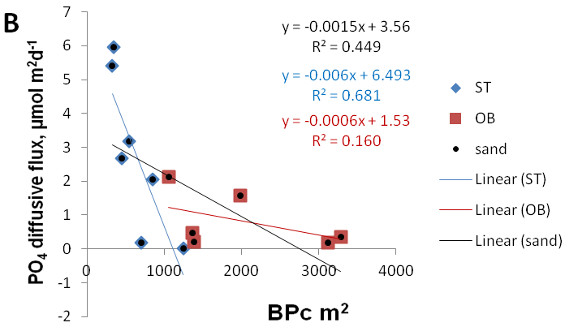

In the Baltic Sea soft-bottom macrofauna can create a three-dimensional structure of ventilated microhabitats around their burrows down to 15 cm beneath the sediment surface (e.g. Hediste diversicolor), or even as far down as 35 cm (e.g. Marenzelleria spp.). This microhabitats may have conditions favourable for the aerobic bacteria and meiofauna. Bioirrigation and bioturbation activity of macrozoobenthos causes enhanced organic matter mineralisation. Density and functional composition exerts significant indirect effects on the form and amount of nutrients released to the overlying water column. Under anoxic conditions insoluble Fe(III) is reduced to soluble Fe(II) ions and phosphorus is released into the porewater and diffuses upwards into the water column. Under oxic conditions, phosphorus is bound to iron(III) oxyhydroxides, which decreases the amount of phosphorus released to the porewater during organic matter degradation (Janas et al., 2017). In agreement with the described mechanism, our data shows significant decreasing effect of bioturbation intensity on phosphate diffusive flux from the sediment (Figure above). However, considered separately for each sediment type significant relationship between diffusive PO₄ flux and BPc is found only for sand stations (Spearman RHO=-0.74, p<0.05), and is particularly strong for ST stations along (Spearman RHO=-.89, p<0.05).

